Interfaces Wiki

Article Preparation document

This document was made to store or the articles that have been written for the Interface wiki project 2024, this was done to help with the writing and editing of the content before implementation to the website.

Scroll down for content.

Episode Articles

Page 2-89

This section will have all articles prepared for episode cataloguer, as made for the interfaces wiki project 2024.

Scroll down for content.

**Episode 1 No Title**

**Sidebar**

Episode Number: 01

Title: No Title

Released (DMY): 09/10/2017

Video Type: Interface Part 1

Synopsis: The beginning.

**Article body**

**Description**

This episode is shows Henryk and Mischief meeting for the first time with Mischief discussing his past with The Philadelphia Experiment.

This is the first episode in the series that introduces the main characters, the episode also introduces some of the most important aspects of the series like The Philadelphia Experiment and Cerebral Electricity.

**Summary**

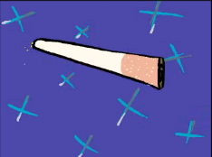**Opening**

Henryk is standing outside a store when suddenly Mischief appears behind him. Mischief pokes Henryk causing him to become startled and drop his cigarette, the cigarette is shown twirling as it falls.

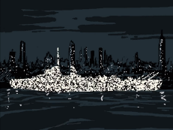Mischief ’s story

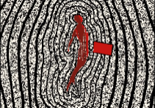Mischief begins to explain the history of The Philadelphia Experiment. Mischief explains that the ship he was stationed on was docked in Philadelphia and it was equipped with an electromagnetic field generator that was meant to make the ship invisible, however it instead teleported them to New York.

The ship teleporting to New York had caused the crew of the ship to fuse with the hull of the ship and destroyed Mischief ’s physical form. Mischief stats that he was forced to regain his physicality but does not specify how.

Ending

The cigarette mentioned earlier is seen and finishes falling. Henryk appears shocked by Mischief before the episode abruptly ends.

**Notes**

This episode likely takes places in Montral.

This is the first episode that introduces Mischief, Henryk, Henryk’s Cigarettes, Cerebral Electricity, Cerebral Electricity Monsters, and The Philadelphia Experiment.

**References**

Cerebral Electricity

Henryk

Mischief

The Philadelphia Experiment

**Sources**

Interface

https://www.youtube.com/watch?v=EHqsCmfTDmI&list=PLPnjato8iGXLQbppBPhOny8XLSRl7S5pM&index=1

Secondary source of information on interface and formatting ideas for webpages. https://umami.fandom.com/wiki/Umami_Wiki

**Episode 2 No Title**

**Sidebar**

Episode Number: 02

Title: No Title

Released (DMY): 10/10/17

Video Type: Interface Part 1

Synopsis: Mischief becomes a bus.

**Article body**

**Description**

This episode is a continuation of episode one which focuses on Mischief and Henryk traveling through the streets of Montreal to the Montreal Museum of Fine Art.

**Summary**

Opening

This episode starts directly after the first, Mischief transforms into his bus form and directs Henryk to bord him and ensure him that he does not intend to harm him.

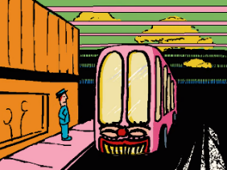Traveling on the Mischief bus

Mischief offers Henryk the opportunity to pick their destination, but Henryk dose not reply so Mischief decides their destination stating, “If you don’t decide, I will… like I’ve done to so many others.”

During this scene he see some scenes of Montreal’s notable locations. we see Turcot Interchange, Montreal’s Olympic stadium, Mount Royal Cross, and the Montreal Museum of Fine Art. noticeable all of these buildings seem infected with Cerebral Electricity.

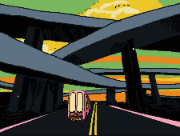 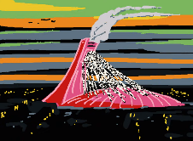 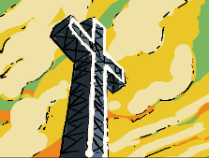 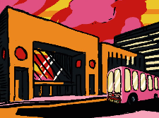

Ending

Mischief in his bus form arrives at the Montréal Museum of Fine Art and changes into his suit form appearing around Henryk as a pink version of his normal suit. As soon as the transformation ends there is a title cared for the series and the video ends.

**Notes**

The building in Montreal suggests that this episode takes place sometime in the 2010s around the time of the episode’s releases.

**References**

Cerebral Electricity

Henryk

Mischief

Notable locations

**Sources**

Interface

https://www.youtube.com/watch?v=EHqsCmfTDmI&list=PLPnjato8iGXLQbppBPhOny8XLSRl7S5pM&index=1

Secondary source of information on interface and formatting ideas for webpages. <https://umami.fandom.com/wiki/Umami_Wiki>

**Episode 3 Greetings Robotics**

**Sidebar**

Episode Number: 03

Title: Greetings Robotics

Released (DMY): 9/1/18

Video Type: Interface Part 1

Synopsis: None

**Article body**

**Description**

This episode takes place at a United Nations meeting where KAMI mark one is announced and demonstrated.

This episode introduces the primary antagonists of the series Joseph Greetings and KAMI as well as introducing the Greetings robotics corporation.

**Summary**

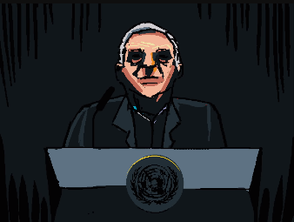Opening

This episode opens with a shoot of the Greetings Robotics blimp called The Mechanical Saccorhytus before panning down to the United Nations Headquarters, during this scene we hear Mr Greeting monologing about the Cerebral Electricity in a clearly negative manner.

Mr Greetings monologue

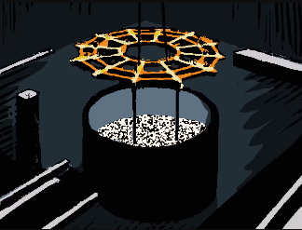Mr Greetings talks about how since 1943 Cerebral Electricity has cased ghost stories and myths to become more than just superstition but a horrifying reality, during this segment we see Mr Greetings and the crowed at the UN headquarters.

Mr Greetings then discuses Cerebral Electricity how it was not a foreign substance but something that had been revealed to humanity as a result of The Philadelphia Experiment, during this segment we see Mr Greetings talking before we see a vat of cerebral electricity and some scientists experimenting on KAMI.

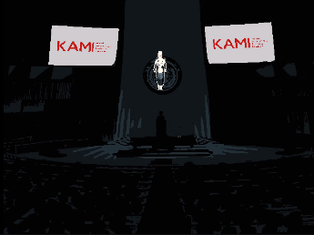Mr Greeting then discusses the various scientists, engineers, nations, and corporate sponsors that have helped him that help his company protects society form celebre electricity, during this scene we see a mask being lowered onto KAMI.

We see a sign saying that Greetings robotics is working with the United Nations counter-terrorism committee. Finally, Mr Greetings announces that Greetings Robotics has developed an android call KAMI, generation one. KAMI teleports above the stage before floating down to the ground with the crowd applauding.

Ending

There are several angles of KAMI shown before a shot of her hand forming a fist is shown and the episode ends.

**Notes**

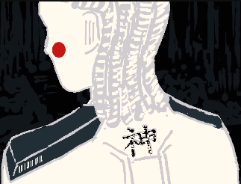This episode shows that the united nation counter-terrorism committee is working in partnership with Greetings robotics which would imply that the actions of the Cerebral Electricity Monsters are considered an act of terrorism by most governments. (speculation)

This is the first video where Joseph Greetings, KAMI, and Greetings Robotics.

This video has the clearest shot of the symbol on KAMI’s back which means “god” in Japanese, God in Japanese translates to KAMI.

**References**

Cerebral Electricity

The Philadelphia Experiment

Joseph Greetings

KAMI

Notable locations

Greetings robotics

**Sources**

Interface

https://www.youtube.com/watch?v=EHqsCmfTDmI&list=PLPnjato8iGXLQbppBPhOny8XLSRl7S5pM&index=1

Secondary source of information on interface and formatting ideas for webpages. <https://umami.fandom.com/wiki/Umami_Wiki>

**Episode 4 The Ghost**

**Sidebar**

Episode Number: 04

Title: The Ghost

Released (DMY): 13/2/18

Video Type: Interface Part 1

Synopsis: Who is the mysterious hand and the young girl?

**Article body**

**Description**

This episode focuses on The Ghost and the little girl and introduces a mystery of who these characters are and what The Ghosts relationship with Mischief is.

This episode introduces The Ghost, Henryks great-granddaughter and Henryk’s family.

**Summary**

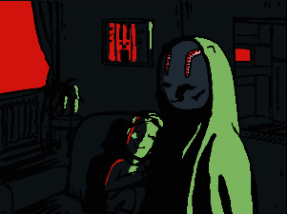Opening

The episode opens with The Ghost and Henryk’s great-granddaughter, who is seen to peacefully sleep well cuddling with The Ghost, who is watching TV which is shown a series of random faces commonly associated with Cerebral Electricity.

The Ghosts Memory

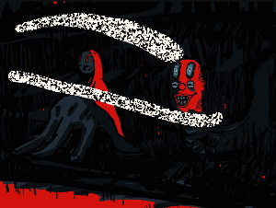The scene then changes to a memory of the past we see a car filled with members of Henryk’s family including his great-granddaughter being submerged in water, while Mischief and The Ghost watch from the riverbank.

Cerebral Electricity is seen to rise from the river and is consumed by Mischief. The Ghost is then seen to use their hand power to raise Henryk’s great-granddaughter from the wreckage before the memory ends and Henryk’s great-granddaughter is shown to wake up.

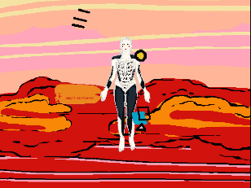KAMI’s Attack

KAMI is seen floating from the Greetings Robotic blimp towards the building that The Ghost and child are in. the child notices KAMI floating towards the building and runs to The Window looking scared. KAMI then uses her powers to remove the walls of the building before somehow absorbing The Ghost

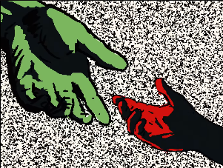Ending

As The Ghost is being absorbed the child tries to hold The Ghost’s hand but fails as she floats away, she then begins to cry as the episode ends.

Artworks

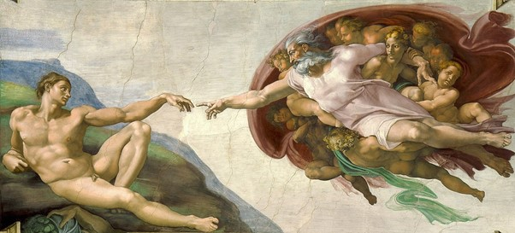

The Creation of Adam

This is meant to be a Reference to The Creation of Adam, however there is little correlation in meaning or even apparitions other than the focuses on hands. Unfortunately, I have no interpretation for what this could mean and primarily think this was a simple reference.

**Notes**

Given that The Ghost does not seem to be causing any harm it is unclear why KAMI would attack her. There are two common theories as to why, Greetings robotics may be targeting all forms of Cerebral Electricity monsters regardless of threat posed or that The Ghost is posing a threat to society in an unseen way.

This episode introduces The Ghost, Henryk’s great-granddaughter, and Henryk’s Family.

This is the first episode of the series to feature no dialogue.

**References**

Cerebral Electricity

The Ghost

Henryk’s great-granddaughter

Henryk’s Family

KAMI

Greetings robotics

The Mechanical Saccorhytus

**Sources**

Interface

https://www.youtube.com/watch?v=EHqsCmfTDmI&list=PLPnjato8iGXLQbppBPhOny8XLSRl7S5pM&index=1

Secondary source of information on interface and formatting ideas for webpages. <https://umami.fandom.com/wiki/Umami_Wiki>

Wikipedia - The Creation of Adam:

Main source of information on the artwork featured in the article.

https://en.wikipedia.org/wiki/The_Creation_of_Adam

**Episode 5 The Son of Man**

**Sidebar**

Episode Number: 05

Title: The Son of Man

Released (DMY): 13/5/18

Video Type: Interface Part 1

Synopsis: none

**Article body**

**Description**

This episode focuses on Henryk and Mischief exploring the Montreal Museum of Fine Art and discussing the painting called The Son of Man.

This is the first episode that takes place in the Montreal Museum of Fine Art and the first episode that focuses heavily on artwork for the meaning of the episode.

**Summary**

Opening

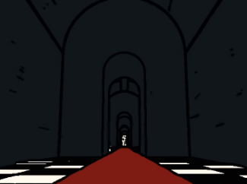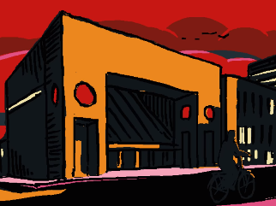The episode opens with Henryk wearing Mischief in his suit form as they enter the Montreal Museum of Fine Art, they walk up the stairs before find a long hallway filled with Cerebral Electricity. Henryk and Mischief are then seen to appear in the room with the painting called The Son of Man.

Mischief ’s discussion with Henryk

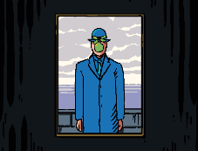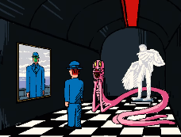Mischief changes into his primary form and comments on how he has forgotten what it is like to be human and how restrictive he finds the human body. Mischief also comments on that when he sees through Henryk’s eyes the world would look the same too him but that he cannot understand what desires are driving Henryk. Mischief stats that he knows when something is blocking Henryk’s way as the picture of The Son of Man is shown but with Henryk as the person in the painting.

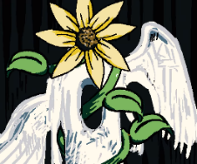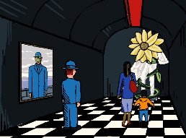Ending

Thay are then interrupted by The Museum Boy and his mother causing Mischief to transform into a sunflower wrapped around a sculpture called The Eye. Mischief talks to the boy telling him he is a beautiful sunflower clearly scaring him before the episode fades to black and ending.

**Artworks**

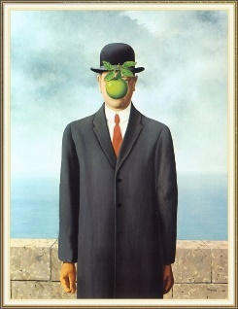 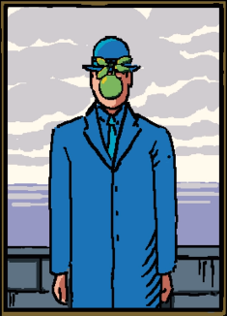

**The Son of Man**

**Analysis of artwork**

The son of man is the focus of this episode and is likely being used as a metaphor for Mischief not being able to understand what Henryk wants and Henryk not being able to understand modern the world they are in as he is stuck in the past rejecting the world as it is especially after the trauma of losing his family.

The Son of Man can literally mean what comes after man or the next generation, this supports the metaphor that apples may represent the future and the importance of the next generation which will appear more in future episodes.

I believe that this is supported by the quote in the description (” Everything we see hides another thing, we always want to see what is hidden by what we see. There is an interest in that which is hidden and which the visible does not show us. This interest can take the form of a quite intense feeling, a sort of conflict, one might say, between the visible that is hidden and the visible that is present.") and what is shown in this episode as well as other episodes mentioned on the page for The Son of Man

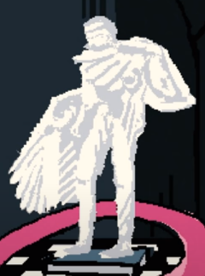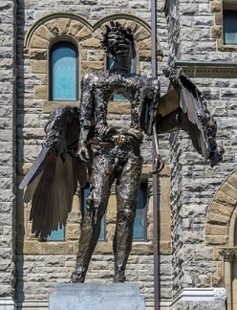

**The Eye**

There is no description for the statue given in the description other than that the statue is made of bronze, additionally the statue is not focused on in the episode over than when Mischief is wrapped around it, It is for these reasons I believe that this statue was only meant to be set dressing for this episode.

**Notes**

There is no synopsis for this episode in its places is a list of art references and a quote from the painter of The Son of Man ”Everything we see hides another thing, we always want to see what is hidden by what we see. There is an interest in that which is hidden and which the visible does not show us. This interest can take the form of a quite intense feeling, a sort of conflict, one might say, between the visible that is hidden and the visible that is present." - René Magritte

This is the first episode to feature artworks and The Museum Boy.

**References**

The Museum Boy.

The Eye

The Son of Man

Henryk

Mischief

Notable Locations

**Sources**

Interface

https://www.youtube.com/watch?v=EHqsCmfTDmI&list=PLPnjato8iGXLQbppBPhOny8XLSRl7S5pM&index=1

Secondary source of information on interface and formatting ideas for webpages. <https://umami.fandom.com/wiki/Umami_Wiki>

The Son of Man

<https://en.wikipedia.org/wiki/The_Son_of_Man>

The Eye

<https://artpublicmontreal.ca/en/oeuvre/the-eye/>

**Episode 6 Bear Witness**

**Sidebar**

Episode Number: 06

Title: Bear Witness

Released (DMY): 1/5/18

Video Type: Interface Part 1

Synopsis: None

**Article body**

**Description**

This episode focuses on the painting called“Geopoliticus Child Watching the Birth of The New Man” and explores Henryk’s past and powers.

This episode introduces the character of Henryk’s daughter prior to her becoming The Ghost.

**Summary**

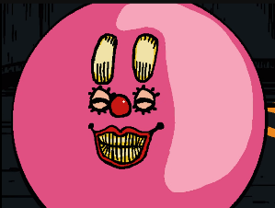**Opening**

The episode opens with a shot of Henryk in an elevator going to a higher floor. Mischief then appears in his ball form before explaining that he took the stairs as its good for cardio, Mischief is then interrupted by an announcement in French that he cannot understand.

After the announcement Mischief tries to explain about how regular exercise can change DNA but is again interrupted by an announcement this time in English saying that the museum will close soon. Knowing that the museum is closing Mischief directs Henryk to the painting called Geopoliticus Child Watching the Birth of The New Man.

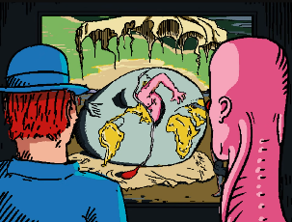Mischief discusses the painting “Geopoliticus Child Watching the Birth of The New Man”

Mischief explains that the painting competed in 1943 was completed the same year as his transformation into a Cerebral Electricity monster, comparing himself to a chicken breaking through an egg with the egg being a metaphor for the world, the same as in the painting being discussed.

Mischief then compares himself to Henryk and asking him when he had broken free, what he had left behind likely speaking metaphorically. When this is said a picture of a crewmate fused to the hull of a ship is shown likely during the Philadelphia Experiment which implies that Henryk was involved in the event.

Henryk’s convocation with his daughter

The scene then transitions to a memory of Henryk speaking with his daughter interspliced with shots of the painting. Henryks daughter discusses about how when she was younger, she wanted to be a photographer like 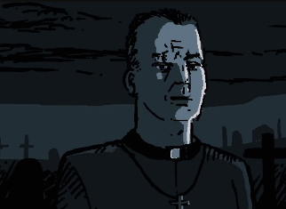Henryk so she could “freeze time and bear witness to the world.” Henryks daughter then continues and says she remembers when her mum died the pastor was staring at Henryk which she did not understand at the time but in hindsight understand that it’s because Henryk was impossible young. This leads to Henryks daughter asking Henryk if she should wait for him when she dies and if Henryk will ever die.

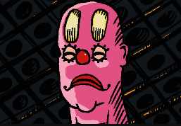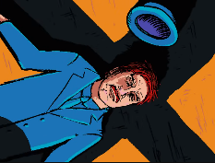Ending

During the monologue of Henryks daughter Henryk is seen to fail to his neighs before fainting leading to Mischief floating over him frowning likely concerned.

**Artworks**

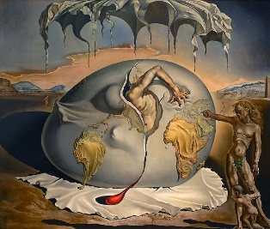 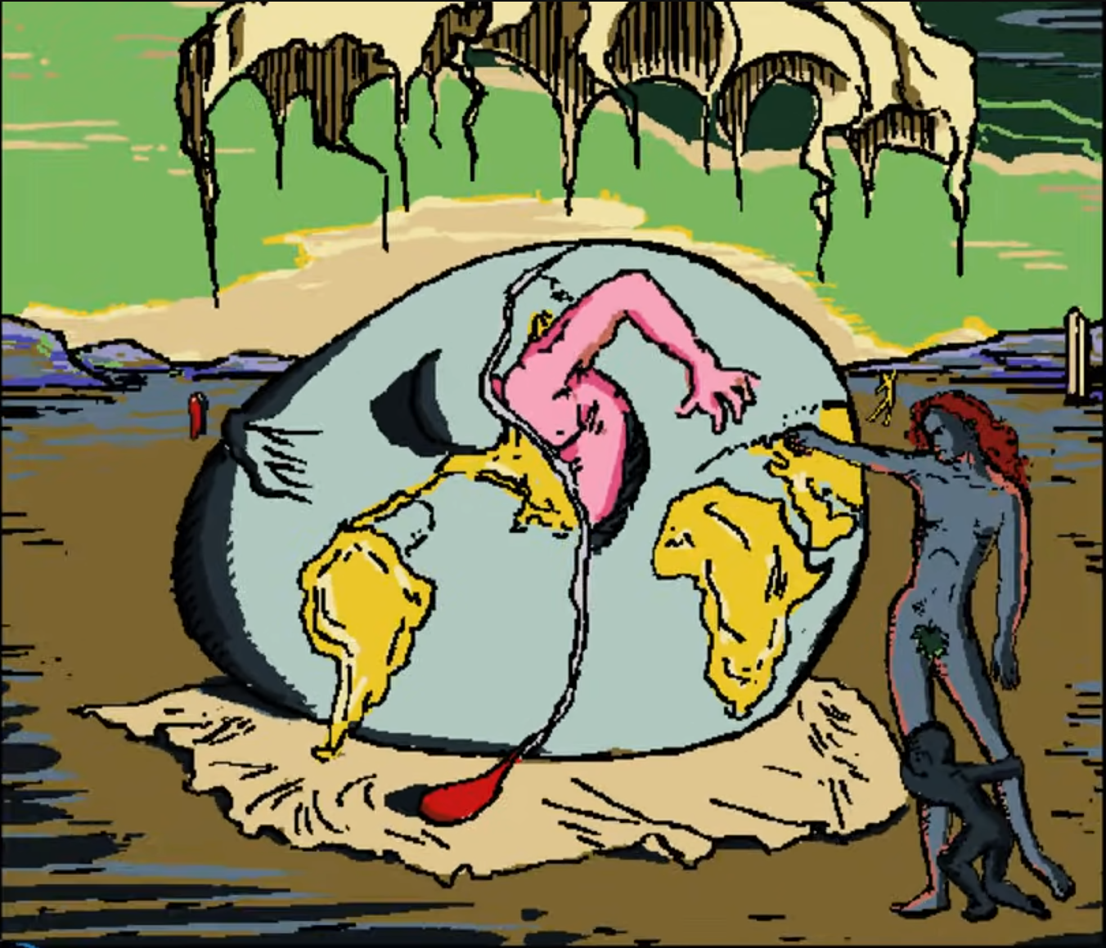

**Geopoliticus Child Watching the Birth of The New Man**

The traditional interpretation of the painting is usually that the Geopolitical child represents the world as it was, and The New Man represents the future and the next generation. This is compered to both Mischief and Henryk.

For Mischief it is clearly implied that he is The New Man the painting is actually altered to have The New Man be pink like Mischief, Mischief also compares himself to the painting and how when he was reborn, he had changed the world. This encourages the metaphor that Mischief and Cerebral Electricity represent progress and the next generation.

For Henryk it is less clear, but my interpretation is that Henryk represents The Geopolitical Child watching the birth of The New Man. Henryks immortality has lead him to watch the world moving on and transforming around him but not being able to fully change to go along with the times, this is also supported by Henryk’s career being a photographer somebody who’s job is to watch the world and record it.

**Notes**

This episode was the first to introduces Henryk’s daughter prior to her transformation into The Ghost.

This episode was the first to imply that Henryk is a Cerebral Electricity Monster despite appearing human, whether or not his is a Cerebral Electricity monster is never confirmed but it is the only explanation for his supposed immortality and incorrigibility.

**References**

Cerebral Electricity

Geopoliticus Child Watching the Birth of The New Man

The Ghost

Henryk

Mischief

**Sources**

Interface

https://www.youtube.com/watch?v=EHqsCmfTDmI&list=PLPnjato8iGXLQbppBPhOny8XLSRl7S5pM&index=1

Secondary source of information on interface and formatting ideas for webpages. <https://umami.fandom.com/wiki/Umami_Wiki>

Geopoliticus Child Watching the Birth of The New Man

<https://en.wikipedia.org/wiki/Geopoliticus_Child_Watching_the_Birth_of_the_New_Man#:~:text=The%20man%20emerging%20from%20egg,Europe%20to%20support%20his%20emergence>

**Episode 7 The Mechanical Saccorhytus**

**Sidebar**

Episode Number: 07

Title: The Mechanical Saccorhytus

Released (DMY): 24/6/18

Video Type: Interface Part 1

Synopsis: Mr. Greetings speaks his thoughts on evolution, and why the universe is the way it is. What is he trying to accomplish? Can you find the hidden messages?

**Article body**

**Description**

This episode focuses on greetings robotics and the aftermath of KAMI’s attack on The Ghost and little girl as well as showing the greetings robotics processes of consuming and coping Cerebral Electricity Monster.

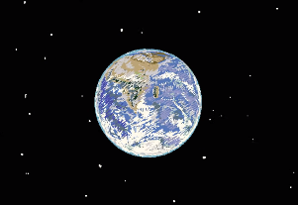**Summary**

Opening and Mr Greetings speech

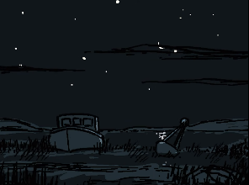The episode starts on a view of the starts slowly focusing in on earth as Mr Greetings talks about the formation of the starts and earth.

The shot then changes to a beach with a boat on it as Mr Greetings starts to talk about the formation and evolution of life.

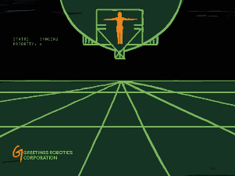we then see pictures of the deep see and he discusses how he believes that atoms over time will try to become more complex, pondering why as the shot refocuses on the stars before The Mechanical Saccorhytus, greetings robotics blimp is seen to float by.

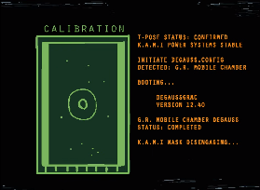Onboard The Mechanical Saccorhytus

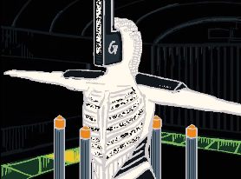We see Mr greeting looking at a screen that displays info on the blimp and KAMI. KAMI is seen T-posing in a docking area well seemingly connecting to the ship to be “degauss” which usually refers to the removal of water, magnetic, energy or data from a system, in KAMI’s case it is most likely Cerebral Electricity being removed.

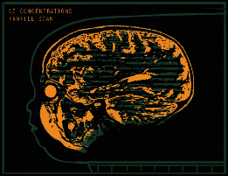KAMI’s mask then begins to disengage and we see some kind of port attach to wear it usually would be before a large amount of Cerebral Electricity is seen to go through the port and connect to the internal structure of The Mechanical Saccorhytus which is shown to have a brain and eyes and even a mouth.

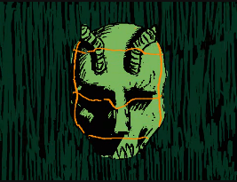The Ghost’s hand is shown as well as hex code, the hex code translating too ULTIMATE COMPLEXITY IS THE FINAL DESTINATION, INCOMING TRANSMISSION INCOMPLETE, GENE SEQUENCING UNKNOWN NUCLEOTIDES, GR DISCOVERY: COPYING DATA AND ORIENTATION.

The scene then shows more scans of the blips brain before an image of The Ghost is shown being scanned as Mr greeting is watching and also seemingly being scanned.

Ending

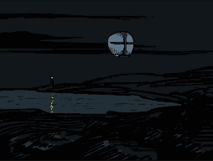We see a lighthouse blinking in the background as a whale briefly appears form the water and the episode ends as a final shot of The Mechanical Saccorhytus is shown.

**Hex Code Meaning**

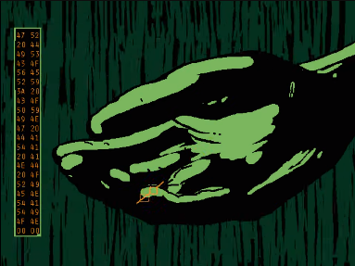ULTIMATE COMPLEXITY IS THE FINAL DESTINATION

This likely correlates to what Mr Greetings is talking about and how the creatures are reaching a stat of ultimate complexity where they cannot get more complex.

INCOMING TRANSMISSION INCOMPLETE

This stats that somehow the data KAMI is sending somehow isn’t complete this isn’t elaborated on and seemingly has no consequences so in my opinion I think this is flavour text.

GENE SEQUENCING UNKNOWN NUCLEOTIDES

This implies that it is breaking down the giant sequence of The Ghost and repurposing them which would implies that all Cerebral Electricity Monsterhave a biological component and are not purely magic, spiritual, or made of Cerebral Electricity.

GR DISCOVERY: COPYING DATA AND ORIENTATION

This implies that The Ghost is being copied and reorientated to serve Greetings Robotics. I believe that this leads to the destruction of the original Ghost, but this is not made clear in the series.

Translated by Josiah Snarr in the Umami Discord server.

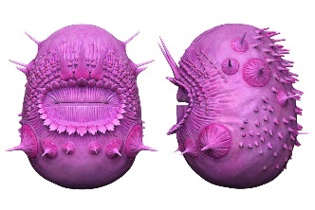**Notes**

A Saccorhytus is one of the oldest known ancestors of human life, pictured on the right.

USS impermanence is briefly shown in the scene with the beach as well as the lighthouse at the end of the video though neither are clearly shown.

**References**

Cerebral Electricity

The Mechanical Saccorhytus

KAMI

Greetings robotics

The Ghost

Joseph Greetings

Notable locations

**Sources**

Interface

https://www.youtube.com/watch?v=EHqsCmfTDmI&list=PLPnjato8iGXLQbppBPhOny8XLSRl7S5pM&index=1

Secondary source of information on interface and formatting ideas for webpages. <https://umami.fandom.com/wiki/Umami_Wiki>

Saccorhytus

<https://en.wikipedia.org/wiki/Saccorhytus>

**Episode 8 The Watchful Eyes**

**Sidebar**

Episode Number: 08

Title: The Watchful Eye

Released (DMY): 3/8/18

Video Type: Interface Part 1

Synopsis: Mischief comes to visit Henryk in the hospital, and he notices some strange things in the medical records.

**Article body**

**Description**

This episode shows the aftermath of Episode 6 Bear Witness, with Henryk in the hospital watching tv when Mischief pays him a visit.

**Summary**

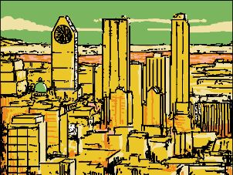Opening

This episode opens on a shot of a city, Montreal. A pink version of the Goddess of Liberty statue is shown with a Cerebral Electricity halo as well as the Montreal Olympic Stadium which is zoomed out of until we see it through The Window of Henryk’s hospital window.

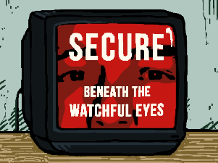Television Adverts

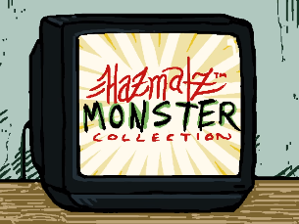In Henryk’s hospital room we see a tv playing an advert from Greetings Robotics. the advert shows a series of random faces before displaying a message saying SUCERE beneath the watchful eyes, followed up by the grating robotics logo and their tagline “Keeping Communities Safe.”

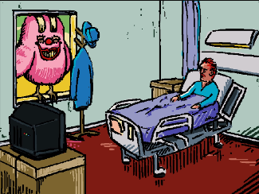A second advert is shown for Hazmatz Monster Collection a business that seems to sell Cerebral Electricity Monster to children. Several monsters are shown most noticeable The Ghost is shown which may imply that this company works with Greetings Robotics and that may imply the monsters sold are entirely tame and safe despite appearances, though there is a warning that they may be dangerous this could just be for marketing.

Mischief Is a Bird

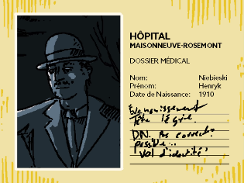Mischief suddenly appears in his bird form saying tweet tweet and explains to Henryk that he is attempting to be a bird but is not good at it yet.

Mischief then decides to check out Henryk’s medical record discovering that his name is Henryk Niebieski and that he was born in 1910 the medical records state that Henryk fainted and was lightheaded as well as questing his date of birth claiming he may have stolen this identity, though this is meant to be clearly false as we know Henryk just doesn’t age.

Mischief is surprised by Henryk’s age and claims that he is hiding something before making a joke about how smooth his skin is for his age transforming the space around him into a health magazine. Mischief then warns Henryk that if he stays here any longer that he will 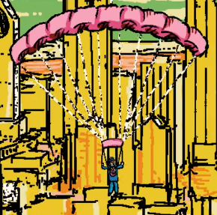likely become a medical experiment and turns into a parachute so Henryk can escape out The Window.

Ending

Henryk is seen floating out The Window making his escape before the scene cuts to black, ending the episode.

**Artworks**

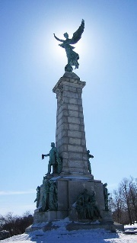 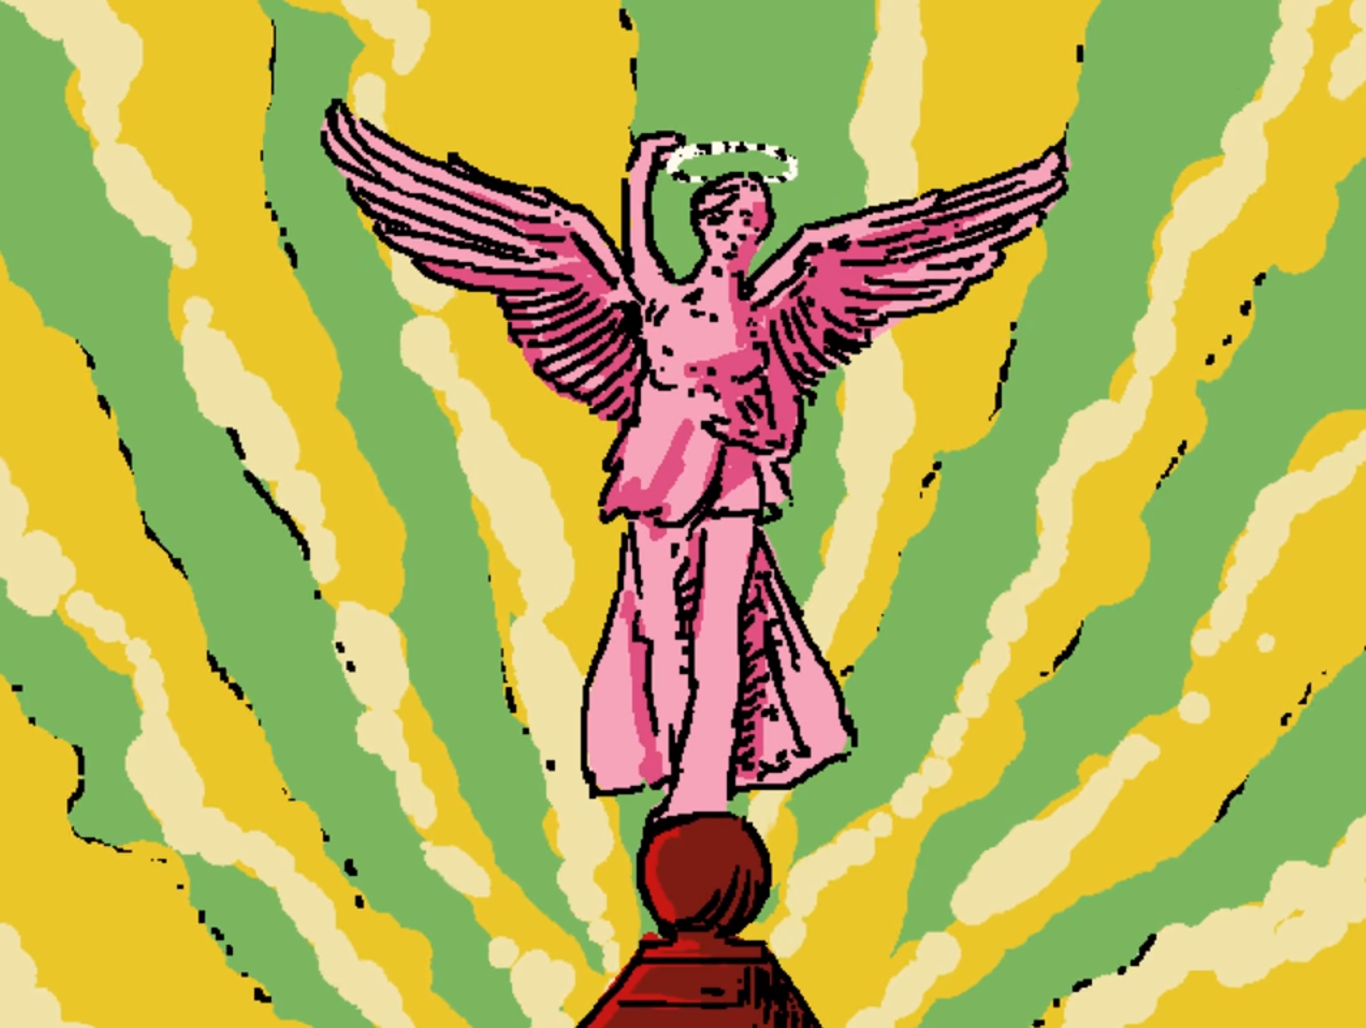

The Goddess of Liberty

This statue is briefly shown with no text in the description for it and no focuses put on it in the episode, these are the main reason that I think that the statue has no greater meaning to the episode and is a form of set dressing as it is located in Montreal.

There are several smaller statues that are not even shown from what I have research the statue primarily meaning is to support the importance’s of justice, liberty, and education, which all have little baring on the series other than education is important for the next generation. The next generation being important to the series.

**Notes**

The Spokesperson also appears in the short Mischief is a bird where he unfortunately gets an intestinal worm.

**References**

Cerebral Electricity

Hazmatz Spokesperson

Henryk

Mischief

Hazmatz Monster Collection

Goddess Of Liberty

**Sources**

Interface

https://www.youtube.com/watch?v=EHqsCmfTDmI&list=PLPnjato8iGXLQbppBPhOny8XLSRl7S5pM&index=1

Secondary source of information on interface and formatting ideas for webpages. <https://umami.fandom.com/wiki/Umami_Wiki>

Goddess Of Liberty

<https://en.wikipedia.org/wiki/George-%C3%89tienne_Cartier_Monument>

**Episode 9 Camouflage**

**Sidebar**

Episode Number: 09

Title: Camouflage

Released (DMY): 15/9/18

Video Type: Interface Part 1

Synopsis: Mischief and Henryk visit a restaurant owned by one of Mischief 's mysterious acquaintances to have a good munch, but it seems The Chef is distraught and there is a lot on his mind.

**Article body**

**Description**

This episode focuses on Henryk and Mischief going to a restaurant and meet Mischifes old friend The Chef, who’s been having visons of a horrifying creature that sees the world in black and white.

**Summary**

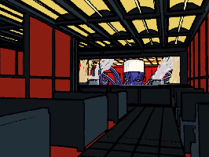Opening

The episode opens with a shot of The Chef who is a cerebral electricity monster that runs a restaurant in Montreal. The Chef is a squid monster that uses his meany limbs for cooking.

Conversation With Mischief

The Chef is seen preparing a food for the restaurant until Henryk and Mischief in his suit form appear at the counter. The Chef informs them that the restraint does not open until later.

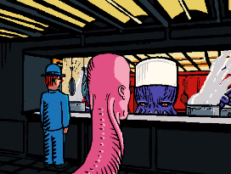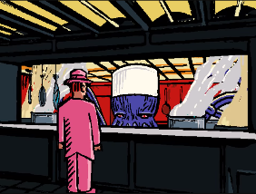Mischief ignores this and stats that The Chef chopping up sea creatures is a form of cannibalism. The Chef retorts with by say “the strong eat the week” in Japanese’s. In response Mischief says “what about parasites”, The Chef replies “one who uses a host for their own survival” in Japanese and then continue in English he says “isn’t that what you’re doing Mischief ” this causes Mischief to revert to his original form and proclaims that he is guilty of being a parasite.

The Chef say that even with his pore hearing Mischief voices is unforgettable and warns him that pink is a pore chose of camouflage, Mischief retorts that it depends on what you are trying to hide from.

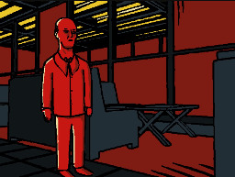The Chef accuses Mischief of not being able to change cooler and clams he can but doesn’t know what colour to change too as he doesn’t understand his enemy.

The Chef’s Vison

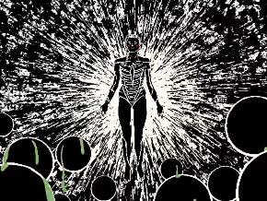A strange man is seen to enter the restraint as The Chef clams that he has been having visons of a creature that process the world in ones and zeros.

The scene shows a dream like sequence of pictures displaying KAMI. The Chef tells Mischief that he is afraid that any colour the pick’s will be ineffective against a creature that sees the world in black and white.

Ending

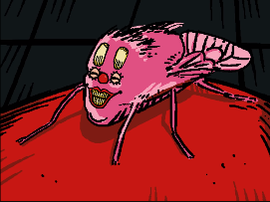Mischief interjects and asks if this is about The Strange Man that enters earlier before changing into his fly form, flying across the room landing on the man and telling him that the restaurant opens at five, echoing the words of The Chef earlier in the episode. the episode then ends.

**Notes**

This episode defines how the word parasite is used in the sires as “one who uses a host for their own survival” which is a slightly broader interpretation of the term than normal. This is important for latter episodes.

This episode introduces a prominent Cerebral Electricity Monster called The Chef.

**References**

Cerebral Electricity

The Chef

The Strange Man

KAMI

Henryk

Mischief

**Sources**

Interface

https://www.youtube.com/watch?v=EHqsCmfTDmI&list=PLPnjato8iGXLQbppBPhOny8XLSRl7S5pM&index=1

Secondary source of information on interface and formatting ideas for webpages. <https://umami.fandom.com/wiki/Umami_Wiki>

**Episode 10 An Illusion of Time**

**Sidebar**

Episode Number: 10

Title: An Illusion of Time

Released (DMY): 11/10/18

Video Type: Interface Part 1

Synopsis: Henryk's past.

**Article body**

**Description**

This episode explores Henryk’s memories of his family and his home.

**Summary**

Opening

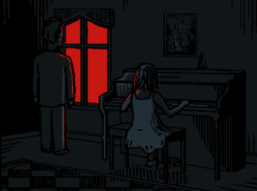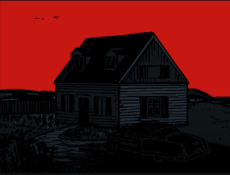The episode opens on a shot of the house before change to a shot inside the house with a girl playing the piano as Henryk approaches.

The Life of a Tree

The scene changes to a tree paining down this is shown to be Henryk’s wedding. The tree is again shown this time slightly bigger with a girl on the swings in front of it. The scene changes again to the same tree much thicker with Henryk taking a picture of a woman holding a baby surrounded by other people.

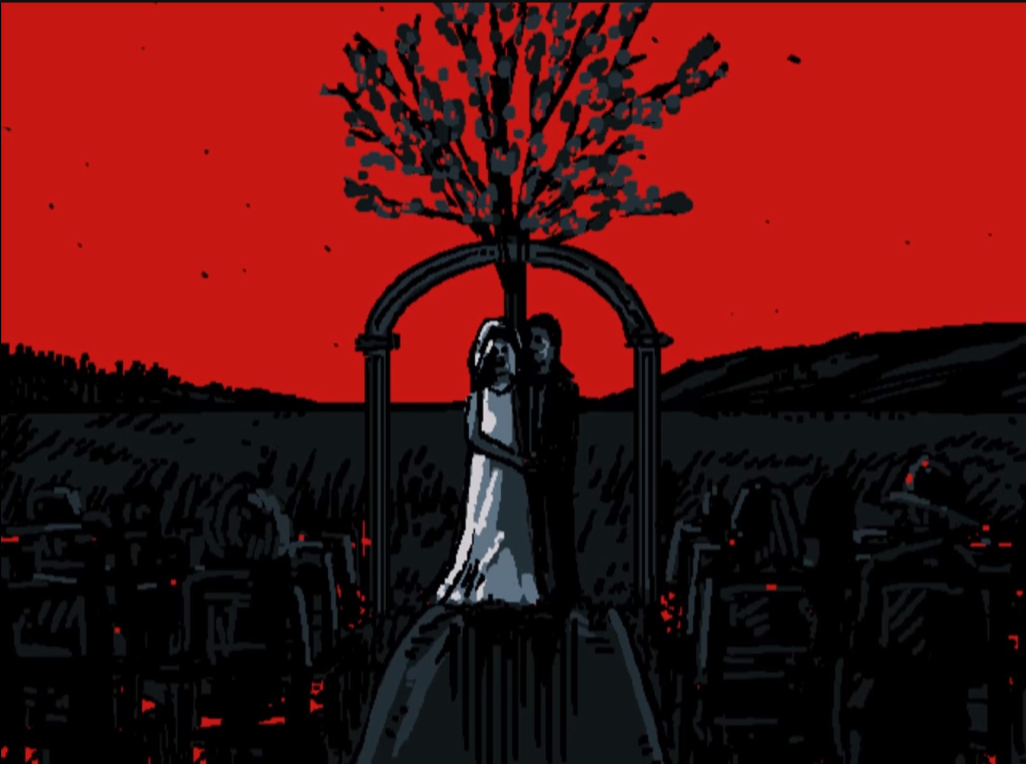 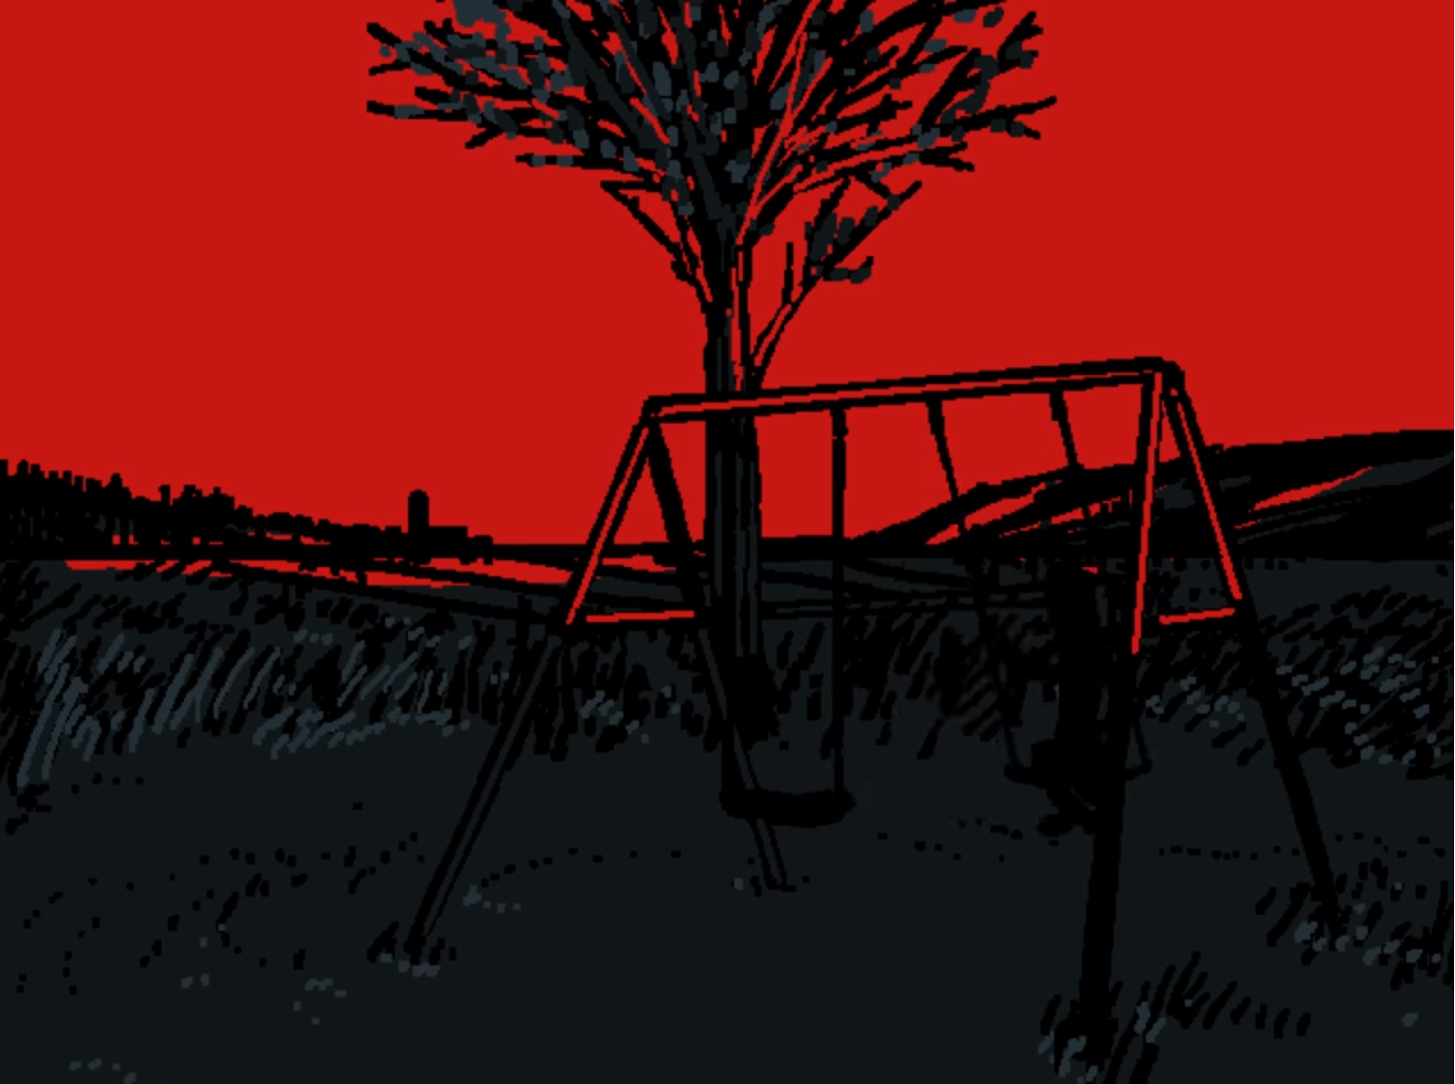 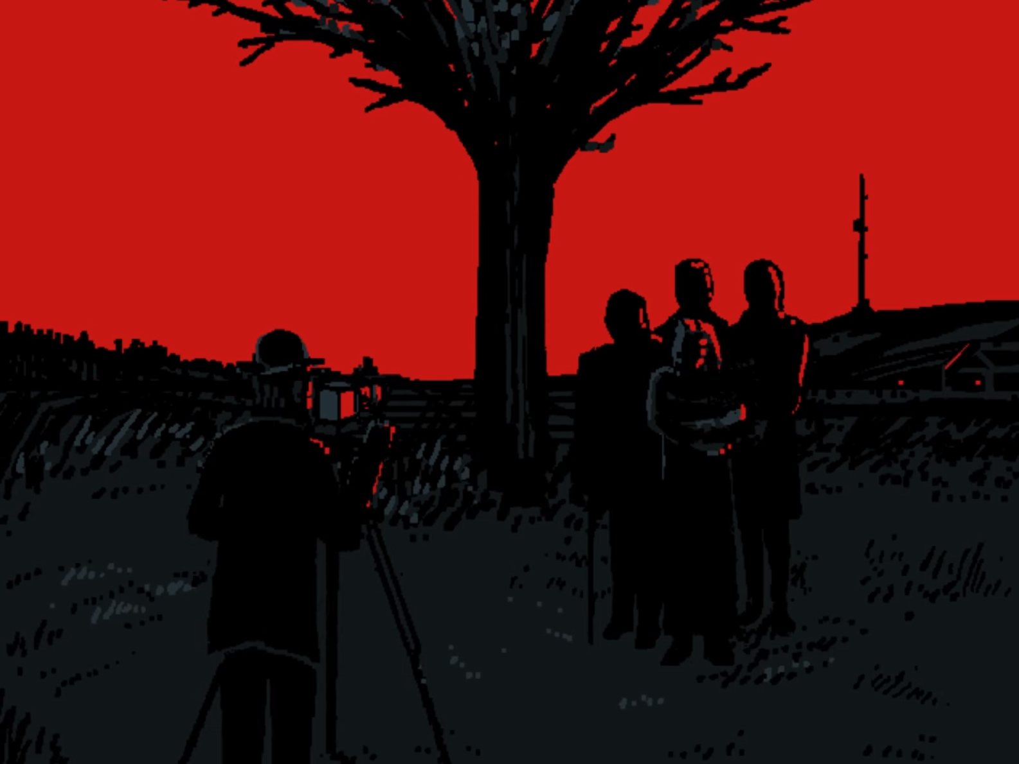 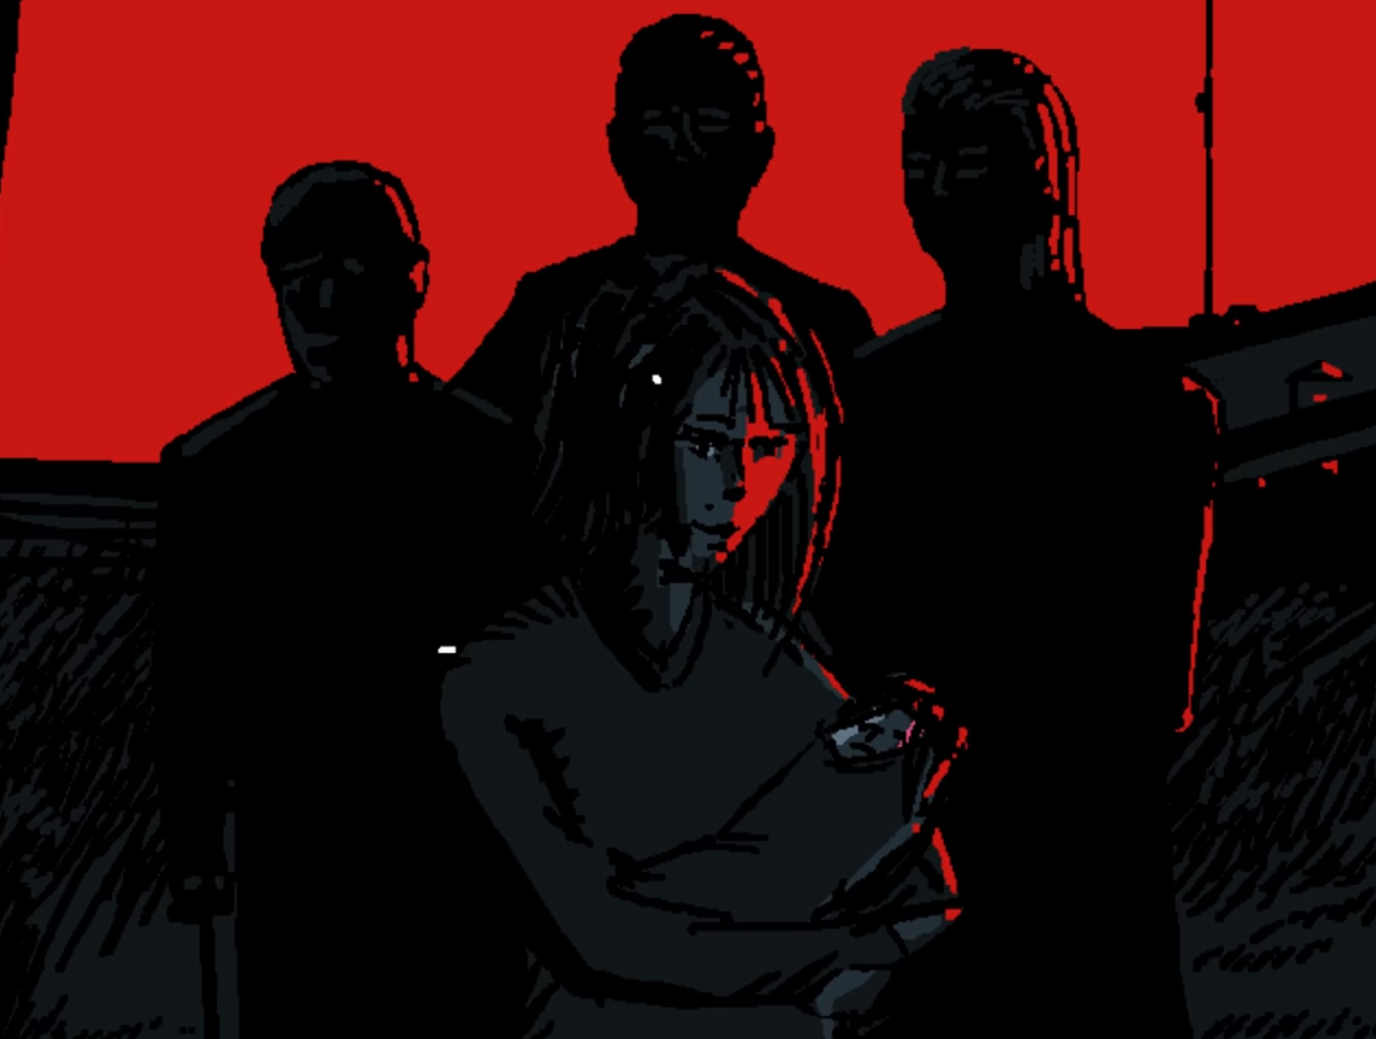

Ending

The episode ends with a finale shot of Henryk by the piano looking out The Window with no girl. 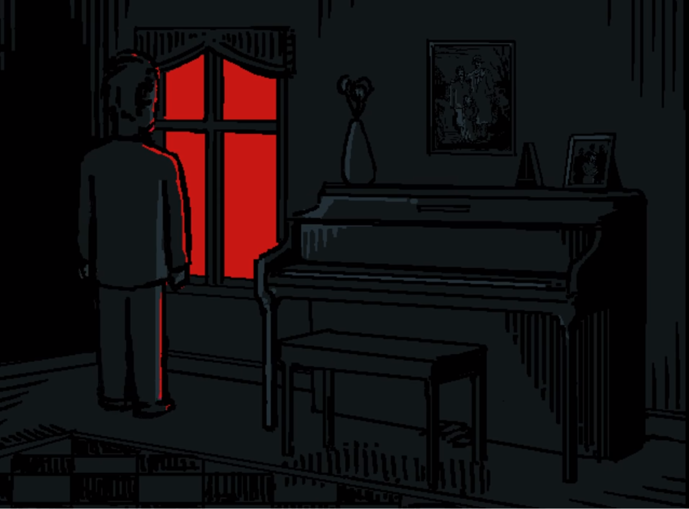

Analysis

This episode is seemingly showing the life of Henryk’s daughter also known as The Ghost. In the first scene the lady on the piano is most likely Henryk’s wife the next scene is Henryk marrying his wife before a scene with a young girl on a set a of swings is shown who is likely his daughter and the final scene depicts a women probably Henryk’s daughter holding a child presumable Henryk’s great-granddaughter however this could be his granddaughter daughter holding his granddaughter

This episode also make reference to an old proverb about how you should plant a tree build a house and raise a child. Henryk is shown to do all these things and in a latter episode it is shown that all of these things have since died or bean destroyed implying that Henryk has lived a full life and live long enough to see all of what he has bult be destroyed.

**Notes**

One of the members of Henryk’s family bears a striking resemblance to KAMI but given the fate of the family. However, in episode elven we learn that this is not possible for any of these character’s to be related to KAMI as their cerebral electricity would have been devoured by Mischief.

**References**

Henryk

Henryk’s family

Henryk great-granddaughter

The Ghost

**Sources**

Interface

https://www.youtube.com/watch?v=EHqsCmfTDmI&list=PLPnjato8iGXLQbppBPhOny8XLSRl7S5pM&index=1

Secondary source of information on interface and formatting ideas for webpages. https://umami.fandom.com/wiki/Umami_Wiki

**Episode 11 Revelation**

**Sidebar**

Episode Number: 11

Title: Revelation

Released (DMY): 4/12/18

Video Type: Interface Part 1

Synopsis: Big Smile and Henryk reach a breakthrough.

**Article body**

**Description**

Mischief and Henryk sit down for a meal and have a discussion leading to the realisation of Henryk’s great-granddaughter survives and the duo decided to try and track her down.

**Summary**

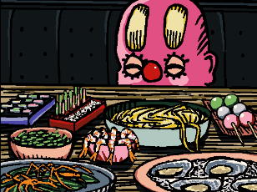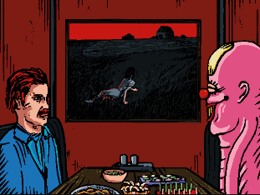Opening

The scene opens on a shot of the painting Christina's World before zooming out to show Henryk and Mischief siting at a table having a meal, surrounded by other dinners.

Mischief spends a long time devouring a single noodle before commenting on how Henryk isn’t eating anything blaming it on him having smoked too many cigarettes.

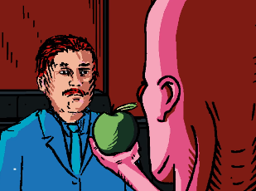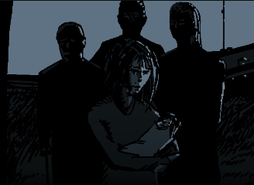Mischief then confirms that he does not need to food eat to survive well implying that there is something else that he needs. Mischief then confirms that he can indeed change colour but chose to be this way as well as commenting on how Henryk never . that chose. Henryk begins looking at a picture of his family as Mischief begins to talk about how he is starting to understand what Henryk wants believing it to be his late family. Mischief then reveals that Henryk’s daughter survives, at this point an image of the little girl from episode four is shown confirming her identity as Henryk’s great-granddaughter.

Mischief then offers an apple to Henryk saying that the only thing that can be known for certain is that the truth will set him free. Henryk can be heard eating the apple before the scene changes.

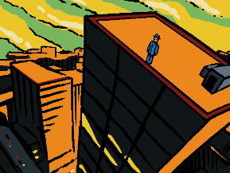Henryk on The Roof

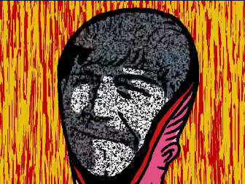The scene changes to Henryk standing on top of a high rise building with Mischief flying through the streets. It is implied as Henryk looks to the road from the top of the high-rise building that he may be considering suicide though this would lily not be effective as he has tried this before with no visible damage as shown in episode 20.

Mischief pounders what is it that is that consumes Henryk and what is it that Mischief had consumed wondering if they were the same, again asking “what have I consumed” before rephrasing the question as “who did I consume”. The scene shows Mischief faces folds back showing a variety of changing faces in cerebral electricity. Henryk steps down form the ledge.

Mischief Memory of The Crash

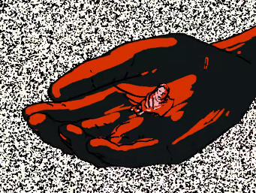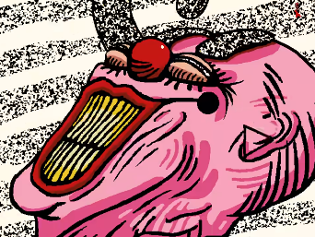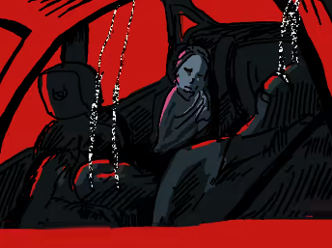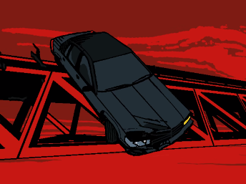The scene changers to a shot of a car driving as Mischief says he can’t explain why it happened despite having looked for answers. The car is then seen to fall into the river before a shot of Mischief is shown consuming the family’s Cerebral Electricity and The Ghost is seen rescuing Henryk’s great-granddaughter.

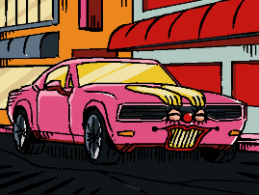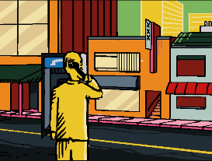Ending

Mischief then says that he only just made the connection turning into his car from allowing them to leave. The strange is shown making a call before another shot of Christina's World is shown and Mischief says it’s time to go home ending the episode.

Artwork

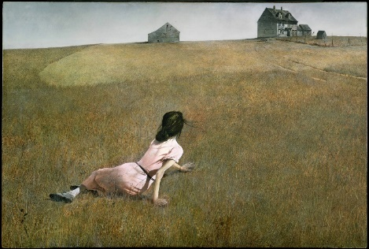 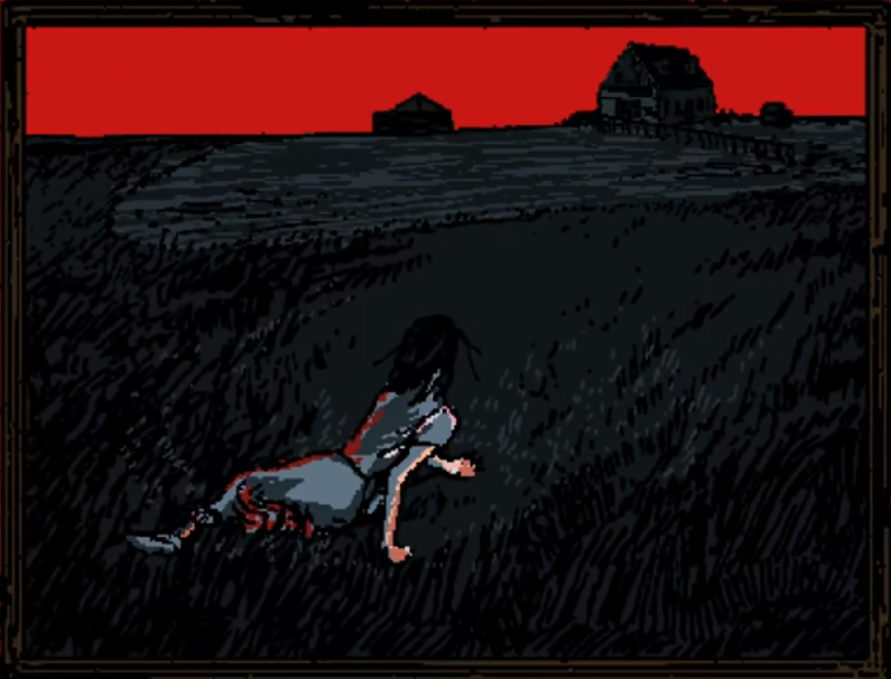

Christina's World

To understand what this painting meanes for the show it is important to understand the origin of the painting. This painting displays the neighbour of the painter Christina crawling through a filed this is because she has a degenerative muscle disease that prevented her from being able to walk. She chose not to uses a wheelchair and preferred to craw everywhere inspiring the painting.

Well at faces value this painting comes off as sad knowing that she chooses not to use a wheelchair recontextualise it to more of a picture of defiance, with Christina choosing to do things the way she prefers instead of how others may expect her to.

In my opinion this painting has two different interpretations by the characters Mischief and Henryk in this episode,

Henryk seams to take the painting at face value as a futile and meaningless struggle this likely being influenced by his depression and memories of his family which this painting seams to remined him off.

Mischief however seemingly understands the original context of the painting that being a woman choosing to live her life her way no matter what offers think. Mischief actually directly compares himself to the Christina when talk about how he can change colours but choses to be this way.

It is worth noting that Mischief is definitely telling the truth about being able to change colours as we see him do this in multiple episodes like in the sun of man where he turns into a sunflower, however this is not common for him.

**Notes**

This episode confirms that Mischief needs to consume Cerebral Electricity from those who have died to live.

This episode implies that The Strange Man is a greetings robotics informant.

This episode seemingly confirms the identities of several of Henryk’s family members as detailed in the Henryk’s family article.

There is a theory supported by this episode that suggested that Henryk actually only needs to consume cigarettes to survive and not food as excluding the apple in this episode he is never seen to eat, which is even commented on by Mischief. This theory is not like and the more likely explanation for Henryk not needing to eat is that he is incorrigible and will always stay the same.

**References**

Christina's World

Henryk’s great-granddaughter

Henryk’s family

Henryk

Mischief

The Chief

The Stranger Man

**Sources**

Interface

https://www.youtube.com/watch?v=EHqsCmfTDmI&list=PLPnjato8iGXLQbppBPhOny8XLSRl7S5pM&index=1

Secondary source of information on interface and formatting ideas for webpages. <https://umami.fandom.com/wiki/Umami_Wiki>

Christina's World

<https://en.wikipedia.org/wiki/Christina%27s_World>

**Episode 12 Metallic Evolution**

**Sidebar**

Episode Number: 12

Title: Metallic Evolution

Released (DMY): 30/3/19

Video Type: Interface Part 1

Synopsis: None

**Article body**

**Description**

This episode focuses on Mr Greetings woes and a battle between KAMI and The Chef, leading to The Chef being captured by Greetings Robotics.

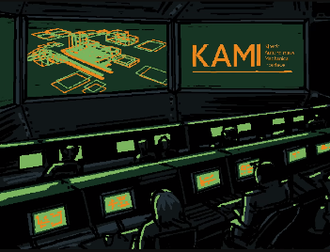**Summary**

Opening

The episode opens on a scene of a Greetings Robotics control centre seemingly operating KAMI.

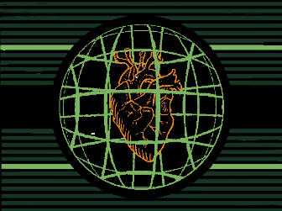Mr Greetings Monologue

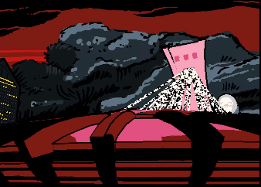Mr Greeting starts monologing claiming that he has pure intentions and that his vision is clear, with a communal goal. The scene changes to a shot of the brain ofThe Mechanical Saccorhytus and Mr Greetings continues saying that they have the most advances technology and simulations as well as machines capable of learning adapting and evolution, Mr Greetings claims that everything is calculated for.

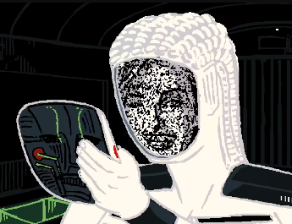The scene changes again to a shot of Mr Greeting staring down at the Montreal Olympic stadium. Mr Greetings continue his monologue saying that he still feels something is wrong and mentions that as they go about clean the world of Cerebral Electric Monster’s they do not destroy them but consumes them and repurpose them meaning that they are not wasted, despite this Mr Greetings is still concerned.

The scene changes to KAMI holding her mask as Mr Greeting Monologue continues, he claims that if you spend long enough staring into an abyss the abys will steres back at you.

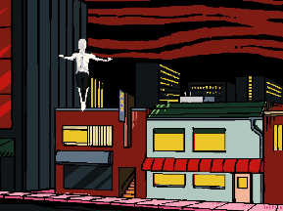KAMI’s Attack on The Chef

Hex code is shown on a green display before the scene changes to KAMI floating down to The Chefs restaurant, immediately removing the wall, and reviling The Chef inside holding knives ready to fight.

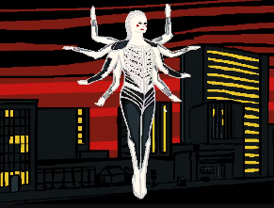A display screen is briefly shown again waring that The Chef is hostile. The scene changes back to KAMI who takes on a many armed forms likely to help counter The Chef how has many arms as he is a squid. The Chef’s knives are seen flying towards KAMI in an apparent attack, but this is ineffective as The Ghosts hand suddenly appears and blocks it.

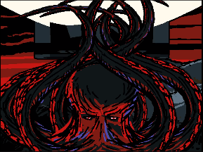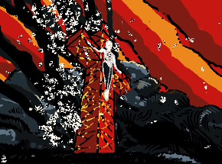The Chef is seen to grow significantly larger before attacking KAMI pushing her all the way to the Mount Royal Cross causing her to take on a pose reminiscent of Jesus however before he can defeat her The Mechanical Saccorhytus and The Ghost’s hand appears seemingly absorbing him as cerebral electricity.

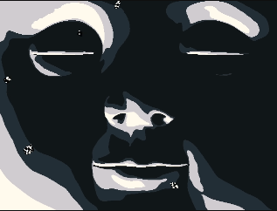Ending

The scene lingers on a shot of the faces of The Mechanical Saccorhytus before cutting to black ending the episode.

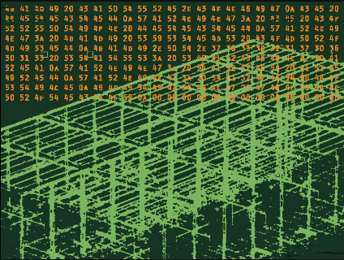**Hex Code**

This hex code appears shortly before the KAMI fight.

KAMI CAPTURE.CONFIG

This means that KAMI is loading a program for catching Cerebral Electricity Monsters.

CE DETECTED

This means that Cerebral Electricity has been detected.

WARNING: CE CORRUPTION DETECTED

This means that the Cerebral Electricity has been corrupted the meaning of this is not explained but likely just means it is being controlled by a Cerebral Electricity Monster

WARNING: KAMI SYSTEMS COMPROMISED

This could mean that KAMI is suffering from a glitch due to an attack or the presences of The Chef.

KAMI.PT.783921706013 STATUS: SEARCHING AREA

This likely means that KAMI is searching the area for The Chef.

WARNING: TARGET HOSTILE

This confirms that they know The Chef will not come peacefully.

INITIATING GHOST.PROTECTOR

This shows that KAMI can summon The Ghost to protect herself.

Translation by 174.70.1.212

**Notes**

This confirms that The Chefs restaurant is located in Montreal.

**References**

Cerebral Electricity

Greetings Robotics

The Chef

The Ghost

KAMI

Mr Greetings

Notable locations

The Mechanical Saccorhytus

**Sources**

Interface

https://www.youtube.com/watch?v=EHqsCmfTDmI&list=PLPnjato8iGXLQbppBPhOny8XLSRl7S5pM&index=1

Secondary source of information on interface and formatting ideas for webpages. <https://umami.fandom.com/wiki/Umami_Wiki>

**Episode 13 The Right Direction**

**Sidebar**

Episode Number: 13

Title: The Right Direction

Released (DMY): 18/5/19

Video Type: Interface Part 2

Synopsis: Henryk and Mischief head east in search of Henryk's lost granddaughter.

**Article body**

**Description**

This episode is about Henryk and Mischief taking a ride down a country road and discuss their desires.

**Summary**

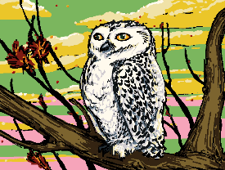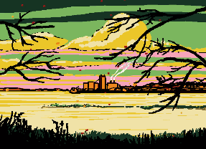Opening

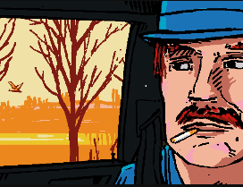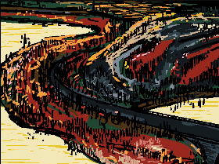The episode opens on a shot of a country road with a city in the far distance presumable Montreal or Québec City, the scene changes to focuses on a picture of an owl followed by a shot of the same owl flying over a river.

The scene then changes to show the owl outside the widow of Mischief in his car form with Henryk sitting on the passenger seat smoking a cigarette. The episode cuts to as wide shot of a forest with a road in it with the duo are driving on before a scene of an owl sitting in a tree as the duo drive off.

Convection in the car

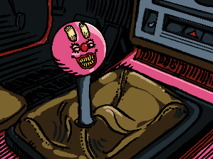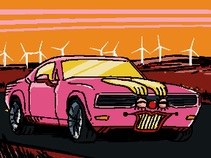We see a close up of Mischief in his car form before he transforms his faces to be on the gear shifting stick inside the car so he can talk to Henryk. Mischief asks Henryk about how meany cigarettes he has in his coat claiming that they spontaneously appear. Mischief then warns Henryk that he does not have any ash trays and does not believe that Henryk will litter, claiming that he has gotten into a conundrum.

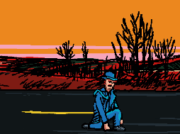The conversation takes a more serious turn as Mischief says he is assuming that they are still on the right direction as Henryk hasn’t said anything, unsurprisingly getting no reply.

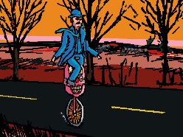Mischief than changes subject to talk about how it was suspicious for him to have known the secret of Henryk’s great-granddaughter surviving all while trying to figure out what Henryk cared about.

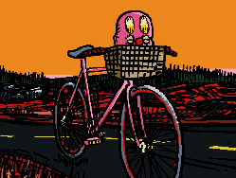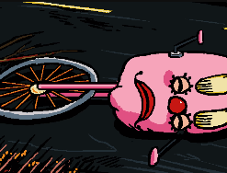Mischief claims to be running low on gas before suddenly changing into a unicycle though still moving at the speed of the car, after a few seconds the pair crash after running over a twig well Henryk dose appear scared, he perfectly lands without injury.

Ending

Mischief apologies to Henryk, claiming that he cannot always help himself. Mischief says that that’s something they may be able to help each other with before changing into his bicycle form, ending the episode.

**Notes**

This episode confirms that The Lighthouse and Henryk’s home is east of Montreal.

This episode gives to large hints too how Henryk’s incorrigibility may work. The first is that Henryk’s cigarettes are mentioned to appear spontaneously which implies that even his cloths and positions on his person will stay the same. The second is that when he falls form Mischief in his unicycle form, Henryk lands perfectly and is completely unharmed if slightly dazed. This encourages the idea that Henryk is more than immortal and actual entirely incorrigible.

**References**

Henryks Great-granddaughter

Henryk

Mischief

Notable Locations

**Sources**

Interface

https://www.youtube.com/watch?v=EHqsCmfTDmI&list=PLPnjato8iGXLQbppBPhOny8XLSRl7S5pM&index=1

Secondary source of information on interface and formatting ideas for webpages. <https://umami.fandom.com/wiki/Umami_Wiki>

**Episode 14 Dreamland**

**Sidebar**

Episode Number: 14

Title: Dreamland

Released (DMY): 6/7/19

Video Type: Interface Part 2

Synopsis: None

**Article body**

**Description**

This episode focuses on Mischief clouded and abstracted memories of his past as a human working at the Foolish House in Dreamland.

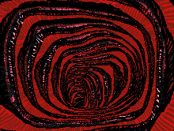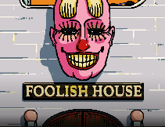**Summary**

**Opening**

The episode opens with a shot of a city believed to be New York paining down to see a building called the Foolish House with what appears to be Mischief ’s head on it. the doors open reviling a corridor that strongly resembles a throat.

The Ringmasters Monologue

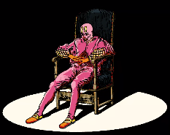The Ringmaster Askes the audiences if they have ever seen the faces of death, as soon as he says death Proto-Mischief is shown in a pose that is reminiscent of the painting Stanczyk before changing back and forth between Proto-Mischief and a Sunflower. During the scene with Proto-Mischief and the Sunflower The Ringmaster continues his monologue saying that whatever they think they can’t be sure as death takes many forms.

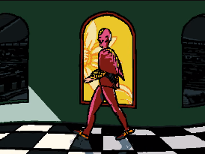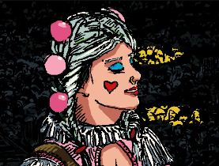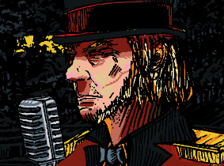The scene changes to show The Ringmaster on stage with a woman playing an accordion and an old man playing a pipe organ, The Ringmaster continues his monologue saying that he reckons that everybody’s seen it, somewhere. before claiming that he saw death in a dream the night before. for clarity sack I will now be quoting what we said directly.

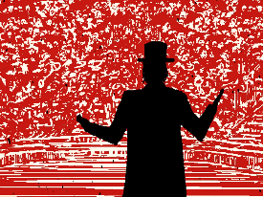The Ringmaster says, “I was taming a 100-foot dragon with just the coarseness of my voice!” the scene changes to Proto-Mischief walking down an abstract corridor. Noticeable as he walks past some of The Windows you can see his reflection replaced with a sunflower.

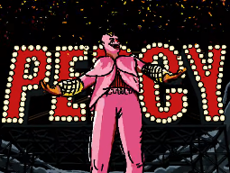The Ringmaster then says “That’s when I saw it! It twisted and twirled towards me. I saw Its wicked smile, I heard its wicked laugh! And I tamed that dragon… by giving him a name!” the scene changes to The Ringmaster looking out on a crowd of twisted faces looking more like random shapes.

Finaly The Ringmaster says, “and in fact, boys, and girls, I convinced him to join us here in Dreamland tonight! So, without further ado – the incorporeal clown… Percy!”.

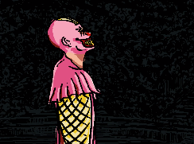Ending

We see Proto-Mischief standing on stage and he is clearly surprised by his name being stated as Percy calming that they had changed the name. the scene then cuts to black.

**Analysis**

**Dreamland or Foolish House**

There is some confusion on whether the venue they are at is called Dreamland or Foolish House, the answer is actual both. In the episode the building clearly has a big sign out front saying Foolish House which would imply it is the name of the business, but The Ringmaster says they are at Dreamland as well as the episode being called that, so this is naturally confusing.

Thankfully, there is a simple explanation Dreamland is the name of an amusement park that Foolish House is located in. Dreamland is actual a real-life theme park that was located on Cony Island, New York until it burned down in 1911. This is directly confirmed by Umami in the description of the episode.

**Sunflowers Are Mischief, Mischief Is a Dragon, And Dragons Are Death**

This episode has what I believe to be a three-layered metaphor about Death, Dragons, Mischief, And Sunflowers I will attempt to explain here.

Layer one, death is a dragon

When The Ringmaster is giving the fine part of his monolog he clearly corelates the dragon with death, The Ringmaster claims that he saw death in his dream but then the story’s about a dragon and if you listening to the monologue its very clear that the dragon is meant to be a metaphor for death. At an earlier point in the monologue The Ringmaster claims that people may have seen death at the bottom of a bottle, this is another example of a similar metaphor to help prove my point.

Layer two, Mischief is a dragon

Mischief being a dragon is easier to explain and prove, in the end of the episode we see The Ringmaster introduces the dragon he apparently tamed before Proto-Mischief is shown. I believe that only would prove the connection but there is more proof at one point in the monologue The Ringmaster says “That’s when I saw it! It twisted and twirled towards me. I saw Its wicked smile, I heard its wicked laugh!” this is clearly talking about Mischief as he is known to travel in a similar manner and is known to have a sinister smile.

Additionally, I believe that Mischief as a dragon still represents death, the part of the monologue that most directly talks about death is as the part that most directly talks about death, the line of the monolog being the line about the dragon twisting and twirling. The way The Ringmaster talks about the dragon makes it seem like his talking about death as a separate entity to the dragon, but the sentence would only really makes sense if he is talking about both. It is important to remember that The Ringmaster is also clearly talking about Mischief, so it only makes sense that Mischief represents both the dragon and death.

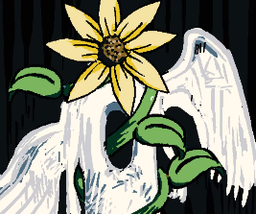Layer three, Mischief is a sunflower

Before getting into this episode, I feel it is important to remind you of when Mischief transformed into a sunflower in episode five and says, “I’m a beautiful sunflower”, it doesn’t really get clearer than that but there is more proof of the metaphor in episode fourteen.

In the episode we see a scene where the shot is constantly changing between Proto-Mischief and a sunflower that may imply that the two are being corelated. We also see another scene where we see Proto-Mischief walking down a corridor with his reflection being replaced by a sunflower. Well ever of these two examples could mean nothing on their own it, but taking both metaphors together with the scene from episode five it is a much clearer corelation between sunflowers and Mischief.

This leaves the question of if sunflowers are also meant to corelate to dragons and death my answer yes-ish.

I believe the dragon analogy purely apples to Mischief in this one scene. Mischief clearly isn’t a dragon, I think the dragon is just a metaphor for death used in the monologue as a way to avoid directly calling Mischief death, in simple terms I believe that if Mischief is not a dragon, is death and Sunflowers are Mischief then sunflowers must represent death and Mischief but not dragons.

**Proto-Mischief ’s Name**

When Proto-Mischief is announced on stage his name is said to be Percy, but Proto-Mischief is confused by this clamming to have changed that.

To explain this, I think it helps to understand that this episode is implied to be a dream or heavily distorted memory of Mischief post transformation in a cerebral electricity monster, so the events are not literal. Percy was likely the stage name of Proto-Mischief but Mischief remembering or dreaming is confused by this as he has changed his name to Mischief.

Additionally, it is possible that Proto-Mischief did actually just change his stage name at some point but for the reasons said above I believe that this is meant to apply to Mischief dreaming of his time as a human.

**Artwork**

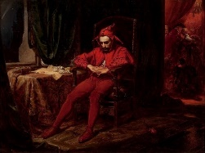 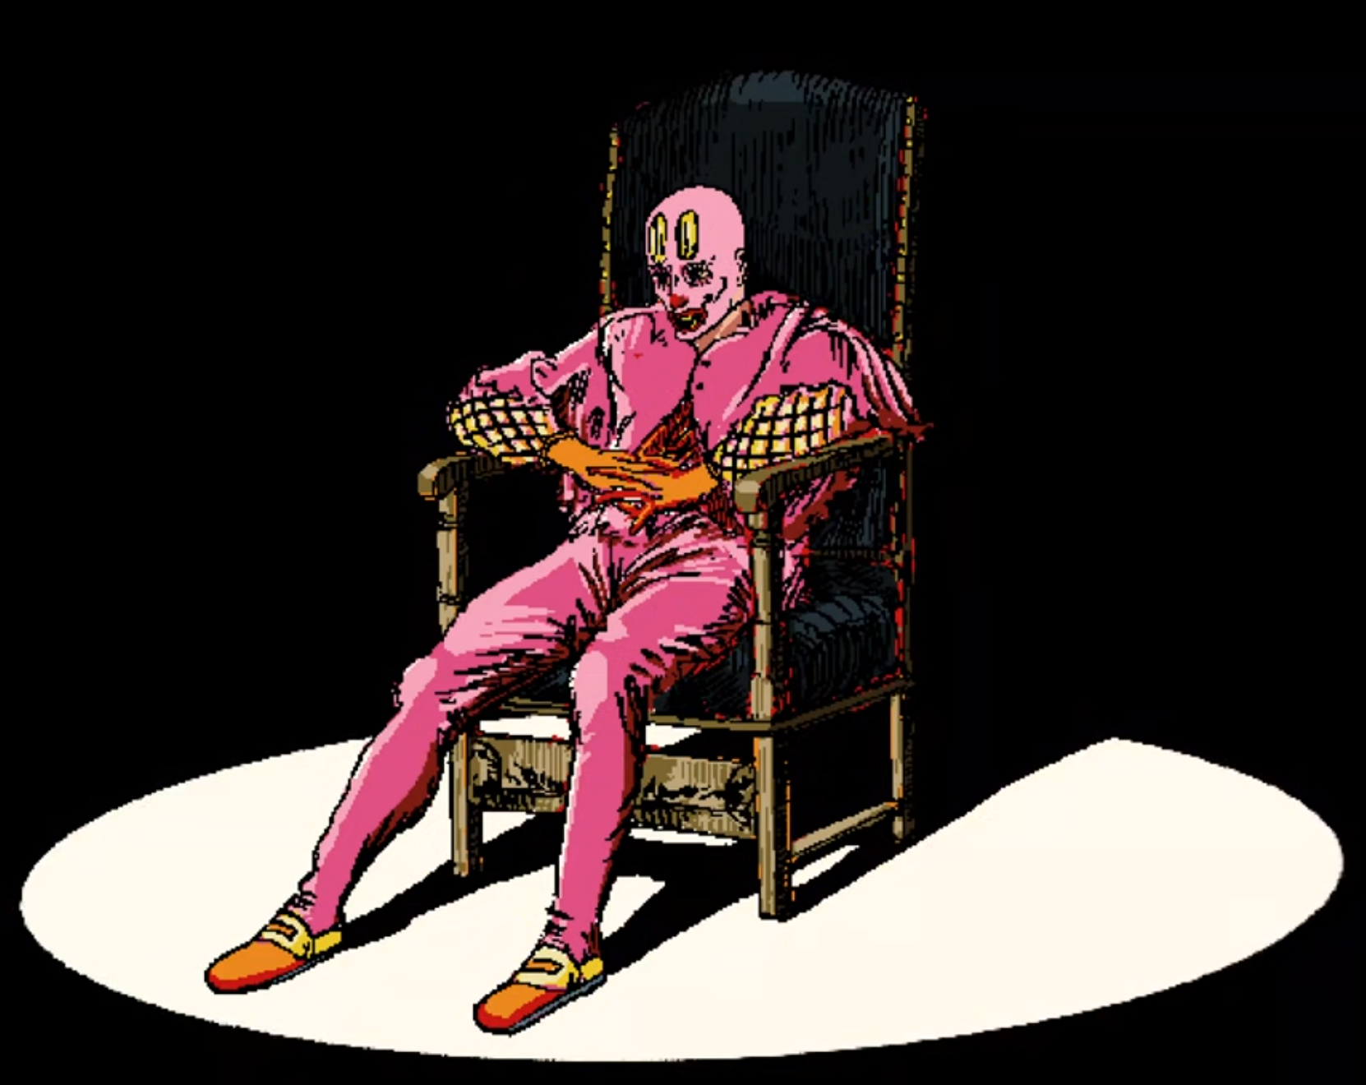

Stanczyk

The most common interpretation of the original painting is the jester is morning the loss of a city that had just been lost to their enemy, this loss possible leading to the doom of the nation. It is important to notice that in the background there is a party clear being held showing that ironically the only person taking the loss of the city seriously is the juster.

I believe that there is a significant chance that this painting is just used for the inspiration of the outfit and pose.

That being said I do have one interpretation of the painting based on the original meaning of the painting; Mischief may be morning the loss of his humanity. The original painting clearly shows the clown distraught at the loss of the city to their enemy which raise the question what would Mischief morning? The easiest answer is that he is morning the loss of his humanity, this episode is about Mischief ether dreaming or remembering his time as a human, so it makes sense that if he is sad about this, he may be mentally correlating himself with the painting.

This would not be the only time that we see a painting used to convey meaning without having to say something aloud so it would not be odd for this to be how the painting is used to show how Mischief feels.

**Notes**

This is the episode that introduces Dreamland and Foolish House

**References**

Stanczyk

Mischief

The Ringmaster

The Foolish Girl

Noticeable locations

**Sources**

Interface

https://www.youtube.com/watch?v=EHqsCmfTDmI&list=PLPnjato8iGXLQbppBPhOny8XLSRl7S5pM&index=1

Secondary source of information on interface and formatting ideas for webpages. <https://umami.fandom.com/wiki/Umami_Wiki>

Dreamland

<https://en.wikipedia.org/wiki/Dreamland_(Coney_Island,_1904)>

Stanczyk

<https://en.wikipedia.org/wiki/Sta%C5%84czyk_(painting)>

**Episode 15 The Winds**

**Sidebar**

Episode Number: 15

Title: The Winds

Released (DMY): 14/9/19

Video Type: Interface Part 2

Synopsis: Henryk and Mischief continue on the road to revisit Henryk's old house in search of his great granddaughter.

**Article body**

**Description**

Mischief and Henryk travel on their way to Henryk’s home before having an encounter with The Wind as he shares a vison with Henryk.

**Summary**

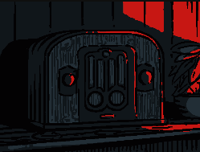**Opening**

The episode opens on a scene of a radio playing a broadcast talking about cerebral electricity while Henryk holds his daughter. The announcer makes several claims about cerebral electricity though is clearly biased.

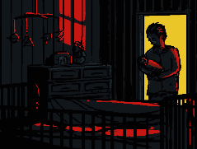I will list his claims now, Cerebral Electricity cannot be removed, neutralised, or destroyed, CE disrupts the structure of atoms, and that people do not like to think about Cerebral Electricity likely due to an innate fear of what they cannot perceive.

It is clear that this takes places in the mid-twenty century as Henryk is holding a baby that is likely his first child and the radio host makes a very blatantly racist comment that would not be allowed in modern times.

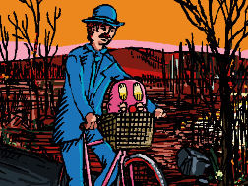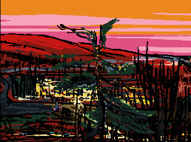The Wind’s warning

We see Henryk riding Mischief to a washed-out portion of the road, leading top Mischief warning it’s a bad idea not try and cross it with him as a bicycle.

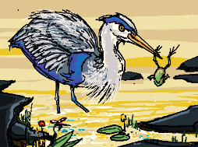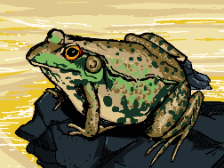Mischief ’s focuses then shifts to a frog he notices he clams to not know much about amphibians before a bird fly’s down grabbing the frog by the leg.

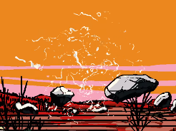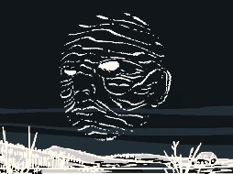Suddenly time appears to freeze, and Cerebral Electricity is shown to be cover the rocks which Mischief immediately takes note of.

Rocks begin to float up around a spear of wind that transforms them into Cerebral Electricity and then transforms into a face, The Wind begins to speak he says the four cardinal directions each with a message.

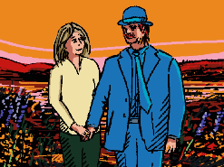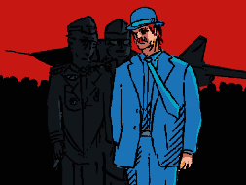For north he says “In this land of rot and erosion” as Henryk’s faces is shown.

for east he says “You stand alone for” the scene showing dragonfly’s resembling Henryk and Mischief.

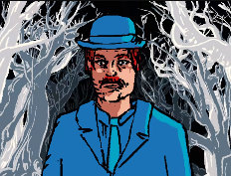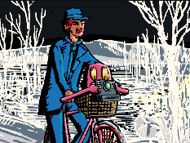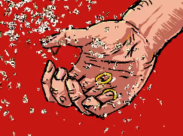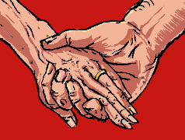for south he says “static, stoic, frozen” showing a scene with Henryk by a plane with two men in military uniforms, then a picture with Henryk and his with and as final image of them holding hands before the female hand disappears leaving only the ring.

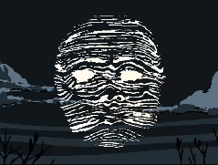for west he says “I scan the horizon... not heavens skies nor cavers below… I see your home a stat of abandon there is no judgment only dangers aglow” during this Mischief is shown to take a photo of The Windows before the shot changes to focuses on Henryk.

The Wind finishes his monologue claiming that he will continue his search as will Henryk but gives Henryk a warning not to get lost in time. During the last section of the monologue, he also her Henryks Daughter asking if she should wait for him.

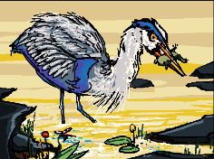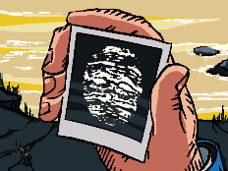Ending

Mischief hands Henryk the photo he took of The Wind and gives him a warning that there are meany different creatures like The Wind out here and not to truest them. We see a shot of the frog’s Cerebral Electricity leaving its body ending the episode.

**Analysis**

**The Wind’s Vision**

In this segment I will be AnalysisThe Winds monologue and explain what I believe it means.

I think that the directions correlate to time in this monologue with north representing the present and futter, east representing the future, south representing the past and present, and lastly west represent the past. Most of the following Analysis still works regardless of this being true but this dose helps the theory.

For north he says “In this land of rot and erosion” as Henryk’s faces is shown.

This may refer to all of Canada or moder times in general regardless of it implies the current world and land is in a state of decay.

for east he says “You stand alone for” the scene showing dragonflies resembling Henryk and Mischief.

This could be implied to refer to Henryk in the future, saying he will be alone. This makes some sense as in episode 24 Mischief is believed to sacrifice himself to Henryk however Henryk still has his granddaughter so he cannot be said to be truly alone.

for south he says “static, stoic, frozen” showing a scene with Henryk by a plane with two men in military uniforms, then a picture with Henryk and his with and as final image of them holding hands before the female hand disappears leaving only the ring.

This is clearly referring to Henryk’s incorrigibility and how the world has moved around him. We see images from Henryk’s past moving forward which falls in line with this line being about Henryk’s incurability and the direction correlating to time.

for west he says “I scan the horizon... not heavens skies nor cavers below… I see your home a stat of abandon there is no judgment only dangers aglow the shot changes to focuses on Henryk for most of this scene.

This Is the segment I am the least clear on but if the direction correlating to time theory is accurate then this segment would seemingly be referring to the destruction of Henryk’s family. This is further supported by Henryk’s daughter comments on Henryk’s immortality being played during this scene.

All together I believe that this monologue is talking about the Henryk’s shame in the death of his family, well enviably everybody in Henryk’s family would die, we see in episode twenty that Henryk has directly responsible for the death of two members of his family and the loss of Henryk’s Great-Granddaughter.

**Notes**

This episode introduces The Wind

The Wind has no confirmed name I have gone with The Wind as it aligns with the naming scheme used for The Ghost.

**References**

The Wind

Henryk’s Family

Henryk

Mischief

Cerebral Electricity

**Sources**

Interface

https://www.youtube.com/watch?v=EHqsCmfTDmI&list=PLPnjato8iGXLQbppBPhOny8XLSRl7S5pM&index=1

Secondary source of information on interface and formatting ideas for webpages. <https://umami.fandom.com/wiki/Umami_Wiki>

**Episode 16 When Skies Were Still Blue**

**Sidebar**

Episode Number: 16

Title: When Skies Were Still Blue

Released (DMY): 26/10/19

Video Type: Interface Part 2

Synopsis: Mischief and Henryk begin their search for the long-lost great granddaughter by returning to Henryk's old home in search for clues. Upon entering, the overwhelming memories haunt Henryk, the same thoughts he tried to escape from.

**Article body**

**Description**

This episode is a direct continuation of episode fifteen with Henryk finally arriving home and remembering an evening spent with his daughter.

**Summary**

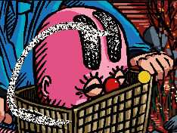Opening

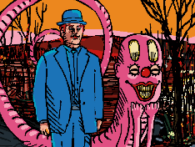The scene opens on a bird eating a frog causing its Cerebral Electricity to be absorbed by Mischief.

Mischief calms that he has just learned a lot about amphibious and that he would like to be one, but it is too dangerous where they are changing into his worm form.

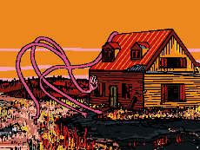Henryk’s Home Destroyed

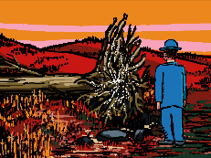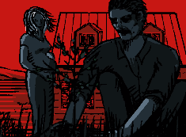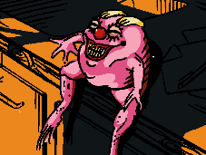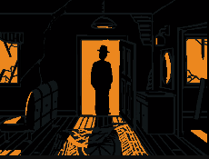Henryk and Mischief finally arrive at his old home and find it in a stat of massive disrepair with the tree outside dead, this is likely the same tree that was focused on in Episode eleven.

Mischief hurry’s inside but Henryk lingers outside for a while focusing on the damage and remembering when he planted the tree with his pregnant wife.

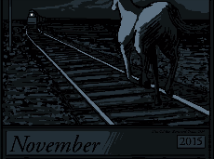 Henryk finally enters the home and finds Mischief siting on the counter in the form of a fat little pink frog, Mischief exclaims “I’m a frog and I’m felling fresh.” Before beginning a monologue talking about the fact that there is nobody there and that there is no life in the house both literally and metaphorically.

Mischief clams they are encased by dead wood and are awaiting a mortician whom they have outlived, this clearly being metaphorical. Noticeable as Mischief discusses this, we see a calendar with the painting Horse and Train on it dated November 2015.

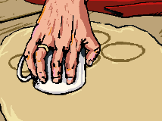Henryk Memory Of Perogies

The scene changes to a memory of Henryk making perogies with his daughter as she begins to talk about her mother sharing stories about their past.

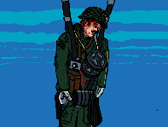Henryk’s daughter discuss a story her mum told her from back when skies where still blue about Henryk falling from the skie with no plane in site, during which we see Henryk falling from a blue sky holding large tape reals and sleeping in his parachute.

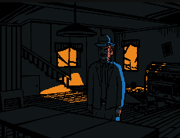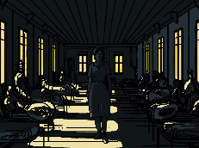 A shot of a woman walking through the hospital is shown as Henryk’s wife is revealed to be the nurse who looked after him, the daughter clams that the first thing Henryk said upon awaking was that he loved her, despite this being there first-time meeting.

Ending

A finale shot is shown of Henryk standing alone in his house before the episode ends fading to black.

**Artwork**

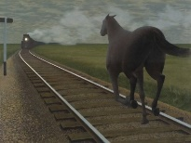 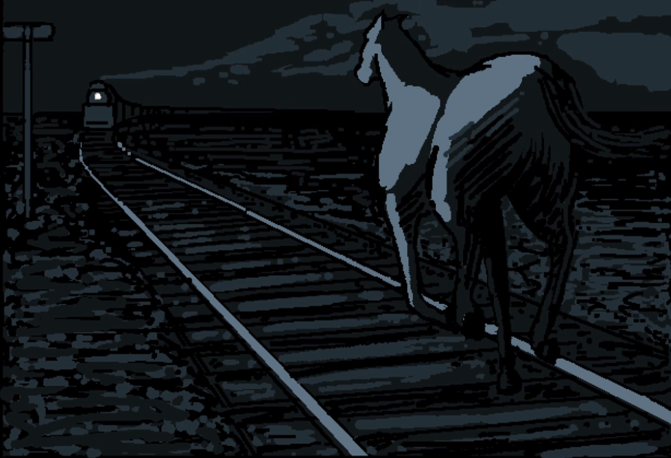

Horse and Train

This painting is inspired by a poem by Roy Campbell “I scorn the goose-step of their massed attack  
And fight with my guitar slung on my back, against a regiment I oppose a brain and a dark horse against an armoured train.”.

The main feature of this painting is the juxtaposition of the horse and the armoured train with the train clearly outmatching the horses in every way, representing the future and the horse representing the past.

The meaning for this episode seems to be contrasting the horses and Henryk. Henryk is the man of the past unable to match the new man, as represented by Mischief who likely represents the train.

**Notes**

This episode gives some evidence to the idea that Henryk is polish or from a polish family. This is that the perogies mentioned in the episode are a traditional polish food.

The calendar was bean left on the data of November 2015 given the apparent age of Henryk’s great-granddaughter this was likely the date of the crash that killed most of Henryk’s family, leading to Henryk abandoning his home. The show most likely taking places 2-10 years after the crash between 2017-2025.

**References**

Henryk

Henryk’s family

The Ghost

Mischief

**Sources**

Interface

https://www.youtube.com/watch?v=EHqsCmfTDmI&list=PLPnjato8iGXLQbppBPhOny8XLSRl7S5pM&index=1

Secondary source of information on interface and formatting ideas for webpages. <https://umami.fandom.com/wiki/Umami_Wiki>

Horse and Train

<https://www.aci-iac.ca/art-books/alex-colville/key-works/horse-and-train/>

**Episode 17 The Fall**

**Sidebar**

Episode Number: 17

Title: The Fall

Released (DMY): 24/12/19

Video Type: Interface Part 2

Synopsis: Mischief reflects on his own past and speaks in metaphorical allegory, which prompts Henryk to consider his painful memories in a new light.

**Article body**

**Description**

This episode focuses on Mischief talking about his past in an allegory to encourage Henryk to look at his past in a new way and find a new path for the pair.

**Summary**

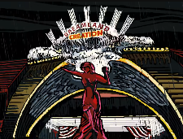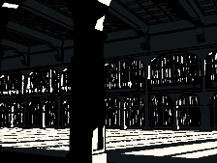Opening

The episode opens on Mischief ’s memory of an empty concert hall in dreamland well there is a storm going outside.

Mischifes Monologue

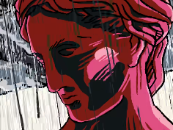Mischief begins to monologue ask why we build and claiming it is to be part of something bigger than ourselves.

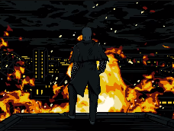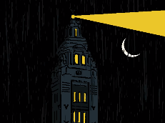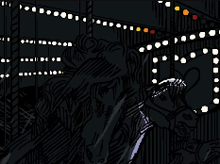Mischief then continues his metaphor with the dangerous of getting lost in the dark and how humans tend to run in circles when they are in a panic, correlating that to the action of coming home likely corelating Henryk having arrived at his ruined home.

Finishing his monologue asks about how do we end things when everything has turned to dust. During this scene a verity of shots from dreamland are shown during a rainstorm before ending on a final shot of Proto-Mischief standing atop a burning dreamland with no rain placing the memory in 1911.

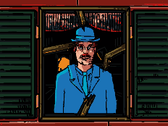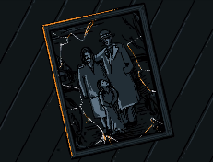Henryk’s Daughter’s Monologue

The scene changes to a shot of a phot of Henryk’s family as Henryk’s daughter begins to speak. She talks about how when she was little Henryk had told her to go to the lighthouse if she got lost and Henryk would come find her, during this scene a shot of The Lighthouses is shown.

Ending

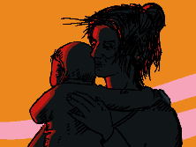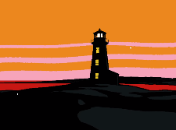A shot of Henryk’s daughter holding who is implied Henryk s grate-granddaughter who may be who she is talking to before the episode ends with the implication there heading towards the light, in this case literally The Lighthouse.

**Artworks**

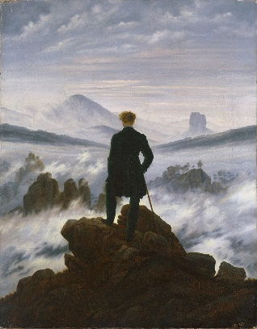 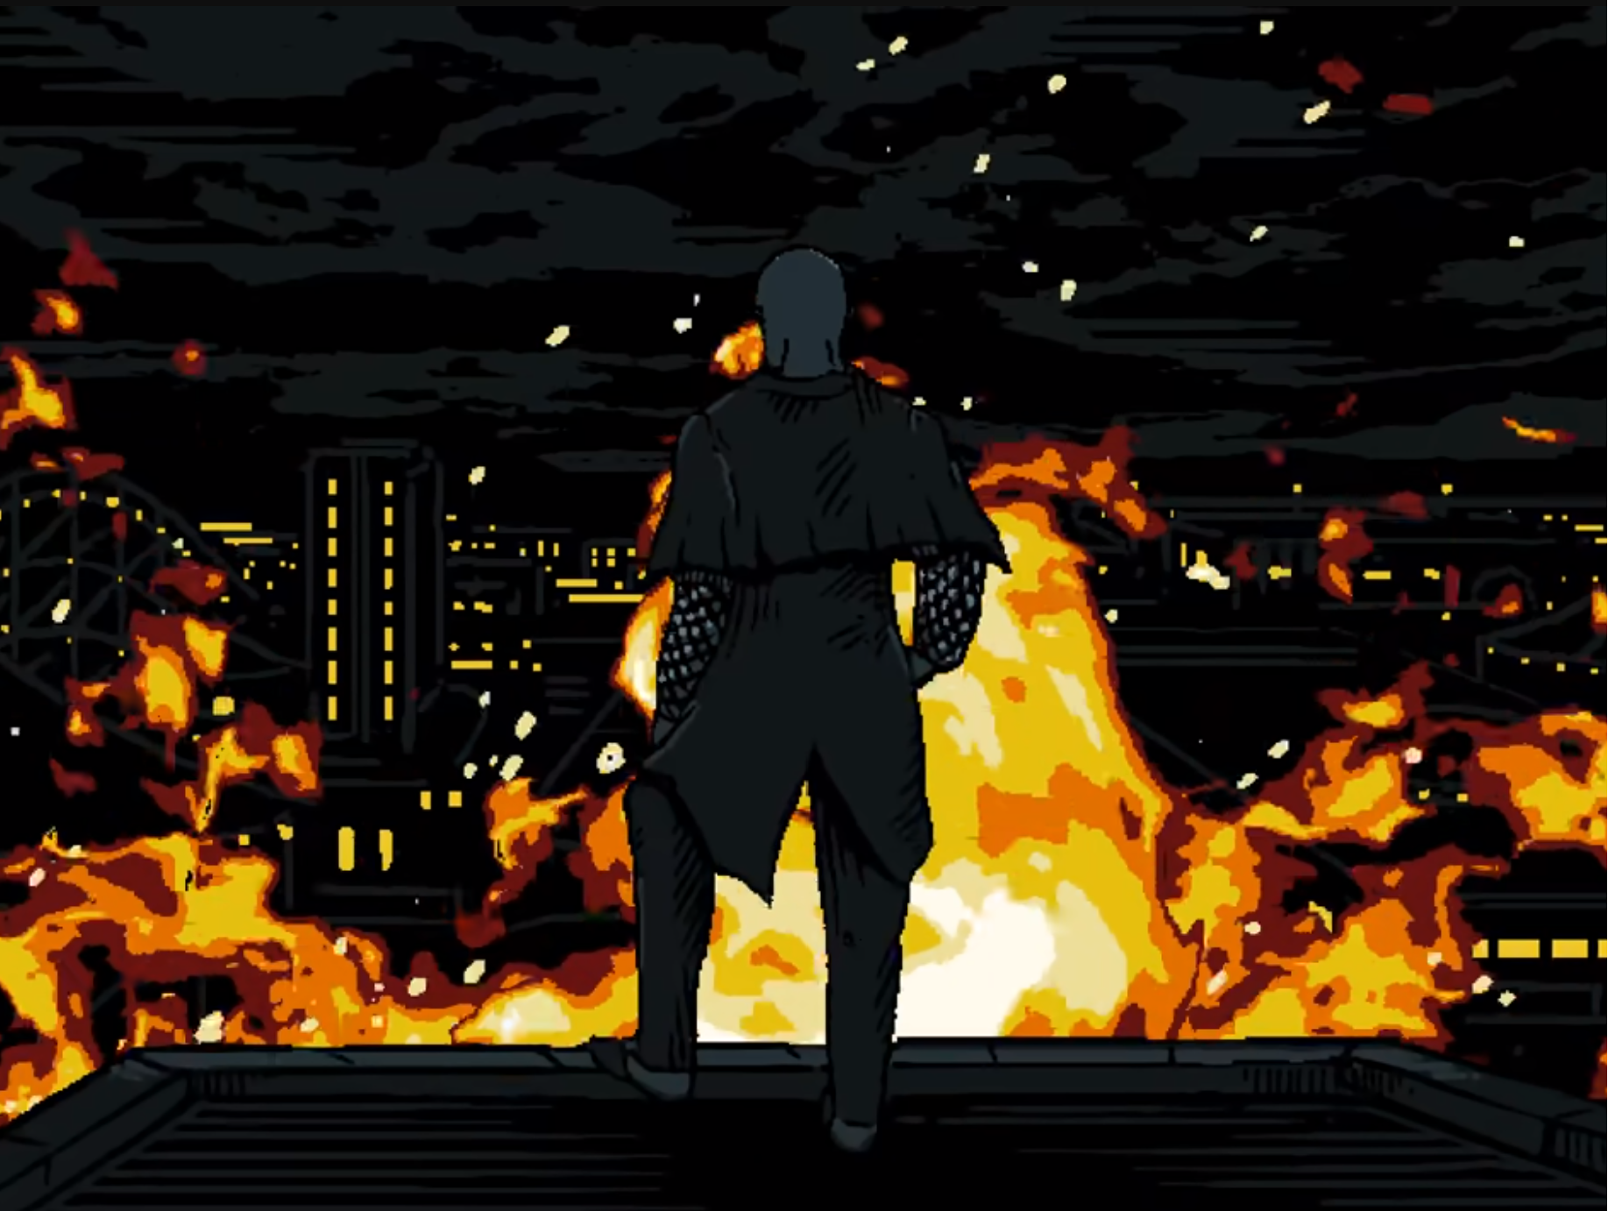

**Wanderer Above the Sea of Fog**

Wounder above the sea of fog is primarily a romantic painting meant to show the beauty of nature and the feelings that are inspired by nature’s beauty.

The meaning of this painting for the episode is likely pretty narrow given that the interfaces version of the painting has no nature in it, which is the focuses of the original version.

I believe that the only part of the painting that is meant to transfer to the episode, is the feeling of sublime dread at the scope of the scene before you. In this case it is shown by the scale of the mountains and the horrifying power of the fire, being able to destroy and inter amusement park in a couple of hours.

**Notes**

This episode shows that Proto-Mischief was at dreamland when it burned.

**References**

Mischief

Henryk

Henryk’s great-granddaughter

Henryk’s family

The Ghost

The Lighthouse

Wanderer Above the Sea of Fog

**Sources**

Interface

https://www.youtube.com/watch?v=EHqsCmfTDmI&list=PLPnjato8iGXLQbppBPhOny8XLSRl7S5pM&index=1

Secondary source of information on interface and formatting ideas for webpages. <https://umami.fandom.com/wiki/Umami_Wiki>

Wanderer Above the Sea of Fog

<https://en.wikipedia.org/wiki/Wanderer_above_the_Sea_of_Fog>

**Episode 18 Rebuilding**

**Sidebar**

Episode Number: 18

Title: Rebuilding

Released (DMY):1/2/20

Video Type: Interface Part 2

Synopsis: KAMI is not dead but was being rebuilt. It has learned new tricks from those it had taken from.

**Article body**

**Description**

This episode focuses on KAMI being repaired, as well as the apartment complex damaged in here attack on The Ghost.

**Summary**

Opening

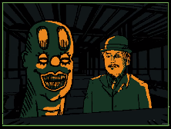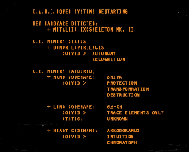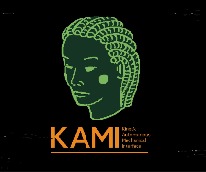The episode opens on a shot of KAMI’s interfaces will she is being repaired. KAMI is shown to have been updated to mark two this is presumably because she took heavy damage in her fight with The Chef. We see a verity of information about the Cerebral Electricity KAMI apparently has access to “Hand Codename”, “LUNG CODENAME” and “HEART CODENAME”.

We see her get retinal data from “Akkorokamui” aka The Chef and an image of Henryk and Mischief loads leading to them being labelled KAMI’s new target.

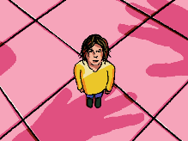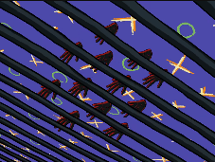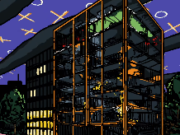Rebuilding The Flats

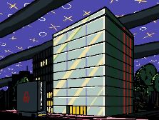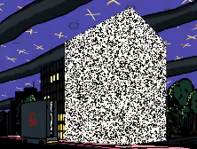A city street is shown with Cerebral Electricity filling the sky, we then see the flats where The Ghost was staying as a ton of her hands appear with Henryk’s great-granddaughter watching.

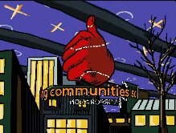The hands use Cerebral Electricity panels to cover the building before we see it transformed into a new building much higher quality than it previous was.

Lastly, we see one of the hands give a thumbs up displaying the grating robotics compony moto.

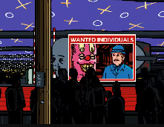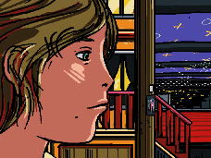Ending

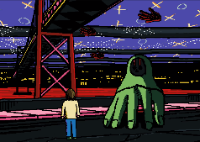We see a scene of Henryk’s great-granddaughter walking down the street as the hands are seemingly recalled to the Greeting Robotics’ blimp before we see some of them make a billboard announcing that Mischief and Henryk are wanted individuals.

The scene ends with The Ghost appearing before Henryk’s great-granddaughter before the episode suddenly ending.

**Analysis**

**KAMIs Interface information**

Hand likely referring to The Ghost and her information is listed as CODENAME: SHIVA, SOLVED: PROTECTION, TRANSFORMATION, DESTRUCTION.

Shiva is a destruction goddess from Hindu culture click here for the Wikipedia article on her

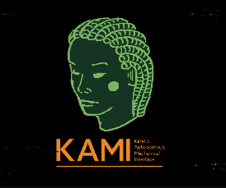Lung likely refers to The Wind their information is “GA-OH, SOLVED: TRACE ELEMENTS ONLY, STATUE: UNKNOWN, this implies she has little access to The Wind as he likely hasn’t been captured yet.

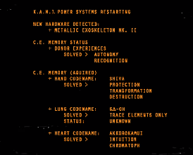Ga-oh is a wind god from Iroquois mythology click here for the Wikipedia article on him

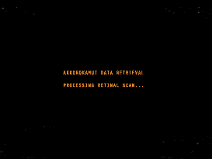Lastly there’s Heart which definitely refers to The Chef the information is listed as CODENAME: AKKOROKAMUI, SOLVED: INTUITION AND CHROMOPHORES. Chromophores are molecules that have the ability to absorb and emit light possible allowing for KAMI to transform colours or see in colour.

Akkorokamui is an Octopus-like monster from Ainu Folklore click here for the Wikipedia article on them.

**Notes**

Henryk’s great-granddaughter does not appear distressed implying that she may already be in contact with Greetings Robotic and The Ghost at this point.

**References**

Henryk’s great-granddaughter

Henryk’s

Mischief

The Ghost

KAMI

The Chef

The Wind

The Mechanical Saccorhytus

**Sources**

Interface

https://www.youtube.com/watch?v=EHqsCmfTDmI&list=PLPnjato8iGXLQbppBPhOny8XLSRl7S5pM&index=1

Secondary source of information on interface and formatting ideas for webpages. <https://umami.fandom.com/wiki/Umami_Wiki>

Shiva

https://en.wikipedia.org/wiki/Shiva

Ga-oh

<https://en.wikipedia.org/wiki/Gaoh>

Akkorokamui

https://en.wikipedia.org/wiki/Akkorokamui

**Episode 19 Entanglement**

**Sidebar**

Episode Number: 19

Title: Entanglement

Released (DMY): 12/3/20

Video Type: Interface Part 2

Synopsis: Mischief and Henryk approach the lighthouse in search for clues on the whereabouts of Henryk's great granddaughter. Mischief may not be telling the whole story about his past and what he witnessed, but he knows Henryk will discover the answers on his own and bestows him the freedom of autonomy.

**Article body**

**Description**

This episode shows Henryk and Mischief on their ways to the light house in search of Henryk’s granddaughter, as Mischief alludes to the secrets of his past.

**Summary**

Opening

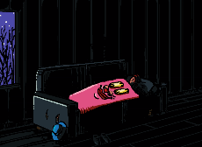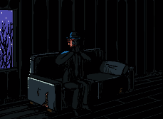The episode opens on Henryk playing the harmonica on a couch in his home, before Mischief in his frog form is seen hopping towered him. The scene changes back to Henryk, and we see he has laid down to sleep with Mischief transforming into a blanket for him to use.

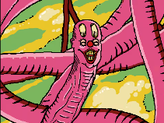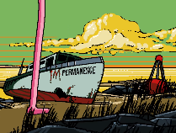Henryk and Mischief conversation by the USS impermanence

Mischief is seen traveling as giant ball of string calling this form of movement quantum entanglement and claiming that if observed the form will collapse. Henryk proceeds to look at Mischief causing the form to collapse.

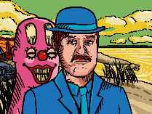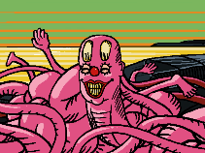Mischief begins to ask Henryk what they are looking for in the lighthouse as Henryk’s great-granddaughter is obviously not still waiting there after so meany years. Mischief asks Henryk if he thinks she would recognise Henryk and if Henryk would recognise her.

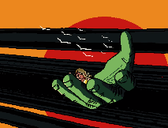Mischief asks Henryk how even when the facade of flesh and memory changes he remains so capable, likely referring to Henryk’s ability to recognise his granddaughter even as she grows. Mischief then says that if Henryk changes like he had Mischief s recognise himself.

Mischief then states that even across the world Henryk would immediately know something is wrong, showing a scene of Henryk’s great-granddaughter riding in The Ghost’s hand.

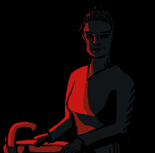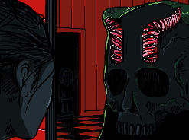Mischief warns Henryk that if he knows everything, he did then Henryk would collapse, adding that he will learn this on his own. A scene is shown The Ghost talking to Henryk’s granddaughter with Henryk’s great-granddaughter in the background, this is followed by a shot of Henryk’s grate-granddaughter faces and then a shot of Henryk’s granddaughter staring at the screen, likely are where Henryk’s great-granddaughter is standing.

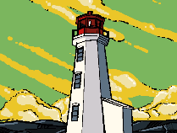Ending

The scene changes to The Lighthouse surrounded by Cerebral Electricity ending the episode.

**Notes**

This episode provides prof that Henryk may be purely human as Mischief says that Henryk has not changed like him. This is not adequate proof that Henryk is fully human as we know his form is similar to a human regardless.

**References**

Henryk

Henryk’s great-granddaughter

Henryk’s family

Mischief

USS Impermanence

The Lighthouse

The Ghost

**Sources**

Interface

https://www.youtube.com/watch?v=EHqsCmfTDmI&list=PLPnjato8iGXLQbppBPhOny8XLSRl7S5pM&index=1

Secondary source of information on interface and formatting ideas for webpages. <https://umami.fandom.com/wiki/Umami_Wiki>

**Episode 20 All That Perish**

**Sidebar**

Episode Number: 20

Title: All That Perish

Released (DMY): 10/5/20

Video Type: Interface Part 2

Synopsis:   
We see what it was that put Henryk over the edge and Mischief 's true motivations become a bit more clear. Is he as harmless as he seems? Is Greetings Robotics doing the world a favour?

**Article body**

**Description**

This episode explores what truly happened at the crash that clams the lives of Henryks family, his bloodguilt and the deal between Mischief and The Ghost.

**Summary**

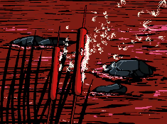Opening

The episode opens on as scene of the river Henryk’s family will crash in as The Ghosty begins her monologue.

The Ghost’s Monologue

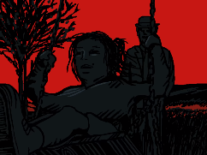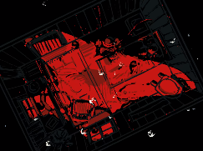The Ghost says that with every year that passes Henryk becomes more quiet. the scene changes to be a shot of Henryk in a room with his daughter and another with Henryk pushing her on a swing likely when she was much younger, during which she claims to have grown older than her father. The Ghost claims that Henryk only looks the same but is changing with time likely getting sadder.

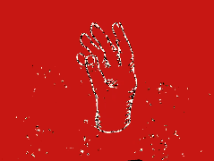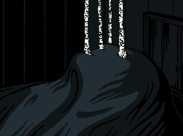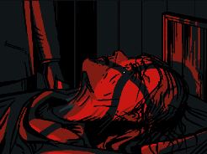We see several shots of crows and a shot of Henryk’s daughter clearly incredibly old. The Lighthouses is shown before a final shot of Henryk’s daughter is shown with cloth covering her faces, her cerebral electricity is released before collecting above the house and forming a hand. This confirms that Henryks daughter is definitely The Ghost.

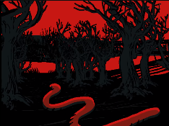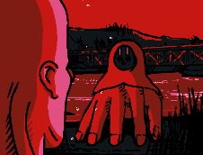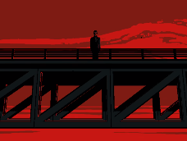The Ghost’s Conversation with Mischief and Henryk’s Suicide Attempt

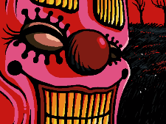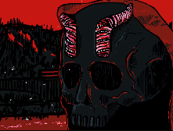Mischief is seen moving through the woods approaching a river and we see Henryk on a bridge looking down. The hand arrives on the riverbank and talks with Mischief.

The Ghost asks Mischief why he is here, and he claims that he wanted to witness a mortal sin and the consequences of bloodguilt adding that it is also suppertime.

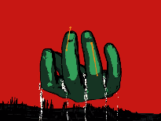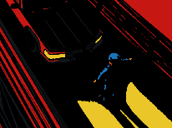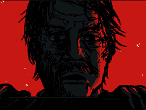Henryk is scene to step out in front of the car filled with the members of his family before the scene cuts to white with signs of Cerebral Electricity. The hand is seen raising Henryk’s grate-granddaughters from the wreck before Henryk is seen unharmed looking into the river.

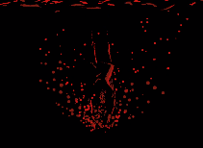The Ghost continues talking to Mischief she says unlike him I’m still here. The Ghost then claims that Mischief can change that and requests that Mischief “bring him back” and let Henryk know about his grate-granddaughters survival. Henryk is seen to jump in the river presumably trying to help his family before the scene change back to Mischief and The Ghost, until Mischief can fulfil his end of the deal The Ghost promises to protect her granddaughter.

Mischief asks what he would get in exchange for his help to witch The Ghost offers all that perish.

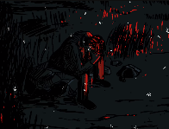Ending

We see a finale shot of Henryk crying into his hands at the side of the river after realising what he has done before the scene cuts to black ending the episode.

**Analysis**

**The Mortal Sin and Bloodguilt**

The mortal sin is likely referring to Henryk’s planed suicide attempt and the consequence of bloodguilt is likely related to how Henryk feels guilty about having outlived his daughter.

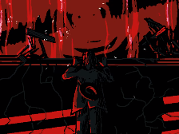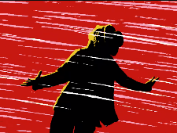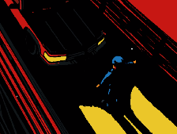**How Henryk Survived**

We see Henryk in the road before the crash and then it cuts to white, there is not enough spaces or time available for the car to turn into the river like we see it did. this implies a part of his powers may be protecting him from harm in whatever way is possible. In this case I believe that Henryk realised a large amount of Cerebral Electricity and blow the car of the road, this is also supported by the fact we see a lot of Cerebral Electricity on the bridge after the crash. In episode 13 we see Henryk perfectly land after a fall which could be a much smaller use of this power.

**Mischief And The Ghost’s Deal**

The Ghost requests that Mischief brings Henryk back to how he used to be, presumably meaning when he was less depressed. She also requests that Mischief informs Henryk of his grate-granddaughters survival.

In exchange for this Mischief will receive all that perish. This is likely referring to all the Cerebral Electricity In the greetings robotics interfaces.

**Notes**

This episode finale shows the details of the crash that lead to the death of Henryk’s family.

**References**

Cerebral Electricity

Henryk’s grate-granddaughters

Henryk’s family

Henryk

The Ghost

Mischief

**Sources**

Interface

https://www.youtube.com/watch?v=EHqsCmfTDmI&list=PLPnjato8iGXLQbppBPhOny8XLSRl7S5pM&index=1

Secondary source of information on interface and formatting ideas for webpages. <https://umami.fandom.com/wiki/Umami_Wiki>

**Episode 21 Restoration**

**Sidebar**

Episode Number: 21

Title: Restoration

Released (DMY): 10/9/20

Video Type: Interface Part 2

Synopsis: Mr. Greetings is interviewed on television and describes the Philadelphia Experiment in 1943 that he witnessed that motivated him to start his company. He is leading the pack with the restoration, but perhaps there is another motive that he is not revealing?

**Article body**

**Description**

This episode focuses on Mr Greetings having an interview, and his memories of The Philadelphia Experiment, and the changes made to the world in its wake. We also get to see The Museum Boy growing a beautiful sunflower.

**Summary**

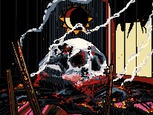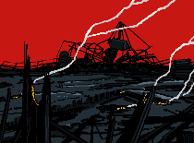Opening

The episode opens on a shot of a burned down area likely Dreamland before focusing on a shot of a charred skull. The scene then suddenly cuts to an interview with Mr Greetings on a show called The Stream.

Mr Greetings Interview and His Memories of The Philadelphia Experiment

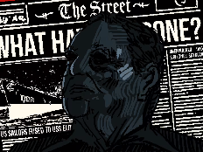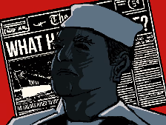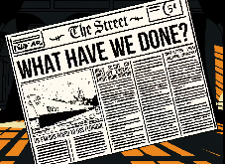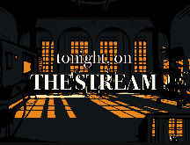The Interviewer introduces Mr Greetings by talking about The Philadelphia Experiment, she claims that Mr Greetings was present for the test as a new recruit to the US military. As she discusses this a newspaper is shown from the immediate aftermath of The Philadelphia Experiment it makes it clear that the public was immediately aware of the paradigm shift as well as confirming The Philadelphia Experiment took Places on the USS Eldridge.

We see a picture of a young Mr Greetings followed by a Photo of an old Mr Greeting before the scene changes to show the Greetings Robotics title card, The Interviewer confirms that Mr Greetings is the founder and CEO of Greetings Robotics, she also confers that the purpose of Greetings Robotics is to restore the world to the way it was before 1943.

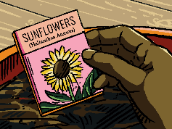A scene of The Museum Boy planting some sunflowers, before The Interviewer begins to discuss the people who were born after 1943 and have only experienced the world as it is. Mr Greetings begins to explain the difficulty of explaining the differences between the world before and after The Philadelphia Experiment to people who did not see the way the world was before. He claims that The Philadelphia Experiment, made much more things visible to people. Mr Greetings claims to believe that something like The Philadelphia Experiment was inevitable was unavoidable and comperes’ Cerebral Electricity to force like nuclear power, the ozone, and climate change.

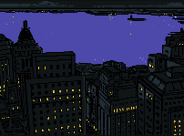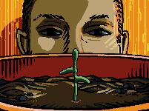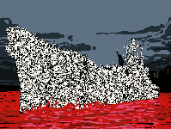During Mr Greetings monologue we see a few different shots, the first is a shot of pre–Philadelphia Experiment New York Before a ship materialise and releases a pulse wave of Cerebral Electricity changing the colours of everything it touches.

Still during Mr Greetings monologue the scene changes to show The Museum Boy watching a sunflower grow surprisingly fast eventually seeing it bloomed.

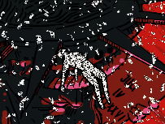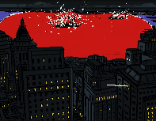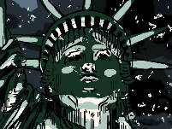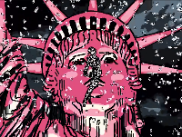As Mr Greetings finishes his monologue, we see the scene change back to know your during The Philadelphia Experiment, The Statue of Liberty is shown as it suddenly changes from blue to pink, we see a Man floating in front of it completely made of Cerebral Electricity.

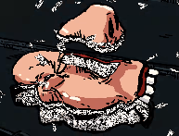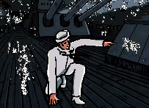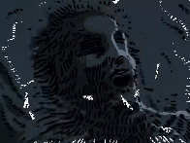We see another wide shot of New York now entirely consumed by the Cerebral Electricity changes, followed by another shot of the floating man by The Statue of Liberty.

The scene changes back to the USS Eldridge as we see a man fuss to the floor of one of the decks. We then see a shot of another man covered in Cerebral Electricity floating slightly above the USS Eldridge before he transforms into Mr Greetings and lands on the Deck of the ship unharmed, we see as he watches the body of a man fused to the hull fall apart seemingly disintegrating into Cerebral Electricity.

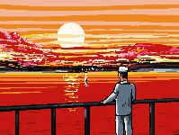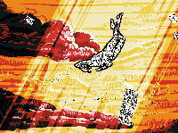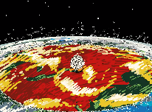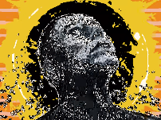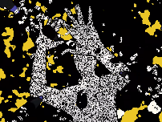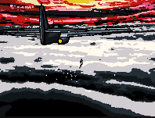We seer planes flying in the orange skies of a post change new York as we see the man floating by The Statue of Liberty again this time much higher, he notices the planes as they begin to open fire, the scene changes to some shots of KAMI before cutting back to a shot of the floating man clearly afraid, we then see another shot of KAMI and the Cerebral Electricity pules wave covering the world.

Finaly, we see the floating man in a pose reminiscent of Satan Descends Upon Earth, as he to falls likely as due to being shot. Mr Greetings is seen to watch him fall from the ship.

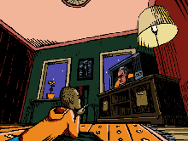Mr Greetings is asked another question by The Interviewer, she asks what he would say to those who are afraid of what’s to come and he replies that the only people who are afraid are the ones born into the post-change world, comparing them to people born into a shadow world and that they will not have a chose as the majority are onboard.

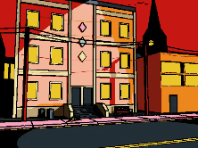During the final question we see The Museum Boy watching the interview with the sunflower in the background, as Mr Greetings begins to speak we see the flower fall before a close up on the boy and a wide shot of the building he lives in with the sunflower on the pavement outside shattered as Greetings Robotics trucks go by.

Ending

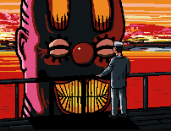We see Mr Greetings on board the USS Eldridge before we see Mischief rise from the water in a much larger form, Mischief says “Boo.” Before rushing away. This confirms the floating man is Mischief mid-transformation. The episode then cuts to black ending the episode.

**Analysis**

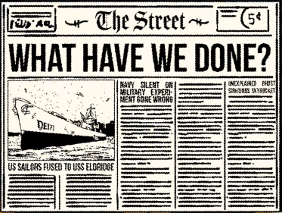**Newspaper breakdown**

The newspaper shown in the beginning of the episode has some easily missed information in it I will transcribe here.

The title says, “WHAT HAVE WE DONE.”.

This is one of the pieces of evidence shown here that implies that the public was immediately aware and horrified by the changes made to the world after The Philadelphia Experiment.

The subtitles that we can read are.

“US SAILORS FUSED TO USS ELDRIDGE.”

This shows that the public are aware of the details of what happened during The Philadelphia Experiment.

“NAVY SILENT ON MILITARY EXPERI-MENT GONE WRONG.”

This shows that the military did not know what happened at first and took time to comment.

“UNEXPLAINED GHOST SIGHTINGS SKYROCKET.”

This shows that there where a verity of Cerebral Electricity Monsters immediately presents after the transformation and that they may have existed before but without people being able to see them.

**Sunflowers**

We see The Museum Boy growing a sunflower before seeing it fall out The Window well, he is watching the interview with Mr Greetings. I believe that the metaphor’s specified in dreamland apply here and gives the scene a deeper meaning, which I will explained here.

The metaphor in Episode 14 Dreamland was that Mischief represents death and sunflowers represent both Mischief and death. Mischief has also been shown to represent the future and the next generation as shown in “bear wittiness” where he is compered to The New Man, who is literally the generation following the year 1943.

The first scene shows The Museum Boy being interested in growing the sunflower, I believe that this is meant to show that the boy is interested in the future and the progress of the world as said above this is what Mischief represents and sunflowers are represents Mischief.

The second scene shows The Museum Boy watching the Mr Greetings interview as the sunflower falls out of The Window. I believe that this is meant to show that the boy losses interest in the future because of what Mr Greetings is saying in the interview, this is lily what Mr Greetings intends due to his sole goal being to take the world back to the way it was before 1943.

Additionally, I believe that this scene could also be about death, in dreamland this is implied to be something that Mischief represents. So, the scene where he grows the sunflower would represent him expecting death in his life and the scene where the sunflower falls would represent him rejecting death. This makes some sense as The Interface is shown to be a form of digital afterlife meaning that Mr Greetings has essentially ended death in the world.

**Artworks**

The Statue of Liberty

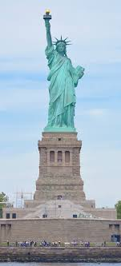 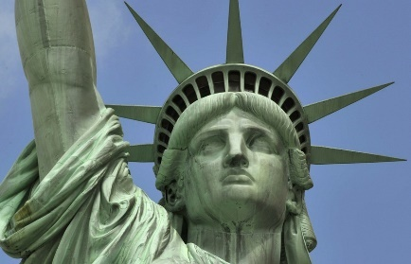 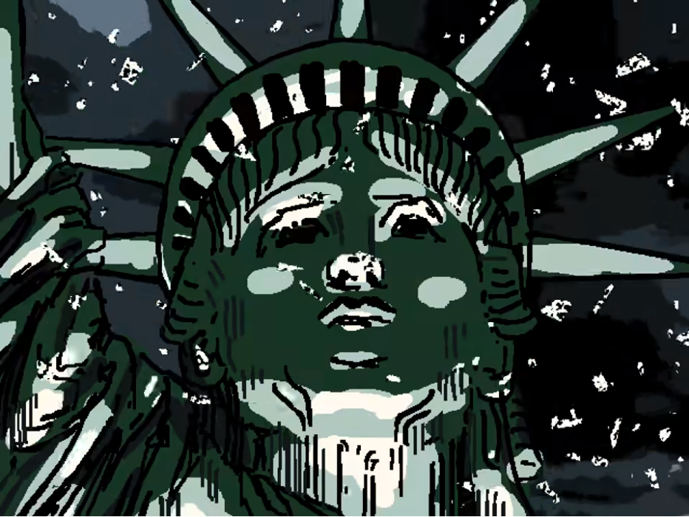 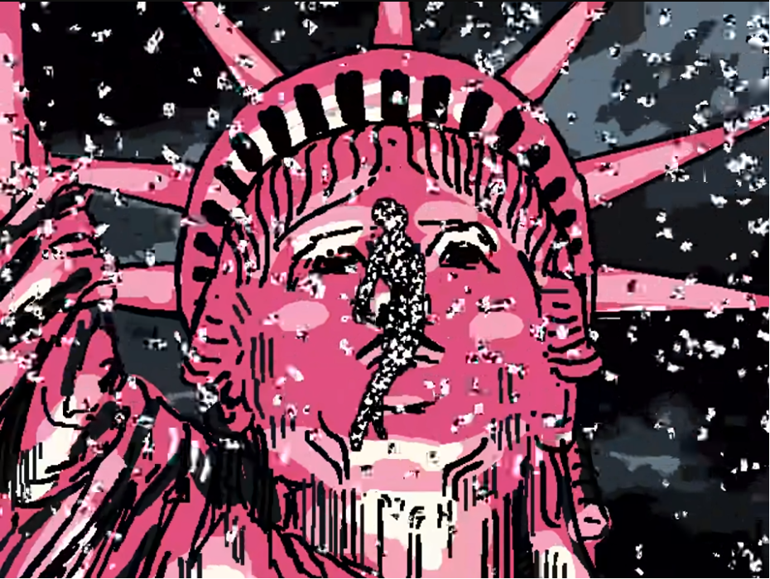

This is a very famous landmark in New York. I do not believe that there is any meaning to this statue belong that. Noticeable this statue is not featured in the credits as an artwork as it is more known as a landmark than an artwork.

This is not the only statue we see that’s been changed to pink implying that this was a common change post- The Philadelphia Experiment,

Satan Descends Upon Earth

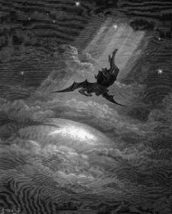 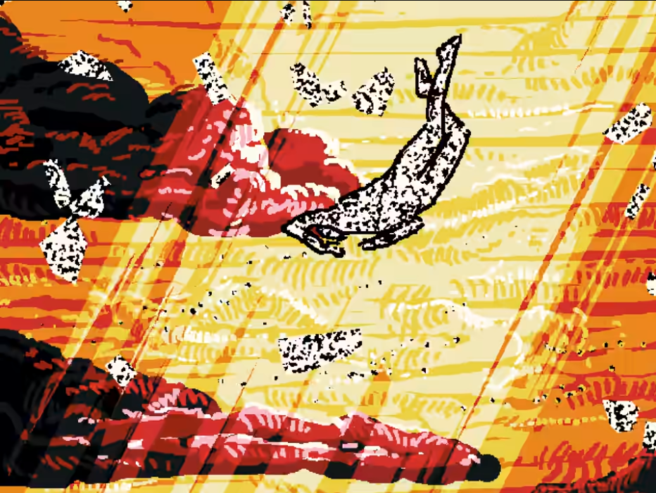

The original painting was meant to depict Satan’s fall from heaven after he was banished by God for being sinful and impure. It may be important to remember that Christians consider the first sine to have been the knowledge of good an evil.

I believe that this painting was meant to depict that Mischief has gain a higher level of understanding of the universe and lost his “purity”.

This would correlate to what we see in “bear witness” as the egg is often used as a symbol of purity in Christion art and Mischief is seen breaking through the egg which could imply that his transformation made him impure in some ways.

**Notes**

This episode is the first to show that Mr Greetings may be a form of Cerebral Electricity Monsters.

**References**

Dreamland

The Statue of Liberty

Mr Greetings

Mischief

Cerebral Electricity

Satan Descends Upon Earth

USS Eldridge

The Museum Boy

The Philadelphia Experiment

**Sources**

Interface

https://www.youtube.com/watch?v=EHqsCmfTDmI&list=PLPnjato8iGXLQbppBPhOny8XLSRl7S5pM&index=1

Secondary source of information on interface and formatting ideas for webpages. <https://umami.fandom.com/wiki/Umami_Wiki>

Satan Descends Upon Earth

<https://www.artbible.info/art/large/666.html>

**Episode 22 Ascend to Solitude**

**Sidebar**

Episode Number: 22

Title: Ascend to Solitude

Released (DMY): 19/12/20

Video Type: Interface Part 2

Synopsis: Henryk and Mischief investigate the lighthouse and discover that it has been repurposed. Is it a trap? Greetings Robotics has been alerted of their presence.

**Article body**

**Description**

Mischief shares some stories of the past as Henryk climbs the Lighthouse. Unknown to the duo, Mr Greetings is preparing for his attack.

**Summary**

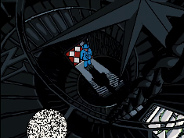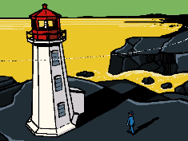Opening

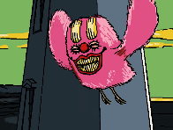The episode opens on a shot of the lighthouse pulsing with Cerebral Electricity, Henryk stairs at it for a while before Mischief comments on the lighthouse making sound, the lighthouse door is seen opening before Mischief asks if the lighthouse is beckoning them.

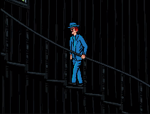Henryk is seen to enter The Lighthouse and Mischief mentions that Henryk will have to take the stairs and is seen to change into his bird from to fly up as flapping is “good for the cardio”.

Mischifes Monologue on The Past

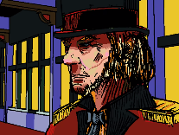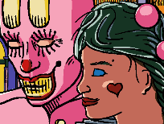Mischief begins to monologue about the past as Henryk is seen climbing up the Lighthouse and Mischief is seen flapping. I will quote Mischief directly for clarity.

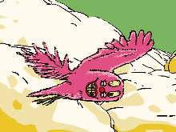Mischief says "The year was 1911. Two comedians take a bow, 54 years too soon." and a scene of Proto-Mischief and The Foolish Girl is shown before The Ringmaster is shown looking upset.

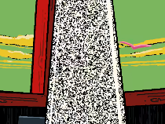Mischief says "1943. Employers shot me down. I've already told you that one." And a scene is shown of Henryk climbing the stairs is shown before a shot of Mischief looking into camera is shown.

Mischief says "1946. The demon core struck twice. Will it strike once more?" Henryk is seen to reach the top of the lighthouse and see a column of Cerebral Electricity.

Mischief says "1954. The apple was a ruse." A shot of an apple falling before shattering into Cerebral Electricity is shown.

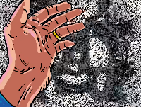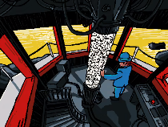Mischief says "1961. My soul, where are you? I will wander with you and ascend to my solitude." Henryk is shown to touch the column before faces appear in the Cerebral Electricity. Mischief then asks When it was for Henryk as Henryk steres into the far distances.

Ending

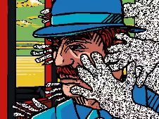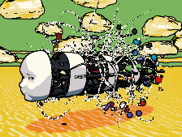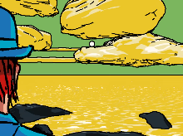We see The Mechanical Saccorhytus appears in the far ground as the shot focuses in on it and it begins to transform, releasing a massive amount of Cerebral Electricity. Hands spread out from the column in the light houses as they around Henryk and The Ghost is heard to say “dad”. The scene is consumed by Cerebral Electricity before the episode ends.

**Analysis**

**Mischifes monologue**

Mischief monologue makes references to several events and dates without elaborating much so I will go over some interpretations of each line here.

Mischief says "The year was 1911. Two comedians take a bow, 54 years too soon." and a scene of Proto-Mischief and The Foolish Girl is shown before The Ringmaster is shown looking upset.

This was the year that Mischief presumably stopped being a comedian and an acter, this would be because of the fire that burned down dreamland, acquiring in 1911.

It is not clear what the cause of the fire was in the show, in real life we know it was an accident caused by pore fire safety and regulations not directly blameable on anybody. However, in the show Proto-Mischief and The Ringmaster are implied to have had something to do with it, possibly over drama with The Foolish Girl. Too be clear this is only ever implied by the show and never confirmed or directly shown.

When he says 54 years to soon, he is referring to the painting Two Comedians which was painted in 1965, by Edward Hopper, as his final painting and goodbye.

Mischief says "1943. Employers shot me down. I've already told you that one." And a scene is shown of Henryk climbing the stairs is shown before a shot of Mischief looking into camera is shown.

This is referring to The Philadelphia Experiment when Mischief transformed into a Cerebral Electricity Monster before being shot down by the military.

When he says I’ve already told you that one it’s because he has in episode one.

Mischief says "1946. The demon core struck twice. Will it strike once more?" Henryk is seen to reach the top of the lighthouse and see a column of Cerebral Electricity.

This refers to an event in 1946 where there were two accidents caused by an unexploded nuclear core called “The Demon Core” which emitted a large amount of radiation killing two people.

It is not clear what the third strike is meant to represents but it is clear that it’s meant to represent a possible coming disaster.

One possible meaning of this could be KAMI’s planed attack on Henryk and Mischief, the first two strikes of the demon core would be her absorbing The Ghost and The Chef, with the third possible strike being her planed attack on the duo.

Mischief says "1954. The apple was a ruse." A shot of an apple falling before shattering into Cerebral Electricity is shown.

This refers to the death of Alan Turing in 1954 he was a prominent computer scientists and war hero. Some believe that his death has caused by him having been assassinated by a poisoned apple or that he killed himself with the same apple, though this is widely believed to be false as it doesn’t hold up to scrutiny.

The most likely answers to his death in the real world was an accident he was experimenting with cyanide and if he consumed even a little by accident he would have died. It is worth noting that next to no research was done on the body of Alan Turing was done so it is hard to confirm for sure what killed him, and it is entirely possible his death was nothing to do with cyanide or the apple.

It is unclear what this is meant to mean in the series, but it likely has something to do with the painting called The Son of Man meaning the apple hiding The Son of Man is a lie.

The son of man in the show is likely meant to refer to two things Mischief not understanding Henryk’s desires and the importance of the next generation.

This line makes more scenes when applied to the first meaning we know that Mischief always intended to bring Henryk to Henryk’s great-granddaughter as this was a part of his deal with The Ghost, so the ruse was presumably referring to Mischief tricking Henryk as he tried to get to know him better.

The importance of the next generation doesn’t apply as well in this scene but could refer to the importance of progress for all generations not just the news generation.

Mischief says "1961. My soul, where are you? I will wander with you and ascend to my solitude." Henryk is shown to touch the column before faces appear in the Cerebral Electricity.

This references the red book in 1961 by Carl Jung the book heavily focuses on the importance of self-realisation. Which seems to be an important concept to Mischief.

Artworks

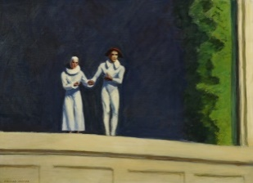 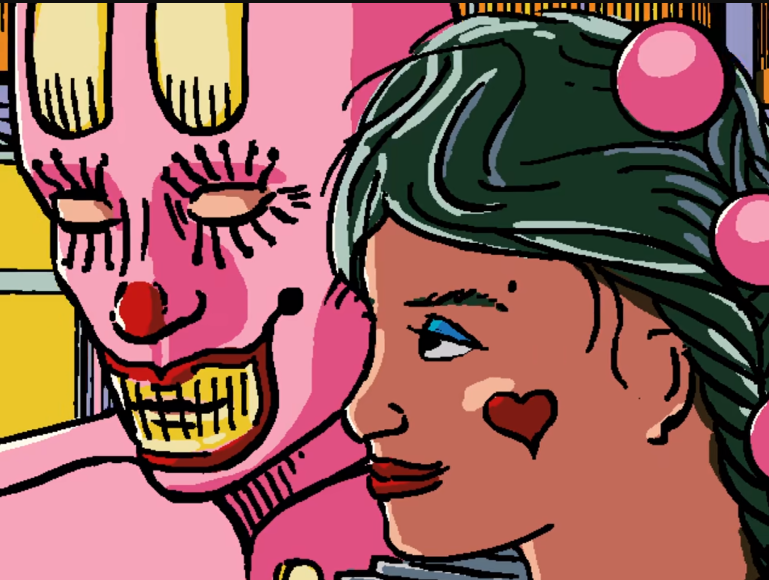 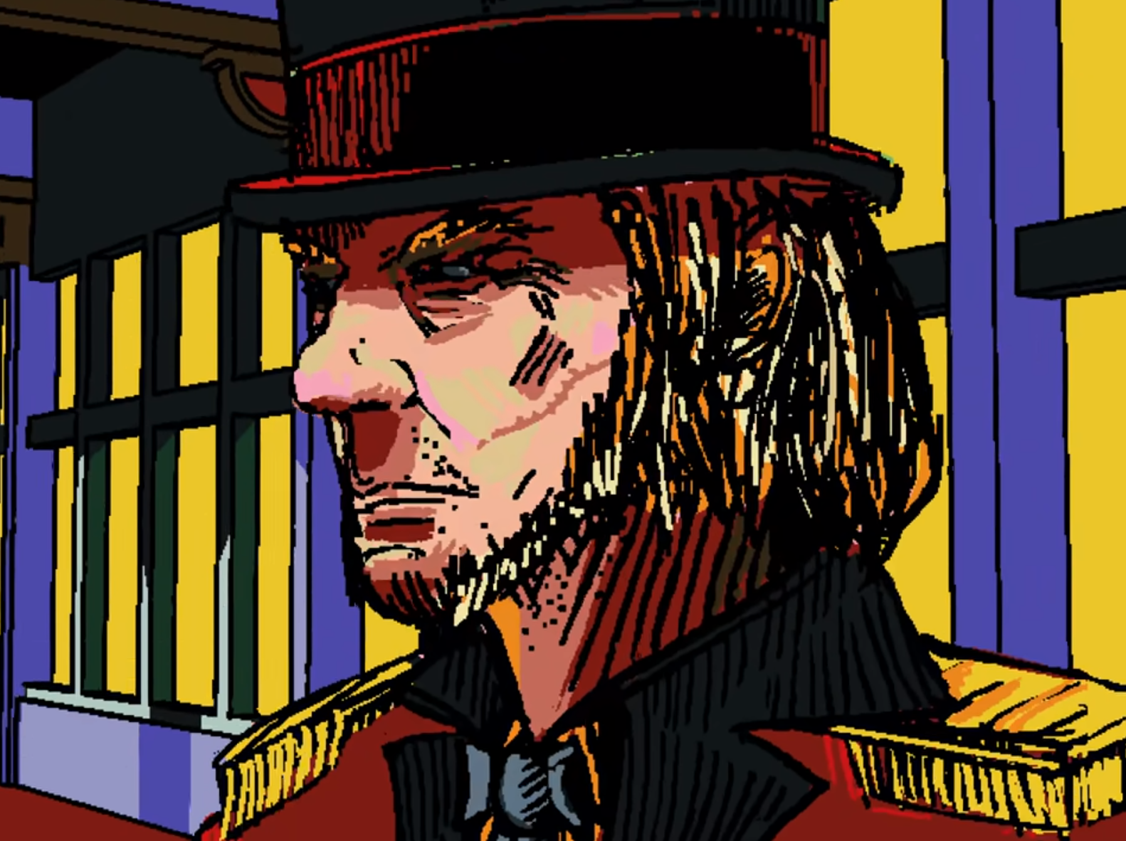

Two Comedians

The original artwork was painted as a goodbye by Edward Hopper in 1965 as his final painting.

In the show it this is references as Mischief say, “Two comedians take a bow, 54 years too soon." and a scene of Proto-Mischief and The Foolish Girl is shown before The Ringmaster is shown looking upset.

This was the year that Mischief presumably stopped being a comedian and an acter, this would be because of the fire that burned down dreamland, acquiring in 1911.

When he says 54 years to soon, he is referring to the painting Two Comedians which was painted in 1965,

**Notes**

This episode shows that The Mechanical Saccorhytus is capable of transformation.

**References**

The Son of Man

Geopoliticus Child Watching the Birth of The New Man

Mischief

The Mechanical Saccorhytus

The Foolish Girl

The Ringmaster

Cerebral Electricity

Notable locations

The Philadelphia Experiment

**Sources**

Interface

https://www.youtube.com/watch?v=EHqsCmfTDmI&list=PLPnjato8iGXLQbppBPhOny8XLSRl7S5pM&index=1

Secondary source of information on interface and formatting ideas for webpages. <https://umami.fandom.com/wiki/Umami_Wiki>

The Son of Man

<https://en.wikipedia.org/wiki/The_Son_of_Man>

Geopoliticus Child Watching the Birth of The New Man

<https://en.wikipedia.org/wiki/Geopoliticus_Child_Watching_the_Birth_of_the_New_Man#:~:text=The%20man%20emerging%20from%20egg,Europe%20to%20support%20his%20emergence>.

**Episode 23 An Unconscious Conscious**

**Sidebar**

Episode Number: 23

Title: An Unconscious Conscious

Released (DMY): 20/12/21

Video Type: Interface Part 2

Synopsis: Within the simulation generated by the brain of The Mechanical Saccorhytus, Mr. Greetings speaks with Henryk about his past and his role in the future. He gives Henryk a choice, to join him and betray Mischief ... or not.

**Article body**

**Description**

This episode focuses on Henryk talking to Mr Greetings in the Interface as he explores his memory of the past and finally reunites with his daughter, leading Mr Greetings to offer Henryk a Faustian Bargain.

**Summary**

Opening

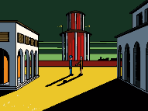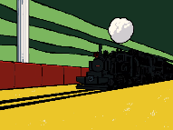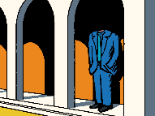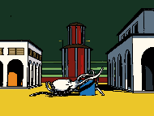This episode opens on a shot of The Chef who appears dead or to be a statue before we see Henryk waiting for a in an area reminiscent of Piazza D'Italia, a train reminiscent of the one from the painting Horse and Train arrives and Mr Greetings welcomes Henryk shaking his hand.

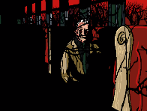The Train Ride with Mr Greetings

In the next shot we see shows Mr Greetings on the train talking to Henryk, Mr Greetings warns Henryk that if he faces the back, he will only see his past offering to show him his futter if he turns round but Henryk refuses as he is only interested in his past.

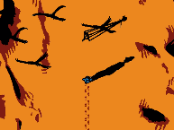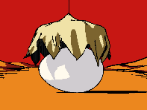We see a ball covered in cloth through The Window of the train before the cloth is raised reviling a large egg, the train stops, and Henryk is seen approaching a camera to take pictures of the egg with Mr Greetings standing behind him. during this scene Mr Greetings asks Henryk what the cause of his dissociation is and tells Henryk he knows the answers if he looks within.

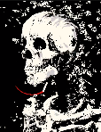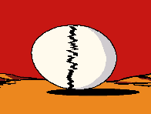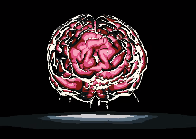The eggshell shatters into CE revelling a glowing pink blob inside that turns into a brain and releases an explosion that removes Henryk’s skin leaving only boon as he smokes a cigarette this resembles the painting call Skeleton with a Burning Cigarette, by Vincent van Gogh. During this scene Mr Greetings says to Henryk that all hunted souls remain on earth because they cannot leave, presumably speaking hyperbolically meaning they are too upset or obsessed to move on. He then asks Henryk why he didn’t leave, as we see Henryk’s flesh return.

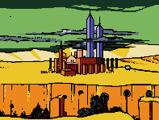Mr Greeting the then claims the man of the past is responsible for “complicity in war.” “The advancement of destruction.” And “furthering the divide between the natural and industrialised society.” during this we see a simulation of New York with pipes spewing sewage into a river.

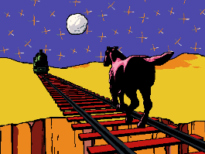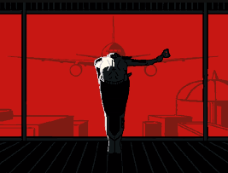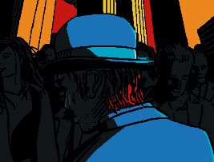The scene changes to a shot of the streets of New York with the twin towers in the background. Mr Greetings begins to talk about how the man of the past becomes obsolete and clams that Henryk and himself are attempting to revers time but unlike Henryk he’s changed, as he finishes, we see a shot of KAMI inside the twin towers bowing as then a plane collides with the building.

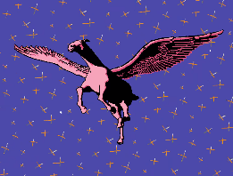Mr Greetings references the story of Icarus calming that if they fly to high, they will melt but if they fly too low, they drown. During which a shot heavily resembling the painting Horse and train is shown

He then discusses why the gods are ignoring their cry for help claiming that they need Henryk as he is the man of the past. During this segment we see the horse doge the oncoming train before gaining wings and flying away,

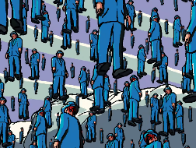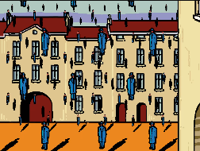The scene changes to a shot reminiscent of the painting Golconda before, Mr Greetings dismisses the idea of the multiverse, as Henryk’s hat is seen flying Mr Greetings continues claiming that there is only one choses Henryk can make at one time in one places, he promises Henryk that if he makes the right choices Henryk can restore the balance, and that the burden on Henryk’s should will be shared across everybody and redeeming Henryk.

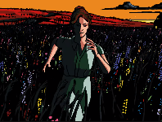Henryks Daughter in the interfaces

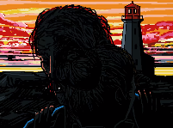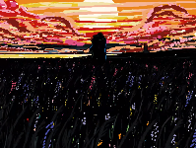The train is seen to arrive in a flower filed with Henryks Daughter standing in it as Mr Greetings promises that if he makes the right chooses Henryk can be happy again.

Henryk embraces his daughter as she claims that everything is like it was before and that see thought she would never have the chance to see him again.

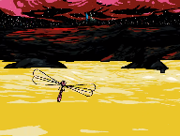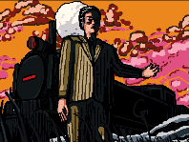Mr Greetings gestures to the train and tells Henryk that if he wants to live forever with his memories of the past he can do so in The Interface.

A scene of a dragonfly is shown as Henryk’s daughter asks if Henryk is here to stay.

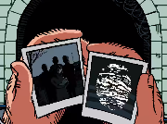Mr Greetings tells Henryk that Mischief has choses in his eyes and that he is hiding more than Henryk wishes to know, before claiming that Henryk isn’t free from guilt which lead to him being followed by Mischief. During this we see Henryk’s hat float down being and caught by Henryk.

The train is shown to be returning Henryk to where the episode started, Mr Greetings asks Henryk if he is afraid of Mischief, claiming that if he is not then he has been tricked.

We see Henryk looking at two photos one of his family the other of The Wind.

Ending

Mr Greetings tells Henryk that within The Lighthouse there is a red button and if he presses it, he will have made the right choice.

**Analysis**

**Henryks Possible Death**

During one scene we see Henryk getting blasted by a nuke casing him to die before getting covered with Cerebral Electricity this would seemingly imply that Henryk died to a nuclear blast but we also know that Henryk had been already transformed when the sky’s where still blue, meaning before 1943 and the first nuke was detonated in 1945 meaning that unless the events of when the skies where still blue are before Henryk’s transformation this cannot be true.

**The Sins of The Man of The Past and There Meaning**

Mr Greeting the then claims the man of the past is responsible for several thing which I will list and explain below.

“Complicity in war.”

This likely refers to how Mr Greetings believes that humanity and Cerebral Electricity Monsters are essentially at war which was largely ignored for years.

“The advancement of destruction.”

Is likely referring to the advancement of weapons technology, with stuff like nuclear weapons and KAMI being made.

“Furthering the divide between the natural and industrialised society.”

This is likely referring to the advancement of society after World War Two and how nature was increasingly abandoned.

**The Ghosts Freewill**

The Ghost is seaming trying to convince Henryk to stay in the interfaces at the cost of Mischief freedom, but it is not clear if she has freewill at the time as she has been absorbed by KAMI.

I do not believe this is even The Ghost in the scene as KAMI is shown to be impersonating her in the final episode, and she has all the information she would need as she should be able to remember everything The Ghost remembers after absorbing her Cerebral Electricity.

**The Wind’s Photo**

Henryk is seen looking at the photo of his family and the photo given to him by Mischief of The Wind. This was likely to remind Henryk of The Winds warning not to get lost in time.

**Artwork**

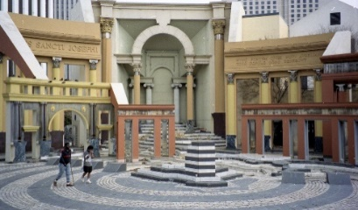 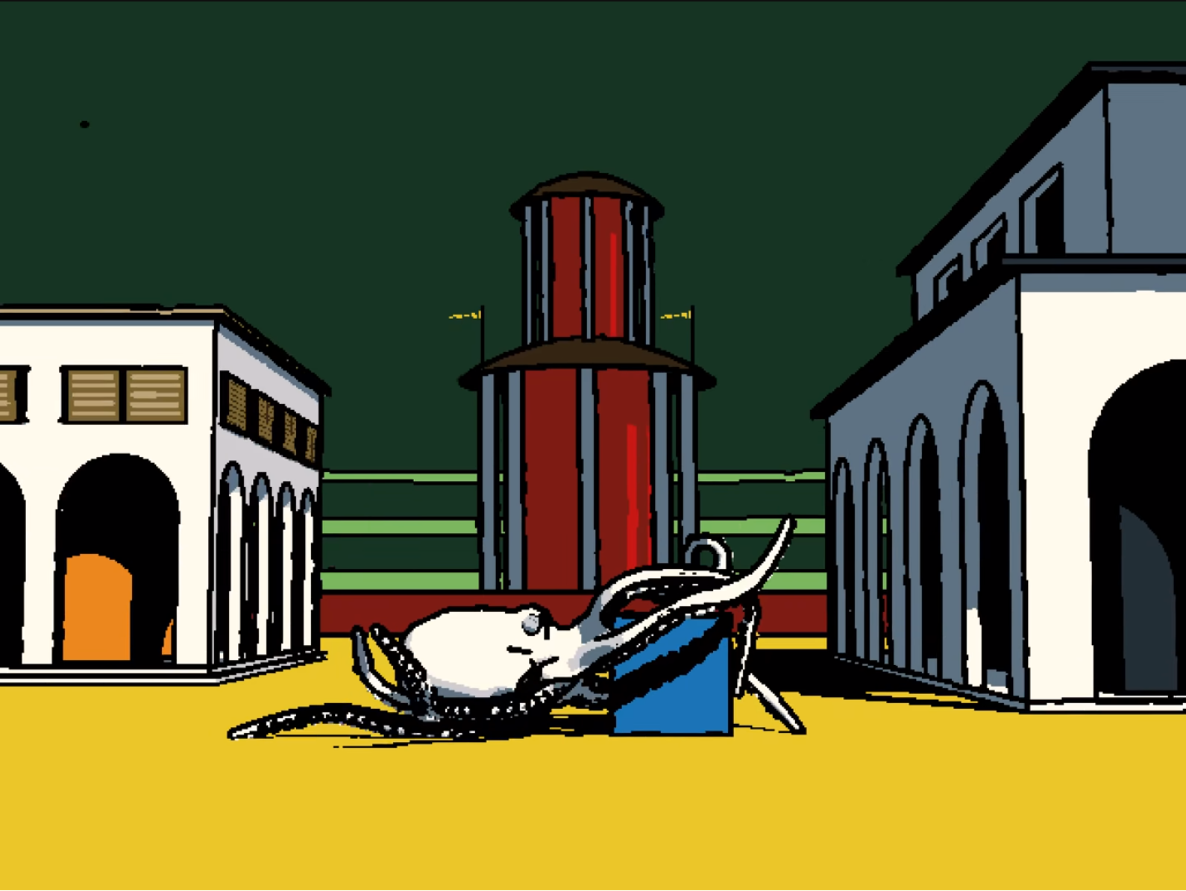 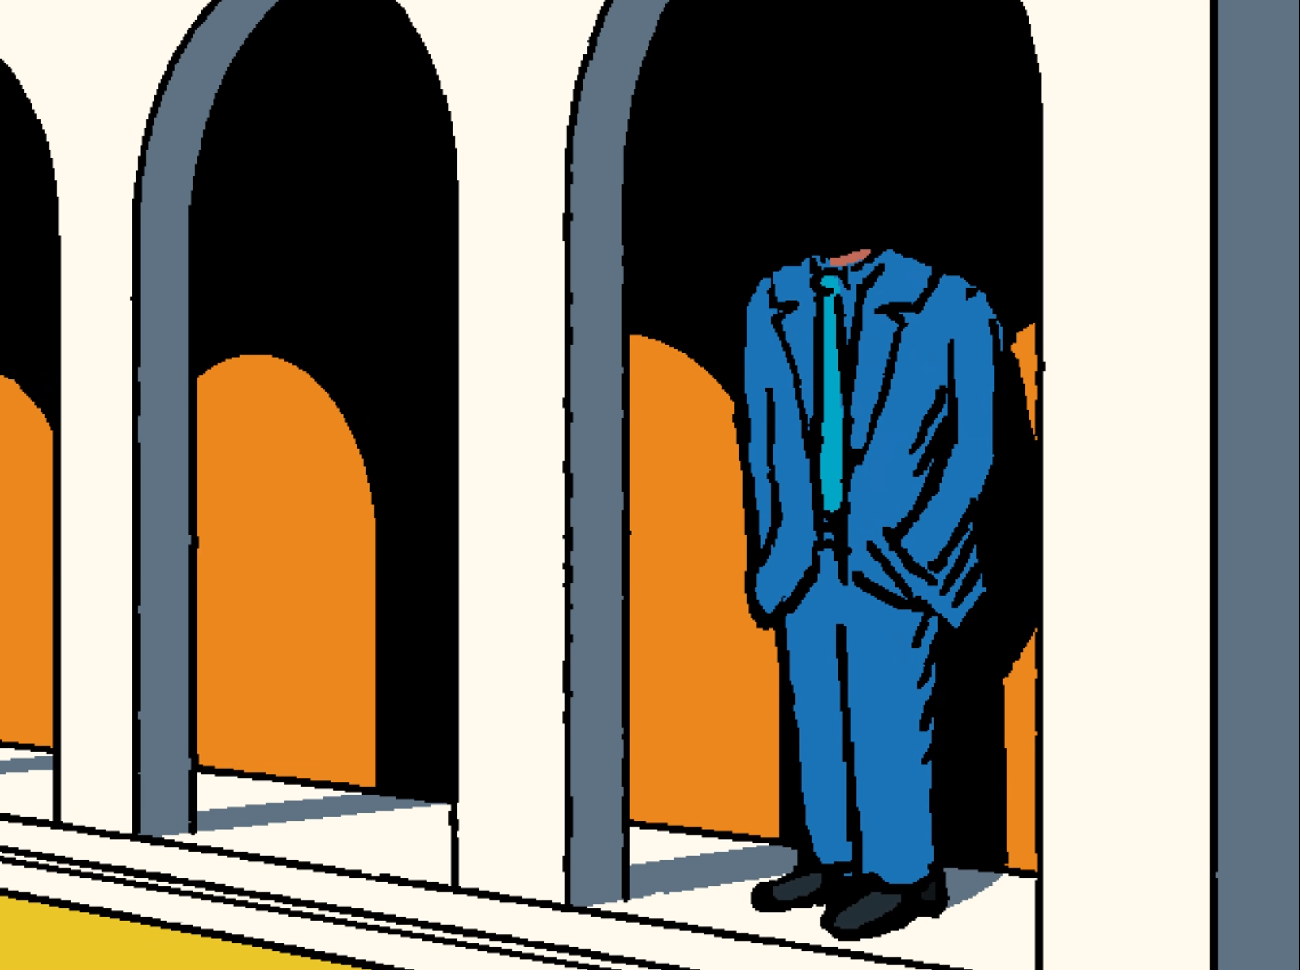

**Piazza D'Italia**

Piazza D'Italia is a public area in New Orleans design in recognition of the Italian community’s contribution to the city and has become an iconic part of the city since it was opened to the public.

There is likely no particular meaning to this appearing in the show, beyond the fact this is a very iconic and unique looking plaza.

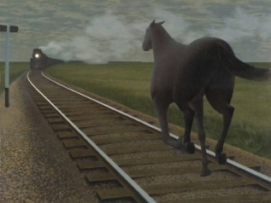 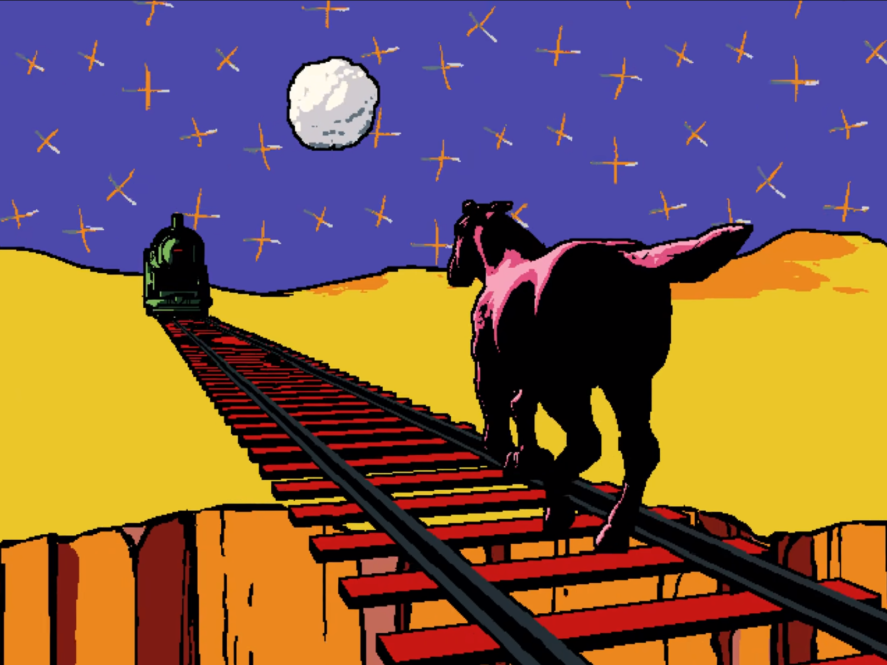 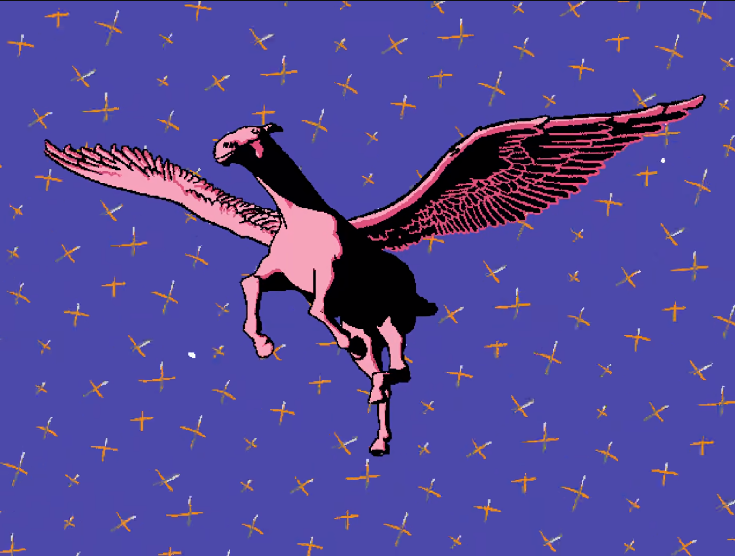

**Hores And Train**

This painting is inspired by a poem by Roy Campbell “I scorn the goose-step of their massed attack  
And fight with my guitar slung on my back, against a regiment I oppose a brain and a dark horse against an armoured train.”.

The main feature of this painting is the juxtaposition of the horse and the armoured train with the train clearly outmatching the horses in every way, representing the future.

Well, the original use of the painting was to represent Henryk as the man of the past being passed by modern technology, in this case It is obvious that the horse represents Mischief and progress. The old train representing the past Mr Greetings serves and the horses representing the new world created by Cerebral Electricity.

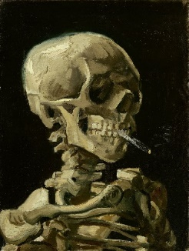 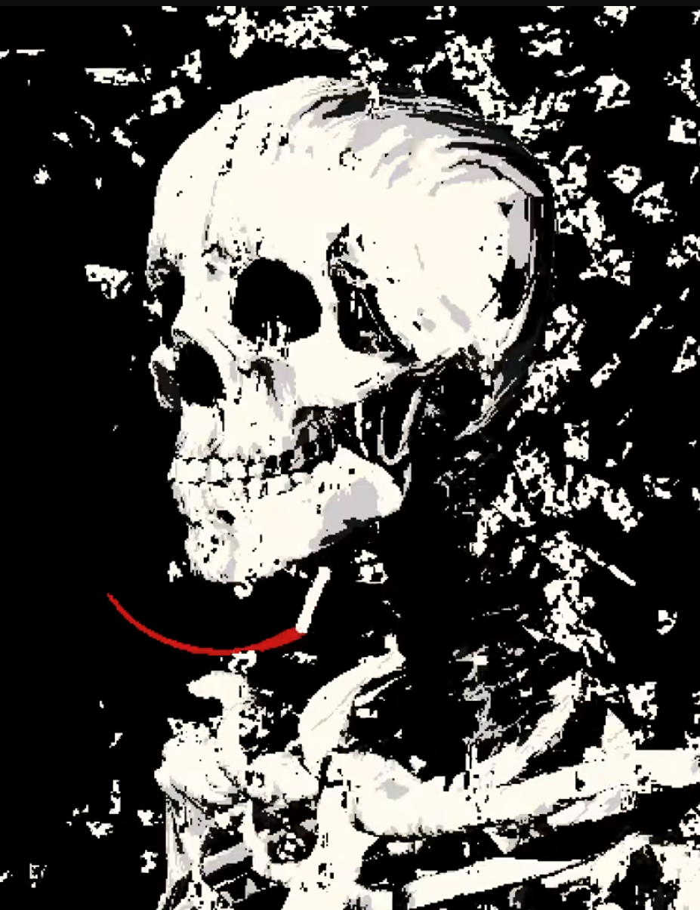 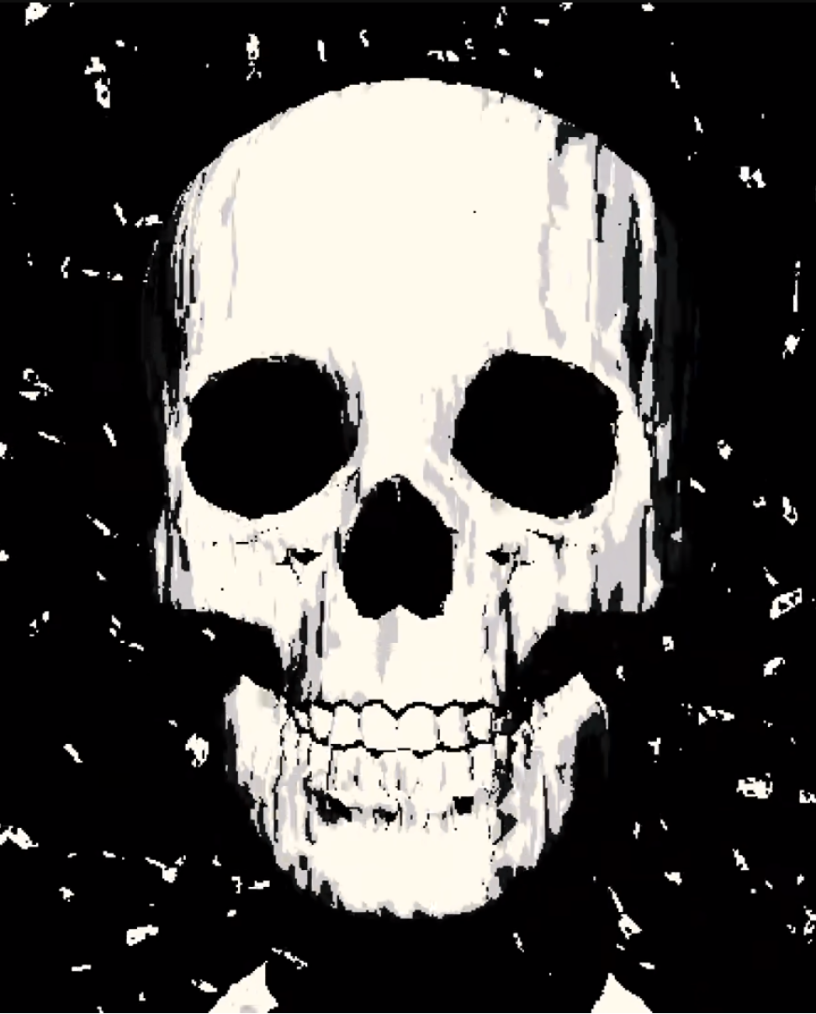

**Skeleton With a Burning Cigarette**

This painting was made by Vincent van Gogh while he was at an art school and has little meaning beyond being an interesting painting and a slight satire of his school’s habit of using skeletons as art modals.

I do not believe this has any hidden meanings in the show beyond it is a popular painting that parallels well with Henryk as he and Vincent van Gogh frequently smoked.

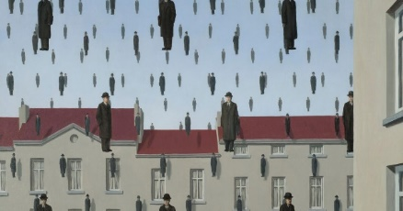 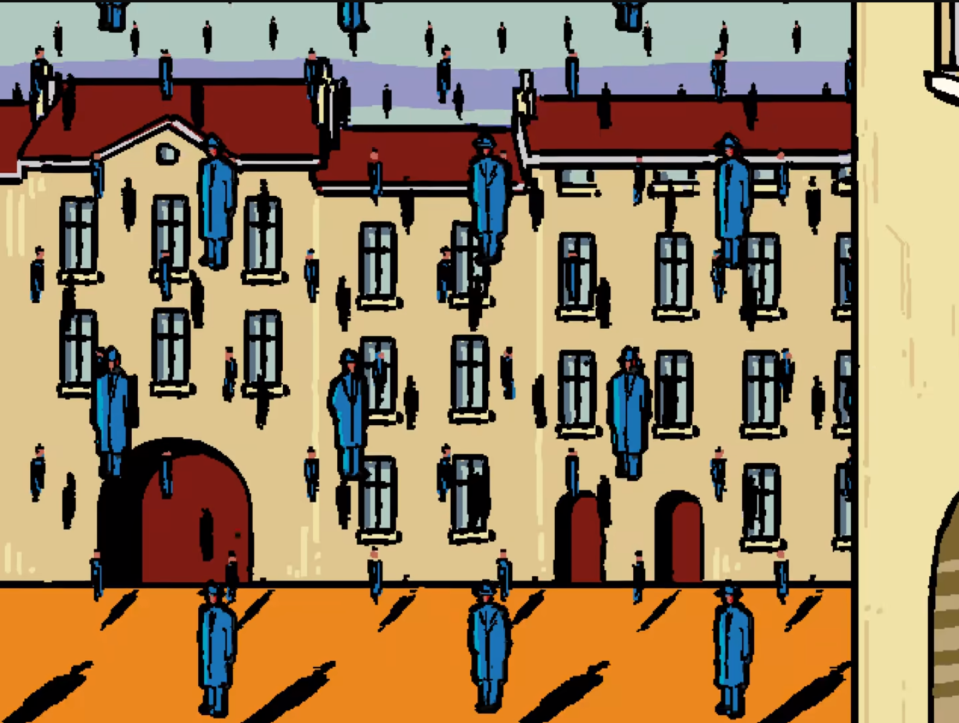

**Golconda**

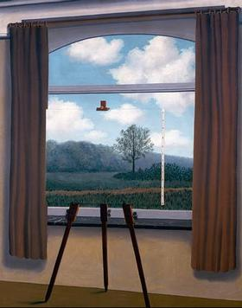Golconda was meant to represent how paintings are false reality of their subjects and can be used in a deceptive manner. in this case it is obviously represented by the verity of floating men but in his other works this appears in many other forms, an example being The Human Condition which shows a painting of a painting in such a perspective that you can barely tell what is what, shown on the right.

It is possible that the false realty of a painting idea represented in the original painting transfers to the series as an allegory for The Interfaces being a false reality but it is more likely just used as a references to The Son Of Man and because Mr Greetings is talking about the multiverse at the time.

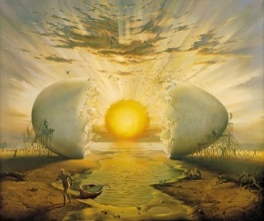 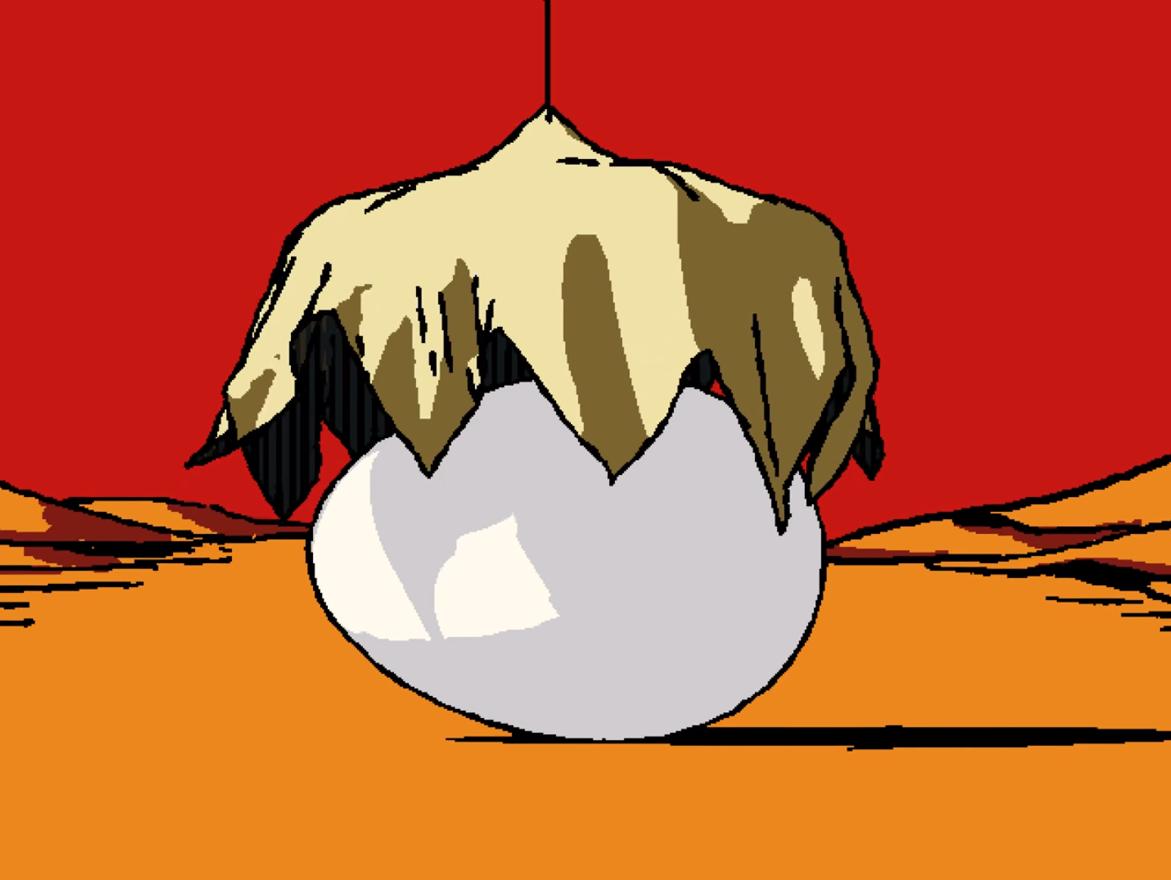 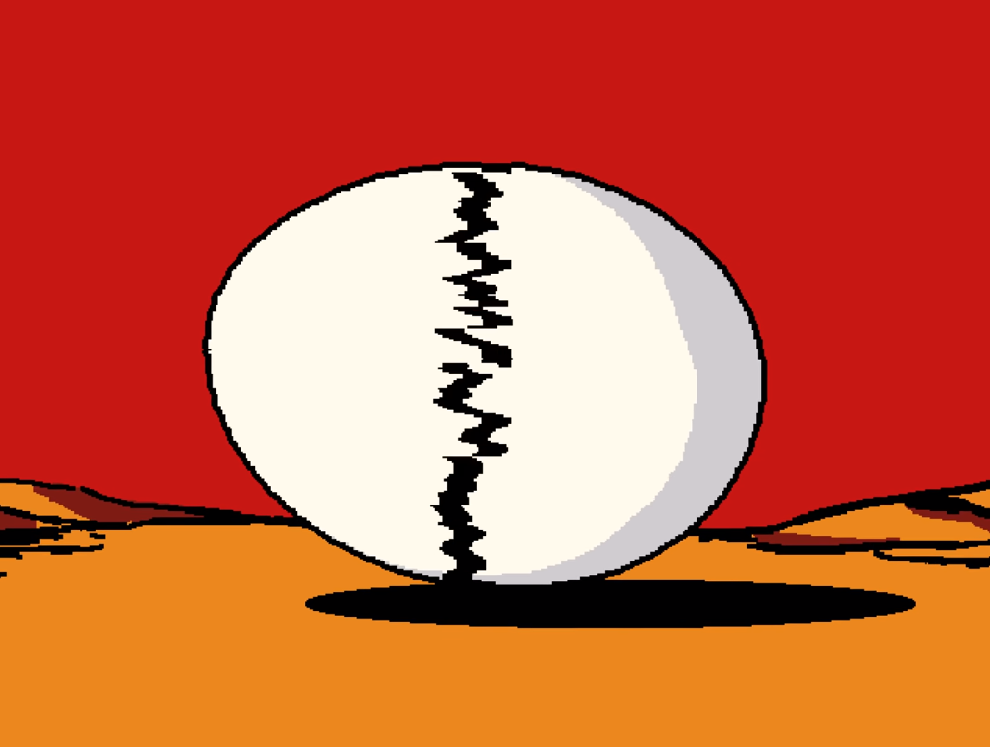 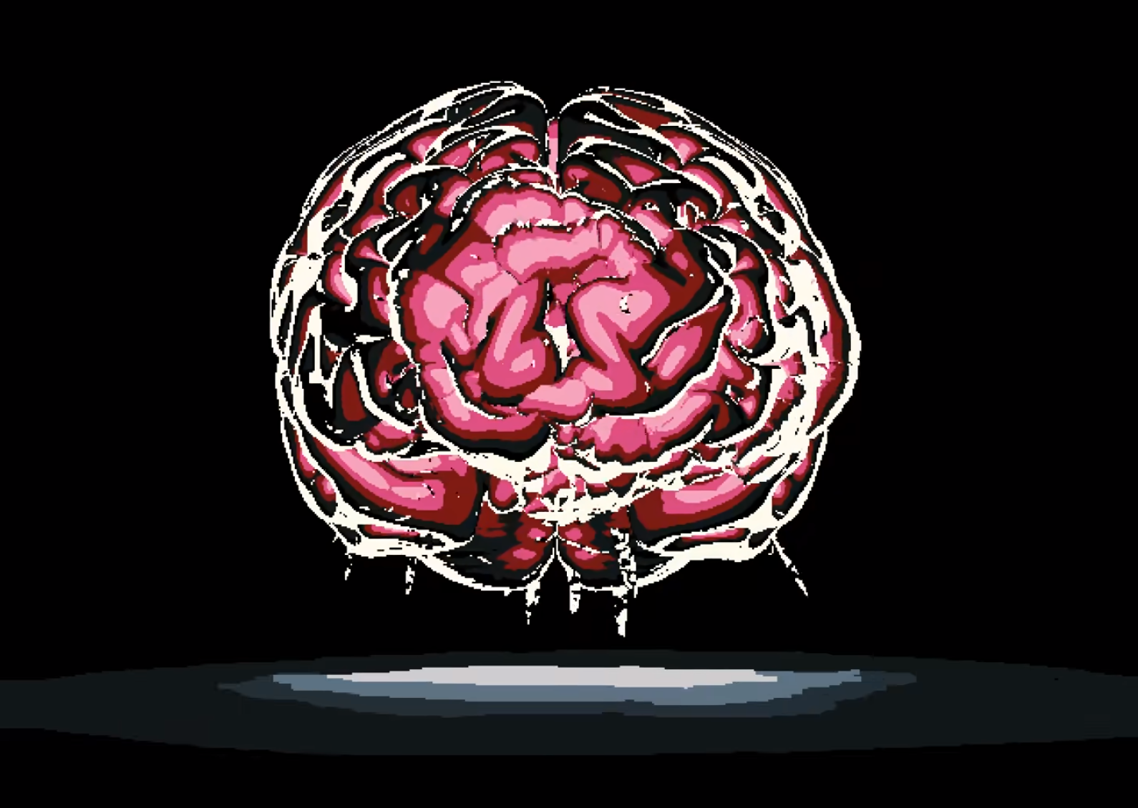

**Sunrise by the Ocean**

This painting was made by Vladimir Kush in 1996 it represents the creation of new life with a verity of different artistic metaphors like the yolk and the sun. This work is similar to Geopoliticus Child Watching the Birth of The New Man by Salvador Dali, Salvador Dali is a common inspiration for Vladimir Kush’s paintings.

In the show the inside of the egg is shown to be a pink blob that then turns into a brain covered in Cerebral Electricity this is likely meant to represent Mischief who was shown as the new man in the painting Geopoliticus Child Watching the Birth of The New Man, in a very similar position.

Essentially, I think this just restates the point of the meaning of Geopoliticus Child Watching the Birth of The New Manin episode 6 that Mischief represents The New Man and progress in the world which Mr Greetings is in stark opposition of**.**

**References**

Piazza D'Italia

Hores And Train

Skeleton With a Burning Cigarette

Golconda

Sunrise by the Ocean

Henryk

Mischief

KAMI

Mr Greetings

Cerebral Electricity

Greetings Robotics

Henryk’s family

Notable locations

The Interface

**Sources**

Interface

https://www.youtube.com/watch?v=EHqsCmfTDmI&list=PLPnjato8iGXLQbppBPhOny8XLSRl7S5pM&index=1

Secondary source of information on interface and formatting ideas for webpages. <https://umami.fandom.com/wiki/Umami_Wiki>

Horse And Train

<https://en.wikipedia.org/wiki/Alex_Colville>

Piazza D'Italia

<https://en.wikipedia.org/wiki/Piazza_d%27Italia_%28New_Orleans%29>

Skeleton with a Burning Cigarette

<https://en.wikipedia.org/wiki/Skull_of_a_Skeleton_with_Burning_Cigarette>

Golconda

<https://en.wikipedia.org/wiki/Golconda_%28Magritte%29>

Sunrise by the Ocean

<https://kushfineart.com/artworks/categories/8/9559-sunrise-by-the-ocean>

**Episode 24 The Abyss**

**Sidebar**

Episode Number: 24

Title: The Abyss

Released (DMY): 17/10/21

Video Type: Interface Part 2

Synopsis: Will Henryk let go, or will he give in?

**Article body**

**Description**

Henryk and Mischief finally confront Henryk’s past and Greetings Robotics, and Henryk finally gets to see his great-granddaughter again.

**Summary**

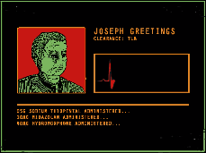Opening

The episode opens on a vitals monitor connected to Mr Greetings, we see a verity of drugs being administered before a shot of Mr Greetings is shown with an odd port on his faeces is shown and he hear him flatline.

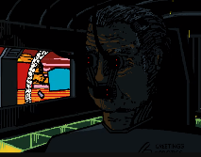The drug cocktail that is administered is identical to the most common form of lethal injection meaning that this was likely intentionally done so Mr Greetings could upload his Cerebral Electricity to The Interface.

In the background of this scene we see The Mechanical Saccorhytus transforming, given that we also see Mr Greetings being uploaded to the interfaces here this part of the episode is likely concurrent with Episode 23.

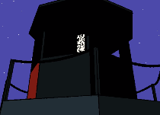Mischifes Monolog on The Stars

The scene opens on a shot of the exterior of The Lighthouses panning up, as we hear a phone ringing in the distance.

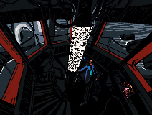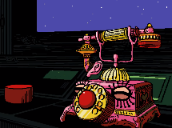The scene changes and we see inside the lighthouse and see that Mischief has transformed into as dial phone, with Henryk lying on the ground. We hear the Cerebral Electricity motif before Mischief stops ringing and begins to talk to Henryk.

Mischief says that he was worrying about his obligations if Henryk hadn’t woken up, confirming that Henryk is awake despite still laying on the ground. Mischief claims that this reminds him of when Henryk fainted in the museum during episode 6.

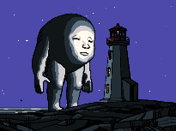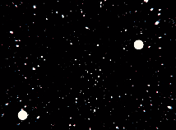The scene changes to show the starts as Mischief begins to monologue, quoted directly he says, “When humans first gazed upon the night, did they see stars? A lung, a heart, a hand, an alter in the sky. What is a constellation, but a sum of its parts?”“They didn’t see stars, they saw titans.” As Mischief says this, we see The Mechanical Saccorhytus patiently waiting outside for Henryk to make his chose.

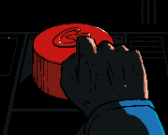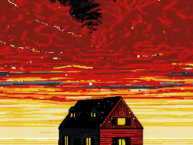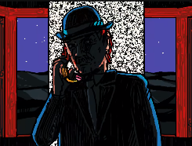The telephone starts ringing again, Henryk picks up Mischief ’s phone handle and putting it too his ear and Mischief continues saying “what came first Henryk the baby chicken or the egg? Man, or God? If man came first, they’ll make God. By doing so they become one.” During this we see a memory of Henryk riding on a train past his home will a storm builds above the houses.

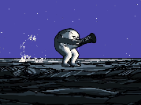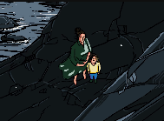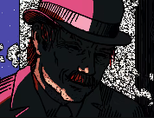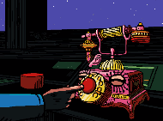The scene shows us Henryk looking at the button that Mr Greetings told him to press in the last episode before Mischief tells Henryk that every choses he makes is a sacrifice, we see Henryk go to press the button before changing his mind and bopping Mischief red nose, Mischief proceeds to change into his suit form. We see Henryk’s daughter and great-grandfather below before the Mischief and Henryk are seen running out of the lighthouse being attacked by one of The Ghost’s hands.

Mischief And Henryk Fight Greetings Robotics

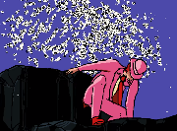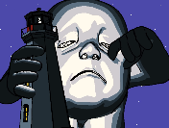We also see The Mechanical Saccorhytus picking up the lighthouse to drink it like a babies bottle, drinking it of cerebral electricity.

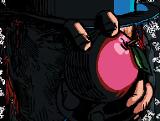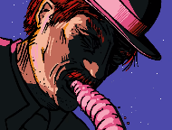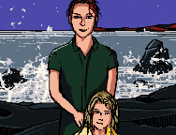Mischief calms that nothing will stop Greetings Robotics and that there never was a chose at all as we see The Mechanical Saccorhytus begin to cry and smash The Lighthouse into Cerebral Electricity. Mischief continues claiming that if your choices is an illusion then so must Henryk’s sacrifice as the scene focuses on Henryk and his great granddaughter, Henryk is then seen to throw up a tiny Mischief as he transforms into an apple.

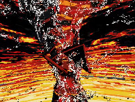Henryk’s daughter threatens Henryk telling him to not forces their hand and that he can still come willingly, she then demands that Henryk’s great-granddaughter smiles. The scene changes between Henryk his daughter and his great-granddaughter before a shot of Henryk is shown with Mischief in his apple form obscuring his faces referencing the painting The Son of Man.

During this we see a shot of the storm form earlier now a full hurricane destroying his house, likely symbolising that Henryk has abandoned his past.

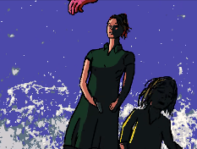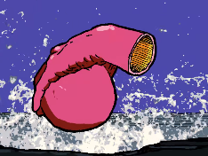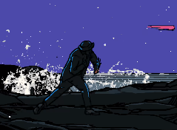Mischief And KAMI’s Confrontation

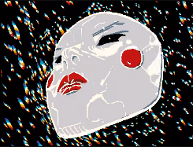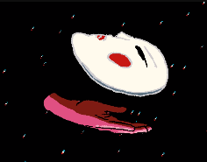Henryk launches Mischief in his apple form at his daughter and we see it transform into a hand before landing on KAMI’s faces removing her mask, reviling that KAMI had been impersonating Henryk’s daughter during this we see Henryk’s Greet-Granddaughter make her escape and reviling that she was being held at knife point.

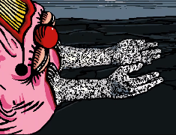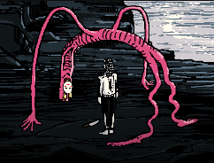 Mischief begins to talk to KAMI, quoted directly he says, “to see through your eyes, the world looks the same to me. The mask only fits one way. You can look out, but you cannot look in. When you gaze up at the night sky, What do you see?” as this is being said we see a verity of different shots of KAMI’s mask surrounded by stars.

Mischief is then shown to by towering over KAMI and that he has put on her mask, before KAMI raises her knife splitting Mischief head in two and breaking the mask, Mischief then begins to reach out into KAMI using Cerebral Electricity hands.

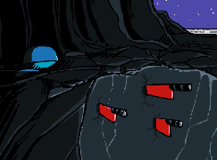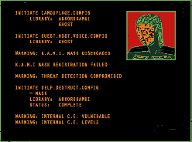We see a verity of different screens form KAMI’s interface as see begins to self-destruct, ripping Mischief body into pieces as Mischief and his great-granddaughter are hiding behind a rock.

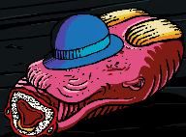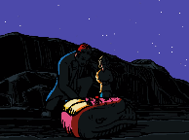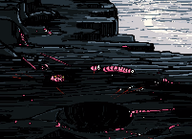Mischifes Last Goodbye and The Mechanical Saccorhytus Last Meal

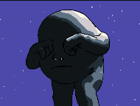 Mischief is scene lying on the ground appearing dead as his body has been ripped to shreds as Henryk covers his faces with his hat in a show of respect.

The Mechanical Saccorhytus is seen crying likely upset at KAMI’s death.

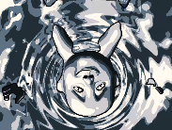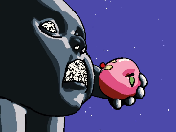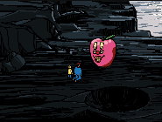Mischief suddenly eats Henryk’s hat claiming its nutritious before transforming into an apple and claiming to be also nutritious. Mischief warns Henryk to flee before The Mechanical Saccorhytus arrives. Mischief references an early conversation from Camouflage claiming that the strong will eat the weak, even eating parasites.

Mischief is seen being eaten by The Mechanical Saccorhytus before he slows down collapsing into the water presumably dead though his cerebral electrics doesn’t leave him.

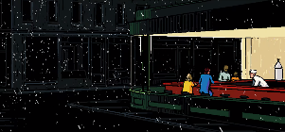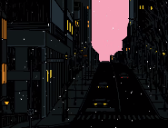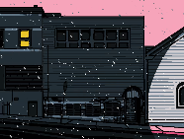Ending

A verity of shots of a town or city are shown until the scene shows a shot that heavily resembles the painting Nighthawks with Henryk and his daughter sitting in the dinner before the credits start to play.

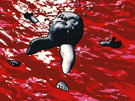Post-Credits Scene

We see a final shot of The Mechanical Saccorhytus lying in the water as seagulls surround him noticeable, he is no longer smiling, and his eyes are closed however his Cerebral Electricity hasn’t vanished as we can see it in his nose making unclear if he is dead or not.

**Analysis**

**Mischief ’s Obligations**

Mischief claims that he was dreading his obligations if Henryk had not awaken but does not specify what he means, I will explain now what I think this means.

I think this refers to his deal with The Ghost, Mischief had promised to help Henryk be happy and bring him to his Grand granddaughter. I believe that Mischief would have ever been focused to fulfil an unspecified condition of the deal that would have not been pleasant for him or that he simply would not have received his reward, presumably The Interface.

**Mischief ’s Star Monolog, Meaning and References**

“When humans first gazed upon the night, did they see stars? A lung, a heart, a hand, an alter in the sky. What is a constellation, but a sum of its parts?”“They didn’t see stars, they saw titans.”

This reflects a common theme of the series that reality is largely based on perception. This line may also provide a parallel to how Cerebral Electricity works.

I believe that there is a double meaning for “Did they see stars? A lung, a heart, a hand, an alter in the sky”

This is a reference in this line which references some of the characters in the series, as shown in episode 18 Lung references to The Wind, Heart references to The Chef, and Hand references to The Ghost.

The stars likely refers to Cerebral Electricity as a whole, this conversation refers to constellations which are largely based on people perception of the sky, similar to Cerebral Electricity Monster who are pure Cerebral Electricity which is being filtered through somebody’s perception of the world, hence their differences in ability and KAMI needing to absorb the Cerebral Electricity of others to gain there powers.

The Alter may refer KAMI as she kills a verity of Cerebral Electricity Monster to gain their powers and alters are commonly associated with the concept of sacrifice.

The telephone starts ringing again as Mischief continues saying “What came first Henryk the baby chicken or the egg? Man, or God? If man came first, they’ll make God. By doing so they become one.”

This still relates to the concept of reality being filtered through perception. Essentially, I believe this question is saying what came first reality or human’s perception of it, though this don’t perfectly map to some of the over lines.

“Every choice we make is a sacrifice. Nothing will stop them. And thus, there never was a choice at all. So, it follows, of your choices is an illusion, so too is your sacrifice.”

This is essentially denying that humans do not have choices or freewill, as we never really have a chose, so we never really decide anything. This is usually based in the hypothesis that a human’s behaver is entirely predictable if you can predict ever verbal involved, whoever this is impossible to test as there is no way to perfectly account for every variable effecting somebody.

“To see through your eyes, the world looks the same to me.” “The mask only fits one way.” “You can look out, but you cannot look in.” “When you gaze up at the night sky, what do you see?”

This is Mischief way of asking KAMI what her perspective of the world is and claiming that she cannot see or understand her own existence.

**The Ghost is dead**

We see that KAMI is impersonating The Ghost in some of the scenes here as well as taking actions we know that The Ghost Never would like threatening Henryk’s Greet-Granddaughter with a knife. This leads me to believe that when a creature is consumed by Greetings Robotics, they are basically dead and only their forms and memories remain to be used as they please regardless of what the person would want.

**Apples**

In this episode we see Henryk raiser an apple obscuring his faces before launching at KAMI, and at a different point we see Mischief transform into an apple to be consumed by The Mechanical Saccorhytus.

I believe that in both scenes the apple is meant to represent desires. In the first scene we could see this as Henryk embracing and understanding his desires, him know speaking to be happy and embraces the progressing world.

In the second scene it would represent Mischief desire to infiltrate the Interfaces which is seemingly the motive for doing what he does through the series, especially in regard to his deal with The Ghost. This could also be because of the desire of The Mechanical Saccorhytusas he is shown as incredible glutens and hungry a simple desire but a desire non the less.

This would correlate to the uses of apples at other points in the series as well most noticeable in The Son of Man where a similar metaphor is used. The son of an is also likely a reference in of itself as this painting is frequently referenced throughout the show.

Additional for Mischief the idea of a poisoned apple is common in media going back to story’s like sleeping beauty, there is also the idea of worms infesting apples which is a common theme in media worms are a form that Mischief commonly takes, so this could mean to imitate this symbolism.

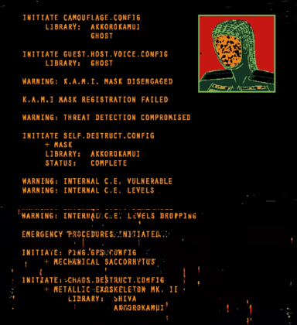**KAMI’s Interface**

In this segment I will go over some of the commands being run in KAMI and what they mean.

Segment 1

INITIATE CAMOUFLAGE.CONFIG LIBRARY: AKKOROKAMUI GHOST, INITIATE GUEST.HOST.VOICE.CONFIG LIBRARY: GHOST

This shows that KAMI is using both The Ghost and The Chefs powers to impersonate Henryk’s Greet-Granddaughter.

Segment 2

WARNING: K.A.M.I. MASK DISENGAGED, K.A.M.I MASK REGISTRATION FAILED

These commands would have been run after Mischief stole KAMI’s mask.

Segment 3

WARNING: THREAT DETECTION COMPROMISED,INITIATE SELF.DESTRUCT.CONFIG + MASK, LIBRARY: AKKOROKAMUI, STATUS: COMPLETE

After KAMI’s mask is stolen, she initiates her self-destruction protocol in a final attempt to kill Mischief.

Segment 4

WARNING: INTERNAL C.E. VULNERABLE WARNING: INTERNAL C.E. LEVELS, WARNING: INTERNAL CLE LEVELS DROPPING

This shows that whatever Mischief was doing to KAMI caused her to loss Cerebral Electricity.

Segment 5

EMERGENCY PROCEDURES INITIATED

INITIATE: PING.'GPS.ONFIG + MECHANICAL SACCORHYTUS

This implies that KAMI was programmed to inform The Mechanical Saccorhytus of her location in the event of her imminent destruction.

Segment 6

INITIATE, CHAOS.DESTRUCT.CONFIG, + METALLIC-EXOSKELETON MK. II, LIBRARY: SHIVA, AKKOROKAMUI

This is the final command that was needed to activate herself destruct implying that KAMI was using both her power and the power of The Chef to do so.

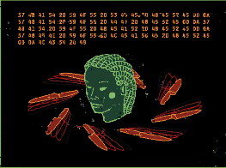**Hex Code**

The last scene in which we see KAMI’s interface we get final during of hex code displayed below.

What You See Here

What You Do Here

What You Hear Here

When You Leave Here

Let It Stay Here

死

This was a pome associated with the aftermath of the Manhattan project where it was posted as a warning to visitors.

The poem is also commonly used by sobriety groups as a call for privacy and the protection of anonymity. This likely doesn’t correlate but given that KAMI is made of other people’s memories there a chance this is meant to represent their memories being destroyed, this is not likely but possible.

死 essentially translates to death in Japanese, a more literal translation being “Shi”.

**The Oni’s Creation**

It is not clear what Mischief was doing to KAMI before her destruction, but it is likely that it led to the creation of The Oni the creature we see in the new short called the condemnation.

From what we see in the series Cerebral Electricity Monsters are created when a creature is turned into pure Cerebral Electrically and dies before being able to return to normal, given that KAMI is made of near pure Cerebral Electricity and she dose die in this episode it is possible she was reborn as a Cerebral Electricity Monsters, which would explain The Oni’s similarities to KAMI.

Additionally, The Oni may have been an early captured Cerebral Electricity Monsters that was used for the creation of KAMI which would explain where the SHIVA liberty came from, there is no evidence for this in the episode but it is the only over explanation for their similarities to KAMI so it’s worth noting.

**The Mechanical Saccorhytus Is in Safe mode**

The sister series to Interfaces, Safe Mode takes places during the last few minutes of Interface as Mischief infects the Interface via The Mechanical Saccorhytus. Safe Mode clearly establishes that The Interfaces spend so time in safe mode before ever removing Mischief or succumbing and being destroyed. However, given what we have seen in the post credit-scene it is not clear if Mischief will succeed in consuming the interfaces aka all the perish. (accurate as of 18/07/24)

This could imply that Greetings Robotics and even Mr Greetings could return in a very depressing ending to the series though from what we have seen of safe mode so far this is not likely.

**Artwork**

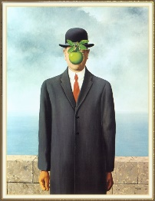 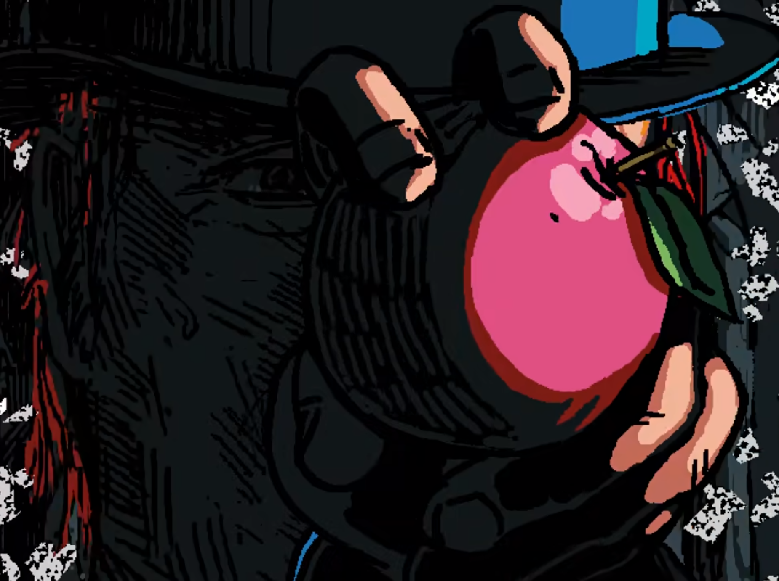

**The Son of Man**

Meny of René Magritte’s paintings include a theme of reality being filtered through the eye of the perceiver which is also true in The Son of Man.

This heavily correlated with the main theme of Mischifes monologue which implies that choice is an illusion based in the perception of the individual. more specifically their lack of an ability for people to understand what drives them.

This is shown in the painting The Son of Man as the apple blocking his faces and the same is true for this episode of interfaces with Mischief blocking Henryk’s view.

This also relates to the episode The Son of Man as this theme is directly discussed there, though more from the perspective of Mischief not understanding Henryks desires.

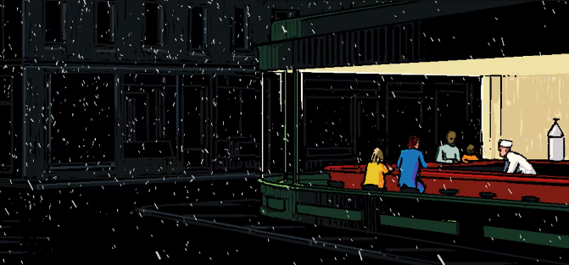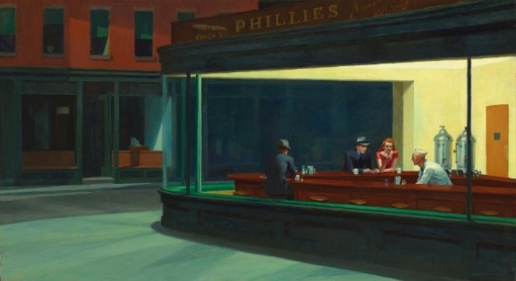

**Nighthawks**

This was a painting made in 1942 by Edward Hopper, it was intended to be a portrayal of an American city in 1942 but the writer admitted that they accidentally captured the loneliness of modern cities.

I believe this painting is meant to represent Henryk embracing the modern world with his granddaughter.

At first this scene may seem depressing but in ever version there is no actual cause for loneliness the characters are surrounded by people and in the show, we see Henryk is with his daughter.

Compering the dark and cold outside to the light and presumably warm interior of the dinner could imply that Henryk is literally turning his back to the dark parts of his life.

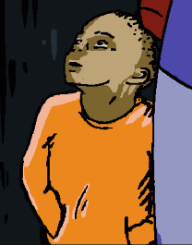Well, this is directly confirmed the boy in the background shares a strong resemblance to The Museum Boy, I think this is the case as in the original picture a man and who is probably his girlfriend is shown, which would make this an odd change to be made for no reason.

This could help to support the interpretation that this uses of the painting is more positive than it may first appear as there is a chance for new relationships here practically with Henryk’s Greet-Granddaughter who seems about the same age as The Museum Boy.

**References**

The son of man

Nighthawks

Henryk

Mischief

KAMI

Mr Greetings

The Mechanical Saccorhytus

The Oni

The Museum Boy

Cerebral Electricity

Greetings Robotics

Henryk’s family

Noticeable location

The Interfaces

The Credits of Interface

**Sources**

Interface

https://www.youtube.com/watch?v=EHqsCmfTDmI&list=PLPnjato8iGXLQbppBPhOny8XLSRl7S5pM&index=1

Secondary source of information on interface and formatting ideas for webpages. <https://umami.fandom.com/wiki/Umami_Wiki>

**Livestreaming From a Lighthouse with Henryk**

**Sidebar**

Title: Livestreaming From a Lighthouse with Henryk

Released (DMY): 26/1/2021

Video Type: Short, Livestream

Synopsis: Mischief just checkin' in on ya.

**Article body**

**Description**

This episode takes places at the same time as episode 23 but from Mischief perspective of events as Henryk stands in the lighthouse seemingly tripping balls.

**Summary**

The short opens on a shot of Mischief before he welcomes the live stream and claims that he was everything under control.

Mischief mentions he is hanging out with buddy Henryk before panning over to him. Henryk is seen standing still with cerebral electricity covering his eyes, Mischief claims that Henryk is tripping balls and has probably taken mushrooms.

Mischief remember that The Mechanical Saccorhytus is floating nearby, before the camera pans over to show him.

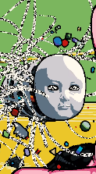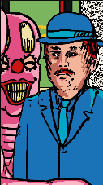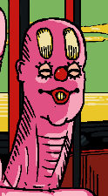Mischief restates that he has everything under control and that he doesn’t need help before closing out the livestream, Mischief is clearly lying about being in control.

**Notes**

It is not clear if Mischief is meant to be contacting a specific character but its most like he is just livestreaming publicly.

This short contains one of three references to the fact theta Henryk doesn’t eat through all of interface.

**References**

Episode 23 An Unconscious Conscience

Mischief

Henryk

The Mechanical Saccorhytus

Notable Locations

**Sources**

Interface

https://www.youtube.com/watch?v=EHqsCmfTDmI&list=PLPnjato8iGXLQbppBPhOny8XLSRl7S5pM&index=1

Secondary source of information on interface and formatting ideas for webpages. <https://umami.fandom.com/wiki/Umami_Wiki>

Livestreaming From a Lighthouse with Henryk

https://www.youtube.com/watch?v=wTjGcdCnaQs&list=PLPnjato8iGXLQbppBPhOny8XLSRl7S5pM&index=23

**Big Smile’s Order**

**Sidebar**

Title: Big Smile’s Order

Released (DMY): 22/3/18

Video Type: Short

more.

**Article body**

**Description**

Mischief orders a modest meal at McDonalds.

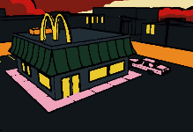**Summary**

Mischief in his car form is seen to pull up to the McDonalds drive through.

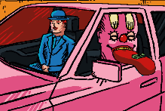Mischief orders Two number 9’s, A number 9 large, A number 6 with extra dip, A number 7, Two number 45’s, one with cheese, and a large soda.

Mischief lets out his oversized tongue with money on it, telling the casher to keep the change.

**Notes**

This short is a joke based on Mischief occasionally being known as big smile which is the seam name as a popular Grand Theft Auto character.

Big smile has a famous line where he makes an absurdly long fast-food order similar to what we see in this video.

This short is implied to take places during the events of the Interface series presumably slightly before the events of Episode 13.

This short contains one of three references to the fact that Henryk doesn’t eat through all of Interface.

**References**

Episode 13 The Right Direction

Mischief

Henryk

**Sources**

Interface

https://www.youtube.com/watch?v=EHqsCmfTDmI&list=PLPnjato8iGXLQbppBPhOny8XLSRl7S5pM&index=1

Secondary source of information on interface and formatting ideas for webpages. <https://umami.fandom.com/wiki/Umami_Wiki>

Big Smile's Order

<https://www.youtube.com/watch?v=CiNvAswZlOI>

**Mischief Is a Bird**

**Sidebar**

Title: Mischief Is a Bird

Released (DMY): 5/1/20

Video Type: Short, Advertisement

**Article body**

**Description**

This short was made to help announces the Mischief bird plush. We see Mischief talk to a dirt dumpster cat and The Hazmatz Spokesperson.

**Summary**

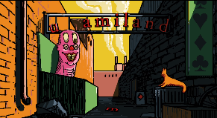The short opens on a shot of an alley way with a dumpster cat in it before Mischief suddenly pops out and tells that cat that he had caught him in the dumpster.

Mischief suddenly realises the creature is a cat and things he knows something that it may want to see.

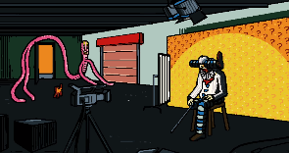The scene charges to show the interior of a tv set with The Hazmatz Spokesperson siting on a stool looking like he is in pain.

The Hazmatz Spokesperson tells Mischief that he has already told him not to bring dumpster animal into the studio and Mischief replies saying that h is the dumpster animal not the cat.

Mischief realises that The Hazmatz Spokesperson is in pain and asks if he is ok, The Hazmatz Spokesperson then claims that he likely has intestinal worms and won’t be able to film the commercial today.

Mischief says that he doubts that The Hazmatz Spokesperson has intestinal worms as he knows a lot about intestinal worms, Mischief then offers to go inside of The Hazmatz Spokesperson to check but is largely ignored by The Hazmatz Spokesperson how hobbles of to go to the hospital.

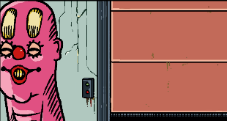Mischief starts talking to the cat again and claims that The Hazmatz Spokesperson hasn’t been the same since he had his leg surgically moved to the side of his head.

Mischief moves on and directed the cat to look inside a garage door.

The promo for the Mischief bird push is played.

**Notes**

This message is in the description. Mischief is an intergalactic clown man who can cosmically shape shift into different objects and living beings. He obtains the instructions of transformation through absorbing cerebral electricity through his large yellow receptacles that protrude from his forehead. In Episode 08 of the Interface web-series, Mischief flies into a hospital window to disrupt Henryk's snooze. He promptly announces that he "is trying to be a bird". Well, today, I can safely say that he is officially a bird.

This is something I've been working on for since the beginning of the year. These plushies are special, and must be pre-ordered so they can offset the cost of being made. Once they sell out (if they do), they may not be available again. So, if you're interested, the orders must be made starting today and ending on the 19th! Shortly after, they will begin the production cycle, and then be sent to your doorstep. They will arrive before Christmas, so that also makes them great gift ideas. I sincerely thank you for watching and sharing my animations!

The Mischief bird plushies are now sold out.

**References**

Episode 8 The Watchful Eyes

The Hazmatz Spokesperson

Mischief

**Sources**

Interface

https://www.youtube.com/watch?v=EHqsCmfTDmI&list=PLPnjato8iGXLQbppBPhOny8XLSRl7S5pM&index=1

Secondary source of information on interface and formatting ideas for webpages. <https://umami.fandom.com/wiki/Umami_Wiki>

Mischief is a Bird

https://www.youtube.com/watch?v=Nose23-XN6M&t=194s

**Mischief Is** **Feelin’ Fresh**

**Sidebar**

Title: Mischief Is Feelin’ Fresh

Released (DMY): 17/7/22

Video Type: Short, Advertisement

**Article body**

**Description**

This video was an advert released to help advertise the Mischief frog plush, we see Mischief hanging out by a river before he asks himself a question, what if I was full of beans.

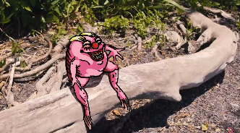**Summary**

Mischief is seen going in his frog from alongside a river before going for a swim and then spends some time hoping between rocks.

Mischief starts talking and says that he is Moisturized, well-hydrated, Fellin’ Fresh.

Mischief then questions what it would be like if he has full of beans before transforming into a marketable plushie.

An ordering pamphlet is shown while Chimney Alfonzo complains about not beaning able to have read the script because of Gulab Jamun keeping him awake all night.

**Notes**

The frog plushie is now out of stock.

**References**

Mischief

**Sources**

Interface

https://www.youtube.com/watch?v=EHqsCmfTDmI&list=PLPnjato8iGXLQbppBPhOny8XLSRl7S5pM&index=1

Secondary source of information on interface and formatting ideas for webpages. <https://umami.fandom.com/wiki/Umami_Wiki>

Mischief is Feelin’ Fresh

https://www.youtube.com/watch?v=VAHGa2REBgU

**Open Wide Up**

**Sidebar**

Title: Open Wide Up

Released (DMY): 27/11/18

Video Type: Short, Adult Swim Commercial

Synopsis: Big Smile goes to the dentist.

**Article body**

**Description**

Mischief goes to the dentist and then becomes the dentist.

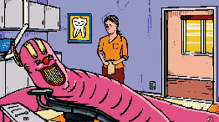**Summary**

Mischief slivers into the dentist’s offices before lying on a chair.

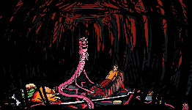The dentists’ beings to tap Mischief teeth like a musical instrument before Mischief warns her he’s not one to be played with. This causes the dentist to panic and drop her tool in Mischief mouth.

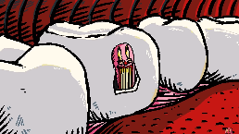Mischief tells the dentist to get the tool out before swallowing her.

The scene changes to show the inside of Mischief with the woman lying down.

Mischief claims to be a dentist know and begins to check her moth shrinking down to examine her teeth and finding that a tooth has a cavity.

**Notes**

This video provides a great example of Mischiefs personality he’s odd and almost threatening but never actually harms anybody even finding a cavity in the lady’s tooth.

This video was originally released as an Adult Swim Commercial

**References**

Mischief

**Sources**

Interface

https://www.youtube.com/watch?v=EHqsCmfTDmI&list=PLPnjato8iGXLQbppBPhOny8XLSRl7S5pM&index=1

Secondary source of information on interface and formatting ideas for webpages. <https://umami.fandom.com/wiki/Umami_Wiki>

Open Wide Up

https://www.youtube.com/watch?v=hNz45i5uwt4

**Strangers Danger**

**Sidebar**

Title: Strangers Danger

Released (DMY): 1/11/18

Video Type: Short, Adult Swim Commercial

**Article body**

**Description**

Mischief is sitting in a storm drain and meats a potentially dangerous stranger, who he makes the mistake of talking to, reviling that this seemingly innocent and kind young boy is actually an anti-vaccer.

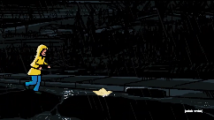**Summary**

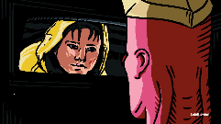The short opens on a shot of a rainy night with a young boy in a yellow raincoat chasing a paper boat before it floats into a storm drain.

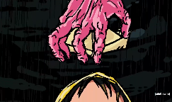Mischief is then seen to pop up with the paper boat on his head like a hat Mischief claims that he shouldn’t be talking to strangers before warning the by about the dangers of the cut on his faces.

The by asks for his paper boat back and Mischief returns it to him before warning him to check that he’s got his tetanus shot and clams that vaccines do not causes autism.

Mischief then says that we don’t wasn’t another epidemic on there hands as the boy runs away.

**Notes**

This episode shows that Mischief dose not believe that vaccines cause autism.

**References**

Mischief

**Sources**

Interface

https://www.youtube.com/watch?v=EHqsCmfTDmI&list=PLPnjato8iGXLQbppBPhOny8XLSRl7S5pM&index=1

Secondary source of information on interface and formatting ideas for webpages. <https://umami.fandom.com/wiki/Umami_Wiki>

Stranger Danger

<https://www.youtube.com/watch?v=A45sfguuzQw>

**A Christmas Stalking**

**Sidebar**

Title: A Christmas Stalking

Released (DMY): 24/12/19

Video Type: Short, Adult Swim Commercial

Synopsis: Mischief is the perfect shape to fit down your fireplace, so you might want to be prepared with snacks.

**Article body**

**Description**

Mischief is feeling the Christmas spirit and decides to become Santa. Unfortunately, he ends up not being particularly good at it and traumatizes a family.

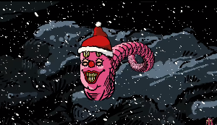**Summary**

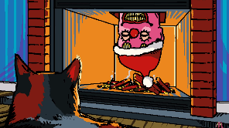Mischief is seen flying around celebrating the Christmas season before flying down a lite chimney catching fire to his hat.

Mischief begins to freak out accidently setting fire to most of the room.

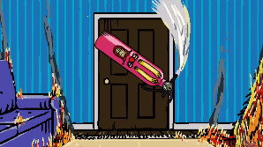Mischief then transforms into a fire extinguisher and puts out most of the fire.

A family is seen outside the door clearly terrified.

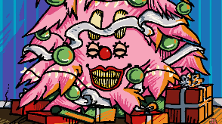Mischief then transforms into a Christmas tree before criticizing the family for not have left out milk and cookies.

**Notes**

This video was released Christmas eve of 2018.

**References**

Mischief

**Sources**

Interface

The full official release of the series.

<https://www.youtube.com/watch?v=EHqsCmfTDmI&list=PLPnjato8iGXLQbppBPhOny8XLSRl7S5pM&index=1>

fandom wiki

Secondary source of information on interface and formatting ideas for webpages. <https://umami.fandom.com/wiki/Umami_Wiki>

A Christmas Stalking

This is the short the article is about.

<https://www.youtube.com/watch?v=FVkYmzHO-9U>

**A Striking Ball**

**Sidebar**

Title: A Striking Ball

Released (DMY): 28/2/19

Video Type: Short, Adult Swim Commercial

Synopsis: You might want to think twice about touching these balls.

**Article body**

**Description**

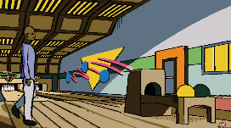Mischief helps a bold man get a strike in exchange for a thorough polishing.

**Summary**

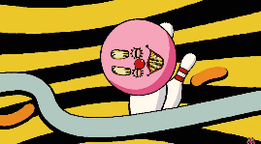The episode opens on a shot of a man bowling before Mischief appears as a ball.

Mischief claims to be magical and offers the man one guaranteed strike if he polishes Mischief.

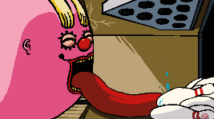The man polish Mischief causing his facial expressions to be rearranged.

Mischief is thrown down the lane before becoming too large to fit in the pin craves. Mischief then lets his tongue don knocking over all the pins.

**References**

Mischief

**Sources**

Interface

https://www.youtube.com/watch?v=EHqsCmfTDmI&list=PLPnjato8iGXLQbppBPhOny8XLSRl7S5pM&index=1

Secondary source of information on interface and formatting ideas for webpages. <https://umami.fandom.com/wiki/Umami_Wiki>

A Striking Ball

<https://www.youtube.com/watch?v=FdmkApuUfu8>

**The Star of All Flames**

**Sidebar**

Title: The Star of All Flames

Released (DMY): 8/4/24

Video Type: Short

**Article body**

**Description**

**Important note: this video may cause seizures for people with photosensitive epilepsy.**

This video contains a poem about the 2024 American eclipse.

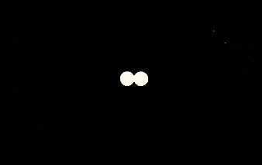**Summary**

Two orbs are seen to collide.

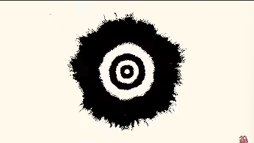A pulsing black and white spiral is shown.

A shot with the full poem a sunflower and a sun icon is shown.

“The Star of All Flames, its luminance flourishes unto my mortal frame,”

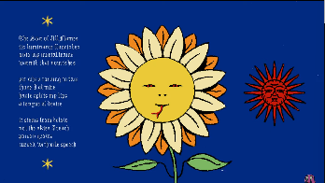A naked man is seen floating in a void.

“Warmth that nourishes,”

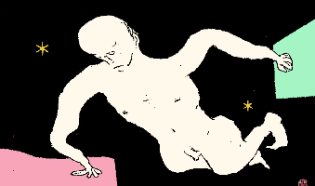a close up of a pink man closing his eyes is shown.

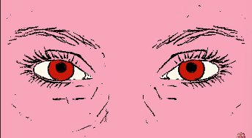“Yet when turning to face those I admire haste splits my lips,”

we return to the shot withthe full poem a sunflower and a un icon is shown.

“a tongue of desire it stems from below not the skies I reach,”

we return to the shot of the pulsing black and white lights.

“Poison grows, cursed, with vile speech.”

the orbs separate.

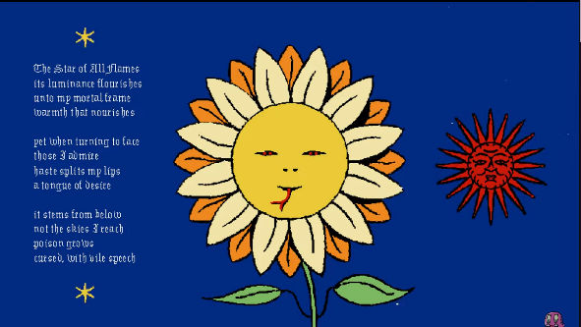**Complete Poem**

The Star of All Flames, its luminance flourishes, unto my mortal frame, warmth that nourishes

yet when turning to face, those I admire, haste splits my lips, a tongue of desire

it stems from below, not the skies I reach, poison grows, cursed, with vile speech.

**Notes**

I believe that this video is meant to be canon to interface as we frequently see what appears to be cerebral electricity in the video as well as sunflower image which are both important to interfaces.

The most common interpretation of this poem is that it is making fun of people looking into the sun during the eclipse and hurting themselves.

**References**

Cerebral electricity

**Sources**

Interface

https://www.youtube.com/watch?v=EHqsCmfTDmI&list=PLPnjato8iGXLQbppBPhOny8XLSRl7S5pM&index=1

Secondary source of information on interface and formatting ideas for webpages. <https://umami.fandom.com/wiki/Umami_Wiki>

The Star of All Flames

<https://www.youtube.com/watch?v=02ew-XwS1-M>

**The Condemnation**

**Sidebar**

Title: The Condemnation

Released (DMY): 28/3/24

Video Type: Short

**Article body**

**Description**

Mischief reads out a poem as The Mysteries Oni is revealed.

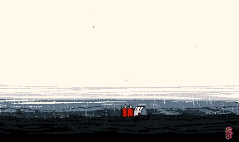**Summary**

The short opens on a wide shot of a farm in the rain, noticeable the skies are grey.

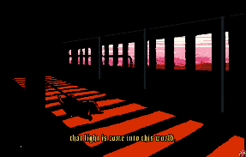We hear a voice that sounds like Mischief say, “This is the condemnation,”

We see an interior shot of a body crawling across the floor. Through The Windows we can see the sky is red and it is raining.

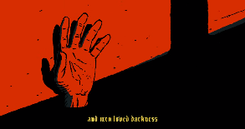Mischief continues “that light is come into this world,”

We see a shot of a hand getting dragged across the wall.

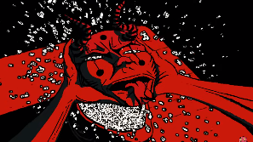Mischief concludes “and men loved darkness rather than light, because there deeds were evil.”

We see a man in an Oni mask, lift up his mask reviling pure cerebral electricity.

The video suddenly ends.

**Analysis**

Note: Given that there’s less than one minute of screen time for The Oni there’s a very good chances any analysis is going to be wrong.

**Two Storms Theory**

In the opening shot we see a wide view of the farm and can clearly see that the sky is grey which would usually imply that the scene is taking places at some point before 1943 when the Philadelphia experiment acquired.

In all the rest of the scenes however it is clear that the sky is a dark red which seams normal for the post 1943 world.

This makes it seem to me that this video may show two different storms happening at the same places but at different times. This would explain why the farm looks well maintained in the opening shot but is clearly dilapidated in the other scenes.

It is not clear why this would be important to show the farm at two different points but given that this video seems to be an extract of a large screen, this likely just means that we haven’t seen why it is important yet.

**Who is The Oni**

The Oni appears to have a connection to KAMI, I believe that The Oni is meant to be a transformed version of KAMI after her self-destruction ion episode 24 The abyss.

The Oni is an incredibly unique creature even within the interface’s universe. As form what we can tell The Oni is the result of KAMI transforming into a Cerebral Electricity Monster, KAMI being a robot containing a large amount of cerebral electricity presumably from humans.

Given that cerebral electricity monsters seem to have forms heavily based on their memory’s and perspectives on the world this would likely lead to The Oni being incurably unique as they are a composite of many people cerebral electricity that was being contained by KAMI.

**Notes**

This message is in the description   
Animations are going to be probably more atmospheric and simple going forward. Maybe a return to what this channel was initially supposed to be. Just elaborate shit posts and or visual poems. I’ve been more interested in producing music than animating these days and I never intended to become an animator. It’s splitting my psyche in two directions. That being said, I’m still working on Safe Mode, with a few other longer animation projects on the way.

**References**

**KAMI**

**The Oni**

**Mischief**

**Sources**

Interface

https://www.youtube.com/watch?v=EHqsCmfTDmI&list=PLPnjato8iGXLQbppBPhOny8XLSRl7S5pM&index=1

Secondary source of information on interface and formatting ideas for webpages. <https://umami.fandom.com/wiki/Umami_Wiki>

The Condemnation

https://www.youtube.com/watch?v=DrBYWoTkT7M&list=PLX2OAQ7nlxWz_ZxiSj1choNzHPd4z6YrY&index=10

Artwork Articles

Page 90-126

Scroll down for content

**The Creation of Adam**

**Sidebar**

Title: The Creation of Adam

Made by: Michelangelo

Year Made: 1512

Type: Painting

**Article body**

 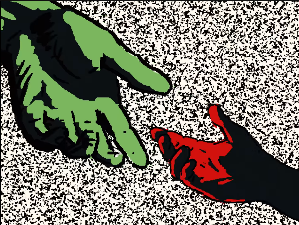

**Description Of the Work**

This painting shows God reaching down to Adam to bestow the gift of knowledge on him.

God is shown in the sky surrounded by angels in a pose which resembles a brain, while Adam is lying on the ground naked.

The figures are shown to be touching their hands together.

**Original Meaning of The Work**

There has been much discussion on the meaning of this painting and what is presented in it. I will go over what I believe the most relevant meanings are here.

The most common interpretation is this depicts go bestowing man with intelligence, God is depicted in a shape resembling a brain and Adam is depicted as naked and primal with a noticeable vacuous look on his faces.

Another interpretation is that this is meant to depict the creation of Eve, Adam is noticeable shown to have an extra rib commonly referred to as Eve’s rib. Additional God is shown with many figures around him including a woman who is staring at an Adam, who is suspected to be Eve.

**Analysis of Uses in The Show**

Episode 4 The Ghost.

In this episode after KAMI is seen to destroys the wall of the building, The Ghost is seen floating away as Henryk’s Greet-Granddaughter tries to reach out to her but fails. I believe this scene is meant to be a reference to The Creation of Adam.

The hands depicted in the scene are likely meant to be a reference to the painting however I am not aware of any deeper meaning to the paintings uses here. It is entirely possible that there is a deeper meaning to this I have missed due to the meany interpretations of the painting, but I have not seen any that seem to match its use in the show.

**References**

Episode 4 The Ghost

KAMI

The Ghost

Henryk’s Greet-Granddaughter

Michelangelo

**Sources**

Interface

https://www.youtube.com/watch?v=EHqsCmfTDmI&list=PLPnjato8iGXLQbppBPhOny8XLSRl7S5pM&index=1

Secondary source of information on interface and formatting ideas for webpages. https://umami.fandom.com/wiki/Umami_Wiki

The Creation of Adam

<https://en.wikipedia.org/wiki/The_Creation_of_Adam>

Michelangelo

<https://en.wikipedia.org/wiki/Michelangelo>

**The Son of Man**

**Sidebar**

Title: The Son of Man

Made by: René Magritte

Year Made: 1964

Type: Painting

**Article body**

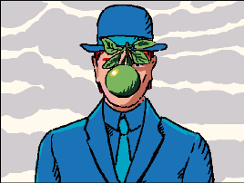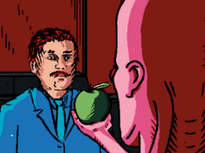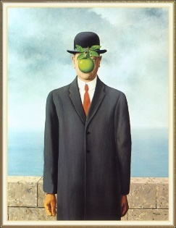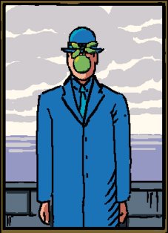

**Description Of the Work**

A bland man in a bluish grey suit is seen standing beside a wall with clouds behind him.

An apple is seen obscuring the details of his face.

**Original Meaning of The Work**

The original meaning of this work is meant to show the treachery of images, this is the most common theme in René’s paintings. The treachery of images is an idea that describes how images deceive the viewer into believing that they are seeing the real thing, but the paintings only actually depict a version of their subject often if not always inaccurately.

One interpretation of this painting that I fell is highly relevant to the show is that this painting represents the viewers desires to see the hidden meanings in artworks as depicted by the apple. If the figures faces were not obscured, we would have no interest in his face but because it is obscured, we desire to learn more about it.

This is a quote from RM talking about the painting “Everything we see hides another thing, we always want to see what is hidden by what we see. There is an interest in that which is hidden and which the visible does not show us. This interest can take the form of a quite intense feeling, a sort of conflict, one might say, between the visible that is hidden and the visible that is present.”

**Analysis of Uses in The Show**

General Use in The Show

This painting is very commonly referenced in the show, most commonly the man or apples are referenced which I will discuss below.

Apples

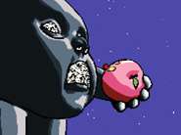I believe that apples in the sires represent the desires of the characters, one of the interpretations of the original paintings is about how it represents the views desires to understand the hidden truths of the paintings, more specifically the details of the man’s faces obscured by the apple.

Some further proof of this is in episode 5 The Son of Man where Mischief directly discuses desires compering it too The Son of Man.

The Son of Man

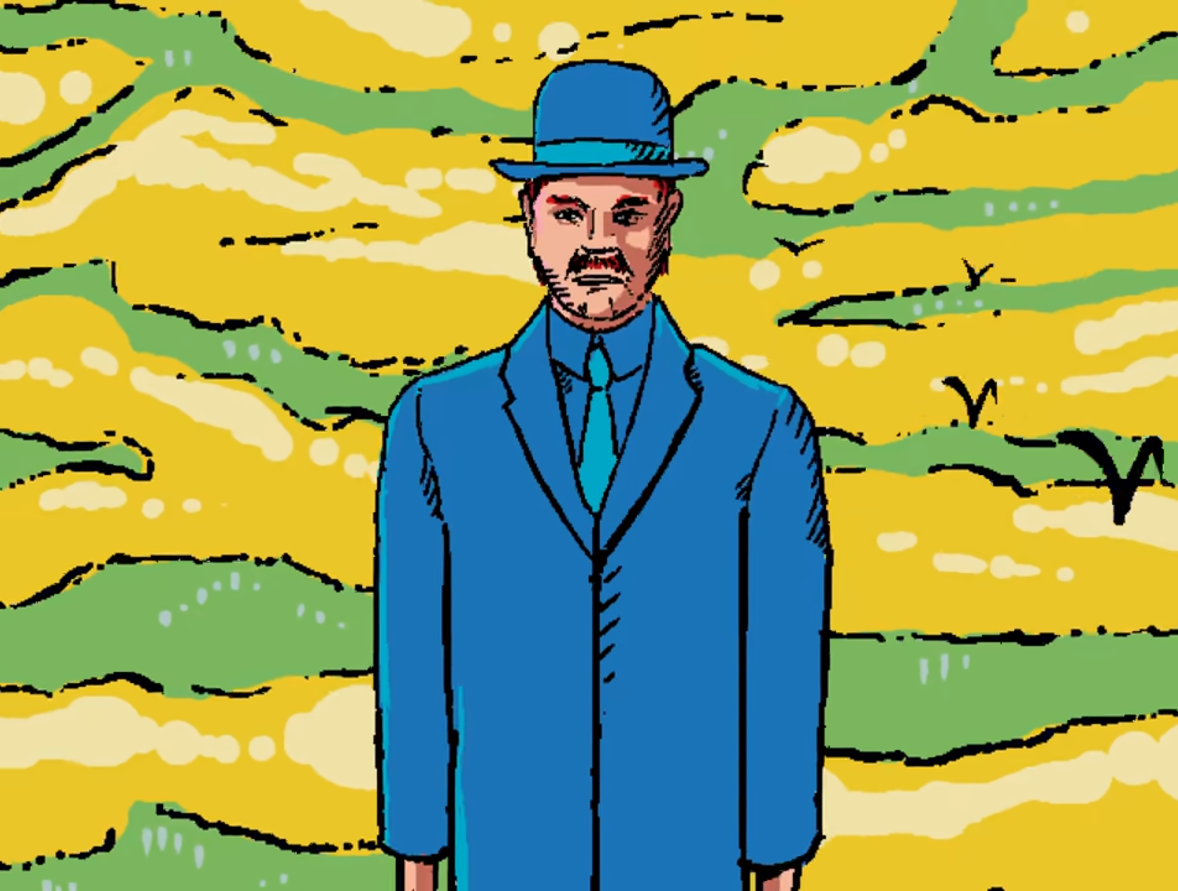

Henryk is clearly meant to represent The Son of Man in the show.

I believe there is a correlation between the apparent boringness of the original Son of Man with Henryk also seeming boring at first glance. In both cases it is not the appearance of the man that is meant to be interesting but the hidden details that are only hinted at in the original work. This could be supported by the chose to make Henryk a silent protagonist which makes him much more mysterious.

In short Henryk being represented by the son of man is a metaphor representing that Henryk is a lot more important and interesting than he first appears.

Episode 5 The Son of Man

The Son of Man is the focus of this episode and is likely being used as a metaphor for Mischief not being able to understand what Henryk wants and Henryk not being able to understand modern the world they are in as he is stuck in the past rejecting the world as it is especially after the trauma of losing his family.

I believe that this is supported by the quote in the description (“Everything we see hides another thing, we always want to see what is hidden by what we see. There is an interest in that which is hidden and which the visible does not show us. This interest can take the form of a quite intense feeling, a sort of conflict, one might say, between the visible that is hidden and the visible that is present.”)

Episode 11 Revelations

Mischief offers an apple to Henryk saying that the only thing that can be known for certain is that the truth will set him free. Henryk can be heard eating the apple before the scene changes. Before a scene is shown that depicts the painting The Son of Man.

This is likely meant to represent Henryk understand his desire to seek out his Great-Granddaughter and embracing that as his new goal.

Episode 24 The Abyss

Meny of René Magritte’s paintings include a theme of reality being filtered through the eye of the perceiver which is also true in The Son of Man.

This heavily correlated with the main theme of Mischifes monologue which implies that choice is an illusion based in the perception of the individual. more specifically their lack of an ability for people to understand what drives them.

This is shown in the painting The Son of Man as the apple blocking his faces and the same is true for this episode of interfaces with Mischief blocking Henryk’s view.

This also relates to the episode The Son of Man as this theme is directly discussed there, though more from the perspective of Mischief not understanding Henryks desires.

Apples In episode 24 The Abyss

Apples are more represent in Episode 24 than the Painting The Son of Man so I will be going over that separately here.

In this episode we see Henryk raiser an apple obscuring his faces before launching at KAMI, and at a different point we see Mischief transform into an apple to be consumed by The Mechanical Saccorhytus.

I believe that in both scenes the apple is meant to represent desires. In the first scene we could see this as Henryk embracing and understanding his desires, him know speaking to be happy and embraces the progressing world.

In the second scene it would represent Mischief desire to infiltrate the Interfaces which is seemingly the motive for doing what he does through the series, especially in regard to his deal with The Ghost. This could also be because of the desire of The Mechanical Saccorhytusas he is shown as incredible glutens and hungry a simple desire but a desire non the less.

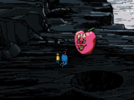Additional for Mischief the idea of a poisoned apple is common in media going back to story’s like sleeping beauty, there is also the idea of worms infesting apples which is a common theme in media worms are a form that Mischief commonly takes, so this could mean to imitate this symbolism.

**References**

**Henryk**

**Mischief**

Episode 5 The Son of Man

Episode 11 Revelations

Episode 24 The Abyss

The Mechanical Saccorhytus

René Magritte

**Sources**

Interface

https://www.youtube.com/watch?v=EHqsCmfTDmI&list=PLPnjato8iGXLQbppBPhOny8XLSRl7S5pM&index=1

Secondary source of information on interface and formatting ideas for webpages. <https://umami.fandom.com/wiki/Umami_Wiki>

The Son of Man

<https://en.wikipedia.org/wiki/The_Son_of_Man>

The Son of Man Video

<https://www.youtube.com/watch?v=4iWgiUkSw_A&t=1s>

René Magritte

<https://en.wikipedia.org/wiki/Ren%C3%A9_Magritte>

**The Eye**

**Sidebar**

Title: The Eye

Made by: David Altmejd

Year Made: 2011

Type: Statue

Location: Montreal

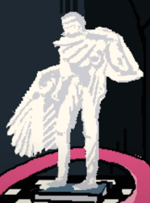**Article body**

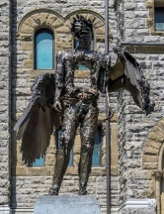

**Description Of the Work**

This statue seemingly represents an angel, but their forms is twisted having a hole in their chest as well as a wrapping around there faces.

**Original Meaning of The Work**

From what I have read it seems this painting may be externalist but none of the sources I found make it practically clear what the painting represents and how.

I bilevel that the existential interpretation for this painting may come from the twisted appearance of the angle depicted in the Work, most noticeable having a giant hole in its chest.

**Analysis of Uses in The Show**

Episode 5 The Son of Man

There is no description for the statue given in the description other than that the statue is made of bronze, additionally the statue is not focused on in the episode over than when Mischief is wrapped around it, It is for these reasons I believe that this statue was only meant to be set dressing for this episode.

**References**

Episode 5 The Son of Man

Mischief

The Museum Boy

**Sources**

Interface

https://www.youtube.com/watch?v=EHqsCmfTDmI&list=PLPnjato8iGXLQbppBPhOny8XLSRl7S5pM&index=1

Secondary source of information on interface and formatting ideas for webpages. https://umami.fandom.com/wiki/Umami_Wiki

The Eye

<https://artpublicmontreal.ca/en/oeuvre/the-eye/>

David Altmejd

https://en.wikipedia.org/wiki/David_Altmejd

**Geopoliticus Child Watching the Birth of The New Man**

**Sidebar**

Title: Geopoliticus Child Watching the Birth of The New Man

Made by: Salvador Dali

Year Made: 1943

Type: Painting

**Article body**

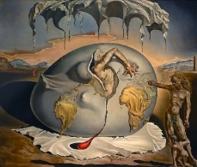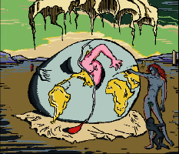

**Description Of the Work**

The painting focuses on an egg hatching in the centre.

the egg is clearly representing the world with countries being shown in yoke.

A man is seen hatching from the egg as other men look and point at the egg.

In the fair background other children are seen playing.

The is a cloth surrounding the egg, likely representing the placenta.

**Original Meaning of The Work**

The traditional interpretation of the painting is usually that the Geopolitical child represents the world as it was, and The New Man represents the future and the next generation.

Note this painting was made in 1943 so the next generation would be arguable in the past or present, however the painting could be interpreted as applying to the future depending on how it is used.

**Analysis of Uses in The Show**

Episode 6 Bear Witness

This is compered to both Mischief and Henryk.

For Mischief it is clearly implied that he is The New Man the painting is actually altered to have The New Man be pink like Mischief, Mischief also compares himself to the painting and how when he was reborn, he had changed the world. This encourages the metaphor that Mischief and Cerebral Electricity represent progress and the next generation.

For Henryk it is less clear, but my interpretation is that Henryk represents The Geopolitical Child watching the birth of The New Man. Henryks immortality has lead him to watch the world moving on and transforming around him but not being able to fully change to go along with the times, this is also supported by Henryk’s career being a photographer somebody who’s job is to watch the world and record it.

**References**

Episode 6 Bear Witness

Mischief

Henryk

Salvador Dali

**Sources**

Interface

https://www.youtube.com/watch?v=EHqsCmfTDmI&list=PLPnjato8iGXLQbppBPhOny8XLSRl7S5pM&index=1

Secondary source of information on interface and formatting ideas for webpages. https://umami.fandom.com/wiki/Umami_Wiki

Geopoliticus Child Watching the Birth of The New Man

<https://en.wikipedia.org/wiki/Geopoliticus_Child_Watching_the_Birth_of_the_New_Man#:~:text=The%20man%20emerging%20from%20egg,Europe%20to%20support%20his%20emergence>.

Salvador Dali

https://en.wikipedia.org/wiki/Salvador_Dal%C3%AD

**The Goddess of Library**

**Sidebar**

Title: The Goddess of Liberty

Made by: George William Hill

Year Made: 1919

Type: Statue

Location: Montreal

**Article body**

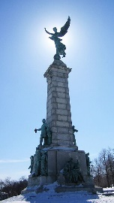 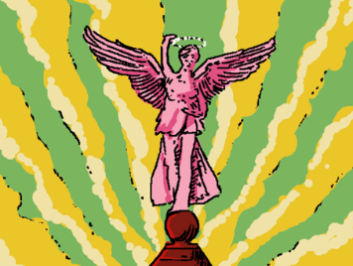

**Description Of the Work**

The main part of the statue is the large angel at the top representing The Goddess of Liberty.

There are several smaller statues surrounding the main statue.

**Original Meaning of The Work**

The main part of the statue is the large angle at the top representing the Goddess of liberty. This part of the statue clearly representing liberty.

There are several smaller statues and from what I have research the statues primarily meaning is to support the importance’s of justice, liberty, and education,

This is an important Montreal landmark.

**Analysis of Uses in The Show**

Episode 8 The Watchful Eyes

This statue is briefly shown with no text in the description for it and no focuses put on it in the episode, these are the main reason that I think that the statue has no greater meaning to the episode and is a form of set dressing as it is located in Montreal.

**References**

Episode 8 The Watchful Eyes

George William Hill

Montreal

**Sources**

Interface

https://www.youtube.com/watch?v=EHqsCmfTDmI&list=PLPnjato8iGXLQbppBPhOny8XLSRl7S5pM&index=1

Secondary source of information on interface and formatting ideas for webpages. https://umami.fandom.com/wiki/Umami_Wiki

The Goddess of Liberty

<https://en.wikipedia.org/wiki/George-%C3%89tienne_Cartier_Monument>

George William Hill

https://en.wikipedia.org/wiki/George_William_Hill_(sculptor)

**Christina's World**

**Sidebar**

Title: Christina's World

Made by: Andrew Wyeth

Year Made: 1948

Type: Painting

**Article body**

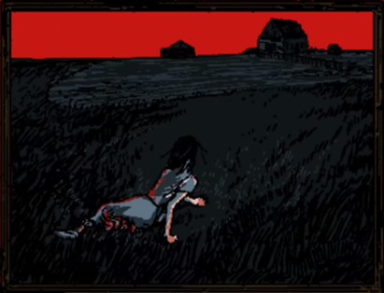

**Description Of the Work**

This painting depicts a woman crawling through a wheat filed towards a house in the far distances.

Two houses are seen in the far distances with the blue sky behind them.

**Original Meaning of The Work**

This painting displays the neighbour of the painter Christina crawling through a filed. This is because she has a degenerative muscle disease that prevented her from being able to walk. She chose not to uses a wheelchair and preferred to craw everywhere inspiring the painting.

Well at faces value this painting comes off as sad knowing that she chooses not to use a wheelchair recontextualise it to more of a picture of defiance, with Christina choosing to do things the way she prefers instead of how others may expect her to.

**Analysis of Uses in The Show**

Episode 10 An Illusion of Time

This episode vaguely references Christena’s World. As shown in episode 11, episode 10 seemingly takes place in the house shown in the far background of the painting but this is more likely meant to show how Henryk is reminded of his home by the painting.

Episode 11 Revelation

In my opinion this painting has two different interpretations by the characters Mischief and Henryk in this episode,

Henryk seams to take the painting at face value as a futile and meaningless struggle this likely being influenced by his depression and memories of his family which this painting seams to remined him off.

Mischief however seemingly understands the original context of the painting that being a woman choosing to live her life her way no matter what offers think. Mischief actually directly compares himself to the Christina when talk about how he can change colours but choses to be this way.

It is worth noting that Mischief is definitely telling the truth about being able to change colours as we see him do this in multiple episodes like in the sun of man where he turns into a sunflower, however this is not common for him.

**References**

Episode 10 An Illusion of Time

Episode 11 Revelation

Mischief

Henryk

**Sources**

Interface

https://www.youtube.com/watch?v=EHqsCmfTDmI&list=PLPnjato8iGXLQbppBPhOny8XLSRl7S5pM&index=1

Secondary source of information on interface and formatting ideas for webpages. https://umami.fandom.com/wiki/Umami_Wiki

Christina's World

<https://en.wikipedia.org/wiki/Christina%27s_World>

Andrew Wyeth

https://en.wikipedia.org/wiki/Andrew_Wyeth

**Stanczyk**

**Sidebar**

Title: Stanczyk

Made by: Jan Alojzy Matejko

Year Made: 1862

Type: Painting

**Article body**

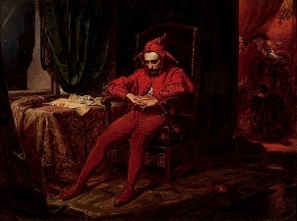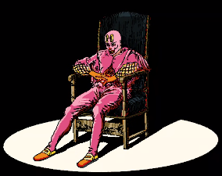

**Description Of the Work**

This painting depicts a depressed looking Jester sitting in a chair after having read the letter on the table.

There is a party that is being held on the right through the door.

**Original Meaning of The Work**

The most common interpretation of the original painting is the jester is morning the loss of a city that had just been lost to their enemy, this loss possible leading to the doom of the nation. It is important to notice that in the background there is a party clear being held showing that ironically the only person taking the loss of the city seriously is the juster.

The full title of the painting is Stańczyk during a ball at the court of Queen Bona in the face of the loss of Smolensk.

**Analysis of Uses in The Show**

Episode 14 Dreamland

I believe that there is a significant chance that this painting is just used for the inspiration of the outfit and pose.

That being said I do have one interpretation of the painting based on the original meaning of the painting; Mischief may be morning the loss of his humanity. The original painting clearly shows the clown distraught at the loss of the city to their enemy which raise the question what would Mischief morning? The easiest answer is that he is morning the loss of his humanity, this episode is about Mischief ether dreaming or remembering his time as a human, so it makes sense that if he is sad about this, he may be mentally correlating himself with the painting.

This would not be the only time that we see a painting used to convey meaning without having to say something aloud so it would not be odd for this to be how the painting is used to show how Mischief feels.

**References**

Episode 14 Dreamland

Mischief

**Sources**

Interface

https://www.youtube.com/watch?v=EHqsCmfTDmI&list=PLPnjato8iGXLQbppBPhOny8XLSRl7S5pM&index=1

Secondary source of information on interface and formatting ideas for webpages. https://umami.fandom.com/wiki/Umami_Wiki

Jan Alojzy Matejko

<https://en.wikipedia.org/wiki/Jan_Matejko>

Stańczyk

https://en.wikipedia.org/wiki/Sta%C5%84czyk_(painting)

**Horse And Train**

**Sidebar**

Title: Horse And Train

Made by: David Alexander Colville

Year Made: 1954

Type: Painting

**Article body**

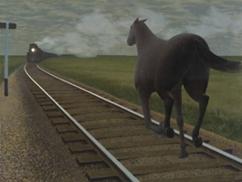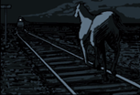

**Description Of the Work**

The focus of the painting is the dark horses galloping on the train tracks.

In the distance you can see a train approaching the horse.

The painting seams set in a grazing filed with a track running through it.

**Original Meaning of The Work**

This painting is inspired by a poem by Roy Campbell “I scorn the goose-step of their massed attack  
And fight with my guitar slung on my back, against a regiment I oppose a brain and a dark horse against an armoured train.”.

The main feature of this painting is the juxtaposition of the horse and the armoured train with the train clearly outmatching the horses in every way, representing the future and the horse representing the past.

**Analysis of Uses in The Show**

**Episode 16 When Skies Were Still Blue**

The meaning for this episode seams to be contrasting the horses and Henryk. Henryk is the man of the past and the horse unable to match the new man, as represented by Mischief who likely represents the train.

**Episode 23 An Unconscious Conscience**

Well, the original use of the painting was to represent Henryk as the man of the past being passed by modern technology, in this case It is obvious that the horse represents Mischief and progress.

The old train representing the past Mr Greetings serves and the horses representing the new world created by Cerebral Electricity.

**References**

Episode 16 When Skies Were Still Blue

Episode 23 An Unconscious Conscience

Mischief

Henryk

Mr Greetings

Greetings Robotics

Cerebral Electricity

**Sources**

Interface

https://www.youtube.com/watch?v=EHqsCmfTDmI&list=PLPnjato8iGXLQbppBPhOny8XLSRl7S5pM&index=1

Secondary source of information on interface and formatting ideas for webpages. <https://umami.fandom.com/wiki/Umami_Wiki>

Horse And Train

<https://en.wikipedia.org/wiki/Alex_Colville>

David Alexander Colville

<https://en.wikipedia.org/wiki/Alex_Colville>

**Wanderer Above the Sea of Fog**

**Sidebar**

Title: Wanderer Above the Sea of Fog

Made by Caspar David Friedrich

Year Made: 1818

Type: Painting

**Article body**



**Description Of the Work**

The painting focuses on a man standing atop a mountain surrounding a by clouds and other mountain peaks.

**Original Meaning of The Work**

Wounder above the sea of fog is primarily a romantic painting meant to show the beauty of nature and the feelings that are inspired by nature’s beauty.

**Analysis of Uses in The Show**

Episode 17 The Fall

The meaning of this painting for the episode is likely pretty narrow given that the interfaces version of the painting has no nature in it, which is the focuses of the original version.

I believe that the only part of the painting that is meant to transfer to the episode, is the feeling of sublime dread at the scope of the scene before you. In this case it is shown by the scale of the mountains and the horrifying power of the fire, being able to destroy and inter amusement park in a couple of hours.

**References**

Mischief

Episode 17 The Fall

**Sources**

Interface

https://www.youtube.com/watch?v=EHqsCmfTDmI&list=PLPnjato8iGXLQbppBPhOny8XLSRl7S5pM&index=1

Secondary source of information on interface and formatting ideas for webpages. https://umami.fandom.com/wiki/Umami_Wiki

Wanderer Above the Sea of Fog

<https://en.wikipedia.org/wiki/Wanderer_above_the_Sea_of_Fog>

Caspar David Friedrich

<https://en.wikipedia.org/wiki/Caspar_David_Friedrich>

**Satan Descends Upon Earth**

**Sidebar**

Title: Satan Descends Upon Earth

Made by: Gustave Doré

Year Made: 1866

Type: Painting

**Article body**



**Description Of the Work**

The painting focuses on a winged wan falling from the sky.

The man is surrounded by clouds with some stars in the background.

The man has a beam of light illuminating him.

This painting is in black and white.

**Original Meaning of The Work**

The original painting was meant to depict Satan’s fall from heaven after he was banished by God for being sinful and impure. It may be important to remember that Christians consider the first sine to have been the knowledge of good an evil.

**Analysis of Uses in The Show**

Episode 21 Restoration

I believe that this painting was meant to depict that Mischief has gain a higher level of understanding of the universe and lost his “purity”.

This would correlate to what we see in “bear witness” as the egg is often used as a symbol of purity in Christion art and Mischief is seen breaking through the egg which could imply that his transformation made him impure in some ways.

**References**

Episode 21 Restoration

Mischief

**Sources**

Interface

https://www.youtube.com/watch?v=EHqsCmfTDmI&list=PLPnjato8iGXLQbppBPhOny8XLSRl7S5pM&index=1

Secondary source of information on interface and formatting ideas for webpages. https://umami.fandom.com/wiki/Umami_Wiki

Satan Descends Upon Earth, by Gustave Doré, 1866

<https://www.artbible.info/art/large/666.html>

Gustave Doré

<https://en.wikipedia.org/wiki/Gustave_Dor%C3%A9>

**Two Comedians**

**Sidebar**

Title: Two Comedians

Made by: Edward Hopper

Year Made: 1966

Type: Painting

**Article body**



**Description Of the Work**

The painting depicts two comedians on a lavish stage taking a bow.

The comedians are dressed in white and are meant to represent the painter and his wife.

**Original Meaning of The Work**

The original artwork was painted as a goodbye by Edward Hopper in 1965 as his final painting. This was noticeable the year before his death.

The painting is actually him and his wife not just regular comedians, this could be to insinuate that they were humorous people who were aiming to make people happy like comedians do.

**Analysis of Uses in The Show**

Episode 22 Ascend to Solitude

In the show it this is references as Mischief say, “Two comedians take a bow, 54 years too soon." and a scene of Proto-Mischief and The Foolish Girl is shown before The Ringmaster is shown looking upset.

This was the year that Mischief presumably stopped being a comedian and an acter, this would be because of the fire that burned down Dreamland, acquiring in 1911.

When he says 54 years to soon, he is referring to the painting Two Comedians which was painted in 1965,

**References**

Episode 22 Ascend to Solitude

Mischief

The Foolish Girl

Dreamland

**Sources**

Interface

https://www.youtube.com/watch?v=EHqsCmfTDmI&list=PLPnjato8iGXLQbppBPhOny8XLSRl7S5pM&index=1

Secondary source of information on interface and formatting ideas for webpages. https://umami.fandom.com/wiki/Umami_Wiki

Two Comedians

https://en.wikipedia.org/wiki/Two_Comedians

Edward Hopper

<https://en.wikipedia.org/wiki/Edward_Hopper>

**Composition 8**

**Sidebar**

Title: Composition 8

Made by: Vasily Kandinsky

Year Made: 1923

Type: Painting

**Article body**

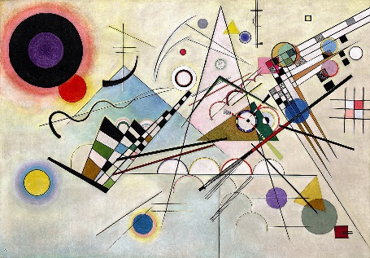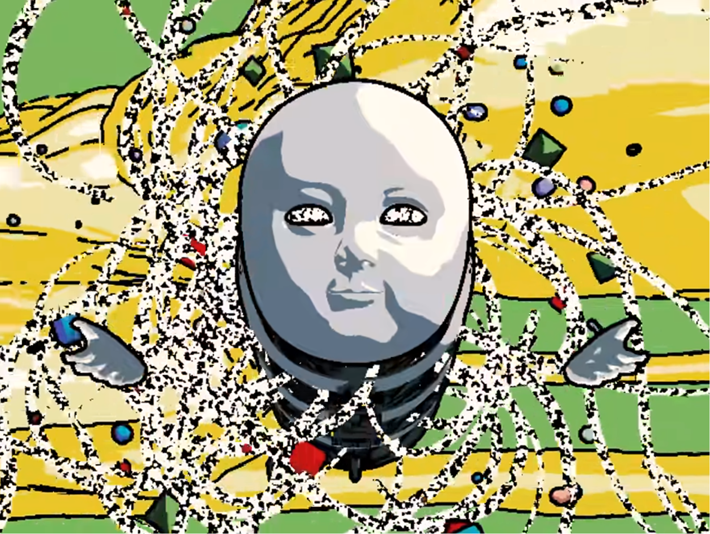

**Description Of the Work**

This painting depicts a verity of shapes and angles sprawled across the canvas.

**Original Meaning of The Work**

This painting is meant to be an abstract exploration of geometry, with a focus on the form of the painting instead of a meaning to the painting.

A possible meaning would be that in something doesn’t have to have substance to be beautiful or alluring which would correlate with one of the other paintings commonly used in the series The Son of Man.

**Analysis of Uses in The Show**

In the show this is used in meany episodes when Cerebral electricity is beaning used to create a verity of materials.

I think that this painting was used to help depicted the cerebral electricity transforming from a state of pure energy to having a physical form having shapes and angles.

**Reference**

Cerebral Electricity

The Son of Man

**Sources**

Interface

https://www.youtube.com/watch?v=EHqsCmfTDmI&list=PLPnjato8iGXLQbppBPhOny8XLSRl7S5pM&index=1

Secondary source of information on interface and formatting ideas for webpages. https://umami.fandom.com/wiki/Umami_Wiki

Composition 8

<https://www.guggenheim.org/artwork/1924>

Vasily Kandinsky

<https://en.wikipedia.org/wiki/Wassily_Kandinsky>

**Skeleton With a Burning Cigarette**

**Sidebar**

Title: Skeleton with a Burning Cigarette

Made by Vincent van Gogh,

Year Made: 1885-1886

Type: Painting

**Article body**



**Description Of the Work**

Painting of a rad skeleton with a smoking a cigarette.



**Original Meaning of The Work**

This painting was made by Vincent van Gogh while he was at an art school and has little meaning beyond being an interesting painting and a slight satire of his school’s habit of using skeletons as art modals.

Additionally,



**Analysis of Uses in The Show**

Episode 23 The Unconscious Conscious

I do not believe this has any hidden meanings in the show beyond it is a popular painting that parallels well with Henryk as he and Vincent van Gogh frequently smoked.

**References**

Episode 23 The Unconscious Conscious

Henryk

**Sources**

Interface

https://www.youtube.com/watch?v=EHqsCmfTDmI&list=PLPnjato8iGXLQbppBPhOny8XLSRl7S5pM&index=1

Secondary source of information on interface and formatting ideas for webpages. https://umami.fandom.com/wiki/Umami_Wiki

Skeleton with a Burning Cigarette

<https://en.wikipedia.org/wiki/Skull_of_a_Skeleton_with_Burning_Cigarette>

Vincent van Gogh

https://en.wikipedia.org/wiki/Vincent_van_Gogh

**Golconda**

**Sidebar**

Title: Golconda

Made by: René Magritte

Year Made: 1953

Type: Painting

**Article body**



**Description Of the Work**

This painting depicts many men floating in the air, wearing a black suit and bowler hat reminiscent of The Son of Man.

The buildings in the Background are meant to represent the fort of Golconda.

**Original Meaning of The Work**

Golconda was meant to represent how paintings are false reality of their subjects and can be used in a deceptive manner. in this case it is obviously represented by the verity of floating men but in his other works this appears in many other forms, an example being The Human Condition which shows a painting of a painting in such a perspective that you can barely tell what is what, shown on the right.

**Analysis of Uses in The Show**

Episode 23 The Unconscious Conscious

It is possible that the false realty of a painting idea is represented in the original painting transfers to the series as an allegory for The Interfaces being a false reality but it is more likely just used as a references to The Son Of Man and because Mr Greetings is talking about the multiverse at the time.

**References**

Episode 23 The Unconscious Conscious

Mr Greetings

The Son of Man

Henryk

**Sources**

Interface

https://www.youtube.com/watch?v=EHqsCmfTDmI&list=PLPnjato8iGXLQbppBPhOny8XLSRl7S5pM&index=1

Secondary source of information on interface and formatting ideas for webpages. https://umami.fandom.com/wiki/Umami_Wiki

Golconda, by René Magritte, 1953

<https://en.wikipedia.org/wiki/Golconda_%28Magritte%29>

René Magritte

**Sunrise By the Ocean**

**Sidebar**

Title: Sunrise by the Ocean

Made by: Vladimir Kush

Year Made: 1996

Type: Painting

**Article body**

 **  **

**Description Of the Work**

This painting depicts a large egg with a crack down the middle.

There is a river in the middle of the paintings.

The sun in the middle of the painting is meant to represent the yoke.

There are several figures depicted in the painting on is seen leaving a boat the rest are seen around scaffolding holding up the egg.

**Original Meaning of The Work**

This painting was made by Vladimir Kush in 1996 it represents the creation of new life with a verity of different artistic metaphors like the yolk and the sun. This work is similar to Geopoliticus Child Watching the Birth of The New Man by Salvador Dali, Salvador Dali is a common inspiration for Vladimir Kush’s paintings.

**Analysis of Uses in The Show**

Episode 23 The Unconscious Conscious

In the show the inside of the egg is shown to be a pink blob that then turns into a brain covered in Cerebral Electricity this is likely meant to represent Mischief who was shown as the new man in the painting Geopoliticus Child Watching the Birth of The New Man, in a very similar position.

Essentially, I think this just restates the point of the meaning of Geopoliticus Child Watching the Birth of The New Manin episode 6 that Mischief represents The New Man and progress in the world which Mr Greetings is in stark opposition of**.**

**References**

Episode 6 Bear Witness

Episode 23 The Unconscious Conscious

Geopoliticus Child Watching the Birth of The New Man

Cerebral Electricity

**Sources**

Interface

https://www.youtube.com/watch?v=EHqsCmfTDmI&list=PLPnjato8iGXLQbppBPhOny8XLSRl7S5pM&index=1

Secondary source of information on interface and formatting ideas for webpages. https://umami.fandom.com/wiki/Umami_Wiki

Sunrise by the Ocean

<https://kushfineart.com/artworks/categories/8/9559-sunrise-by-the-ocean>

Vladimir Kush

<https://en.wikipedia.org/wiki/Vladimir_Kush>

Salvador Dali

**Nighthawks**

**Sidebar**

Title: Nighthawks

Made by: Edward Hopper

Year Made: 1942

Type: Painting

**Article body**

**Description Of the Work**

The painting depicts a street view of an American dinner.

Four figures are depicted in the painting, a man in a suit and hat, a couple in the background and a chef.

**Original Meaning of The Work**

This was a painting made in 1942 by Edward Hopper, it was intended to be a portrayal of an American city in 1942 but the writer admitted that they accidentally captured the loneliness of modern cities.

**Analysis of Uses in The Show**

Episode 24 The Abyss

I believe this painting is meant to represent Henryk embracing the modern world with his granddaughter.

At first this scene may seem depressing but in ever version there is no actual cause for loneliness the characters are surrounded by people and in the show, we see Henryk is with his daughter.

Compering the dark and cold outside to the light and presumably warm interior of the dinner could imply that Henryk is literally turning his back to the dark parts of his life.

Well, this is directly confirmed the boy in the background shares a strong resemblance to The Museum Boy, I think this is the case as in the original picture a man and who is probably his girlfriend is shown, which would make this an odd change to be made for no reason.

This could help to support the interpretation that this uses of the painting is more positive than it may first appear as there is a chance for new relationships here practically with Henryk’s Greet-Granddaughter who seems about the same age as The Museum Boy.

**References**

Episode 24 The Abyss

The Museum Boy

Henryk’s Greet-Granddaughter

Henryk

**Sources**

Interface

https://www.youtube.com/watch?v=EHqsCmfTDmI&list=PLPnjato8iGXLQbppBPhOny8XLSRl7S5pM&index=1

Secondary source of information on interface and formatting ideas for webpages. https://umami.fandom.com/wiki/Umami_Wiki

Nighthawks

<https://en.wikipedia.org/wiki/Nighthawks_(Hopper)>

Edward Hopper

https://en.wikipedia.org/wiki/Edward_Hopper

**The Statue of Liberty**

**Sidebar**

Title: The Statue of Liberty

Made by: Frédéric Auguste Bartholdi

Year Opened: 1886

Type: Statue

Location: New York

**Article body**

  

**Description Of the Work**

This statue depicts a lady dressed in robes holding a torch.

This statue was originally a copper colour but has oxidised to blue.

**Original Meaning of The Work**

This statue was meant to represent freedom and liberty as well as the close relationship between the French and America.

**Analysis of Uses in The Show**

This is a very famous landmark in New York. I do not believe that there is any meaning to this statue belong that. Noticeable this statue is not featured in the credits as an artwork as it is more known as a landmark than an artwork.

This is not the only statue we see that’s been changed to pink implying that this was a common change Post-The Philadelphia Experiment,

**References**

The Philadelphia Experiment

**Sources**

Interface

https://www.youtube.com/watch?v=EHqsCmfTDmI&list=PLPnjato8iGXLQbppBPhOny8XLSRl7S5pM&index=1

Secondary source of information on interface and formatting ideas for webpages. https://umami.fandom.com/wiki/Umami_Wiki

The Statue of Liberty

https://en.wikipedia.org/wiki/Statue_of_Liberty

Frédéric Auguste Bartholdi

https://en.wikipedia.org/wiki/Fr%C3%A9d%C3%A9ric_Auguste_Bartholdi

Character Articles

Page 127-201

This section will have all articles prepared for Character cataloguer, as made for the interfaces wiki project 2024.

Scroll down for content.

**Henryk Niebieski**

**Sidebar**

Name: Henryk Niebieski

Aliases: Blue Guy, The Son of Man, The Man of The Past

Gender Presentation: Male

Approximate Age: 107 Years Old

Status: Alive

Species: Cerebral Electricity Monster (Formerly Human)

Voiced By: none (Grunts Are Probably Justin Tomchuk)

**Article body**

**Description**

Physical Appearance

Henryk appears as a middle-aged man with red hair and moustache, nearly always seen in a blue suit and bowler hat.

Personality

Henryk appears to be depressed, quiet, and contemplative, never speaking in the Interface series. It is clear from his actions that more than everything he cares for his family and feels intense guilt for accidently killing his grandchild and their partner.

**Powers And Abilities**

Henryk is capable of doing anything a normal middle-aged man would be able to do, but he may also have additional powers.

Henryks powers seam to give him a form of incorrigibility, which means an inability to change.

Mer greetings is also a humanoid cerebral electricity monster but is seen to age while Henryk doesn’t age and cannot seemingly be injured as seen in episode 20 where it seams like he must have accidentally blown away the car he was trying to get hit by, additional in episode 13 we see that Henryk perfectly land after falling of a unicycle which leads me to believe Henryk’s powers protect him from any significant physical change.

Henryk is seaming capable of generating infinite cigarettes. This is commented on by Mischief in episode 13, this may imply that Henryk may have a similar power to create things, like how The Ghost can make hands.

**Personal Timeline**

This segment will be going over all the events of Henryk’s life in order.

if multiple events happen in the same year that will be numbered in the order they occur, explanations below for clarity.

Events that happen **within an episode** not a flashback will have the ***episode number after the year***.

if the **order is unclear or there are *no other events*** then there will be ***no number*** to signify what the order they occurred in.

in cases where **only the order of some events are clear**, the events that have no clear order will ***share a number***.

The date is as specific as it is written, explanations below for clarity.

If a year is stated with **no additional** information that is the ***exact year*** it happened.

If a year is said to be **before** a year it is that year or ***any point before***.

If a year is said to be **after** a year it is that year or ***any*** ***point after***.

If a year is said to be **around** a year it is near that year but may be a few years ***before or after.***

1910: Henryk is born.

Justification

This is seen on Henryk’s medical record and directly confirmed by Mischief in Episode 8

Before 1943, 1: Henryk dies accidentally in an nuclear bomb test he was hired to photograph.

Before 1943, 2: Henryk drifts down from the sky in his parachute and meets his wife for the first time, she is working as a nurse at the hospital he is in.

Justification

Henryk is implied to have transformed and regained his physicality during the scene we see in Episode 16 of Henryk falling from the sky in his parachute. As the sky is still blue both events must accrue before The Philadelphia Experiment as this noticeable changed the colour of most thing including the sky.

Noticeable the first known nuclear bomb test happens on July 16th, 1945, two years after the latest date this could have taken place. This may imply there is a differences nuclear bomb development in the Interfaces universe which could also be implied by the blast evidently being significantly larger than expected resulting in Henryk’s death.

After 1945, 1: Henryk plants a tree with his pregnant partner

After 1945, 2: Henryk’s daughter is born, and Henryk becomes a father

After 1945, 3: Henryk marries his wife.

Justification

During Episode 16 we see the tree being planted that is shown in the photo of their wedding. As his wife is not visibly pregnant during the wedding and after the tree has grown, this implies that Henryk’s daughter was born before they were married.

After 1953, 1: Henryk’s Wife died from an unknown illness

After 1953, 2: Henryk attendees his wife’s funeral and the paster who is hosting the funeral, is noticeably freak out by his apparent agelessness.

Justification

Henryks daughter mentions in episode 6 that her mom died when she was young but clearly remember details of her funeral and other stories her mom shared with her implying, she was at lest 8 years old as this is the age children usually develop their long-term memory.

Given that Henryk appeared young enough to be noticeable weird it is implied that this likely happened closer to 1963 or 1973 as Henryk would only be 43 in 1953 so looking young would not be weird, however for the reasons I have stated above I think the earliest date would still be 1953.

After 1963: Henryk’s Granddaughter or Grandson is born making him a Grandfather.

After 1963: The conversation between Henryk and his daughter seen in Episode Six about if Henryk can ever die takes place.

After 1963: Henryk and his daughter also make perogies and the conversation between Henryk and his daughter seen in Episode Sixteen about when Henryk fell from the sky happens.

Justification

The earliest reasonable point for Henryk’s daughter to be born is 1945 after the end of World War 2. This means that the earliest possible point for Henryk’s granddaughter to be born is 1963 as this would be 18 years after the earliest year Henryk’s daughter is born, though it is likely latter.

Additional for the same reasons this is the earliest point for the conversations seen in episode 6 and 16 as Henryk’s daughter is seen as an adult who is not noticeable old.

Around 2012, 1: Henryk’s great-granddaughter is born

Around 2012, 2: Henryk’s family photo is taken by Henryk.

Justification

We know Henryks Great-Granddaughter was still a baby around 1 to 3 years old in 2015 as this is the date of the crash, given that the series is believed to be set in 2017 then it would make her 3 years old at youngest and 5 years old at oldest. If she is 5 years old this would also roughly match the appearance of Henryk’s Great-Granddaughter.

We see the photo of Henryk’s family has both his daughter and great-granddaughter meaning that Henryk’s daughter must die after Henryk’s Great-Granddaughter was born, given that Henryk’s Great-Granddaughter is still a bay during the crash she this would be about at the similar time.

2015, EP20, 1: Henryks’ daughter dies of old age and becomes The Ghost.

2015, EP20, 2: After watching his daughter die Henryk attempts suicide by walking out into traffic. either Henryk’s powers activate to protect him or the car swerves into the river, regardless, Henryk’s family die excluding his Great-Granddaughter who is taken by The Ghost.

2015, EP20, 3: The cerebral electricity of Henryk’s dead family is consumed by Mischief.

2015, EP20, 4: Henryk Abandons his home, prsumeble out of gult.

Justification

These events are shown to happen in quick succession in Episode 20 of Interfaces, so they likely happen on the same day.

My reasoning for these events happening in 2015 is the calendar we see in episode 16 where we see a calendar in Henryk’s abandoned house dated November 2015 it is odd for the scene to focus on this for no reason, so I think it has given a hint to when the home was abandoned.

I believe that Henryk would have abandoned his home Immediately after his suicide attempted, as this place is likely painful for him, hence him abandoning it.

This also makes sense with Henryk’s daughter as she is shown as a baby in episode 20 and a young child 7 at most through the series which is set in about 2017 making her likely 2-3 years old during the crash and 4-5 years old in the show.

2017, 1: The start of the Interface series.

Justification

9 Dec 2017 is the release data of the first episode. Given that the series is shown to be set in the modern day, roughly during fall or summer then it makes sense that the series would take places in middle to late 2017.

A statue appears in the series called The Eye which was realised in 2011 meaning the series must take places after this.

In Episode 16 we see a calendar with a date on it of November 2015 which implies the series takes places a few years after this.

Some of the other apparent dates in the series like how old Mr Greetings or Henryk’s great granddaughter appear in the series.

2017, EP1: Henryk meats Mischief in Montreal and Mischief discusses his past with The Philadelphia experiment.

2017, EP2: Henryk rides Mischief in his bus form to the Montreal Museum of Fine Art.

2017, EP5: Henryk and Mischief view the painting, the son of man and discuss the painting and Henryk wants.

2017, EP6, 1: Henryk and Mischief view the painting, Geopoliticus Child Watching the Birth of The New Man and discuss its meaning and how it relates to Henryk and Mischief.

2017, EP6, 2: Henryk faints as a result of stress from his conversation with Mischief.

2017, EP8, 1: Henryk watches tv in the hospital and talks to Mischief about his age and abilities.

2017, EP8, 2: Henryk escapes the hospital by using Mischief as a parachute.

2017, EP9,1: Henryk and Mischief visit a restaurant and Mischief and The Chief discuss parasites.

2017, EP9, 2: The Chef share the vision he has been having about KAMI to Mischief and Henryk.

2017, EP10: Henryk remembers his past well sitting in The Chefs restaurant looking at the painting Christians World.

2017, EP11, 1: Mischief reveals that Henryk’s Greet-Granddaughter survived.

2017, EP11, 2: Henryk embraces his desire to have a family again and aggress to travel home with Mischief.

2017, EP13, 1: Henryk and Mischief travel east from Montreal towards the lighthouse

2017, EP13, 2: Mischief transforms into a unicycle and makes Henryk fall before apologizing.

2017, EP15, 1: Henryk receives a vison form The Winds.

2017, EP15, 2: Henryk remembers a conversation with his daughter about if he will ever die.

2017, EP15, 3: Henryk receives a photo of The Winds from Mischief.

2017, EP16, 1: Henryk returns home finding it abandoned and in a state of disrepair.

2017, EP16, 2: Mischief transforms into a frog and talks to Henryk about his house.

2017, EP16, 3: Henryk remember a conversation with his daughter about when he met his wife.

2017, EP17, 1: Mischief shares memories of his past with Henryk.

2017, EP17, 2: Henryk and Mischief deicide to travel to The Lighthouse.

2017, EP19, 1: Henryk plays the harmonica in his home before going to sleep.

2017, EP19, 2: Henryk and Mischief travels to The Lighthouse.

2017, EP19, 3: Henryk and Mischief talk about the secrets of their past and Mischief reference to the deal he made with The Ghost.

2017, EP22, 1: Henryk ascends The Lighthouse.

2017, EP22, 2: Henryk connects to The Interface via The Lighthouse’s Cerebral Electricity column.

2017, EP23, 1: Henryk meats Mr Greeting well in the interfaces and they go on a train ride together.

2017, EP23, 2: Mr Greeting and Henryk discuss Henryk’s past and how he died in a nuclear bomb text.

2017, EP23, 3: Henryk see his daughter in the interface, and they discuss if Henryk will stay in the interfaces.

2017, EP23, 4: Henryk looks at his family photo and the photo of The Winds before leaving the interface.

2017, EP24, 1: Henryk and Mischief discuss philosophy and the stars.

2017, EP24, 2: Henryk rejects Mr Greetings offer and embraces the modern world.

2017, EP24, 3: Henryk and Mischief escapes The Lighthouse and survive an attempted attack by KAMI.

2017, EP24, 4: Henryk and Mischief fight KAMI who is disguised as Henryk’s great-granddaughter.

2017, EP24, 5: Henryk hides with his great-granddaughter behind a rock.

2017, EP24, 6: Henryk morns Mischief with his great-granddaughter before reviling that Mischief is alive.

2017, EP24, 7: Mischief is consumed by The Mechanical Saccorhytuswell Henryk and his great-granddaughter watches.

2017, EP24, 8: Henryk and his greet-granddaughter visit a dinner that resembles the painting Nighthawks, The Museum Boy may be present in the background.

**Analysis**

**Henryk Is Polish**

Henryk is likely polish or from a polish family. His family are known to cock perogies and his name is polish.

Given the importance of World War 2 in the series this could imply that Henryk was one of the many refugees created by the Nazi invasion of Poland. This is not conferred or disproven by the series so far.

**How Did Henryk Survive His Suicide Attempted**

We see Henryk in the road before the crash and then it cuts to white, there is not enough spaces or time available for the car to turn into the river like we see it did.

This implies a part of his powers may be protecting him from harm in whatever way is possible. In this case I believe that Henryk realised a large amount of Cerebral Electricity and blow the car of the road, this is also supported by the fact we see a lot of Cerebral Electricity on the bridge after the crash. In episode 13 we see Henryk perfectly land after a fall which could be a much smaller use of this power.

**Henryks Death Is Very Complicated.**

During one scene from episode 23 we see Henryk getting blasted by a nuke casing him to die before getting covered with Cerebral Electricity and reviving.

This would seemingly imply that Henryk died to a nuclear blast, but we also know that Henryk was transformed when the sky’s where still blue, meaning before 1943.

This is odd as the first nuke was detonated in 1945, meaning that unless the events of when the skies where still blue are before Henryk’s transformation Henryk dying to a nuke seemingly cannot be true.

The most likely conclusion is that this is a small continuity error and that UMAMI did not realize that the first bomb test was 1945 but I think this could also imply that in the interfaces universe the early nuclear bomb testes where more successful than in our universe.

This could be explained by the presents of cerebral electricity in Interface if cerebral electricity or water weas used to power The Philadelphia Experiment was used instead of uranium this could explain how the development of nuclear blasts was quicker in Interface.

Amusing the bomb was seemingly powered by cerebral electricity would also explain how Henryk became a Cerebral Electricity Monster before The Philadelphia Experiment, as well as why the nuclear blast was likely bigger than the military expected.

Henryk transformation into a cerebral electricity monster prior to the Philadelphia experiment is not a contradiction as ghost stories and superstitions are explained to have always been a result of cerebral electricity but where only provable after the experiment acquired.

I believe that the nuclear blast weas larger than the military expected because of Henryk’s death the military wouldn’t tell Henryk to go somewhere they know he would die the only explanation is that they didn’t think the blast would be as big as it was. This may add to the evidence that the material used for bomb wasn’t uranium but something related to cerebral electricity.

A crazier theory for Henryk somehow dying to a nuke years before they were made is that Henryk may have time travelled after his death, he appears out of nowhere in episode 16 and this is the simplest explanation for this seaming continuity error additionally Cerebral electricity is shown to be able to effect time, as we see The Wind can freeze time, all that being said this is pretty blatantly not intended.

**Henryk Represents The Son of Man**



Henryk is clearly meant to represent The Son of Man in the show.

I believe there is a correlation between the apparent boringness of the original Son of Man with Henryk also seeming boring at first glance. In both cases it is not the appearance of the man that is meant to be interesting but the hidden details that are only hinted at in the original work. This could be supported by the chose to make Henryk a silent protagonist which makes him much more mysterious.

In short Henryk being represented by The Son of Man is a metaphor representing that Henryk is a lot more important and interesting than he first appears.

For a much deeper analysis of this painting and its importance to the show check out The Son of Man’s page here**.**

**Unclear Personal Details**

Approximate Age Justification

Henryks birthday is known to be at some point in 1910 so assuming that the series takes places in 2017, then Henryk would be 107. 2017 is the release date of Episode One.

**Trivia**

Henryk roughly translate form polish to English as patriarch, while Niebieski roughly translate to Blue. making Henryk’s name approximately translate to blue father.

**Videos They Appear In**

Episode 1 No Title

Episode 2 No Title

Episode 5 The Son of Man

Episode 6 Bear Witness

Episode 8 The Watchful Eyes

Episode 9 Camouflage

Episode 11 Revelations

Episode 10 An Illusion of Time

Episode 13 The Right Direction

Episode 15 The Winds

Episode 16 When Skies Where Still Blue

Episode 17 The Fall

Episode 19 Entangalment

Episode 20 All That Perish

Episode 22 Ascent to Solitude

Episode 24 The Abyss

**References**

Episode 1 No Title

Episode 2 No Title

Episode 5 The Son of Man

Episode 6 Bear Witness

Episode 8 The Watchful Eyes

Episode 9 Camouflage

Episode 11 Revelations

Episode 10 An Illusion of Time

Episode 13 The Right Direction

Episode 15 The Winds

Episode 16 When Skies Where Still Blue

Episode 17 The Fall

Episode 19 Entangalment

Episode 20 All That Perish

Episode 22 Ascent to Solitude

Episode 24 The Abyss

Mr Greetings

Greetings robotics

The Chef

The Ghost

The Wind

Henryk’s Great-Granddaughter

Henryk’s Family

Henryk

Mischief

Cerebral electricity

**Sources**

Interface

https://www.youtube.com/watch?v=EHqsCmfTDmI&list=PLPnjato8iGXLQbppBPhOny8XLSRl7S5pM&index=1

Secondary source of information on interface and formatting ideas for webpages. <https://umami.fandom.com/wiki/Umami_Wiki>

**Mischief**

**Sidebar**

Name: Unknown

Aliases: Mischief, Demon, The New Man, Pink Guy, Smile,

Gender Presentation: Male, (C.E.M)

Approximate Age: Older Than 106 Years Old

Status: Unclear

Species: Cerebral Electricity Monster (Formerly Human)

Voiced By: Justin Tomchuk

**Article body**

**Description**

Physical Appearance

Before his transformation Proto-Mischief looked mostly like a normal human with most of his features covered by clown makeup and his clown attire.

After his transformation Mischief usually appears as a bright pink worm like creature with yellow horn-like things on his forehead, a big smile with yellow teeth and a clown nose.

Mischief is commonly shown to shapeshift meaning he can look like anything, usually he limits himself to being pink, but he has been confirmed to be able to change colours in Episode 11 Revelations and Episode 5 The Son of Man.

Personality

Mischief is very outgoing and friendly, but he is not above being deceptive. Mischief can be somewhat self-interested and can struggle to control his impulses but is not shown to be actively malicious.

**Powers And Abilities**

Mischief is able to shapeshift including the ability to change colours, fly and float, and absorb cerebral electricity which seemingly gives him knowledge on what he has absorbed, it is not clear if he also gets there powers like KAMI.

**Personal Timeline**

This segment will be going over all the events of Mischifes life in order.

if multiple events happen in the same year that will be numbered in the order they occur, explanations below for clarity.

Events that happen **within an episode** not a flashback will have the ***episode number after the year***.

if the **order is unclear or there are *no other events*** then there will be ***no number*** to signify what the order they occurred in.

in cases where **only the order of some events are clear**, the events that have no clear order will ***share a number***.

The date is as specific as it is written, explanations below for clarity.

If a year is stated with **no additional** information that is the ***exact year*** it happened.

If it is stated to be **between two years**, then we know ***the events fall*** ***between two years***.

If a year is said to be **before** a year it is that year or ***any point before***.

If a year is said to be **after** a year it is that year or ***any*** ***point after***.

If a year is said to be **around** a year it is near that year but may be a few years ***before or after.***

Before 1893 Proto-Mischief is born.

Justification

We know that Proto-Mischief was working for dreamland in 1911 and appeared to be an adult so that means he was likely born at least 18 years before 1911.

Between 1904-1911: Proto-Mischief joined the Foolish house in dreamland.

Justification

We know that Mischief was working for Dreamland when it burned down meaning he must have been working there before hand, as he is the head on the building it is likely he has there from the beginning, meaning 1904.

1911, 1: Proto-Mischief and The Foolish Girl take a bow on the stage of The Foolish House.

1911, 2: Proto-Mischief leaves the entertainment industry.

1911, 3: the same day Proto-Mischief retires dreamland burns down.

Justification

At one point in Episode 21 Mischief says "The year was 1911. Two comedians take a bow, 54 years too soon." This references the painting the two comedians.

This all implies that Proto-Mischief retired from dreamland and did not leave because of the fire. However, we also see Proto-Mischief watching the fire well dressed in his comedian outfit, implying that he retires the day of the fire.

The Ringmaster appears noticeably upset during the scene he is shown in Episode 21 this may imply that he and Proto-Mischief had been having problems and one of them may have purposely or accidently set fire to dreamland. This is contradicted by reality where the fire was an accident.

Before 1943:Proto-Mischief joins the military more specifically the navy.

Justification

We know that Proto-Mischief was in the military during 1945 as this is the date of The Philadelphia Experiment so he must have been in the military before that.

1943, 1: The Philadelphia Experiment accusers teleporting the USS Eldridge to New York from Philadelphia.

1943, 2: Proto-Mischief is turned into pure cerebral electricity before floating into the sky and being shot to death by the military.

1943, 3: Proto-Mischief falls to the earth and fully transforms into a cerebral electricity monster. As Proto-Mischief transforms into Mischief the screen shows pictures of KAMI to compare the two.

1943, 4: Mischief says boo to Mr Greeting before leaving.

Justification

The events of The Philadelphia Experiment is repeatedly mentioned to have taken places in 1943.

2015, EP20, 1: Mischief slivers through the woods.

2015, EP20, 2: Mischief speaks to The Ghost and makes a deal with her.

2015, EP20, 3: Mischief absorbs the cerebral electricity of Henryks family.

Justification

These events are shown to happen in quick succession in Episode 20 of Interfaces, so they likely happen on the same day.

My reasoning for these events happening in 2015 is the calendar we see in episode 16 where we see a calendar in Henryk’s abandoned house dated November 2015 it is odd for the scene to focus on this for no reason, so I think it has given a hint to when the home was abandoned.

I believe that Henryk would have abandoned his home Immediately after his suicide attempted, as this place is likely painful for him, hence him abandoning it.

This also makes sense with Henryk’s daughter as she is shown as a baby in episode 20 and a young child 7 at most through the series which is set in about 2017 making her likely 2-3 years old during the crash and 4-5 years old in the show.

2017, 1: The start of the Interface series.

Justification

9 Dec 2017 is the release data of the first episode. Given that the series is shown to be set in the modern day, roughly during fall or summer then it makes sense that the series would take places in middle to late 2017.

A statue appears in the series called The Eye which was realised in 2011 meaning the series must take places after this.

In Episode 16 we see a calendar with a date on it of November 2015 which implies the series takes places a few years after this.

Some of the other apparent dates in the series like how old Mr Greetings or Henryk’s great granddaughter appear in the series.

2017, EP1: Henryk meats Mischief in Montreal and Mischief discusses his past with The Philadelphia experiment.

2017, EP2: Henryk rides Mischief in his bus form to the Montreal Museum of Fine Art.

2017, EP5, 1: Henryk and Mischief view the painting, the son of man and discuss the painting and Henryk wants.

2017, EP5, 2: Mischief transforms into a sunflower and scares The Museum Boy.

2017, EP6, 1: Henryk and Mischief view the painting, Geopoliticus Child Watching the Birth of The New Man and discuss its meaning and how it relates to Henryk and Mischief.

2017, EP6, 2: Henryk faints as a result of stress from his conversation with Mischief.

2017, EP8, 1: Henryk watches tv in the hospital and talks to Mischief about his age and abilities.

2017, EP8, 2: Henryk escapes the hospital by using Mischief as a parachute.

2017, EP9: Henryk and Mischief visit a restaurant and Mischief and The Chief discuss parasites.

2017, EP9: The Chef share the vision he has been having about KAMI to Mischief and Henryk.

2017, EP9, 2: Mischief informs The Strange Man that the restaurant opens at 5PM.

2017, EP11, 1: Mischief reveals that Henryk’s Greet-Granddaughter survived.

2017, EP11, 2: Henryk embraces his desire to have a family again and aggress to travel home with Mischief.

2017, EP11, 3: Mischief monologues about eating people’s ghosts before transforming into car and driving off with Henryk.

2017, EP13, 1: Henryk and Mischief travel east from Montreal towards the lighthouse

2017, EP13, 2: Mischief transforms into a unicycle and makes Henryk fall before apologizing.

2017, EP14: Mischief dreams of his past at dreamland.

Justification

The events of this episode are much more surrealist than normal, yet this episode is set in 1911 at the latest which is well before The Philadelphia experiment. This is easily explained by this being a dream of Mischief past.

Where the dream would take places in the timeline is less clear but it’s likely some point in 2017 and I’m putting it here as this is in line with the episode order. A more likely point for this to take places is during episode 19 well Henryk sleeps, though it is not confirmed if Mischief sleep at that point or not.

2017, EP15: Henryk receives a photo of The Winds from Mischief.

2017, EP16: Mischief transforms into a frog and talks to Henryk about his house.

2017, EP17, 1: Mischief shares memories of his past with Henryk.

2017, EP17, 2: Henryk and Mischief deicide to travel to The Lighthouse.

2017, EP19, 2: Henryk and Mischief travels to The Lighthouse.

2017, EP19, 3: Henryk and Mischief talk about the secrets of their past and Mischief reference to the deal he made with The Ghost.

2017, EP22, 1: Mischief transforms into a bird and flies to the top of The Lighthouse house.

2017, EP22, 2: Mischief shares stories of his past.

2017, EP24, 1: Henryk and Mischief discuss philosophy and the stars.

2017, EP24, 3: Henryk and Mischief escapes The Lighthouse and survive an attempted attack by KAMI.

2017, EP24, 4: Henryk and Mischief fight KAMI who is disguised as Henryk’s daughter.

2017, EP24, 5: Mischief interfaces with KAMI and corrupts her triggering a self-destruct.

2017, EP24, 6: Henryk morns Mischief with his great-granddaughter before reviling that Mischief is alive.

2017, EP24, 7: Mischief is consumed by The Mechanical Saccorhytuswell Henryk and his great-granddaughter watches.

2017, EP24, 8: Mischief transfers to the interfaces and forces it into safe mode.

**Mischifes Transformations**

Worm (Normal Form)

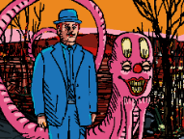

Bus

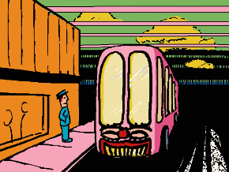

Suit

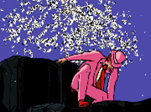

Sunflower

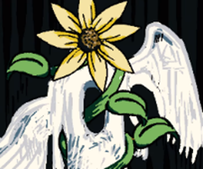

Ball

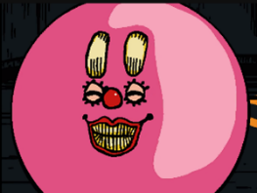

Bird

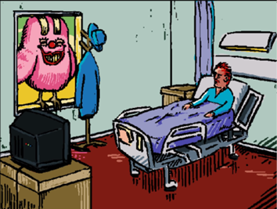

Parachute

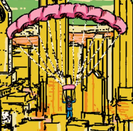

Fly

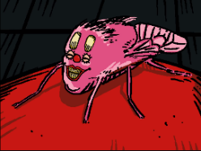

Car

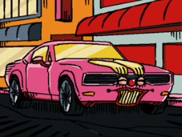

Proto-Mischief

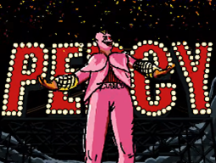

Unicycle

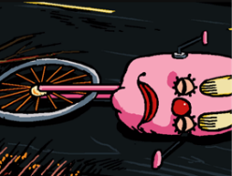

Bicycle

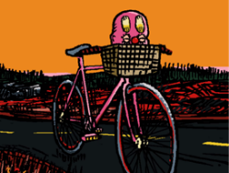

Fat Little Pink Frog

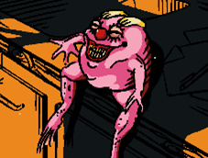

Blanket



Tapeworm



Apple



Hand

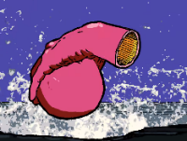

Fire Extinguisher

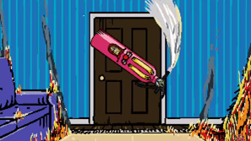

Christmas Tree

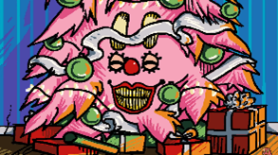

**Analysis**

**The Ghosts Deal with Mischief**

The Ghost requests that Mischief brings Henryk back to how he used to be, presumably meaning when he was less depressed. She also commands that Mischief informs Henryk of his grate-granddaughters survival.

In exchange for this Mischief will receive all that perish, the meaning of this is not entirely clear but it seems more than likely that this refers to the cerebral electricity in the interface, the interfaces is a form of digital afterlife that “all that perish” will presumably go to.

This would also explain The Ghost’s actions in episode 4 as she shows no resistance to being absorbed to the Greetings Robotics system. This appears odd in the series be could be explained by this being a part of their deal.

Mischief mentions in Episode 24 that he was worried about the consequences of Henryk not waking up this may imply that there are established consequences of breaking the deal that are not made clear in the series. Additionally, it is possible that this would only result in him not getting what The Ghost promised him.

Mischief likely could not have beaten The Mechanical Saccorhytus without being consumed by him and corrupting him, which is odd considering that The Mechanical Saccorhytus seams to be made with the intent of being able to absorb large amounts of cerebral electricity so Mischief should not be able to corrupt him. This leads me to believe that as part of their deal when Henryk and his greet-granddaughter are reunited she will somehow disable whatever was protecting The Mechanical Saccorhytus to allow Mischief to consume the Cerebral Electricity from The Interface.

**Was Mischief Being Lying to Henryk**

When the details of Mischief deal with The Ghost where reviled it appears that he was lying to Henryk. However, I do not agree with this I will explain why bellow.

The main reasons people think he is lying are his actions before Episode 11, he doesn’t tell Henryk about the deal with The Ghost and makes it seem like he has just interested in Henryk, during Episode 5 he makes it seem like he doesn’t know what Henryk wants when he should know the sources of Henryk trauma. This makes it seem like Mischief is trying to lie to Henryk.

However, Mischief never lies about knowing where Henryk’s Greet-Granddaughter, Henryk never asks, and Mischief tells him as soon as he feels that he understands Henryk. Additional in episode 8 we see that Mischief was unaware of Henryk’s age and it seams like he has generally pore knowledge on Henryk beyond what happened during the crash that killed most of Henryk’s family.

To me this makes it seem a lot more like Mischief was trying to learn more about Henryk and what drives him before reviling his greet granddaughter survived. This makes sense considering that one of the key terms of Mischifes deal with The Ghost seams to be that he will make Henryk happy again, so it would be important to get to know him before dropping a massive piece of information like that, which may have been destressing to Henryk.

So in short well Mischief was clearly being dishonest I don’t think it is fair to say that he was lying or being malicious before episode 11.

**Mischief and Sunflowers**

Sunflowers are commonly associated with Mischief so I will go over the analyses of their use in each episode bellow.

Sunflowers in Episode 5 The Son of Man

When The Museum Boy enters the room with the son of man painting in it Mischief hides as a sunflower and ends up searching The Museum Boy.

If we are going on the interpretation of sunflowers being a reputation of death then this would show likely with most people the museum oy is scared of death.

Sunflowers in Episode 14 Dreamland

Sunflowers Are Mischief, Mischief Is a Dragon, And Dragons Are Death

This episode has what I believe to be a three-layered metaphor about Death, Dragons, Mischief, And Sunflowers I will attempt to explain here.

Layer one, death is a dragon

When The Ringmaster is giving the fine part of his monolog he clearly corelates the dragon with death, The Ringmaster claims that he saw death in his dream but then the story’s about a dragon and if you listening to the monologue its very clear that the dragon is meant to be a metaphor for death. At an earlier point in the monologue The Ringmaster claims that people may have seen death at the bottom of a bottle, this is another example of a similar metaphor to help prove my point.

Layer two, Mischief is a dragon

Mischief being a dragon is easier to explain and prove, in the end of the episode we see The Ringmaster introduces the dragon he apparently tamed before Proto-Mischief is shown. I believe that only would prove the connection but there is more proof at one point in the monologue The Ringmaster says “That’s when I saw it! It twisted and twirled towards me. I saw Its wicked smile, I heard its wicked laugh!” this is clearly talking about Mischief as he is known to travel in a similar manner and is known to have a sinister smile.

Additionally, I believe that Mischief as a dragon still represents death, the part of the monologue that most directly talks about death is as the part that most directly talks about death, the line of the monolog being the line about the dragon twisting and twirling. The way The Ringmaster talks about the dragon makes it seem like his talking about death as a separate entity to the dragon, but the sentence would only really makes sense if he is talking about both. It is important to remember that The Ringmaster is also clearly talking about Mischief, so it only makes sense that Mischief represents both the dragon and death.

Layer three, Mischief is a sunflower

Before getting into this episode, I feel it is important to remind you of when Mischief transformed into a sunflower in episode five and says, “I’m a beautiful sunflower”, it doesn’t really get clearer than that but there is more proof of the metaphor in episode fourteen.

In the episode we see a scene where the shot is constantly changing between Proto-Mischief and a sunflower that may imply that the two are being corelated. We also see another scene where we see Proto-Mischief walking down a corridor with his reflection being replaced by a sunflower. Well ever of these two examples could mean nothing on their own it, but taking both metaphors together with the scene from episode five it is a much clearer corelation between sunflowers and Mischief.

This leaves the question of if sunflowers are also meant to corelate to dragons and death my answer yes-ish.

I believe the dragon analogy purely apples to Mischief in this one scene. Mischief clearly isn’t a dragon, I think the dragon is just a metaphor for death used in the monologue as a way to avoid directly calling Mischief death, in simple terms I believe that if Mischief is not a dragon, is death and Sunflowers are Mischief then sunflowers must represent death and Mischief but not dragons.

Sunflowers in Episode 21 Revelations

We see The Museum Boy growing a sunflower before seeing it fall out The Window well, he is watching the interview with Mr Greetings. I believe that the metaphor’s specified in dreamland apply here and gives the scene a deeper meaning, which I will explained here.

The metaphor in Episode 14 Dreamland was that Mischief represents death and sunflowers represent both Mischief and death. Mischief has also been shown to represent the future and the next generation as shown in “bear wittiness” where he is compered to The New Man, who is literally the generation following the year 1943.

The first scene shows The Museum Boy being interested in growing the sunflower, I believe that this is meant to show that the boy is interested in the future and the progress of the world as said above this is what Mischief represents and sunflowers are represents Mischief.

The second scene shows The Museum Boy watching the Mr Greetings interview as the sunflower falls out of The Window. I believe that this is meant to show that the boy losses interest in the future because of what Mr Greetings is saying in the interview, this is lily what Mr Greetings intends due to his sole goal being to take the world back to the way it was before 1943.

Additionally, I believe that this scene could also be about death, in dreamland this is implied to be something that Mischief represents. So, the scene where he grows the sunflower would represent him expecting death in his life and the scene where the sunflower falls would represent him rejecting death. This makes some sense as The Interface is shown to be a form of digital afterlife meaning that Mr Greetings has essentially ended death in the world.

Sunflowers In Safe Moad

The character snooze button appears to be a flower of some kind and may be a sunflower if this is the case I assume that snooze button will turn out to be Mischief in disguise.

at the moment we do not have enough information to accurately analyse Safe Mode so I will leave this theory here.

**Unclear Personal Details**

Approximate age

We know that Proto-Mischief was working for dreamland in 1911 and appeared to be an adult so that means he was likely born at least 18 years before 1911. Making him 106 years old at the time of the interface series.

Gender Presentation (C.E.M) Means

Cerebral Electricity Monsters are shown to be essential entirely unique species for each different character, entirely defined by their perspective and memories of the world.

This could be interpreted as them being entirely unique creatures in every way which may involve gender or sex, however the details of their transformation are not made clear in the series so I went with how they largely appear in the series.

That being said Mischief seams to identify as a male, when we see him in 1911 that he has male when he was still human and there’s no evidence presented in the series that would imply that this has changed. Noticeable, all characters that refer directly to Mischief with pronounces use he, him, though that’s basically just Mr Greetings in episode 24.

Approximate Age Justification

Mischief Earliest known point in The Timeline is 1911 as he was at Dreamland when it burned down. assuming he was born during the fire that would make him exactly 106, however this is absurd as at this point, he was human and appears as an adult.

From his appearance he was in his twenties or thirty’s making him around 126 to 136 years old, but I would say more than 106 as this is the most accurate.

All this is assuming that the series takes places in 2017, which is the release date of Episode One.

**Videos They Appear In**

Episode 1 No Title

Episode 2 No Title

Episode 5 The Son of Man

Episode 6 Bear Witness

Episode 8 The Watchful Eyes

Episode 9 Camouflage

Episode 11 Revelations

Episode 13 The Right Direction

Episode 14 Dreamland

Episode 15 The Winds

Episode 16 When Skies Where Still Blue

Episode 17 The Fall

Episode 19 Entangalment

Episode 20 All That Perish

Episode 22 Ascent to Solitude

Episode 24 The Abyss

**References**

Episode 1 No Title

Episode 2 No Title

Episode 5 The Son of Man

Episode 6 Bear Witness

Episode 8 The Watchful Eyes

Episode 9 Camouflage

Episode 11 Revelations

Episode 13 The Right Direction

Episode 14 Dreamland

Episode 15 The Winds

Episode 16 When Skies Where Still Blue

Episode 17 The Fall

Episode 19 Entangalment

Episode 20 All That Perish

Episode 22 Ascent to Solitude

Episode 24 The Abyss

Henryk

Henryk’s family

Henryk’s Grete Granddaughter

The Ringmaster

The Foolish Girl

Mr Greetings

KAMI

The Chef

The Wind

The Ghost

The Mechanical Saccorhytus

**Sources**

Interface

https://www.youtube.com/watch?v=EHqsCmfTDmI&list=PLPnjato8iGXLQbppBPhOny8XLSRl7S5pM&index=1

Secondary source of information on interface and formatting ideas for webpages. <https://umami.fandom.com/wiki/Umami_Wiki>

**KAMI**

**Sidebar**

Name: Kinetic, Autonomous, Mechanical, Interface

Aliases: KAMI, KAMI MRK1, KAMI MRK2, The Creature, The Alter

Gender Presentation: Unclear (C.E.C)

Approximate Age: Unclear

Status: Unclear (presumed Transformed)

Species: Cerebral Electricity Container

Voiced By: None

**Article body**

**Description**

Physical Appearance

KAMI is a white and black robot with wires coming out the back of her head that resembles dreadlocks, her chest is covered by what appears to be a ribcage with cerebral electricity behind it, at the centre of her ribcage is a small heart. On her back there is a Japanese’s symbol that means God or KAMI in Japanese’s.

KAMI’s mask has to bright red circles on her checks, bright red lips and to holes for her to see through.

Personality

KAMI is a robot that contains cerebral electricity if she has a personality, she doesn’t show it externally, beyond occasionally staring at her mask.

**Powers And Abilities**

KAMI has the ability to absorb the cerebral electricity of others, this granted her the memories and abilities of anybody she absorbs.

Her original powers where seemingly flying, telekinesis and the ability to destroy and rebuild physical objects. She is also likely capable of anything a regular human can do but we only see her fighting.

KAMI absorbed The Ghost which seemingly expanded her transformation ability and lets her use her meany armed form, this also gave her the ability to summon and use The Ghost’s hands.

KAMI absorbed The Chef gained his powers this allowed her to change colours and fully shapeshift, according to her code she also got “INTUITION” from him, it is not clear what this means but it likely refers to the visons The Chef has so this likely gives her a limited form of precognition

KAMI may have received some powers form The Wind as her code seemingly references him but it also claims that “TRANCES ELEMENTS ONLY” only so I don’t think she has significant abilities from this.

**Personal Timeline**

This segment will be going over all the events of KAMI life in order.

if multiple events happen in the same year that will be numbered in the order they occur, explanations below for clarity.

Events that happen **within an episode** not a flashback will have the ***episode number after the year***.

if the **order is unclear or there are *no other events*** then there will be ***no number*** to signify what the order they occurred in.

in cases where **only the order of some events are clear**, the events that have no clear order will ***share a number***.

The date is as specific as it is written, explanations below for clarity.

If a year is stated with **no additional** information that is the ***exact year*** it happened.

If it is stated to be **between two years**, then we know ***the events fall*** ***between two years***.

If a year is said to be **before** a year it is that year or ***any point before***.

If a year is said to be **after** a year it is that year or ***any*** ***point after***.

If a year is said to be **around** a year it is near that year but may be a few years ***before or after.***

2017, EP3, 1: KAMI MRK 1 is constructed by Greetings Robotics.

2017, EP3, 2: KAMI MRK 1 is unveiled by Mr Greetings to the public at the United Nations Headquarters.

2017, EP4: KAMI floats down from The Mechanical Saccorhytus and attacks The Ghost and little girl, successfully capturing The Ghost.

2017, EP7: KAMI is degaussed after absorbing The Ghost.

2017, EP12, 1: KAMI looks at her mask well riding The Mechanical Saccorhytus.

2017, EP12, 2: KAMI floats down from The Mechanical Saccorhytus and attacks The Chef taking on her meany armed form and using The Ghost to protect herself.

2017, EP12, 3: KAMI is pinned to the Mount Royal Cross and ever destroyed or critically damaged by The Chef.

2017, EP18, 1: KAMI is seen aboard The Mechanical Saccorhytus and is being repaired and upgraded as well as having absorbed The Chef

2017, EP18, 2: KAMI is seen to view the memories of The Chef and learn about Henryk’s and Mischief.

2017, EP23: KAMI is seen in the simulation of New York inside The Twin Towers as a plane collides with them.

2017, EP24, 1: KAMI holds Henryks greet-granddaughter hostage well disguised as Henryk’s daughter

2017, EP24, 2: KAMI attacks Henryk and Mischiefs by using The Ghost’s hands.

2017, EP24, 3: KAMI’s mask is removed by Mischief.

2017, EP24, 4: Mischief talks with KAMI before KAMI Attack’s Mischief again.

2017, EP24, 5: Mischief interfaces with KAMI causing her to become corrupt and self-destruct.

2017, EP24, 6: After KAMI dies, she persuasible transforms into The Oni.

**Analysis**

**KAMI’s Interface Information**

**KAMI’s Interface Information from Episode 7**

T-POSE STATUS: CONFIRMED

K.A.M.I POWER SYSTEMS STABLE

INITIATE DEGAUSS.CONFIG

DETECTED: G.R. MOBILE CHAMBER

BOOTING...

DEGAUSSGRMC

VERSION 12.40

G.R. MOBILE CHAMBER DEGAUSS STATUS: COMPLETED

K.A.M.I MASK DISENGAGING...

This code seams to referrer to her absorbing The Ghost after her conflict with The Ghost and removing her mask.

To “degauss” something usually refers to the removal of water, magnetic, energy or data from a system.

**KAMI’s Interface Information from Episode 18**

Hand likely referring to The Ghost and her information is listed as CODENAME: SHIVA, SOLVED: PROTECTION, TRANSFORMATION, DESTRUCTION.

Shiva is a destruction goddess from Hindu culture click here for the Wikipedia article on her

Lung likely refers to The Wind their information is “GA-OH, SOLVED: TRACE ELEMENTS ONLY, STATUE: UNKNOWN, this implies she has little access to The Wind as he likely hasn’t been captured yet.

Ga-oh is a wind god from Iroquois mythology click here for the Wikipedia article on him

Lastly there’s Heart which definitely refers to The Chef the information is listed as CODENAME: AKKOROKAMUI, SOLVED: INTUITION AND CHROMOPHORES. Chromophores are molecules that have the ability to absorb and emit light possible allowing for KAMI to transform colours or see in colour.

Akkorokamui is an Octopus-like monster from Ainu Folklore click here for the Wikipedia article on them.

**KAMI’s Interface Information from Episode 24**

In this segment I will go over some of the commands being run in KAMI and what they mean.

Segment 1

INITIATE CAMOUFLAGE.CONFIG LIBRARY: AKKOROKAMUI GHOST, INITIATE GUEST.HOST.VOICE.CONFIG LIBRARY: GHOST

****This shows that KAMI is using both The Ghost and The Chefs powers to impersonate Henryk’s Greet-Granddaughter.

Segment 2

WARNING: K.A.M.I. MASK DISENGAGED, K.A.M.I MASK REGISTRATION FAILED

These commands would have been run after Mischief stole KAMI’s mask.

Segment 3

WARNING: THREAT DETECTION COMPROMISED,INITIATE SELF.DESTRUCT.CONFIG + MASK, LIBRARY: AKKOROKAMUI, STATUS: COMPLETE

After KAMI’s mask is stolen, she initiates her self-destruction protocol in a final attempt to kill Mischief.

Segment 4

WARNING: INTERNAL C.E. VULNERABLE WARNING: INTERNAL C.E. LEVELS, WARNING: INTERNAL CLE LEVELS DROPPING

This shows that whatever Mischief was doing to KAMI caused her to loss Cerebral Electricity.

Segment 5

EMERGENCY PROCEDURES INITIATED

INITIATE: PING.'GPS.ONFIG + MECHANICAL SACCORHYTUS

This implies that KAMI was programmed to inform The Mechanical Saccorhytus of her location in the event of her imminent destruction.

Segment 6

INITIATE, CHAOS.DESTRUCT.CONFIG, + METALLIC-EXOSKELETON MK. II, LIBRARY: SHIVA, AKKOROKAMUI

This is the final command that was needed to activate herself destruct implying that KAMI was using both her power and the power of The Chef to do so.

**Hex Code and There Meaning**

**Hex Code Form Episode 7**

ULTIMATE COMPLEXITY IS THE FINAL DESTINATION

This likely correlates to what Mr Greetings is talking about and how the creatures are reaching a stat of ultimate complexity where they cannot get more complex.

INCOMING TRANSMISSION INCOMPLETE

This stats that somehow the data KAMI is sending somehow isn’t complete this isn’t elaborated on and seemingly has no consequences so in my opinion I think this is flavour text.

GENE SEQUENCING UNKNOWN NUCLEOTIDES

This implies that it is breaking down the giant sequence of The Ghost and repurposing them which would implies that all Cerebral Electricity Monsterhave a biological component and are not purely magic, spiritual, or made of Cerebral Electricity.

GR DISCOVERY: COPYING DATA AND ORIENTATION

This implies that The Ghost is being copied and reorientated to serve Greetings Robotics. I believe that this leads to the destruction of the original Ghost, but this is not made clear in the series.

Translated by Josiah Snarr in the Umami Discord server.

**Hex Code Form Episode 12**

KAMI CAPTURE.CONFIG

This means that KAMI is loading a program for catching Cerebral Electricity Monsters.  
CE DETECTED

This means that Cerebral Electricity has been detected.   
WARNING: CE CORRUPTION DETECTED

This means that the Cerebral Electricity has been corrupted the meaning of this is not explained but likely just means it is being controlled by a Cerebral Electricity Monster   
WARNING: KAMI SYSTEMS COMPROMISED

This could mean that KAMI is suffering from a glitch due to an attack or the presences of The Chef.  
KAMI.PT.783921706013 STATUS: SEARCHING AREA

This likely means that KAMI is searching the area for The Chef.  
WARNING: TARGET HOSTILE

This confers that they know The Chef will not come peacefully.  
INITIATING GHOST.PROTECTOR

This shows that KAMI can summon The Ghost to protect herself.

Translation by 174.70.1.212 on fandom wiki

**Hex Code from Episode 24**

What You See Here

What You Do Here

What You Hear Here

When You Leave Here

Let It Stay Here

死

This was a pome associated with the aftermath of the Manhattan project where it was posted as a warning to visitors.

The poem is also commonly used by sobriety groups as a call for privacy and the protection of anonymity. This likely doesn’t correlate but given that KAMI is made of other people’s memories there a chance this is meant to represent their memories being destroyed, this is not likely but possible.

死 essentially translates to death in Japanese, a more literal translation being “Shi”.

Translated by [sp0nser](https://www.youtube.com/@sp0nser) on YouTube

**KAMI Represents The Loss Of Individuality To Society**

Individuality is something that seems particularly important to the series, Mischief is arguably meant to represent individualisation, noticeably in episode 22 quoting The Red Book which is all about individuality.

KAMI how is directly antithetical to Mischief seems to be some form of robot that is powered by the collected Cerebral Electricity of the dead. I think this may be meant to represent the loss of individuality that society often tries to enforce, practically by people who are like Mr Greetings and are obsessed with an idea of how the world is meant to be.

**Unclear Personal Details**

Gender Presentation: Unclear (C.E.C)

I have put unclear as KAMI is a robot and seemingly dose not have individuality which would likely mean that she doesn’t have a gender. KAMI has a noticeably female appearance so I usually refer to her in female pronounces. This would work regardless as objects similar to KAMI use female pronounces like you would do for a ship.

Approximate Age: Unclear

KAMI is seemingly unveiled at the start of the series in episode 3 this would make her age measured in days to months, unless the unveiling is at an unknown point before the start of the series.

Regardless of when she is unveiled, I do not feel that we have enough information to give her a definitive age.

Status: Unclear (presumed Transformed)

We see after The Chef nearly destroyed KAMI that she is capable of being rebuilt so its possible that whatever is left of greetings robotics can rebuild her.

Additionally, it seems like The Oni is directly related to KAMI but its not clear how. I feel that it is most likely that she transformed into The Oni after her self-destruction.

It could also be that this is from before KAMI was bult and this is a cerebral electricity monster that was used as a base for KAMI, if this was the case whoever I would expect to see their code in KAMI’s programming which we do not.

Species: Unclear (presumed Cerebral Electricity Container)

KAMI doesn’t appear to be a cerebral electricity monster as she has not transformed from a human and still seams animated by pure cerebral electricity. KAMI appears to just be a robot that is being powered and animated by cerebral electricity, I have decide to call devices like this “Cerebral Electricity Container”, but I will put unclear as nothing is confirmed in the series.

**Trivia**

KAMI is Japanese for God.

**Videos They Appear In**

Episode 3 Greetings Robotics

Episode 4 The Ghost

Episode 7 The Mechanical Saccorhytus

Episode 12 Metallic Evolution

Episode 18 Rebuilding

Episode 23 an Unconscious Consciences

Episode 24 The Abyss

**References**

Episode 3 Greetings Robotics

Episode 4 The Ghost

Episode 7 The Mechanical Saccorhytus

Episode 12 Metallic Evolution

Episode 18 Rebuilding

Episode 23 an Unconscious Consciences

Episode 24 The Abyss

Mr Greetings

Greetings robotics

The Oni

The Chef

The Ghost

The Wind

Henryk’s Great-Granddaughter

Henryk

Mischief

Cerebral electricity

**Sources**

Interface

https://www.youtube.com/watch?v=EHqsCmfTDmI&list=PLPnjato8iGXLQbppBPhOny8XLSRl7S5pM&index=1

Secondary source of information on interface and formatting ideas for webpages. <https://umami.fandom.com/wiki/Umami_Wiki>

**Joseph Greetings**

**Sidebar**

Name: Joseph Greeting

Aliases: Mr Greetings, The Man of The Past, Old Man, CEO of Greetings Robotics

Gender Presentation: Male

Approximate Age: Older Than 74 Years Old

Status: Deceased (Upload to The Interface)

Species: Unclear

Voiced By: Philip Hersh

**Article body**

**Description**

Physical Appearance

Mr Greetings is an extremely old man with white hair that is usually well dressed.

Personality

Mr Greetings is very contemplative commonly monologuing to himself and seems smart but also quite prejudice.

**Powers And Abilities**

Mr Greetings appears to be a regular elderly human, but it is clear from episode 21 that Mr Greetings is no longer human as he would have been transformed into a cerebral electricity monster, noticeable he has seemingly maintained his human appearance and it is not clear if he got any powers form this.

Other than this he likely only has the abilities of an old man.

**Personal Timeline**

This segment will be going over all the events of Mr Greetings life in order.

if multiple events happen in the same year that will be numbered in the order they occur, explanations below for clarity.

Events that happen **within an episode** not a flashback will have the ***episode number after the year***.

if the **order is unclear or there are *no other events*** then there will be ***no number*** to signify what the order they occurred in.

in cases where **only the order of some events are clear**, the events that have no clear order will ***share a number***.

The date is as specific as it is written, explanations below for clarity.

If a year is stated with **no additional** information that is the ***exact year*** it happened.

If it is stated to be **between two years**, then we know ***the events fall*** ***between two years***.

If a year is said to be **before** a year it is that year or ***any point before***.

If a year is said to be **after** a year it is that year or ***any*** ***point after***.

If a year is said to be **around** a year it is near that year but may be a few years ***before or after.***

Before 1925: Mr Greetings is born.

Justification

Mr Greetings must have been born at least 18 years before joining the military so the earliest possible date for him being born is 1925, it is possible he was born before this as he looks slightly old in the photos shown of him from 1943.

Before 1943:Mr Greetings joins the military more specifically the navy.

Justification

We know that Mr Greetings was in the military during 1943 as this is the date of The Philadelphia Experiment so he must have been in the military before that.

1943, 1: The Philadelphia Experiment accusers teleporting the USS Eldridge to New York from Philadelphia.

1943, 2: Mr Greetings is turned into pure cerebral electricity before rematerializing slightly above the USS Eldridge. Seemingly unharmed and uncharged.

1943, 3: Mr Greetings watches many of the solders aboard the USS Eldridge die after being fussed to the hull of the ship.

1943, 4: Mischief says boo to Mr Greetings before leaving.

Justification

The events of The Philadelphia Experiment is repeatedly mentioned to have taken places in 1943.

After 1945: Greetings Robotics is founded by Mr Greetings.

After 1945: The Mechanical Saccorhytus is bult by Greetings Robotics presumably ordered by Mr Greetings.

Justification

We do not get much information on when Greetings Robotics was founded but it can be assumed that this was shortly after World War 2 as Mr Greeting is a very well-known and established person in The Interfaces world which would imply that he has been actively working for quite some time.

It is easy to assume that The Mechanical Saccorhytus was more likely bult during the 2000s but we do not get any information on when it was bult or unveiled so all I can say for sure is that it was bult after World War 2. Additionally, it is possible that the blimp was originally made earlier, and latter modified into The Mechanical Saccorhytus.

2017, EP3, 1: Mr Greetings hosts a meeting at the United Nations Headquarters.

2017, EP3, 2: KAMI MRK 1 is unveiled by Mr Greetings to the public at the United Nations Headquarters.

2017, EP7, 1: Mr Greetings monologues well KAMI Is processing The Ghost.

2017, EP12, 1: Mr Greetings monologues well Greetings Robotics prepares for the attack on The Chef.

2017, EP21, 1: Mr Greetings is the subject of an interview by The Interviewer.

2017, EP21, 2: Mr Greetings remembers his past well talking to The Interviewer.

2017, EP23, 1: Henryk meats Mr Greeting well in the interfaces and they go on a train ride together.

2017, EP23, 2: Mr Greeting and Henryk discuss Henryk’s past and how he died in a nuclear bomb text.

2017, EP23, 3: Henryk see his daughter in the interface, and they discuss if Henryk will stay in the interfaces.

2017, EP23, 4: Henryk looks at his family photo and the photo of The Winds before leaving the interface.

2017, EP24: While onboard The Mechanical Saccorhytus, Mr Greetings executes himself to be permanently uploaded to The Interface.

Justification

This may happen concurrently with Episode 23 or slightly after, as we know Mr Greetings was in the interface to talk to Henryk during Episode 23, but he may have bean able to visit the interface without dying like Henryk did.

**Analysis**

**Mr Greetings Represents the Past**

I believe that both Henryk and Mr Greetings represent the past, I believe that Mr Greetings is meant to represent the old people in the world that refuse to except that the world has moved on from when they were young and are scared of the new world.

This is pretty clear throughout the series especially in Episode 21 Restoration where Mr Greetings admits that a lot of people born after 1943 don’t think there’s anything wrong with the new world and don’t understand what the past was like.

**Unclear Personal Details**

Species: Unclear

Mr Greetings appear to be a regular human being but we see in episode 21 restoration that during the Philadelphia Experiment that he was transformed into pure cerebral electricity and transformed back into his original form. This would seemingly imply that he is no longer purely human but it is not completely clear.

**Videos They Appear In**

Episode 3 Greetings Robotics

Episode 7 The Mechanical Saccorhytus

Episode 12 Metallic Evolution

Episode 21 Restoration

Episode 23 an Unconscious Consciences

Episode 24 The Abyss

**References**

Episode 3 Greetings Robotics

Episode 7 The Mechanical Saccorhytus

Episode 12 Metallic Evolution

Episode 21 Restoration

Episode 23 an Unconscious Consciences

Episode 24 The Abyss

KAMI

Greetings Robotics

Cerebral Electricity

**Sources**

Interface

https://www.youtube.com/watch?v=EHqsCmfTDmI&list=PLPnjato8iGXLQbppBPhOny8XLSRl7S5pM&index=1

Secondary source of information on interface and formatting ideas for webpages. <https://umami.fandom.com/wiki/Umami_Wiki>

**The Mechanical Saccorhytus**

**Sidebar**

Name: The Mechanical Saccorhytus

Aliases: Greetings Robotics blimp, Big Baby

Gender Presentation: none, Unclear

Approximate Age: Unclear

Status: Unclear

Species: Unclear (Cerebral Electricity Container)

Voiced By: None

**Article body**

**Description**

Physical Appearance

The Mechanical Saccorhytus is usually a large blimp with a face at the front of it. However, The Mechanical Saccorhytus can transform into another form that heavily resembles a large baby.

Personality

The Mechanical Saccorhytus is usually inanimate but after transforming into a big baby we take on the usually personality of a baby being very hungry and emotional.

**Powers And Abilities**

In his normal formThe Mechanical Saccorhytus will be able to do anything a blimp can do and can seemingly absorb and store cerebral electricity.

In his baby form he seems much more capable of absorbing cerebral electricity and seems massively strong even being able to pick up a lighthouse, he doesn’t portray any special abilities beyond that however.

The Mechanical Saccorhytus may be able to uses the abilities of the cerebral electricity monsters like KAMI as in episode 12 and 18 it looks like he uses The Ghost powers, but it could just be KAMI doing this of screen.

**Personal Timeline**

This segment will be going over all the events of The Mechanical Saccorhytus life in order.

if multiple events happen in the same year that will be numbered in the order they occur, explanations below for clarity.

Events that happen **within an episode** not a flashback will have the ***episode number after the year***.

if the **order is unclear or there are *no other events*** then there will be ***no number*** to signify what the order they occurred in.

in cases where **only the order of some events are clear**, the events that have no clear order will ***share a number***.

The date is as specific as it is written, explanations below for clarity.

If a year is stated with **no additional** information that is the ***exact year*** it happened.

If it is stated to be **between two years**, then we know ***the events fall*** ***between two years***.

If a year is said to be **before** a year it is that year or ***any point before***.

If a year is said to be **after** a year it is that year or ***any*** ***point after***.

If a year is said to be **around** a year it is near that year but may be a few years ***before or after.***

After 1945: The Mechanical Saccorhytus is bult by Greetings Robotics presumably ordered by Mr Greetings.

Justification

It is easy to assume that The Mechanical Saccorhytus was more likely bult during the 2000s but we do not get any information on when it was bult or unveiled so all I can say for sure is that it was bult after World War 2. Additionally, it is possible that the blimp was originally made earlier, and latter modified into The Mechanical Saccorhytus.

2017, EP3: The Mechanical Saccorhytus is seen floating near the United Nations Headquarters.

2017, EP4: KAMI floats down from The Mechanical Saccorhytus and attacks The Ghost and little girl, successfully capturing The Ghost.

2017, EP7, 1: The Mechanical Saccorhytus is seen floating near The Lighthouse.

2017, EP7, 2: KAMI is degaussed aboard The Mechanical Saccorhytusafter absorbing The Ghost.

2017, EP12, 1: The Mechanical Saccorhytus is seen floating above Montreal.

2017, EP12, 2: KAMI looks at her mask well riding The Mechanical Saccorhytus.

2017, EP12, 3: KAMI floats down from The Mechanical Saccorhytus and attacks The Chef taking on her meany armed form and using The Ghost to protect herself.

2017, EP12, 4: The Mechanical Saccorhytus is seen floating as The Ghost captures The Chef

2017, EP18, 1: KAMI is seen aboard The Mechanical Saccorhytus and is being repaired and upgraded as well as having absorbed The Chef.

2017, EP18, 2: The Mechanical Saccorhytus is seen floating above the bay near the apartment that The Ghost was staying in.

2017, EP22: The Mechanical Saccorhytus is seen floating towards The Lighthouse and transforming into his baby form.

2017, EP24, 1: While onboard The Mechanical Saccorhytus, Mr Greetings executes himself to be permanently uploaded to The Interface.

2017, EP24, 2: The Mechanical Saccorhytus is seen waiting outside The Lighthouse.

2017, EP24, 3: The Mechanical Saccorhytus drinks the Cerebral Electricity of The Lighthouse and destroys it.

2017, EP24, 4: The Mechanical Saccorhytus is seen crying after KAMI’s destruction.

2017, EP24, 5: Mischief is consumed by The Mechanical Saccorhytuswell Henryk and his great-granddaughter watches.

2017, EP24, 6: Mischief transfers to the interfaces via The Mechanical Saccorhytus and forces it into safe mode.

**Analysis**

**Why Have KAMI When The Mechanical Saccorhytus Is So Much Stronger**

During her fight with The Chef, we see that The Chef was capable of beating KAMI before The Mechanical Saccorhytus using The Ghosts powers appears behind him capturing him. We also see that after KAMI self-destruction The Mechanical Saccorhytus is sent in to capture Mischief, this leads to the question why Greetings Robotics needed KAMI.

I think this is simply because KAMI is easier to control and can be relied upon while The Mechanical Saccorhytus is unreliable. When The Mechanical Saccorhytus is in his baby form he is massively emotionally and seams easily distracted likely meaning that he is not reliable for capturing other Cerebral electricity monsters.

**Unclear Personal Details**

Gender Presentation: none, Unclear

The Mechanical Saccorhytus has two forms, a baby and a blimp never have a gendered appearance.

The Mechanical Saccorhytus appears to be a robotic blimp animated by cerebral electricity, meaning whatever conscience they have is likely a composite of the memories contained in the cerebral electricity which would likely lead it to having a difficult time understanding itself enough similar to a baby. Thia is why I don’t think they have a meaningful gender at all.

Approximate Age: Unclear

It is entirely unclear when The Mechanical Saccorhytus was made, as there is no information given on this over than we know it would have to be after The Philadelphia Experiment during 1943, it is likely that he was bult shortly before The Interface series in 2017, similar to KAMI.

Status: Unclear

After Mischief is consumed by The Mechanical Saccorhytus it slows down and then collapses, appearing dead but this is never confirmed in the series. During safe mode we see that Mischief had forced the Interfaces and presumably The Mechanical Saccorhytus into its safe mode which could explain why it collapses, making it unclear if they are dead at the ends of the series.

Species: Unclear (Cerebral Electricity Container)

The Mechanical Saccorhytus doesn’t appear to be a cerebral electricity monster as it has not transformed from a human and still seams animated by pure cerebral electricity. The Mechanical Saccorhytus appears to just be a blimp that is being powered and animated by cerebral electricity, I have decide to call devices like this “Cerebral Electricity Container”, but I will put unclear as nothing is confirmed in the series.

**Trivia**

Umami has confessed that the scene where The Mechanical Saccorhytus drinks the cerebral electricity of the lighthouse was not originally planned.

**Videos They Appear In**

Episode 3 Greetings Robotics

Episode 4 The Ghost

Episode 7 The Mechanical Saccorhytus

Episode 12 Metallic Evolution

Episode 18 Rebuilding

Episode 22 Ascent to Solitude

Episode 23 an Unconscious Consciences

Episode 24 The Abyss

**References**

Episode 3 Greetings Robotics

Episode 4 The Ghost

Episode 7 The Mechanical Saccorhytus

Episode 12 Metallic Evolution

Episode 18 Rebuilding

Episode 22 Ascent to Solitude

Episode 23 an Unconscious Consciences

Episode 24 The Abyss

Greetings Robotics

Mr Greetings

KAMI

**Sources**

Interface

https://www.youtube.com/watch?v=EHqsCmfTDmI&list=PLPnjato8iGXLQbppBPhOny8XLSRl7S5pM&index=1

Secondary source of information on interface and formatting ideas for webpages. <https://umami.fandom.com/wiki/Umami_Wiki>

**The Chef**

**Sidebar**

Name: Unknown

Aliases: The Chef, The Heart, CODENAME HEART, Octopus Chef

Gender Presentation: Male (C.E.M)

Approximate Age: Unclear

Status: Consumed and Repurposed

Species: Cerebral Electricity Monster (Formerly Human)

Voiced By: Yoshi Ando

**Article body**

**Description**

Physical Appearance

The Chef is a large octopus that can change colours and wears a chef’s hat.

Personality

The Chef appears friendly but very stoic and seams a little confused at points, but this is not overly clear and may just be because of his confusing vision of KAMI.

**Powers And Abilities**

The Chef was all the powers of a hyper intelligent octopus that has the ability to change colour as well as massive destructive powers seemingly being able to defeat KAMI and has at least a partial ability to see the future, but this may be uncontrolled from how he describes it.

**Personal Timeline**

This segment will be going over all the events of The Chef life in order.

if multiple events happen in the same year that will be numbered in the order they occur, explanations below for clarity.

Events that happen **within an episode** not a flashback will have the ***episode number after the year***.

if the **order is unclear or there are *no other events*** then there will be ***no number*** to signify what the order they occurred in.

in cases where **only the order of some events are clear**, the events that have no clear order will ***share a number***.

The date is as specific as it is written, explanations below for clarity.

If a year is stated with **no additional** information that is the ***exact year*** it happened.

If it is stated to be **between two years**, then we know ***the events fall*** ***between two years***.

If a year is said to be **before** a year it is that year or ***any point before***.

If a year is said to be **after** a year it is that year or ***any*** ***point after***.

If a year is said to be **around** a year it is near that year but may be a few years ***before or after.***

Before 1925: Proto-Chef is born.

Justification

Proto-Chef must have been born at least 18 years before joining the military so the earliest possible date for him being born is 1925, it is possible he was born before this.

This assumes that The Chef was created during The Philadelphia Experiment it is however possible that he transformed before or after The Philadelphia Experiment as this is shown to be possible, at other points in the series. this is our best guess as this is the only places a large amount of cerebral electricity monsters are made.

Before 1943:Proto-Chef joins the military more specifically the navy.

Justification

We know that Proto-Chef was in the military during 1945 as this is the date of The Philadelphia Experiment so he must have been in the military before that.

1943: The Philadelphia Experiment accusers teleporting the USS Eldridge to New York from Philadelphia.

1943: Proto-Chef transforms into The Chef

Justification

1943 is reputedly stated to be the year that The Philadelphia Experiment happened.

Before 2017 Mischief and The Chef become friends.

Justification

Mischief and The Chef are shown to have been friends before episode 9 so they must have become friends sometime before 2017.

2017, EP9: Henryk and Mischief visit a restaurant and Mischief and The Chief discuss parasites.

2017, EP9: The Chef share the vision he has been having about KAMI to Mischief and Henryk.

2017, EP11: The Chef is seen cocking in the back of the restaurant.

2017, EP12, 1: KAMI floats down from The Mechanical Saccorhytus and attacks The Chef taking on her meany armed form and using The Ghost to protect herself.

2017, EP12, 2: KAMI is pinned to the Mount Royal Cross and ever destroyed or critically damaged by The Chef.

2017, EP12, 3: The Mechanical Saccorhytus is seen floating as The Ghost captures The Chef

2017, EP18, 1: KAMI is seen aboard The Mechanical Saccorhytus and is being repaired and upgraded as well as having absorbed The Chef.

2017, EP18, 2: KAMI is seen to view the memories of The Chef and learn about Henryk’s and Mischief.

2017, EP23: A statue of The Chef is shown.

**Analysis**

**Comparison to Ga-Oh**

The Chef is compered to Akkorokamui an Octopus-like monster from Ainu Folklore by greetings robotics,

The only thing I have found that practically corelates Akkorokamui to The Chef is that Akkorokamui is a very large octopus how gets captured by a god, who may correlate to KAMI.

**Unclear Personal Details**

Gender Presentation: (C.E.M) Meaning

Cerebral Electricity Monsters are shown to be essential entirely unique species for each different character, entirely defined by their perspective and memories of the world.

This could be interpreted as them being entirely unique creatures in every way which may involve gender or sex, however the details of there transformation are not made clear in the series so I went with how they largely appear in the series.

Approximate Age: Unclear

The Chef’s age is not made clear as he only appears after The Philadelphia Experiment, and we never see him before his transformation if we assume that he transformed during The Philadelphia Experiment then he must be at least 92 years old.

**Trivia**

The Chef is an admitted cannibal.

**Videos They Appear In**

Episode 9 Camouflage

Episode 11 Revelations

Episode 12 Metallic Evolution

Episode 18 Rebuilding

Episode 23 An Unconscious Conscious

**References**

Episode 9 Camouflage

Episode 11 Revelations

Episode 12 Metallic Evolution

Episode 18 Rebuilding

Episode 23 An Unconscious Conscious

Henryk

KAMI

Mr Greetings

Mischief

Greetings Robotics

**Sources**

Interface

https://www.youtube.com/watch?v=EHqsCmfTDmI&list=PLPnjato8iGXLQbppBPhOny8XLSRl7S5pM&index=1

Secondary source of information on interface and formatting ideas for webpages. <https://umami.fandom.com/wiki/Umami_Wiki>

Akkorokamui

<https://en.wikipedia.org/wiki/Akkorokamui>

**The Wind**

**Sidebar**

Name: Unknown

Aliases: The Wind, The Lung, CODENAME LUNG, Flying Head

Gender Presentation: Male (C.E.M)

Approximate Age: Unclear

Status: Unclear

Species: Cerebral Electricity Monster (Formerly Human)

Voiced By: Bob Grossi

**Article body**

**Description**

Physical Appearance

The Wind appears as a large floating head made form The Wind.

Personality

The Winds personality seams mostly friendly but is also quite intimidating and powerful.

**Powers And Abilities**

The Wind seems to have some form of limited-omniscience as they seem to be able to see the past and future but they also talk about searching for something meaning they likely can’t see everything, The Wind also has the ability to float and freeze time.

**Personal Timeline**

This segment will be going over all the events of The Wind life in order.

if multiple events happen in the same year that will be numbered in the order they occur, explanations below for clarity.

Events that happen **within an episode** not a flashback will have the ***episode number after the year***.

if the **order is unclear or there are *no other events*** then there will be ***no number*** to signify what the order they occurred in.

in cases where **only the order of some events are clear**, the events that have no clear order will ***share a number***.

The date is as specific as it is written, explanations below for clarity.

If a year is stated with **no additional** information that is the ***exact year*** it happened.

If it is stated to be **between two years**, then we know ***the events fall*** ***between two years***.

If a year is said to be **before** a year it is that year or ***any point before***.

If a year is said to be **after** a year it is that year or ***any*** ***point after***.

If a year is said to be **around** a year it is near that year but may be a few years ***before or after.***

Before 1925: Proto-Wind is born.

Justification

Proto-Wind must have been born at least 18 years before joining the military so the earliest possible date for him being born is 1925, it is possible he was born before this.

Before 1943:Proto-Wind joins the military more specifically the navy.

Justification

We know that Proto-Wind was in the military during 1945 as this is the date of The Philadelphia Experiment so he must have been in the military before that.

1943: The Philadelphia Experiment accusers teleporting the USS Eldridge to New York from Philadelphia.

Before 2017: The Wind is scanned by Greetings Robotics, or they somehow partially capture him.

Justification

We see in the scenes of KAMI’s programming from episode 18, that she has data from The Wind but has not captured him. this is never greatly elaborated upon so this would be my best gusset.

2017, EP15, 1: The Wind appears and freezes time.

2017, EP15, 2: Henryk receives a vison form The Winds.

2017, EP15, 3: Henryk receives a photo of The Winds from Mischief.

2017, EP15, 4: The Wind vanishes and time resumes.

2017, EP23: Henryk looks at his family photo and the photo of The Winds before leaving the interface.

**Analysis**

**Comparison to Ga-Oh**

The Wind is compered to Ga-Oh a wind god from Iroquois mythology by greetings robotics,

Ga-oh is a wind god from Iroquois mythology, this is likely meant to contrasty to The Wind who observes has a strong correlation with wind.

From what I have read it seems that Ga-Oh is a mostly benevolent spirit but can become restless and dangerous which seems to correlate well with The Winds. Ga-Oh is also related to the cardinal directions which relates to The Wind as he talks about these in his visions.

**The Wind’s Vision**

In this segment I will be analysisThe Winds monologue from Episode 15 The Winds and explain what I believe it means.

I think that the directions correlate to time in this monologue with north representing the present and futter, east representing the future, south representing the past and present, and lastly west represent the past. Most of the following Analysis still works regardless of this being true but this dose helps the theory.

For north he says “In this land of rot and erosion” as Henryk’s faces is shown.

This may refer to all of Canada or moder times in general regardless of it implies the current world and land is in a state of decay.

for east he says “You stand alone for” the scene showing dragonflies resembling Henryk and Mischief.

This could be implied to refer to Henryk in the future, saying he will be alone. This makes some sense as in episode 24 Mischief is believed to sacrifice himself to Henryk however Henryk still has his granddaughter so he cannot be said to be truly alone.

for south he says “static, stoic, frozen” showing a scene with Henryk by a plane with two men in military uniforms, then a picture with Henryk and his with and as final image of them holding hands before the female hand disappears leaving only the ring.

This is clearly referring to Henryk’s incorrigibility and how the world has moved around him. We see images from Henryk’s past moving forward which falls in line with this line being about Henryk’s incurability and the direction correlating to time.

for west he says “I scan the horizon... not heavens skies nor cavers below… I see your home a stat of abandon there is no judgment only dangers aglow the shot changes to focuses on Henryk for most of this scene.

This Is the segment I am the least clear on but if the direction correlating to time theory is accurate then this segment would seemingly be referring to the destruction of Henryk’s family. This is further supported by Henryk’s daughter comments on Henryk’s immortality being played during this scene.

All together I believe that this monologue is talking about the Henryk’s shame in the death of his family, well enviably everybody in Henryk’s family would die, we see in episode twenty that Henryk has directly responsible for the death of two members of his family and the loss of Henryk’s Great-Granddaughter.

**Unclear Personal Details**

Gender Presentation: (C.E.M) Meaning

Cerebral Electricity Monsters are shown to be essential entirely unique species for each different character, entirely defined by their perspective and memories of the world.

This could be interpreted as them being entirely unique creatures in every way which may involve gender or sex, however the details of there transformation are not made clear in the series so I went with how they largely appear in the series.

Approximate Age: Unclear

The Wind’s age is not made clear as he only appears after The Philadelphia Experiment, and we never see him before his transformation if we assume that he transformed during The Philadelphia Experiment then he must be at least 92 years old.

Status: Unclear

The Wind is presumably alive but as Greetings Robotics seems to have at least scanned him that makes his fate more nebules.

**Videos They Appear In**

Episode 15 The Winds

**References**

Episode 15 The Winds

Episode 23An Unconscious Conscious

**Sources**

Interface

https://www.youtube.com/watch?v=EHqsCmfTDmI&list=PLPnjato8iGXLQbppBPhOny8XLSRl7S5pM&index=1

Secondary source of information on interface and formatting ideas for webpages. <https://umami.fandom.com/wiki/Umami_Wiki>

Ga-oh

<https://en.wikipedia.org/wiki/Gaoh>

**The Ghost**

**Sidebar**

Name: Unknown

Aliases: The Ghost, Henryk’s Daughter, The Hand, CODENAME HAND, Shiva

Gender Presentation: Female (C.E.M)

Approximate Age: Less Than 74 years old

Status: Consumed And Repurposed

Species: Cerebral Electricity Monster (Formerly Human)

Voiced By: Christa Elliott

**Article body**

**Description**

Physical Appearance

Henryk’s Daughter appears as a normal middle-aged woman with long brown hair tied into a ponytail.

The Ghost appears as a large hand with a body where the wrist should be, her head looks like a skull with two pink horns.

Personality

Henryks daughter seams relatively normal and mondain with a strong connection to her family, she appears to be more melancholy after her death.

**Powers And Abilities**

Henryks’s daughter likely has normal human abilities and may have some other powers inherited from Henryk however this is not shown, unless her becoming a cerebral electricity monster is related to her being henry’s daughter.

The Ghost has normal human abilities and seems to have limited shapeshifting powers, the ability to create multiple hands which she can control, and the ability to flat and fly.

**Personal Timeline**

This segment will be going over all the events of The Ghost life in order.

if multiple events happen in the same year that will be numbered in the order they occur, explanations below for clarity.

Events that happen **within an episode** not a flashback will have the ***episode number after the year***.

if the **order is unclear or there are *no other events*** then there will be ***no number*** to signify what the order they occurred in.

in cases where **only the order of some events are clear**, the events that have no clear order will ***share a number***.

The date is as specific as it is written, explanations below for clarity.

If a year is stated with **no additional** information that is the ***exact year*** it happened.

If it is stated to be **between two years**, then we know ***the events fall*** ***between two years***.

If a year is said to be **before** a year it is that year or ***any point before***.

If a year is said to be **after** a year it is that year or ***any*** ***point after***.

If a year is said to be **around** a year it is near that year but may be a few years ***before or after.***

After 1945, 2: Henryk’s daughter is born, and Henryk becomes a father

Justification

During Episode 16 we see the tree being planted that is shown in the photo of their wedding. As his wife is not visibly pregnant during the wedding and after the tree has grown, this implies that Henryk’s daughter was born before they were married.

After 1953, 1: Henryk’s Wife died from an unknown illness.

After 1953, 2: Henryk attendees his wife’s funeral with his daughter and the paster who is hosting the funeral, is noticeably freak out by his apparent agelessness.

Justification

Henryk’s daughter mentions in episode 6 that her mom died when she was young but clearly remember details of her funeral and other stories her mom shared with her implying, she was at lest 8 years old as this is the age children usually develop their long-term memory.

Given that Henryk appeared young enough to be noticeable weird it is implied that this likely happened closer to 1963 or 1973 as Henryk would only be 43 in 1953 so looking young would not be weird, however for the reasons I have stated above I think the earliest date would still be 1953.

After 1963: Henryk’s Granddaughter or Grandson is born making Henryk’s daughter a mother.

After 1963: The conversation between Henryk and his daughter seen in Episode Six about if Henryk can ever die takes place.

After 1963: Henryk and his daughter also make perogies and the conversation between Henryk and his daughter seen in Episode Sixteen about when Henryk fell from the sky happens.

Justification

The earliest reasonable point for Henryk’s daughter to be born is 1945 after the end of World War 2. This means that the earliest possible point for Henryk’s granddaughter to be born is 1963 as this would be 18 years after the earliest year Henryk’s daughter is born, though it is likely latter.

Additional for the same reasons this is the earliest point for the conversations seen in episode 6 and 16 as Henryk’s daughter is seen as an adult who is not noticeable old.

Around 2012, 1: Henryk’s great-granddaughter is born making Henryk a great-grandfather and Henryk’s daughter a grandmother.

Around 2012, 2: Henryk’s family photo is taken by Henryk.

Justification

We know Henryks Great-Granddaughter was still a baby around 1 to 3 years old in 2015 as this is the date of the crash, given that the series is believed to be set in 2017 then it would make her 3 years old at youngest and 5 years old at oldest. If she is 5 years old this would also roughly match the appearance of Henryk’s Great-Granddaughter.

We see the photo of Henryk’s family has both his daughter and great-granddaughter meaning that Henryk’s daughter must die after Henryk’s Great-Granddaughter was born, given that Henryk’s Great-Granddaughter is still a bay during the crash she this would be about at the similar time.

2015, EP20, 1: Henryks’ daughter dies of old age and becomes The Ghost.

2015, EP20, 2: After watching his daughter die Henryk attempts suicide by walking out into traffic. either Henryk’s powers activate to protect him or the car swerves into the river, regardless, Henryk’s family die excluding his Great-Granddaughter who is taken by The Ghost.

2015, EP20, 3: The Ghost talks with Mischief and makes a deal with him.

2015, EP20, 4: The cerebral electricity of Henryk’s dead family is consumed by Mischief.

Justification

These events are shown to happen in quick succession in Episode 20 of Interfaces, so they likely happen on the same day.

My reasoning for these events happening in 2015 is the calendar we see in episode 16 where we see a calendar in Henryk’s abandoned house dated November 2015 it is odd for the scene to focus on this for no reason, so I think it has given a hint to when the home was abandoned.

I believe that Henryk would have abandoned his home Immediately after his suicide attempted, as this place is likely painful for him, hence him abandoning it.

This also makes sense with Henryk’s daughter as she is shown as a baby in episode 20 and a young child 7 at most through the series which is set in about 2017 making her likely 2-3 years old during the crash and 4-5 years old in the show.

2017, 1: The start of the Interface series.

Justification

9 Dec 2017 is the release data of the first episode. Given that the series is shown to be set in the modern day, roughly during fall or summer then it makes sense that the series would take places in middle to late 2017.

A statue appears in the series called The Eye which was realised in 2011 meaning the series must take places after this.

In Episode 16 we see a calendar with a date on it of November 2015 which implies the series takes places a few years after this.

Some of the other apparent dates in the series like how old Mr Greetings or Henryk’s great granddaughter appear in the series.

2017, EP4: The Ghost watches tv with her granddaughter.

2017, EP4: KAMI floats down from The Mechanical Saccorhytus and attacks The Ghost and little girl, successfully capturing The Ghost.

2017, EP7: KAMI is degaussed after absorbing The Ghost.

2017, EP10: Henryk remembers his family and daughter well sitting in The Chefs restaurant looking at the painting Christians World.

2017, EP12, 2: KAMI floats down from The Mechanical Saccorhytus and attacks The Chef taking on her meany armed form and using The Ghost to protect herself.

2017, EP12, 4: The Ghost captures The Chef as The Mechanical Saccorhytus is seen floating behind them.

2017, EP18, 1: Henryk’s Greet-Granddaughter watches as The Ghost’s hands are seen repairing the apartment complex, they used to live in.

2017, EP18, 2: The Ghost’s hands are seen to return to The Mechanical Saccorhytus.

2017, EP18, 3: One of The Ghosts hands is seen to land and turn into The Ghost to meet Henryks greet-granddaughter.

2017, EP23: Henryk see his daughter in the interface, and they discuss if Henryk will stay in the interface.

2017, EP24, 1: Henryk and Mischief escapes The Lighthouse and survive an attempted attack by KAMI using The Ghost’s powers.

2017, EP24, 2: Henryk and Mischief fight KAMI who is disguised as Henryk’s daughter.

2017, EP24, 3: The Ghost is presumably destroyed when KAMI self-destructs

**Analysis**

**The Ghosts Deal with Mischief**

The Ghost requests that Mischief brings Henryk back to how he used to be, presumably meaning when he was less depressed. She also commands that Mischief informs Henryk of his grate-granddaughters survival.

In exchange for this Mischief will receive all that perish, the meaning of this is not entirely clear but it seems more than likely that this refers to the cerebral electricity in the interface, the interfaces is a form of digital afterlife that “all that perish” will presumably go to.

This would also explain The Ghost’s actions in episode 4 as she shows no resistance to being absorbed to the Greetings Robotics system. This appears odd in the series be could be explained by this being a part of their deal.

Mischief mentions in Episode 24 that he was worried about the consequences of Henryk not waking up this may imply that there are established consequences of breaking the deal that are not made clear in the series. Additionally, it is possible that this would only result in him not getting what The Ghost promised him.

Mischief likely could not have beaten The Mechanical Saccorhytus without being consumed by him and corrupting him, which is odd considering that The Mechanical Saccorhytus seams to be made with the intent of being able to absorb large amounts of cerebral electricity so Mischief should not be able to corrupt him. This leads me to believe that as part of their deal when Henryk and his greet-granddaughter are reunited she will somehow disable whatever was protecting The Mechanical Saccorhytus to allow Mischief to consume the Cerebral Electricity from The Interface.

**Shiva Comparison**

The Ghost is compared to a Hindu goddess called shiva by Greetings Robotics.

I believe that the origine of this is form the quote, “We knew the world would not be the same. A few people laughed; a few people cried. Most people were silent. I remembered the line from the Hindu scripture, the Bhagavad Gita; Vishnu is trying to persuade the prince that he should do his duty, and to impress him, takes on his multiarmed form and says, ‘Now I am become Death, the destroyer of worlds.’ I suppose we all thought that, one way or another.”

This quote is highly relevant to the series as it is about the change to the world after the creation of nuclear bombs, which allegorically relates to interfaces which is about the changes to the world after the discovery of cerebral electricity.

From what I have read Shiva is a different form of Vishnu and another god called Rudra. Noticeably all these gods are portrayed as having multiple arms which relates to The Ghost as she has many hands.

**Unclear Personal Details**

Name speculation

Christina or Christa

The Ghost is compared to a painting named Christina’s World and her voices acter is called Christa, this is likely a coincidence but may imply that The Ghosts real name is some verity of Christina.

**Videos They Appear In**

Episode 4 The Ghost

Episode 7 The Mechanical Saccorhytus

Episode 10 An Illusion Of Time

Episode 12 Metallic Evolution

Episode 18 Rebuilding

Episode 23 An Unconscious Conscience

Episode 24 The Abyss

**References**

Episode 4 The Ghost

Episode 7 The Mechanical Saccorhytus

Episode 10 An Illusion Of Time

Episode 12 Metallic Evolution

Episode 18 Rebuilding

Episode 23 An Unconscious Conscience

Episode 24 The Abyss

Henryk’s Greet-Granddaughter

Henryk

Henryk’s Family

Mischief

Greetings Robotics

Mr Greetings

KAMI

**Sources**

Interface

https://www.youtube.com/watch?v=EHqsCmfTDmI&list=PLPnjato8iGXLQbppBPhOny8XLSRl7S5pM&index=1

Secondary source of information on interface and formatting ideas for webpages. <https://umami.fandom.com/wiki/Umami_Wiki>

Shiva

https://en.wikipedia.org/wiki/Shiva

**Henryk’s Greet-Granddaughter**

**Sidebar**

Name: Unknown

Aliases: Henryk’s Greet-Granddaughter, Little Girl, The Ghost’s Granddaughter

Gender Presentation: Female, Child

Approximate Age: Young Child, Likely 3-13

Status: Alive

Species: Humen

Voiced By: None

**Article body**

**Description**

Physical Appearance

Henryk’s Greet-Granddaughter appears as a young girl with long brown hair.

Personality

Henryk’s Greet-Granddaughter personality is not clear in the series as she has no lines and few appearances in the series. The only thing that is clear about this character is that she seems to love her grandmother, The Ghost as she is upset when she is taken and seams happier when they have been reunited in episode 21.

**Powers And Abilities**

Henryk’s Greet-Granddaughter is seemingly a normal child and likely has the ability of a regular person.

Henryk’s Greet-Granddaughter may be more powerful than she first appears as she is a direct descendant of Henryk. she may have inhered some of his powers or may have a grater chances of becoming a cerebral electricity monster when she dies like The Ghost did.

**Personal Timeline**

This segment will be going over all the events of Henryk’s Greet-Granddaughter life in order.

if multiple events happen in the same year that will be numbered in the order they occur, explanations below for clarity.

Events that happen **within an episode** not a flashback will have the ***episode number after the year***.

if the **order is unclear or there are *no other events*** then there will be ***no number*** to signify what the order they occurred in.

in cases where **only the order of some events are clear**, the events that have no clear order will ***share a number***.

The date is as specific as it is written, explanations below for clarity.

If a year is stated with **no additional** information that is the ***exact year*** it happened.

If it is stated to be **between two years**, then we know ***the events fall*** ***between two years***.

If a year is said to be **before** a year it is that year or ***any point before***.

If a year is said to be **after** a year it is that year or ***any*** ***point after***.

If a year is said to be **around** a year it is near that year but may be a few years ***before or after.***

Around 2012, 1: Henryk’s great-granddaughter is born

Around 2012, 2: Henryk’s family phot is taken by Henryk.

Justification

We know Henryks Great-Granddaughter was still a baby around 1 to 3 years old in 2015 as this is the date of the crash, given that the series is believed to be set in 2017 then it would make her 3 years old at youngest and 5 years old at oldest. If she is 5 years old this would also roughly match the appearance of Henryk’s Great-Granddaughter.

We see the photo of Henryk’s family has both his daughter and great-granddaughter meaning that Henryk’s daughter must die after Henryk’s Great-Granddaughter was born, given that Henryk’s Great-Granddaughter is still a bay during the crash she this would be about at the similar time.

2015, EP20: After watching his daughter die Henryk attempts suicide by walking out into traffic. either Henryk’s powers activate to protect him or the car swerves into the river, regardless, Henryk’s family die excluding his Great-Granddaughter who is taken by The Ghost.

Justification

These events are shown to happen in quick succession in Episode 20 of Interfaces, so they likely happen on the same day.

My reasoning for these events happening in 2015 is the calendar we see in episode 16 where we see a calendar in Henryk’s abandoned house dated November 2015 it is odd for the scene to focus on this for no reason, so I think it has given a hint to when the home was abandoned.

I believe that Henryk would have abandoned his home Immediately after his suicide attempted, as this place is likely painful for him, hence him abandoning it.

This also makes sense with Henryk’s daughter as she is shown as a baby in episode 20 and a young child 7 at most through the series which is set in about 2017 making her likely 2-3 years old during the crash and 4-5 years old in the show.

2017, 1: The start of the Interface series.

Justification

9 Dec 2017 is the release data of the first episode. Given that the series is shown to be set in the modern day, roughly during fall or summer then it makes sense that the series would take places in middle to late 2017.

A statue appears in the series called The Eye which was realised in 2011 meaning the series must take places after this.

In Episode 16 we see a calendar with a date on it of November 2015 which implies the series takes places a few years after this.

Some of the other apparent dates in the series like how old Mr Greetings or Henryk’s great granddaughter appear in the series.

2017, EP4: The Ghost watches tv with her granddaughter.

2017, EP4: KAMI floats down from The Mechanical Saccorhytus and attacks The Ghost and little girl, successfully capturing The Ghost.

2017, EP18, 1: Henryk’s Greet-Granddaughter watches as The Ghost’s hands are seen repairing the apartment complex, they used to live in.

2017, EP18, 2: The Ghost’s hands are seen to return to The Mechanical Saccorhytus.

2017, EP18, 2: One of The Ghosts hands is seen to land and turn into The Ghost to meet Henryks greet-granddaughter.

2017, EP24, 1: KAMI holds Henryks greet-granddaughter hostage well disguised as Henryk’s daughter

2017, EP24, 2: Henryk and Mischief fight KAMI who is disguised as Henryk’s daughter.

2017, EP24, 3: Henryk’s Greet-Granddaughter makes a run for it after KAMI’s mask is stolen.

2017, EP24, 4: Henryk hides with his great-granddaughter behind a rock.

2017, EP24, 5: Henryk morns Mischief with his great-granddaughter before reviling that Mischief is alive.

2017, EP24, 6: Mischief is consumed by The Mechanical Saccorhytuswell Henryk and his great-granddaughter watches.

2017, EP24, 7: Henryk and his greet-granddaughter visit a dinner that resembles the painting Nighthawks, The Museum Boy may be present in the background.

**Analysis**

**Is She a Willing Hostage**

In Episode 21 she is shown to be much happier as her old apartment building is restored, she then walks away and is seemingly greeted by The Ghost, this seemingly implies she was tricked by Greetings Robotics into thinking that The Ghost was willingly working with them.

However in episode 24 she is clearly uncomfortable and runs away as soon as possible so she has likely figured out that this was only a copy of The Ghost being used by Greetings Robotics.

If I am right about her having been tricked, she would not be a willing hostage but would have likely gone with them willingly at first.

**Videos They Appear In**

Episode 4 The Ghost

Episode 21 Restoration

Episode 24 The Abyss

**References**

Episode 4 The Ghost

Episode 21 Restoration

Episode 24 The Abyss

Henryk

The Ghost

Greetings Robotics

KAMI

**Sources**

Interface

https://www.youtube.com/watch?v=EHqsCmfTDmI&list=PLPnjato8iGXLQbppBPhOny8XLSRl7S5pM&index=1

Secondary source of information on interface and formatting ideas for webpages. <https://umami.fandom.com/wiki/Umami_Wiki>

**The Ringmaster**

**Sidebar**

Name: Unknown

Aliases: The Ringmaster, Dreamland Man

Gender Presentation: Male

Approximant Age: At Least 106 Years Old

Status: Presumed Dead

Species: Human

Voiced By: The Minute Hour

**Article body**

**Description**

Physical Appearance

The Ringmaster is a middle-aged man with sideburns and dirty blonde hair wearing traditional ringmaster’s attire.

Personality

The Ringmaster’s stage performances present him as a friendly but intense person however it is not clear what he is like off stage.

**Powers And Abilities**

The Ringmaster is a normal human who likely has the abilities of a regular person.

**Personal Timeline**

This segment will be going over all the events of The Ringmaster life in order.

if multiple events happen in the same year that will be numbered in the order they occur, explanations below for clarity.

Events that happen **within an episode** not a flashback will have the ***episode number after the year***.

if the **order is unclear or there are *no other events*** then there will be ***no number*** to signify what the order they occurred in.

in cases where **only the order of some events are clear**, the events that have no clear order will ***share a number***.

The date is as specific as it is written, explanations below for clarity.

If a year is stated with **no additional** information that is the ***exact year*** it happened.

If it is stated to be **between two years**, then we know ***the events fall*** ***between two years***.

If a year is said to be **before** a year it is that year or ***any point before***.

If a year is said to be **after** a year it is that year or ***any*** ***point after***.

If a year is said to be **around** a year it is near that year but may be a few years ***before or after.***

Before 1893 The Ringmaster is born.

Justification

We know that The Ringmaster was working for dreamland in 1911 and appeared to be an adult so that means he was likely born at least 18 years before 1911.

Between 1904-1911: The Ringmaster joined the Foolish house in dreamland.

Justification

We know that The Ringmaster was working for Dreamland when it burned down meaning he must have been working there before hand, as he is the head on the building it is likely he has there from the beginning, meaning 1904.

1911, 1: The Ringmaster stands of stage of Proto-Mischief retires and looks upset.

1911, 2: the same day Proto-Mischief retires Dreamland burns down.

1911, 3: The Ringmaster likely leaves the entertainment industry after Dreamland burns down.

Justification

At one point in Episode 21 Mischief says "The year was 1911. Two comedians take a bow, 54 years too soon." This references the painting the two comedians.

This all implies that Proto-Mischief retired from dreamland and did not leave because of the fire. However, we also see Proto-Mischief watching the fire well dressed in his comedian outfit, implying that he retires the day of the fire.

The Ringmaster appears noticeably upset during the scene he is shown in Episode 21 this may imply that he and Proto-Mischief had been having problems and one of them may have purposely or accidently set fire to dreamland. This is contradicted by reality where the fire was an accident.

**Unclear Personal Details**

Approximate Age

We know that The Foolish Girl was working for dreamland in 1911 and appeared to be an adult so that means he was likely born at least 18 years before 1911. Making her 106 years old at the time of the interface series and likely dead.

Presumed dead

As she is extremely old not shown in the series and is not implied to be a cerebral electricity monster I believe that she will be dead by the time of the interfaces series.

**Trivia**

This character was written and performed by The Minute Hour.

**Videos They Appear In**

Episode 14 Dreamland

Episode 22 Ascent to Solitude

**References**

The Minute Hour

Episode 14 Dreamland

Episode 22 Ascent to Solitude

**Sources**

Interface

https://www.youtube.com/watch?v=EHqsCmfTDmI&list=PLPnjato8iGXLQbppBPhOny8XLSRl7S5pM&index=1

Secondary source of information on interface and formatting ideas for webpages. <https://umami.fandom.com/wiki/Umami_Wiki>

The Minute Hour

<https://www.youtube.com/@theminutehour/videos>

**The Foolish Girl**

**Sidebar**

Name: Unknown

Aliases: The Foolish Girl, The Dreamland Woman

Gender Presentation: Female

Approximate Age: At Least 106 Years Old

Status: Presumed Dead

Species: Humen

Voiced By: None

**Article body**

**Description**

Physical Appearance

The Foolish Girl is presented as a women dressed as a clown with heavy cosmetic makeup, hearts on her checks and braided long hair.

Personality

The Foolish Girl’s personality is not clear but is known to perform as a musician so likely to be enthusiastic about music.

**Powers And Abilities**

The Foolish Girl likely has normal human abilities with the addition of some musical abilities as she is shown to play an accordion.

**Personal Timeline**

This segment will be going over all the events of The Foolish Girl life in order.

if multiple events happen in the same year that will be numbered in the order they occur, explanations below for clarity.

Events that happen **within an episode** not a flashback will have the ***episode number after the year***.

if the **order is unclear or there are *no other events*** then there will be ***no number*** to signify what the order they occurred in.

in cases where **only the order of some events are clear**, the events that have no clear order will ***share a number***.

The date is as specific as it is written, explanations below for clarity.

If a year is stated with **no additional** information that is the ***exact year*** it happened.

If it is stated to be **between two years**, then we know ***the events fall*** ***between two years***.

If a year is said to be **before** a year it is that year or ***any point before***.

If a year is said to be **after** a year it is that year or ***any*** ***point after***.

If a year is said to be **around** a year it is near that year but may be a few years ***before or after.***

Before 1893 The Foolish Girl is born.

Justification

We know that The Foolish Girl was working for dreamland in 1911 and appeared to be an adult so that means he was likely born at least 18 years before 1911.

Between 1904-1911: The Foolish Girl joined the Foolish house in dreamland.

Justification

We know that The Foolish Girl was working for Dreamland when it burned down meaning he must have been working there before hand, as he is the head on the building it is likely he has there from the beginning, meaning 1904.

1911: Proto-Mischief and The Foolish Girl take a bow on the stage of The Foolish House.

1911: The same day Proto-Mischief retires Dreamland burns down.

1911: The Foolish Girl likely leaves the entertainment industry after Dreamland burns down.

Justification

At one point in Episode 21 Mischief says "The year was 1911. Two comedians take a bow, 54 years too soon." This references the painting the two comedians.

This all implies that Proto-Mischief retired from dreamland and did not leave because of the fire. However, we also see Proto-Mischief watching the fire well dressed in his comedian outfit, implying that he retires the day of the fire.

The Ringmaster appears noticeably upset during the scene he is shown in Episode 21 this may imply that he and Proto-Mischief had been having problems and one of them may have purposely or accidently set fire to dreamland. This is contradicted by reality where the fire was an accident.

**Unclear Personal Details**

Approximate Age

We know that The Foolish Girl was working for dreamland in 1911 and appeared to be an adult so that means he was likely born at least 18 years before 1911. Making her 106 years old at the time of the interface series and likely dead.

Presumed dead

As she is extremely old not shown in the series and is not implied to be a cerebral electricity monster I believe that she will be dead by the time of the interfaces series.

**Videos They Appear In**

Episode 14 Dreamland

Episode 22 Ascent to Solitude

**References**

Episode 14 Dreamland

Episode 22 Ascent to Solitude

Important locations

Mischief

The Ringmaster

**Sources**

Interface

https://www.youtube.com/watch?v=EHqsCmfTDmI&list=PLPnjato8iGXLQbppBPhOny8XLSRl7S5pM&index=1

Secondary source of information on interface and formatting ideas for webpages. <https://umami.fandom.com/wiki/Umami_Wiki>

**The Museum Boy**

**Sidebar**

Name: Unknown

Aliases: The Museum Boy, Sunflower Kid

Gender Presentation: Male, Child

Approximate Age: Young Child, Likely 3-13

Status: Alive

Species: Humen

Voiced By: None

**Article body**

**Description**

Physical Appearance

The Museum Boy is a young boy with a bold head and dark skin commonly scene wearing an orange shirt

Personality

The Museum Boy seems somewhat shy and is implied to be curious as we see him growing sunflowers after meeting Mischief and he watches the interview with Mr Greetings

**Powers And Abilities**

The Museum Boy is a normal human child and is presumably has the ability of a normal child.

**Personal Timeline**

This segment will be going over all the events of The Museum Boy life in order.

if multiple events happen in the same year that will be numbered in the order they occur, explanations below for clarity.

Events that happen **within an episode** not a flashback will have the ***episode number after the year***.

if the **order is unclear or there are *no other events*** then there will be ***no number*** to signify what the order they occurred in.

in cases where **only the order of some events are clear**, the events that have no clear order will ***share a number***.

The date is as specific as it is written, explanations below for clarity.

If a year is stated with **no additional** information that is the ***exact year*** it happened.

If it is stated to be **between two years**, then we know ***the events fall*** ***between two years***.

If a year is said to be **before** a year it is that year or ***any point before***.

If a year is said to be **after** a year it is that year or ***any*** ***point after***.

If a year is said to be **around** a year it is near that year but may be a few years ***before or after.***

Around 2012, 1: The Museum Boy is born.

Justification

We know Henryks Great-Granddaughter was still a baby around 1 to 3 years old in 2015 as this is the date of the crash, given that the series is believed to be set in 2017 then it would make her 3 years old at youngest and 5 years old at oldest. If she is 5 years old this would also roughly match the appearance of Henryk’s Great-Granddaughter.

Given that The Museum Boy appears the same age as Henryk’s Great-Granddaughter this can be used to approximate his age.

2017, 1: The start of the Interface series.

Justification

9 Dec 2017 is the release data of the first episode. Given that the series is shown to be set in the modern day, roughly during fall or summer then it makes sense that the series would take places in middle to late 2017.

A statue appears in the series called The Eye which was realised in 2011 meaning the series must take places after this.

In Episode 16 we see a calendar with a date on it of November 2015 which implies the series takes places a few years after this.

Some of the other apparent dates in the series like how old Mr Greetings or Henryk’s great granddaughter appear in the series.

2017, EP5, 2: Mischief transforms into a sunflower and scares The Museum Boy

2017, EP21, 1: The Museum Boy returns is seen planting sunflower seeds and growing a sunflower.

2017, EP21, 1: The Museum Boy watches interview with Mr Greetings.

2017, EP21, 1: The Museum Boy’s sunflower is seen falling out The Window.

2017, EP24: Henryk and his greet-granddaughter visit a dinner that resembles the painting Nighthawks, The Museum Boy may be present in the background.

**Analysis**

**Sunflowers**

Sunflowers are commonly associated with The Museum Boy most notably in episode 5 and episode 21, I will go over both bellow.

Episode 5 The Son of Man

When The Museum Boy enters the room with the son of man painting in it Mischief hides as a sunflower and ends up searching The Museum Boy.

If we are going on the interpretation of sunflowers being a reputation of death then this would show likely with most people the museum oy is scared of death.

Episode 21 Revelations

We see The Museum Boy growing a sunflower before seeing it fall out The Window well, he is watching the interview with Mr Greetings. I believe that the metaphor’s specified in dreamland apply here and gives the scene a deeper meaning, which I will explained here.

The metaphor in Episode 14 Dreamland was that Mischief represents death and sunflowers represent both Mischief and death. Mischief has also been shown to represent the future and the next generation as shown in “bear wittiness” where he is compered to The New Man, who is literally the generation following the year 1943.

The first scene shows The Museum Boy being interested in growing the sunflower, I believe that this is meant to show that the boy is interested in the future and the progress of the world as said above this is what Mischief represents and sunflowers are represents Mischief.

The second scene shows The Museum Boy watching the Mr Greetings interview as the sunflower falls out of The Window. I believe that this is meant to show that the boy losses interest in the future because of what Mr Greetings is saying in the interview, this is lily what Mr Greetings intends due to his sole goal being to take the world back to the way it was before 1943.

Additionally, I believe that this scene could also be about death, in dreamland this is implied to be something that Mischief represents. So, the scene where he grows the sunflower would represent him expecting death in his life and the scene where the sunflower falls would represent him rejecting death. This makes some sense as The Interface is shown to be a form of digital afterlife meaning that Mr Greetings has essentially ended death in the world.

**Trivia**

This character seams to appear in Episode 24 at the end scene in the dinner reminiscent of Nighthawk.

**Videos They Appear In**

Episode 5 The Son of Man

Episode 21 Restoration

Episode 24 The Abyss

**References**

Episode 5 The Son of Man

Episode 21 Restoration

Episode 24 The Abyss

Sunflowers

Mischief

**Sources**

Interface

https://www.youtube.com/watch?v=EHqsCmfTDmI&list=PLPnjato8iGXLQbppBPhOny8XLSRl7S5pM&index=1

Secondary source of information on interface and formatting ideas for webpages. <https://umami.fandom.com/wiki/Umami_Wiki>

**The Interviewer**

**Sidebar**

Name: Unknown

Aliases: The Interviewer, Television Host

Gender Presentation: Female

Approximate Age: Middle-Age

Status: Alive

Species: Humen

Voiced By: Libby Brien

**Article body**

**Description**

Physical Appearance

The Interviewer appears to be a middle-aged woman with short hair and is dressed casually but professionally.

Personality

The Interviewer seams nice and personable but little information is given on them beyond that.

**Powers And Abilities**

The Interview is a normal human, capable of doing most things a normal person can do.

The Interviewer doesn’t have any special powers.

**Personal Timeline**

This segment will be going over all the events of The Mechanical Saccorhytus life in order.

if multiple events happen in the same year that will be numbered in the order they occur, explanations below for clarity.

Events that happen **within an episode** not a flashback will have the ***episode number after the year***.

if the **order is unclear or there are *no other events*** then there will be ***no number*** to signify what the order they occurred in.

in cases where **only the order of some events are clear**, the events that have no clear order will ***share a number***.

The date is as specific as it is written, explanations below for clarity.

If a year is stated with **no additional** information that is the ***exact year*** it happened.

If it is stated to be **between two years**, then we know ***the events fall*** ***between two years***.

If a year is said to be **before** a year it is that year or ***any point before***.

If a year is said to be **after** a year it is that year or ***any*** ***point after***.

If a year is said to be **around** a year it is near that year but may be a few years ***before or after.***

Before 1999: The Interviewer is born.

Justification

The Interviewer is definitely an adult at the time of her interview with Mr Greetings so she must have been born at least 18 years before 2017 when the interview acquired. She is likely much older, but this is the early possibly date.

2017, EP21, 1: Mr Greetings is the subject of an interview by The Interviewer.

**Videos They Appear In**

Episode 21 Restoration

**References**

Episode 21 Restoration

Mr Greetings

Greetings Robotics

**Sources**

Interface

https://www.youtube.com/watch?v=EHqsCmfTDmI&list=PLPnjato8iGXLQbppBPhOny8XLSRl7S5pM&index=1

Secondary source of information on interface and formatting ideas for webpages. https://umami.fandom.com/wiki/Umami_Wiki

**The Strange Man**

**Sidebar**

Name: Unknown

Aliases: The Strange Man

Gender Presentation: Male

Approximate Age: Middle-Age

Status: Alive

Species: Humen

Voiced By: none

**Article body**

**Description**

Physical Appearance

The Strange Man appears as a middle-aged man that is well dressed and partially bold.

Personality

The Strange Man appears professional and seemingly works for greetings robotics

**Powers And Abilities**

The Strange Man appears to be a normal human and is probably capable of anything a normal human can do.

**Personal Timeline**

This segment will be going over all the events of The Strange Man life in order.

if multiple events happen in the same year that will be numbered in the order they occur, explanations below for clarity.

Events that happen **within an episode** not a flashback will have the ***episode number after the year***.

if the **order is unclear or there are *no other events*** then there will be ***no number*** to signify what the order they occurred in.

in cases where **only the order of some events are clear**, the events that have no clear order will ***share a number***.

The date is as specific as it is written, explanations below for clarity.

If a year is stated with **no additional** information that is the ***exact year*** it happened.

If it is stated to be **between two years**, then we know ***the events fall*** ***between two years***.

If a year is said to be **before** a year it is that year or ***any point before***.

If a year is said to be **after** a year it is that year or ***any*** ***point after***.

If a year is said to be **around** a year it is near that year but may be a few years ***before or after.***

Before 1999: The Strange Man is born.

Justification

The Strange Man is definitely an adult at the time of their appearance in Interface so he must have been born at least 18 years before 2017. He is likely much older as he is bolding, but this is the early possibly date.

2017, EP9, 1: The Strange Man enters The Chef restaurant.

2017, EP9, 2: Mischief informs The Strange Man that the restaurant opens at 5PM.

2017, EP11: The Strange Man is seen calling somebody who is most likely Greetings Robotics.

**Analysis**

**Greetings Robotics Agent**

The Strange Man is almost definitely a Greetings Robotic agent as we is seen calling somebody shorty before greetings robotics attack on The Chef’s restaurant and this is also implied by Mischief in episode 9.

**Videos They Appear In**

Episode 9 Camouflage

Episode 11 Revelation

**References**

Episode 9 Camouflage

Episode 11 Revelation

The Chef

Greetings Robotics

Mischief

**Sources**

Interface

https://www.youtube.com/watch?v=EHqsCmfTDmI&list=PLPnjato8iGXLQbppBPhOny8XLSRl7S5pM&index=1

Secondary source of information on interface and formatting ideas for webpages. https://umami.fandom.com/wiki/Umami_Wiki

**Hazmatz Spokesperson**

**Sidebar**

Name: Unknown

Aliases: Hazmatz Spokesperson

Gender Presentation: Male

Approximate Age: Middle-Age

Status: Alive

Species: Humen

Voiced By: None

**Article body**

**Description**

Physical Appearance

The Hazmatz Spokesperson appears to be a man dressed in clown cloths with one leg moved to the sides of his head.

Personality

In adverts his personality comes of as friendly and charming but this may just be as part of the performance.

In the advert Mischief is a bird he seems a lot more down and in pain Mischief implies some of this may be due to him having had one of his legs surgically moved to the side of his head, but it could also be because he has intestinal worms.

**Powers And Abilities**

The Hazmatz Spokesperson has no special powers and is likely capable of slightly less than a regular person as one of his legs has been making moved to the side of his head, this may make it hard to move around, balances, or wear hats.

**Personal Timeline**

This segment will be going over all the events of Hazmatz Spokesperson life in order.

if multiple events happen in the same year that will be numbered in the order they occur, explanations below for clarity.

Events that happen **within an episode** not a flashback will have the ***episode number after the year***.

if the **order is unclear or there are *no other events*** then there will be ***no number*** to signify what the order they occurred in.

in cases where **only the order of some events are clear**, the events that have no clear order will ***share a number***.

The date is as specific as it is written, explanations below for clarity.

If a year is stated with **no additional** information that is the ***exact year*** it happened.

If it is stated to be **between two years**, then we know ***the events fall*** ***between two years***.

If a year is said to be **before** a year it is that year or ***any point before***.

If a year is said to be **after** a year it is that year or ***any*** ***point after***.

If a year is said to be **around** a year it is near that year but may be a few years ***before or after.***

Before 1999: The Hazmatz Spokesperson is born

Justification

The Hazmatz Spokesperson is definitely an adult at the time of their appearance in Interface so he must have been born at least 18 years before 2017. He is likely much older as he has had a surgery to relocate one of his legs to the side of his head hitch seems to have taken a long time to heal, but this is the early possibly date.

Before 2017: The Hazmatz Spokesperson appears in an advert for Hazmatz Monster collection.

Justification

This advert is seen running in 2017 so this implies that the advert was made before that.

**Trivia**

The Hazmatz Spokesperson is friends with Mischief as shown in the advert Mischief is a bird.

**Videos They Appear In**

Episode 8 The Watchful Eyes

Mischief Is A Bird

**References**

Episode 8 The Watchful Eyes

Mischief Is A Bird

Mischief

**Sources**

Interface

https://www.youtube.com/watch?v=EHqsCmfTDmI&list=PLPnjato8iGXLQbppBPhOny8XLSRl7S5pM&index=1

Secondary source of information on interface and formatting ideas for webpages. https://umami.fandom.com/wiki/Umami_Wiki

**The Oni**

**Sidebar**

Name: Unknown

Aliases: The Oni, Post-KAMI, Proto-KAMI

Gender Presentation: Unclear (C.E.M)

Approximate Age: Unclear

Status: Alive, Injured

Species: Cerebral Electricity Monster

Voiced By: None

**Article body**

**Description**

Physical Appearance

The Oni strongly resembles an adult human wearing an Oni mask.

Oni masks are originally from Japan and are made to resemble creatures that are usually described as monsters or demons.

The Oni may be red in coloration as this is what they appear as in The Condemnation however this could just be a result of the lighting of the scene.

Personality

The Oni has no observable personality as of yet.

It is possible that their personality will be an invers of KAMI’s as there appearance is strongly reminiscent of a Japanese Oni, Oni’s represent demons in Japan while KAMI usually translates to god which would imply they are opposites.

Note

All information in this article acts under the assumption that this is a variation of KAMI that was created as a result of her self-destruction in episode 24. If this is proven false, basically everything here will be false.

**Powers And Abilities**

The Oni’s abilities are largely unknown as we have seen very little of them.

It is possible that they will have inherited KAMI’s powers, which would include The Chefs and The Ghosts powers.

**Personal Timeline**

This segment will be going over all the events of KAMI life in order.

if multiple events happen in the same year that will be numbered in the order they occur, explanations below for clarity.

Events that happen **within an episode** not a flashback will have the ***episode number after the year***.

if the **order is unclear or there are *no other events*** then there will be ***no number*** to signify what the order they occurred in.

in cases where **only the order of some events are clear**, the events that have no clear order will ***share a number***.

The date is as specific as it is written, explanations below for clarity.

If a year is stated with **no additional** information that is the ***exact year*** it happened.

If it is stated to be **between two years**, then we know ***the events fall*** ***between two years***.

If a year is said to be **before** a year it is that year or ***any point before***.

If a year is said to be **after** a year it is that year or ***any*** ***point after***.

If a year is said to be **around** a year it is near that year but may be a few years ***before or after.***

2017, 1: The start of the Interface series.

Justification

9 Dec 2017 is the release data of the first episode. Given that the series is shown to be set in the modern day, roughly during fall or summer then it makes sense that the series would take places in middle to late 2017.

A statue appears in the series called The Eye which was realised in 2011 meaning the series must take places after this.

In Episode 16 we see a calendar with a date on it of November 2015 which implies the series takes places a few years after this.

Some of the other apparent dates in the series like how old Mr Greetings or Henryk’s great granddaughter appear in the series.

2017, EP3, 1: KAMI MRK 1 is constructed by Greetings Robotics.

2017, EP3, 2: KAMI MRK 1 is unveiled by Mr Greetings to the public at the United Nations Headquarters.

2017, EP4: KAMI floats down from The Mechanical Saccorhytus and attacks The Ghost and little girl, successfully capturing The Ghost.

2017, EP7: KAMI is degaussed after absorbing The Ghost.

2017, EP12, 1: KAMI looks at her mask well riding The Mechanical Saccorhytus.

2017, EP12, 2: KAMI floats down from The Mechanical Saccorhytus and attacks The Chef taking on her meany armed form and using The Ghost to protect herself.

2017, EP12, 3: KAMI is pinned to the Mount Royal Cross and ever destroyed or critically damaged by The Chef.

2017, EP18, 1: KAMI is seen aboard The Mechanical Saccorhytus and is being repaired and upgraded as well as having absorbed The Chef

2017, EP18, 2: KAMI is seen to view the memories of The Chef and learn about Henryk’s and Mischief.

2017, EP23: KAMI is seen in the simulation of New York inside The Twin Towers as a plane collides with them.

2017, EP24, 1: KAMI holds Henryks greet-granddaughter hostage well disguised as Henryk’s daughter

2017, EP24, 2: KAMI attacks Henryk and Mischiefs by using The Ghost’s hands.

2017, EP24, 3: KAMI’s mask is removed by Mischief.

2017, EP24, 4: Mischief talks with KAMI before KAMI Attack’s Mischief again.

2017, EP24, 5: Mischief interfaces with KAMI causing her to become corrupt and self-destruct.

2017, EP24, 6: After KAMI dies, she persuasible transforms into The Oni.

2017, 2: The end of the Interface series.

2017, 3:The Oni is seen crawling through an abandoned farm.

Justification

Assuming The Oni is a post transformation KAMI it makes the most sense for this scene to take places slightly after the events of the series.

**Analysis**

**Who is The Oni**

The Oni appears to have a connection to KAMI, I believe that The Oni is meant to be a transformed version of KAMI after her self destruction ion episode 24 The abyss.

The Oni is an incredibly unique creature even within the interface’s universe. As form what we can tell The Oni is the result of KAMI transforming into a Cerebral Electricity Monster, KAMI being a robot containing a large amount of cerebral electricity presumably from humans.

Given that cerebral electricity monsters seem to have forms heavily based on their memory’s and perspectives on the world this would likely lead to The Oni being incurably unique as they are a composite of many people cerebral electricity that was being contained by KAMI.

**Unclear Personal Details**

Gender Presentation: Unclear (C.E.M)

The Oni’s unique origins make it very hard to tell what there gender would be as well as their appearance not paratactically leaning male or female. Thay are not currently shown to have enough of a personality that would tell us what their gender may be.

Approximate Age: Unclear

KAMI was seemingly unveiled in 2017 so this may imply that The Oni is one years old, as the year is not shown to change during the interfaces series which takes places in 2017.

If The Oni and KAMI are to be considered different characters, then their age would reset at the end of the interfaces series. This would still leave there age as unclear as it is not clear when The Condemnation takes places.

**Trivia**

This is the first major character to debut outside of an Interface or Safe Moad episode.

**Videos They Appear In**

The Condemnation

**References**

The Condemnation

Cerebral Electricity Monsters

Cerebral Electricity

**Sources**

Interface

https://www.youtube.com/watch?v=EHqsCmfTDmI&list=PLPnjato8iGXLQbppBPhOny8XLSRl7S5pM&index=1

Secondary source of information on interface and formatting ideas for webpages. <https://umami.fandom.com/wiki/Umami_Wiki>

Oni

https://en.wikipedia.org/wiki/Oni

Other Articles

Page 202-250

This section will have all articles prepared for Other Articles cataloguer, as made for the interfaces wiki project 2024.

Scroll down for content.

**Timeline**

This page will be going over all the events in The Interface universe in order. I will do this as extensively as possible so some speculation will be included but this will be shown as speculation to the best of my ability.

Below is an explanation for how the timeline works.

All events will be in chronological order if possible.

if multiple events happen in the same year that will be numbered in the order they occur, explanations below for clarity.

Events that happen **within an episode** not a flashback will have the ***episode number after the year***.

if the **order is unclear or there are *no other events*** then there will be ***no number*** to signify what the order they occurred in.

in cases where **only the order of some events are clear**, the events that have no clear order will ***share a number***.

The date is as specific as it is written, explanations below for clarity.

If a year is stated with **no additional** information that is the ***exact year*** it happened.

If a year is said to be **before** a year it is that year or ***any point before***.

If a year is said to be **after** a year it is that year or ***any*** ***point after***.

If a year is said to be **around** a year it is near that year but may be a few years ***before or after.***

Before 1893 Proto-Mischief, The Ringmaster, and The Foolish Girl is born.

Justification

We know that Proto-Mischief, The Ringmaster, and The Foolish Girl was working for dreamland in 1911 and appeared to be an adult so that means he was likely born at least 18 years before 1911.

Between 1904-1911: Proto-Mischief, The Ringmaster, and The Foolish Girl joined the Foolish house in dreamland.

Justification

We know that Proto-Mischief, The Ringmaster, and The Foolish Girl was working for Dreamland when it burned down meaning he must have been working there before hand, as he is the head on the building it is likely he has there from the beginning, meaning 1904.

1910: Henryk is born.

Justification

This is seen on Henryk’s medical record and directly confirmed by Mischief in Episode 8

1911, 1: Proto-Mischief and The Foolish Girl take a bow on the stage of The Foolish House.

1911, 2: The Ringmaster stands of stage of Proto-Mischief retires and looks upset.

1911, 3: Proto-Mischief leaves the entertainment industry.

1911, 4: the same day Proto-Mischief retires dreamland burns down.

1911, 5: The Ringmaster and The Foolish Girl likely leaves the entertainment industry after Dreamland burns down.

Justification

At one point in Episode 21 Mischief says "The year was 1911. Two comedians take a bow, 54 years too soon." This references the painting the two comedians.

This all implies that Proto-Mischief retired from dreamland and did not leave because of the fire. However, we also see Proto-Mischief watching the fire well dressed in his comedian outfit, implying that he retires the day of the fire.

The Ringmaster appears noticeably upset during the scene he is shown in Episode 21 this may imply that he and Proto-Mischief had been having problems and one of them may have purposely or accidently set fire to dreamland. This is contradicted by reality where the fire was an accident.

Before 1925: Proto-Chef, Proto-Wind, and Mr Greetings are born.

Justification

Proto-Chef, Proto-Wind, and Mr Greetings must have been born at least 18 years before joining the military so the earliest possible date for him being born is 1925, it is possible they were born before this.

This assumes that The Chef and The Wind was created during The Philadelphia Experiment it is however possible that he transformed before or after The Philadelphia Experiment as this is shown to be possible, at other points in the series. this is our best guess as this is the only places a large amount of cerebral electricity monsters are made.

Before 1943, 1:Mr Greetings,Proto-Chef, Proto-Wind, and Proto-Mischief joins the military more specifically the navy.

Justification

We know that Mr Greetings,Proto-Chef, Proto-Wind, and Proto-Mischief were likely in the military during 1943 as this is the date of The Philadelphia Experiment so they must have been in the military before that.

Before 1943, 1: Henryk dies accidentally in an nuclear bomb test he was hired to photograph.

Before 1943, 2: Henryk drifts down from the sky in his parachute and meets his wife for the first time, she is working as a nurse at the hospital he is in.

Justification

Henryk is implied to have transformed and regained his physicality during the scene we see in Episode 16 of Henryk falling from the sky in his parachute. As the sky is still blue both events must accrue before The Philadelphia Experiment as this noticeable changed the colour of most thing including the sky.

Noticeable the first known nuclear bomb test happens on July 16th, 1945, two years after the latest date this could have taken place. This may imply there is a differences nuclear bomb development in the Interfaces universe which could also be implied by the blast evidently being significantly larger than expected resulting in Henryk’s death.

1943, 1: The Philadelphia Experiment accusers teleporting the USS Eldridge to New York from Philadelphia.

1943, 2: Mr Greetings is turned into pure cerebral electricity before rematerializing slightly above the USS Eldridge. Seemingly unharmed and uncharged.

1943, 3: Proto-Chef and Proto-Wind likely transform into pure cerebral electricity before transform into The Wind and The Chef respectively.

1943, 4: Mr Greetings watches many of the solders aboard the USS Eldridge die after being fussed to the hull of the ship.

1943, 5: Proto-Mischief is turned into pure cerebral electricity before floating into the sky and being shot to death by the military.

1943, 6: Proto-Mischief falls to the earth and fully transforms into a cerebral electricity monster. As Proto-Mischief transforms into Mischief the screen shows pictures of KAMI to compare the two.

1943, 7: Mischief says boo to Mr Greeting before leaving.

Justification

The events of The Philadelphia Experiment is repeatedly mentioned to have taken places in 1943.

After 1945, 1: Henryk plants a tree with his pregnant partner

After 1945, 2: Henryk’s daughter is born, and Henryk becomes a father

After 1945, 3: Henryk marries his wife.

Justification

During Episode 16 we see the tree being planted that is shown in the photo of their wedding. As his wife is not visibly pregnant during the wedding and after the tree has grown, this implies that Henryk’s daughter was born before they were married.

After 1945, 1: Greetings Robotics is founded by Mr Greetings.

After 1945, 2: The Mechanical Saccorhytus is bult by Greetings Robotics presumably ordered by Mr Greetings.

Justification

We do not get much information on when Greetings Robotics was founded but it can be assumed that this was shortly after World War 2 as Mr Greeting is a very well-known and established person in The Interfaces world which would imply that he has been actively working for quite some time.

It is easy to assume that The Mechanical Saccorhytus was more likely bult during the 2000s but we do not get any information on when it was bult or unveiled so all I can say for sure is that it was bult after World War 2. Additionally, it is possible that the blimp was originally made earlier, and latter modified into The Mechanical Saccorhytus.

After 1953, 1: Henryk’s Wife died from an unknown illness

After 1953, 2: Henryk attendees his wife’s funeral with his daughter and the paster who is hosting the funeral, is noticeably freak out by his apparent agelessness.

Justification

Henryks daughter mentions in episode 6 that her mom died when she was young but clearly remember details of her funeral and other stories her mom shared with her implying, she was at lest 8 years old as this is the age children usually develop their long-term memory.

Given that Henryk appeared young enough to be noticeable weird it is implied that this likely happened closer to 1963 or 1973 as Henryk would only be 43 in 1953 so looking young would not be weird, however for the reasons I have stated above I think the earliest date would still be 1953.

After 1963: Henryk’s Granddaughter or Grandson is born making him a Grandfather and making Henryk’s daughter a mother.

After 1963: The conversation between Henryk and his daughter seen in Episode Six about if Henryk can ever die takes place.

After 1963: Henryk and his daughter also make perogies and the conversation between Henryk and his daughter seen in Episode Sixteen about when Henryk fell from the sky happens.

Justification

The earliest reasonable point for Henryk’s daughter to be born is 1945 after the end of World War 2. This means that the earliest possible point for Henryk’s granddaughter to be born is 1963 as this would be 18 years after the earliest year Henryk’s daughter is born, though it is likely latter.

Additional for the same reasons this is the earliest point for the conversations seen in episode 6 and 16 as Henryk’s daughter is seen as an adult who is not noticeable old.

Before 1999: The Interviewer and The Strange Man are born.

Justification

The Interviewer is definitely an adult at the time of her interview with Mr Greetings so she must have been born at least 18 years before 2017 when the interview acquired. She is likely much older, but this is the early possibly date.

Around 2012, 1: The Museum Boy is born.

Around 2012, 2: Henryk’s great-granddaughter is born making Henryk a great-grandfather and Henryk’s daughter a grandmother.

Around 2012, 3: Henryk’s family photo is taken by Henryk.

Justification

We know Henryks Great-Granddaughter was still a baby around 1 to 3 years old in 2015 as this is the date of the crash, given that the series is believed to be set in 2017 then it would make her 3 years old at youngest and 5 years old at oldest. If she is 5 years old this would also roughly match the appearance of Henryk’s Great-Granddaughter.

Given that The Museum Boy appears the same age as Henryk’s Great-Granddaughter this can be used to approximate his age.

We see the photo of Henryk’s family has both his daughter and great-granddaughter meaning that Henryk’s daughter must die after Henryk’s Great-Granddaughter was born, given that Henryk’s Great-Granddaughter is still a bay during the crash she this would be about at the similar time.

2015, EP20, 1: Henryks’ daughter dies of old age and becomes The Ghost.

2015, EP20, 2: Mischief slivers through the woods.

2015, EP20, 3: After watching his daughter die Henryk attempts suicide by walking out into traffic. either Henryk’s powers activate to protect him or the car swerves into the river, regardless.

2015, EP20, 4: Mischief speaks to The Ghost and makes a deal with her.

2015, EP20, 5: Henryk’s family die excluding his Great-Granddaughter who is taken by The Ghost.

2015, EP20, 6: The cerebral electricity of Henryk’s dead family is consumed by Mischief.

2015, EP20, 7: Henryk Abandons his home, prsumeble out of gult.

Justification

These events are shown to happen in quick succession in Episode 20 of Interfaces, so they likely happen on the same day.

My reasoning for these events happening in 2015 is the calendar we see in episode 16 where we see a calendar in Henryk’s abandoned house dated November 2015 it is odd for the scene to focus on this for no reason, so I think it has given a hint to when the home was abandoned.

I believe that Henryk would have abandoned his home Immediately after his suicide attempted, as this place is likely painful for him, hence him abandoning it.

This also makes sense with Henryk’s daughter as she is shown as a baby in episode 20 and a young child 7 at most through the series which is set in about 2017 making her likely 2-3 years old during the crash and 4-5 years old in the show.

Before 2017: Mischief and The Chef become friends.

Justification

Mischief and The Chef are shown to have been friends before episode 9 so they must have become friends sometime before 2017.

Before 2017: The Wind is scanned by Greetings Robotics, or they somehow partially capture him.

Justification

We see in the scenes of KAMI’s programming from episode 18, that she has data from The Wind but has not captured him. this is never greatly elaborated upon so this would be my best gusset.

Before 2017: The Hazmatz Spokesperson appears in an advert for Hazmatz Monster collection.

Justification

This advert is seen running in 2017 so this implies that the advert was made before that.

2017, 1: The start of the Interface series.

Justification

9 Dec 2017 is the release data of the first episode. Given that the series is shown to be set in the modern day, roughly during fall or summer then it makes sense that the series would take places in middle to late 2017.

A statue appears in the series called The Eye which was realised in 2011 meaning the series must take places after this.

In Episode 16 we see a calendar with a date on it of November 2015 which implies the series takes places a few years after this.

Some of the other apparent dates in the series like how old Mr Greetings or Henryk’s great granddaughter appear in the series.

2017, EP1: Henryk meats Mischief in Montreal and Mischief discusses his past with The Philadelphia experiment.

2017, EP2: Henryk rides Mischief in his bus form to the Montreal Museum of Fine Art.

2017, EP3, 1: The Mechanical Saccorhytus is seen floating near the United Nations Headquarters.

2017, EP3, 2: Mr Greetings hosts a meeting at the United Nations Headquarters.

2017, EP3, 3: KAMI MRK 1 is constructed by Greetings Robotics.

2017, EP3, 4: KAMI MRK 1 is unveiled by Mr Greetings to the public at the United Nations Headquarters.

2017, EP4, 1: The Ghost watches tv with her granddaughter.

2017, EP4, 2: KAMI floats down from The Mechanical Saccorhytus and attacks The Ghost and little girl, successfully capturing The Ghost.

2017, EP5, 1: Henryk and Mischief view the painting, the son of man and discuss the painting and Henryk wants.

2017, EP5, 2: Mischief transforms into a sunflower and scares The Museum Boy.

2017, EP6, 1: Henryk and Mischief view the painting, Geopoliticus Child Watching the Birth of The New Man and discuss its meaning and how it relates to Henryk and Mischief.

2017, EP6, 2: Henryk faints as a result of stress from his conversation with Mischief.

2017, EP7, 1: The Mechanical Saccorhytus is seen floating near The Lighthouse.

2017, EP7, 2: Mr Greetings monologues well KAMI Is processing The Ghost.

2017, EP7, 3: KAMI is degaussed aboard The Mechanical Saccorhytusafter absorbing The Ghost.

2017, EP8, 1: Henryk watches tv in the hospital and talks to Mischief about his age and abilities.

2017, EP8, 2: Henryk escapes the hospital by using Mischief as a parachute.

2017, EP9, 1: Henryk and Mischief visit a restaurant and Mischief and The Chief discuss parasites.

2017, EP9, 2: The Chef share the vision he has been having about KAMI to Mischief and Henryk.

2017, EP9, 3: The Strange Man enters The Chef restaurant.

2017, EP9, 4: Mischief informs The Strange Man that the restaurant opens at 5PM.

2017, EP10: Henryk remembers his past well sitting in The Chefs restaurant looking at the painting Christians World.

2017, EP11, 1: The Chef is seen cocking in the back of the restaurant.

2017, EP11, 2: Mischief reveals that Henryk’s Greet-Granddaughter survived.

2017, EP11, 3: Henryk embraces his desire to have a family again and aggress to travel home with Mischief.

2017, EP11, 4: Mischief monologues about eating people’s ghosts before transforming into car and driving off with Henryk.

2017, EP11, 5: The Strange Man is seen calling somebody who is most likely Greetings Robotics.

2017, EP12, 1: The Mechanical Saccorhytus is seen floating above Montreal.

2017, EP12, 2: Mr Greetings monologues well Greetings Robotics prepares for the attack on The Chef.

2017, EP12, 3: KAMI looks at her mask well riding The Mechanical Saccorhytus.

2017, EP12, 4: KAMI floats down from The Mechanical Saccorhytus and attacks The Chef taking on her meany armed form and using The Ghost to protect herself.

2017, EP12, 5: KAMI is pinned to the Mount Royal Cross and ever destroyed or critically damaged by The Chef.

2017, EP12, 6: The Ghost captures The Chef as The Mechanical Saccorhytus is seen floating behind them.

2017, EP13, 1: Henryk and Mischief travel east from Montreal towards the lighthouse

2017, EP13, 2: Mischief transforms into a unicycle and makes Henryk fall before apologizing.

2017, EP14: Mischief dreams of his past at dreamland.

Justification

The events of this episode are much more surrealist than normal, yet this episode is set in 1911 at the latest which is well before The Philadelphia experiment. This is easily explained by this being a dream of Mischief past.

Where the dream would take places in the timeline is less clear but it’s likely some point in 2017 and I’m putting it here as this is in line with the episode order. A more likely point for this to take places is during episode 19 well Henryk sleeps, though it is not confirmed if Mischief sleep at that point or not.

2017, EP15, 1: The Wind appears and freezes time.

2017, EP15, 2: Henryk receives a vison form The Winds.

2017, EP15, 3: Henryk remembers a conversation with his daughter about if he will ever die.

2017, EP15, 4: The Wind vanishes and time resumes.

2017, EP15, 5: Henryk receives a photo of The Winds from Mischief.

2017, EP16, 1: Henryk returns home finding it abandoned and in a state of disrepair.

2017, EP16, 2: Mischief transforms into a frog and talks to Henryk about his house.

2017, EP16, 3: Henryk remember a conversation with his daughter about when he met his wife.

2017, EP17, 1: Mischief shares memories of his past with Henryk.

2017, EP17, 2: Henryk and Mischief deicide to travel to The Lighthouse.

2017, EP18, 1: KAMI is seen aboard The Mechanical Saccorhytus and is being repaired and upgraded as well as having absorbed The Chef

2017, EP18, 2: KAMI is seen to view the memories of The Chef and learn about Henryk’s and Mischief.

2017, EP18, 3: Henryk’s Greet-Granddaughter watches as The Ghost’s hands are seen repairing the apartment complex, they used to live in.

2017, EP18, 4: The Ghost’s hands are seen to return to The Mechanical Saccorhytus.

2017, EP18, 5: The Mechanical Saccorhytus is seen floating above the bay near the apartment that The Ghost was staying in.

2017, EP18, 6: One of The Ghosts hands is seen to land and turn into The Ghost to meet Henryks greet-granddaughter.

2017, EP19, 1: Henryk plays the harmonica in his home before going to sleep.

2017, EP19, 2: Henryk and Mischief travels to The Lighthouse.

2017, EP19, 3: Henryk and Mischief talk about the secrets of their past and Mischief reference to the deal he made with The Ghost.

2017, EP21, 1: The Museum Boy returns is seen planting sunflower seeds and growing a sunflower.

2017, EP21, 2: Mr Greetings is the subject of an interview by The Interviewer.

2017, EP21, 3: Mr Greetings remembers his past well talking to The Interviewer.

2017, EP21, 4: The Museum Boy watches interview with Mr Greetings.

2017, EP21, 5: The Museum Boy’s sunflower is seen falling out The Window.

2017, EP22, 1: Henryk ascends The Lighthouse.

2017, EP22, 2: Mischief transforms into a bird and flies to the top of The Lighthouse house.

2017, EP22, 3: Mischief shares stories of his past.

2017, EP22, 4: Henryk connects to The Interface via The Lighthouse’s Cerebral Electricity column.

2017, EP22, 5: The Mechanical Saccorhytus is seen floating towards The Lighthouse and transforming into his baby form.

2017, EP23, 1: A statue of The Chef is shown.

2017, EP23, 2: Henryk meats Mr Greeting well in the interfaces and they go on a train ride together.

2017, EP23, 3: Mr Greeting and Henryk discuss Henryk’s past and how he died in a nuclear bomb text.

2017, EP23, 4: KAMI is seen in the simulation of New York inside The Twin Towers as a plane collides with them.

2017, EP23, 5: Henryk see his daughter in the interface, and they discuss if Henryk will stay in the interface.

2017, EP23, 6: Henryk looks at his family photo and the photo of The Winds before leaving the interface.

2017, EP24, 1: While onboard The Mechanical Saccorhytus, Mr Greetings executes himself to be permanently uploaded to The Interface.

Justification

This may happen concurrently with Episode 23 or slightly after, as we know Mr Greetings was in the interface to talk to Henryk during Episode 23 but he may have bean able to visit the interface without dying like Henryk did.

2017, EP24, 1: Henryk and Mischief discuss philosophy and the stars.

2017, EP24, 2: The Mechanical Saccorhytus is seen waiting outside The Lighthouse.

2017, EP24, 3: Henryk rejects Mr Greetings offer and embraces the modern world.

2017, EP24, 4: KAMI holds Henryks greet-granddaughter hostage well disguised as Henryk’s daughter

2017, EP24, 5: Henryk and Mischief escapes The Lighthouse and survive an attempted attack by KAMI using The Ghost’s hands.

2017, EP24, 6: The Mechanical Saccorhytus drinks the Cerebral Electricity of The Lighthouse and destroys it.

2017, EP24, 7: Henryk and Mischief fight KAMI who is disguised as Henryk’s great-granddaughter.

2017, EP24, 8: KAMI’s mask is removed by Mischief.

2017, EP24, 9: Mischief interfaces with KAMI and corrupts her triggering a self-destruct.

2017, EP24, 10: The Mechanical Saccorhytus is seen crying after KAMI’s destruction.

2017, EP24, 11: After KAMI dies, she persuasible transforms into The Oni.

2017, EP24, 12: Henryk hides with his great-granddaughter behind a rock.

2017, EP24, 13: Henryk morns Mischief with his great-granddaughter before reviling that Mischief is alive.

2017, EP24, 14: Mischief is consumed by The Mechanical Saccorhytuswell Henryk and his great-granddaughter watches.

2017, EP24, 15: Mischief transfers to the interfaces and forces it into safe mode.

2017, EP24, 16: Henryk and his greet-granddaughter visit a dinner that resembles the painting Nighthawks, The Museum Boy may be present in the background.

2017, 2: The end of the Interface series.

2017, 3:The Oni is seen crawling through an abandoned farm.

Justification

Assuming The Oni is a post transformation KAMI it makes the most sense for this scene to take places slightly after the events of the series.

**Sources**

Interface

https://www.youtube.com/watch?v=EHqsCmfTDmI&list=PLPnjato8iGXLQbppBPhOny8XLSRl7S5pM&index=1

Secondary source of information on interface and formatting ideas for webpages. <https://umami.fandom.com/wiki/Umami_Wiki>

**The Credits of Interface**

This page holds the credits from the interface series for the purpose of reference.

Note, credits taken directly from episode 24.

**Credits**

Created by: Justin Tomchuck

Assistant writer and additional animations by: Karolina Szablewska

Cast

(in order of appearance)

Mischief: Justin Tomchuk

Mr. Greetings: Philip Hersh

Museum Staff: Eve Sevigny

Henryk's Daughter: Christa Elliott

Octopus Chef: Yoshi Ando

Hazmatz Mascot: Phil Jamesson

Ringmaster: The Minute Hour

Flying Head: Bob Grossi

Television Host: Libby Brien

Hazmatz Commercial: Written & Voiced by Phil Jamesson

Ringmaster Speech: Written & Voiced by The Minute Hour

G.R. Airship & Baby Models by: Rovný Zdeněk

Rigging & Animation by: Sadaf Mohiti

3D Models

Olympic Stadium: Alexander Mika

Bell P-59 AiraComet: Baranger Emmanuel

Horse: Tomasz Jurczyk

Rigging: Carlos Contreras

Animation: Amitesh Nandan

Airship Transformation & Tumbler-Snapper Animation: Ray Elemento

Original Soundtrack Composed by: Justin Tomchuk

"A Future" Performed & Recorded at Solitaire Recording Studio

Violinist & Violist: Ella Haluk Whelan

Recording Engineer: Alan Whelan

Art & Misc References (in order of appearance)

The Creation of Adam, 1508-1512, Michelangelo

The Son of Man, 1964, René Magritte

The Eye, 2010-2011, David Altmejd

Geopoliticus Child Watching the Birth of the New Man, 1943, Salvador Dalí

Goddess of Liberty, Sir George-Étienne Cartier Monument, 1862-1934, George William Hill

Christina's World, 1943, Andrew Wyeth

Stańczyk, 1862, Jan Matejko

Horse And Train, 1954, Alex Coville

Wanderer Above the Sea of Fog, 1818, Caspar David Friedrich

Satan Descends Upon Earth, 1866, Gustave Dore

Two Comedians, 1965, Edward Hopper

Composition 8, 1923, Vasily Kandinsky

Piazza d'Italia, 1913, Giorgio de Chirico

Skull with Burning Cigarette, 1885, Vincent van Gogh

Golconda, 1953, René Magritte

Sunrise by the Ocean, 1996, Vladimir Kush

Nighthawks, 1942, Edward Hopper

One Hour of Imaginary Celebrities, NVIDIA Corporation & Aalto University, Creative Commons Attribution License

The Red Book: Liber Novus, 1913-1917, Carl Gustav Jung

Sincerely, thank you:

To my Patreon supporters and fans, for their ongoing enthusiasm and generosity which has helped tremendously in bringing this project to life.

**Sources**

Interface

https://www.youtube.com/watch?v=EHqsCmfTDmI&list=PLPnjato8iGXLQbppBPhOny8XLSRl7S5pM&index=1

Secondary source of information on interface and formatting ideas for webpages. <https://umami.fandom.com/wiki/Umami_Wiki>

**The Interface**

**Description of The Interface**

The Interface refers to a large amount of Cerebral Electricity under the control of Greetings Robotics. Greetings robotics uses this to create a digital afterlife for people to live in a simulation of the real world presumably before 1943 and The Philadelphia Experiment.

**Analysis**

**What’s It Like in The Interface**

The interface seems similar to the real world but more in the way a video game is like the real world rather than a direct simulation.

During episode 23 we see several shots of the landscape and New York these all seem like real places but with less detail, this excluding Henryk’s home which is extremely detailed. To me this makes it seam like the interfaces will eventually be a perfect simulation but currently lacks the resources to perfectly recreate the world.

**How Do You Enter the Interface**

We see two characters enter the interfaces on permanently the over temporarily I will explain both bellow.

We see in Episode 22 Henryk is taken into The Interface by Cerebral Electricity hands which causes his eyes to glaze over with Cerebral Electricity before he collapses.

In the beginning of Episode 24 we see Mr Greetings execute himself with a mask attached to his faces to capture his cerebral electricity. This show us there is a direct way to be uploaded to The Interfaces, but they may be able to harvest the Cerebral Electricity that is lose in the world and reassemble it into a person.

**Where And What Exactly Is the Interface**

The Interface is not implied to be a centralised system be an aggregate of a verity of different cerebral electricity container’s being used by greetings robotics. Some of the systems that are likely directly connected to the Interface are KAMI, The Mechanical Saccorhytus and the lighthouse.

The Lighthouse is seen to directly connect to the Interfaces via the cerebral electricity column at the centre of The Lighthouse as Henryk enters the interfaces via the hands that come out from it.

KAMI is implied to be able to directly absorb cerebral electricity monsters though she is never shown to do this on camera.

The Mechanical Saccorhytus has been shown taking cerebral electricity form KAMI and haws also bean shown taking Mr Greetings cerebral electricity via a port.

**Safe mode**

The sister series to interface Safe Moad seemingly entirely takes places in The Interface while it is in safe mode with Mischief slowly consuming it. I will not analysis this further as there are currently only six episodes of safe mode any analysis will inevitable be wrong.

**Sources**

Interface

https://www.youtube.com/watch?v=EHqsCmfTDmI&list=PLPnjato8iGXLQbppBPhOny8XLSRl7S5pM&index=1

Secondary source of information on interface and formatting ideas for webpages. <https://umami.fandom.com/wiki/Umami_Wiki>

**The Philadelphia Experiment**

**Description of The Philadelphia Experiment**

The Philadelphia Experiment happened in 1943, the military was experimenting with a generator that was meant to make the USS Eldridge invisible, but this failed and actually teleported the ship from Philadelphia to New York.

The crew of the ship were transformed into pure cerebral electricity before reconstituting themselves, most of the crew were fused to the hull of the ship and died. The only known survivors are Mr Greetings and Mischief though Mischief did temporarily die during his transformation after being shot.

After the ship was teleported, a large shockwave is seen radiating out from the USS Eldridge. This shockwave reviled and changed the world to show the previously hidden Cerebral Electricity.

**Timeline of The Philadelphia Experiment**

This page will be going over all the events in The Interface universe in order. I will do this as extensively as possible so some speculation will be included but this will be shown as speculation to the best of my ability.

Below is an explanation for how the timeline works.

All events will be in chronological order if possible.

if multiple events happen in the same year that will be numbered in the order they occur, explanations below for clarity.

1943, 1: The Philadelphia Experiment accusers teleporting the USS Eldridge to New York from Philadelphia.

1943, 2: Mr Greetings is turned into pure cerebral electricity before rematerializing slightly above the USS Eldridge. Seemingly unharmed and uncharged.

1943, 3: Proto-Chef and Proto-Wind likely transform into pure cerebral electricity before transform into The Wind and The Chef respectively.

1943, 4: Mr Greetings watches many of the solders aboard the USS Eldridge die after being fussed to the hull of the ship.

1943, 5: Proto-Mischief is turned into pure cerebral electricity before floating into the sky and being shot to death by the military.

1943, 6: Proto-Mischief falls to the earth and fully transforms into a cerebral electricity monster. As Proto-Mischief transforms into Mischief the screen shows pictures of KAMI to compare the two.

1943, 7: Mischief says boo to Mr Greeting before leaving.

Justification

The events of The Philadelphia Experiment is repeatedly mentioned to have taken places in 1943.

**Analysis**

**Episode 21 Newspaper breakdown**

The newspaper shown in the beginning of the episode has some easily missed information in it I will transcribe here.

The title says, “WHAT HAVE WE DONE.”.

This is one of the pieces of evidence shown here that implies that the public was immediately aware and horrified by the changes made to the world after The Philadelphia Experiment.

The subtitles that we can read are.

“US SAILORS FUSED TO USS ELDRIDGE.”

This shows that the public are aware of the details of what happened during The Philadelphia Experiment.

“NAVY SILENT ON MILITARY EXPERI-MENT GONE WRONG.”

This shows that the military did not know what happened at first and took time to comment.

“UNEXPLAINED GHOST SIGHTINGS SKYROCKET.”

This shows that there where a verity of Cerebral Electricity Monsters immediately presents after the transformation and that they may have existed before but without people being able to see them.

**Sources**

Interface

https://www.youtube.com/watch?v=EHqsCmfTDmI&list=PLPnjato8iGXLQbppBPhOny8XLSRl7S5pM&index=1

Secondary source of information on interface and formatting ideas for webpages. <https://umami.fandom.com/wiki/Umami_Wiki>

**Notable Locations**

**The Lighthouse**

The lighthouse is an extremally important location within interfaces which is seemingly where greetings robotics was storing cerebral electricity. This was the location that Henryk and Mischief have their confrontation with greetings robotics in the finale episode.

The location of The Lighthouse is likely somewhere along the Saint Lawrence River as it is the closes places to the east of Montreal where you cannot usually see the over side of the river as shown in episode 22 and episode 24.

I believe that the most likely location for The Lighthouse is somewhere in the middle of the blue line shown on the map below as in episode 13 we see Henryk driving by several rivers which must be near his home as he is capable of cycling to his home from there. We also see in the background of this shot a picture of a city likely Quebec City which would match my theory that the lighthouse is in the rough middle of this line.

Additional it is technically possible that the Lighthouse is located somewhere alongside the New Brunswick cost but I believe this could have been harder to travel to from Montral as they likely would have had to travel through Maine which is across the American border, additionally this doesn’t match the rivers or city seen in episode 13.

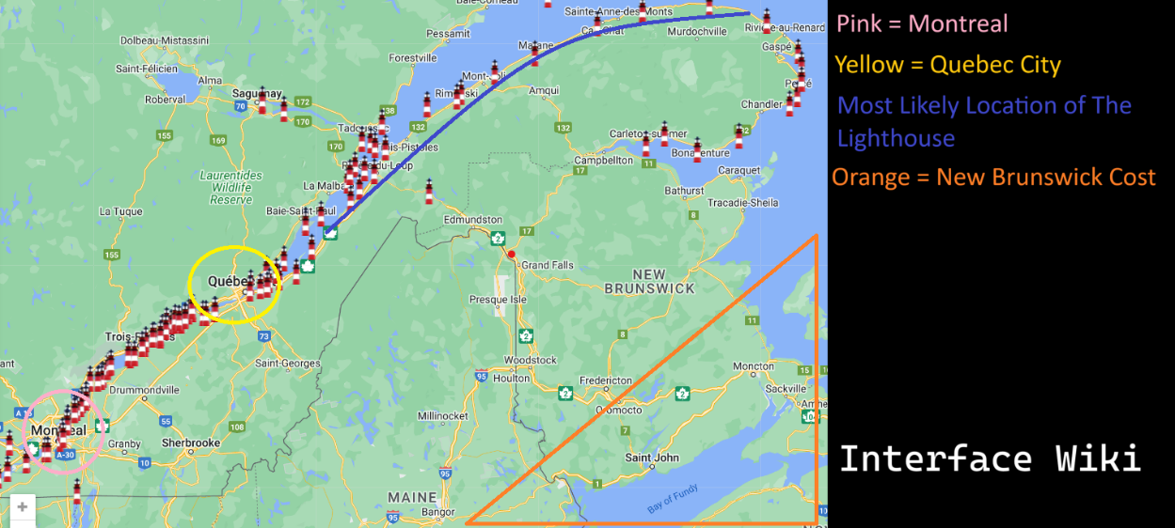

**Montreal**

Montreal is the city which the majority of interfaces is based around. Bellow, I will explain the basic details of the most prominent details of the key locations shown in the series.

**Turcot Interchange**

This is a famous interchange in Montreal that was opened in 1967.

This Hyperlink will take you to the Wikipedia page for Turcot Interchange

**Montreal’s Olympic stadium**

The Montreal Olympic stadium is a notable sports stadium located in Montreal it was originally opened in 1976 for the Olympics.

This Hyperlink will take you to the Wikipedia page for Olympic stadium

**Mount Royal Cross**

Is a prominent monument in Montreal the first illuminated cross was made in 1924.

This Hyperlink will take you to the Wikipedia page for Mount Royal Cross

**Montreal Museum of Fine Art**

The Montreal Museum of Fine Art is the most prominent location for art in Montreal and was opened in 1860.

This Hyperlink will take you to the Wikipedia page for The Montreal Museum of Fine Art

**New York**

New York is seen during The Philadelphia Experiment as well as in the interface there are three noticeable location shown form New York in the series.

This Hyperlink will take you to the Wikipedia page for New York

**The Twin Towers**

The Twin Towers are briefly shown in episode 23 being simulated in the interfaces, there is a brief interior shot of The Twin Towers where KAMI is seen standing inside before a plane collides with the building.

This Hyperlink will take you to the Wikipedia page for The Twin Towers

**The Statue of Liberty**

This statue depicts a lady dressed in robes holding a torch. This statue was originally a copper colour but has oxidised to blue. This statue was meant to represent freedom and liberty as well as the close relationship between the French and America.

Statue of Liberty has a page on the Interface Wiki so click here to find out more.

This Hyperlink will take you to the Wikipedia page for The Statue of Liberty

**United Nations Headquarters**

This is the building that usually hosts united nations meetings including the meeting shown in episode three where we see KAMI being unveiled.

This Hyperlink will take you to the Wikipedia page for the United Nations Headquarters

**Dreamland**

Dreamland is also technically located in New York on a small island called cony island, it was bult in 1904 and was in operation until 1911 when it burned down.

The only noticeable differences between the real worlds Dreamland and Interface Dreamland is the addition of The foolish house where Mischief was known to work.

This Hyperlink will take you to the Wikipedia page for Dreamland

**New Orleans**

New Orleans is briefly shown in episode 23 where we see a simulation of Piazza D'Italia an iconic plaza in New Orleans.

This Hyperlink will take you to the Wikipedia page for New Orleans

Piazza D'Italia has a page on the Interface Wiki so click here to find out more.

This Hyperlink will take you to the Wikipedia page for Piazza D'Italia

**Sources**

Interface

https://www.youtube.com/watch?v=EHqsCmfTDmI&list=PLPnjato8iGXLQbppBPhOny8XLSRl7S5pM&index=1

Secondary source of information on interface and formatting ideas for webpages. <https://umami.fandom.com/wiki/Umami_Wiki>

Lighthouse Map

<https://www.lighthousefriends.com/maps.html>

Montreal

<https://en.wikipedia.org/wiki/Montreal>

Turcot Interchange

https://en.wikipedia.org/wiki/Turcot_Interchange

Mount Royal Cross

<https://en.wikipedia.org/wiki/Mount_Royal_Cross>

Montreal Museum of Fine Arts

<https://en.wikipedia.org/wiki/Montreal_Museum_of_Fine_Arts>

Olympic Stadium

<https://en.wikipedia.org/wiki/Olympic_Stadium_(Montreal)>

New York City

<https://en.wikipedia.org/wiki/New_York_City>

World Trade Centre

<https://en.wikipedia.org/wiki/World_Trade_Center_(1973%E2%80%932001)>

Statue of Liberty

<https://en.wikipedia.org/wiki/Statue_of_Liberty>

Headquarters of the United Nations

<https://en.wikipedia.org/wiki/Headquarters_of_the_United_Nations>

Dreamland

https://en.wikipedia.org/wiki/Dreamland_(Coney_Island,_1904)

New Orleans

<https://en.wikipedia.org/wiki/New_Orleans>

Piazza d'Italia

<https://en.wikipedia.org/wiki/Piazza_d%27Italia_(New_Orleans)>

**Cerebral Electricity**

**What Is Cerebral Electricity**

Cerebral electricity is seemingly a type of energy created by the brain and nerve system of animals and humans, form what we see in the series it seems this is stored in the body until the death of the subject when it is relied through the eyes and mouth.

Cerebral electricity has aways existed in the interfaces universe, but it was not visible to humans until the Philadelphia experiment in 1943, it is not explained how the cerebral electricity was reviled beyond that it has something to do with The USS Eldridge being teleported from Philadelphia to new York. It is implied by Mr Greetings that after the cerebral electricity was realised and understood by humans it could not be rehidden.

Cerebral electricity created a variety of changes in the world not all of which are explained, most noticeable the sky changed colours now usually appearing a shade of red to orange, occasionally being green. metal was shown to also change colours usually to pink.

**Cerebral Electricity Before 1943**

Cerebral electricity is confirmed to have existed before 1943 at several points in the series most notably most ghost stories are explained to have been the result of cerebral electricity, this implies that it was possible to become a Cerebral electricity monster before 1943.

Myths and religions are likely also explained by cerebral electricity having existed prior to 1943. In episode 16 he see Henryk falling from the sky before 1943 noticeably this is implied to be immediately after to his transformation this would imply that humanoid and some of the non humanoid cerebral electricity monster where around prior to 1943 but some were likely not visible.

**What Are Cerebral Electricity Monsters**

Cerebral electricity monsters are animals usually humans that have ever died leading to there cerebral electricity transforming into a creature based on their memories and perspective or a person who have had there body’s changed into cerebral electricity like what happened in the Philadelphia experiment.

One of the most important things to know about cerebral electricity monsters is that there form and powers are seemingly entirely based on their memory’s and perspective of the world.

For example let’s look at Mischief and Mr Greetings, Mischief’s form is clearly based on his costume that he wore as a performer at The Foolish House in Dreamland this could also help to explain his powers which is primarily shown to be transformation, something that would let hi m tell better jokes and help him to fulfil his curiosity which is on of Mischief other prominent character trats.

Mr Greetings on the offer hand appears entirely human and is nether shown to have powers despite the fact we know he has transformed decades ago during the Philadelphia. This is very easily explained by the fact we see that the pre-Philadelphia experiment world and humanity are extremality important to him, likely meaning that his perspective of the world prevented him from significantly changing.

I would consider there to be two distinct forms of cerebral electricity monsters and one form of creature that is against to cerebral electricity monsters I will explain each bellow.

**Complete Cerebral Containment Monsters (CEM Type 1)**

CEM Type 1’s are the most commonly seen type of cerebral electricity monster. Characters who are in this category are noticeable no humanoid having a verity of physical features that are not considered normal, they also usually have stronger powers.

Notable characters in this category are Mischief, The Ghost, The Chef, and The Wind

The transformation process for these characters seams to heavily involve death, we see in episode 21 Mischief rise into the sky still noticeable humanoid and then get shot down into the sea turning into his wormlike form. We also see The Ghost passing of old age, before her realised cerebral electricity is transformed into The Ghost.

I believe the transformation into a Complete Cerebral Containment Monster you need to have your physical form destroyed and have a strong enough cerebral electricity to be able to reconstruct a physical form.

Unfortunately, the only complete cerebral electricity monsters we see die are absorbed by KAMI of screen so we do not know what happens after they die, it is possible that when they die if they are strong enough they are capable of rebuilding themselves.

**Humanoid Cerebral Electricity Monsters (CEM type 2)**

CEM Type 2’s are people who have been transformed into a CEM but has maintained their human form, they may have some powers, but these will usually be weaker not usually being noticeable.

Notable characters in this category are Henryk, and Mr Greeting.

The creation of a Humanoid Cerebral Electricity Monsters is a lot less clear, but I think that the main way they come into existence is by having there body’s be converted into cerebral electricity and being able to rematerialize without your body being destroyed like we see happen in the Philadelphia experiment.

This explains Mr Greetings and the navy men that got fused to the hull of the USS Eldridge, but Henryk doesn’t neatly fit into this as he is believed to have died in a nuclear attack that would have destroyed his body. Ther most likely answer to this is that if your body is destroyed or if you die then you can rematerialize as a humanoid but only if you have an extremely strong connection to their humanity. This would also explain why Henryk doesn’t age well Mr Greetings dose, Mr Greetings is still in his human body while Henryk is in a reconstructed body.

Noticeable these creatures are still shown to release cerebral electricity when that die the crew of the USS Eldridge were shown to partially dissolve into cerebral electricity after their deaths and Mr Greetings cerebral electricity is seen to leave his body and be absorbed by The Interface after his death. This may imply that they are still capable of a full transformation.

**What Are Cerebral Electricity Containers (CEC)**

CEC’s are not cerebral electricity monsters but are machines most commonly robots that are being used to control and contain cerebral electricity. These characters are shown to have limited sentences as a result of being made from cerebral electricity and have been shown to be massively powerful.

Noticeable characters from this category are KAMI, The Mechanical Saccorhytus, and arguable The Interface.

These characters are shown to have the memories and abilities of those they have absorbed and in the interface’s case the consciousness of those absorbed by the system are shown to still be functional.

If The Oni is the result of KAMI having undergone a transformation after her destruction this would imply that these machines are technically alive.

**Comparistion To Composition 8**

This painting is used in many episodes when Cerebral electricity is beaning used to create a verity of materials.

I think that this painting was used to help depicted the cerebral electricity transforming from a state of pure energy to having a physical form having shapes and angles.

**References**

Henryk

Mischief

Mr Greetings

KAMI

The Mechanical Saccorhytus

The Ghost

The Wind

The Chef

The Oni

Composition 8

**Sources**

Interface

https://www.youtube.com/watch?v=EHqsCmfTDmI&list=PLPnjato8iGXLQbppBPhOny8XLSRl7S5pM&index=1

Secondary source of information on interface and formatting ideas for webpages. <https://umami.fandom.com/wiki/Umami_Wiki>

**Piazza D'Italia**

**Sidebar**

Name: Piazza D'Italia

Designed By: Charles Moore

Year Opened: 1978

Location: New Orleans

**Article body**

**Description**

Piazza D'Italia is a public area in New Orleans design in recognition of the Italian community’s contribution to the city and has become an iconic part of the city since it was opened to the public.

**Analysis of Uses in The Show**

Episode 23 The Unconscious Conscious

There is likely no particular meaning to this appearing in the show, beyond the fact this is a very iconic and unique looking plaza.

Both this piazza located in New Orleans and New York are shown in this episode which proves that The Interfaces is not 1 to 1 with the real world and you can likely travel as you wish. I usually don’t like to reference Safe Mode, but this is shown there, and it is referred to as Fast Traveling, like in a video game.

**References**

Episode 23 The Unconscious Conscious

The Interfaces

**Sources**

Interface

https://www.youtube.com/watch?v=EHqsCmfTDmI&list=PLPnjato8iGXLQbppBPhOny8XLSRl7S5pM&index=1

Secondary source of information on interface and formatting ideas for webpages. https://umami.fandom.com/wiki/Umami_Wiki

Piazza D'Italia

<https://en.wikipedia.org/wiki/Piazza_d%27Italia_%28New_Orleans%29>

Charles Moore

<https://en.wikipedia.org/wiki/Charles_Moore_(architect)>

**Henryk’s Family**

**Description of The Majer Members of the Niebieski family**

This segment will go over all the basic information on the members of the Niebieski family.

**Description of Henryk**

Name: Henryk Niebieski

Aliases: Blue Guy, The Son of Man, The Man of The Past

Gender Presentation: Male

Approximate Age: 107 Years Old

Status: Alive

Species: Cerebral Electricity Monster (Formerly Human)

Voiced By: none (Grunts Are Probably Justin Tomchuk)

Physical Appearance

Henryk appears as a middle-aged man with red hair and moustache, nearly always seen in a blue suit and bowler hat.

Personality

Henryk appears to be depressed, quiet, and contemplative, never speaking in the Interface series. It is clear from his actions that more than everything he cares for his family and feels intense guilt for accidently killing his grandchild and their partner.

**Description of Henryk’s Wife**

Name: Unknown

Aliases: Henryk’s wife, The Ghost’s Mum

Gender Presentation: Female

Approximate Age: Middle-Age

Status: dead

Species: Human

Voiced By: none

Physical Appearance

Henryk’s wife appears as a middle-aged woman with long brown hair.

Personality

Henryk’s Wife appears to be friendly and compassionate, noticeable working as a nurse.

**Description of The Ghost**

Name: Unknown

Aliases: The Ghost, Henryk’s Daughter, The Hand, CODENAME HAND, Shiva

Gender Presentation: Female (C.E.M)

Approximate Age: Less Than 74 years old

Status: Consumed And Repurposed

Species: Cerebral Electricity Monster (Formerly Human)

Voiced By: Christa Elliott

Physical Appearance

Henryk’s Daughter appears as a normal middle-aged woman with long brown hair tied into a ponytail.

The Ghost appears as a large hand with a body where the wrist should be, her head looks like a skull with two pink horns.

Personality

Henryks daughter seams relatively normal and mondain with a strong connection to her family, she appears to be more melancholy after her death.

**Description of Henryk’s Greet-Granddaughter**

Name: Unknown

Aliases: Henryk’s Greet-Granddaughter, Little Girl, The Ghost’s Granddaughter

Gender Presentation: Female, Child

Approximate Age: Young Child, Likely 3-13

Status: Alive

Species: Humen

Voiced By: None

Physical Appearance

Henryk’s Greet-Granddaughter appears as a young girl with long brown hair.

Personality

Henryk’s Greet-Granddaughter personality is not clear in the series as she has no lines and few appearances in the series. The only thing that is clear about this character is that she seems to love her grandmother, The Ghost as she is upset when she is taken and seams happier when they have been reunited in episode 21.

**Timeline**

This segment will be going over all the events of Henryk’s family in order.

if multiple events happen in the same year that will be numbered in the order they occur, explanations below for clarity.

Events that happen **within an episode** not a flashback will have the ***episode number after the year***.

if the **order is unclear or there are *no other events*** then there will be ***no number*** to signify what the order they occurred in.

in cases where **only the order of some events are clear**, the events that have no clear order will ***share a number***.

The date is as specific as it is written, explanations below for clarity.

If a year is stated with **no additional** information that is the ***exact year*** it happened.

If a year is said to be **before** a year it is that year or ***any point before***.

If a year is said to be **after** a year it is that year or ***any*** ***point after***.

If a year is said to be **around** a year it is near that year but may be a few years ***before or after.***

1910: Henryk is born.

Justification

This is seen on Henryk’s medical record and directly confirmed by Mischief in Episode 8

Before 1943, 1: Henryk dies accidentally in an nuclear bomb test he was hired to photograph.

Before 1943, 1: Henryk drifts down from the sky in his parachute and meets his wife for the first time, she is working as a nurse at the hospital he is in.

Justification

Henryk is implied to have transformed and regained his physicality during the scene we see in Episode 16 of Henryk falling from the sky in his parachute. As the sky is still blue both events must accrue before The Philadelphia Experiment as this noticeable changed the colour of most thing including the sky.

Noticeable the first known nuclear bomb test happens on July 16th, 1945, two years after the latest date this could have taken place. This may imply there is a differences nuclear bomb development in the Interfaces universe which could also be implied by the blast evidently being significantly larger than expected resulting in Henryk’s death.

After 1945, 1: Henryk plants a tree with his pregnant partner

After 1945, 2: Henryk’s daughter is born, and Henryk becomes a father

After 1945, 3: Henryk marries his wife.

Justification

During Episode 16 we see the tree being planted that is shown in the photo of their wedding. As his wife is not visibly pregnant during the wedding and after the tree has grown, this implies that Henryk’s daughter was born before they were married.

After 1953, 1: Henryk’s Wife died from an unknown illness

After 1953, 2: Henryk attendees his wife’s funeral and the paster who is hosting the funeral, is noticeably freak out by his apparent agelessness.

Justification

Henryks daughter mentions in episode 6 that her mom died when she was young but clearly remember details of her funeral and other stories her mom shared with her implying, she was at lest 8 years old as this is the age children usually develop their long-term memory.

Given that Henryk appeared young enough to be noticeable weird it is implied that this likely happened closer to 1963 or 1973 as Henryk would only be 43 in 1953 so looking young would not be weird, however for the reasons I have stated above I think the earliest date would still be 1953.

After 1963: Henryk’s Granddaughter or Grandson is born making him a Grandfather and Henryk’s daughter a mother.

After 1963: The conversation between Henryk and his daughter seen in Episode Six about if Henryk can ever die takes place.

After 1963: Henryk and his daughter also make perogies and the conversation between Henryk and his daughter seen in Episode Sixteen about when Henryk fell from the sky happens.

Justification

The earliest reasonable point for Henryk’s daughter to be born is 1945 after the end of World War 2. This means that the earliest possible point for Henryk’s granddaughter to be born is 1963 as this would be 18 years after the earliest year Henryk’s daughter is born, though it is likely latter.

Additional for the same reasons this is the earliest point for the conversations seen in episode 6 and 16 as Henryk’s daughter is seen as an adult who is not noticeable old.

Around 2012, 1: Henryk’s great-granddaughter is born

Around 2012, 2: Henryk’s family photo is taken by Henryk.

Justification

We know Henryks Great-Granddaughter was still a baby around 1 to 3 years old in 2015 as this is the date of the crash, given that the series is believed to be set in 2017 then it would make her 3 years old at youngest and 5 years old at oldest. If she is 5 years old this would also roughly match the appearance of Henryk’s Great-Granddaughter.

We see the photo of Henryk’s family has both his daughter and great-granddaughter meaning that Henryk’s daughter must die after Henryk’s Great-Granddaughter was born, given that Henryk’s Great-Granddaughter is still a bay during the crash she this would be about at the similar time.

2015, EP20, 1: Henryks’ daughter dies of old age and becomes The Ghost.

2015, EP20, 2: After watching his daughter die Henryk attempts suicide by walking out into traffic. either Henryk’s powers activate to protect him or the car swerves into the river, regardless, Henryk’s family die excluding his Great-Granddaughter who is taken by The Ghost.

2015, EP20, 3: The Ghost talks with Mischief and makes a deal with him.

2015, EP20, 3: The cerebral electricity of Henryk’s dead family is consumed by Mischief.

2015, EP20, 4: Henryk Abandons his home, prsumeble out of gult.

Justification

These events are shown to happen in quick succession in Episode 20 of Interfaces, so they likely happen on the same day.

My reasoning for these events happening in 2015 is the calendar we see in episode 16 where we see a calendar in Henryk’s abandoned house dated November 2015 it is odd for the scene to focus on this for no reason, so I think it has given a hint to when the home was abandoned.

I believe that Henryk would have abandoned his home Immediately after his suicide attempted, as this place is likely painful for him, hence him abandoning it.

This also makes sense with Henryk’s daughter as she is shown as a baby in episode 20 and a young child 7 at most through the series which is set in about 2017 making her likely 2-3 years old during the crash and 4-5 years old in the show.

2017, 1: The start of the Interface series.

Justification

9 Dec 2017 is the release data of the first episode. Given that the series is shown to be set in the modern day, roughly during fall or summer then it makes sense that the series would take places in middle to late 2017.

A statue appears in the series called The Eye which was realised in 2011 meaning the series must take places after this.

In Episode 16 we see a calendar with a date on it of November 2015 which implies the series takes places a few years after this.

Some of the other apparent dates in the series like how old Mr Greetings or Henryk’s great granddaughter appear in the series.

2017, EP1: Henryk meats Mischief in Montreal and Mischief discusses his past with The Philadelphia experiment.

2017, EP2: Henryk rides Mischief in his bus form to the Montreal Museum of Fine Art.

2017, EP4: The Ghost watches tv with her granddaughter.

2017, EP4: KAMI floats down from The Mechanical Saccorhytus and attacks The Ghost and little girl, successfully capturing The Ghost.

2017, EP5: Henryk and Mischief view the painting, the son of man and discuss the painting and Henryk wants.

2017, EP6, 1: Henryk and Mischief view the painting, Geopoliticus Child Watching the Birth of The New Man and discuss its meaning and how it relates to Henryk and Mischief.

2017, EP6, 2: Henryk faints as a result of stress from his conversation with Mischief.

2017, EP7: KAMI is degaussed after absorbing The Ghost.

2017, EP8, 1: Henryk watches tv in the hospital and talks to Mischief about his age and abilities.

2017, EP8, 2: Henryk escapes the hospital by using Mischief as a parachute.

2017, EP9: Henryk and Mischief visit a restaurant and Mischief and The Chief discuss parasites.

2017, EP9: The Chef share the vision he has been having about KAMI to Mischief and Henryk.

2017, EP10: Henryk remembers his family and daughter well sitting in The Chefs restaurant looking at the painting Christians World.

2017, EP11, 1: Mischief reveals that Henryk’s Greet-Granddaughter survived.

2017, EP11, 2: Henryk embraces his desire to have a family again and aggress to travel home with Mischief.

2017, EP12, 2: KAMI floats down from The Mechanical Saccorhytus and attacks The Chef taking on her meany armed form and using The Ghost to protect herself.

2017, EP12, 4: The Ghost captures The Chef as The Mechanical Saccorhytus is seen floating behind them.

2017, EP13, 1: Henryk and Mischief travel east from Montreal towards the lighthouse

2017, EP13, 2: Mischief transforms into a unicycle and makes Henryk fall before apologizing.

2017, EP15, 1: Henryk receives a vison form The Winds.

2017, EP15, 2: Henryk remembers a conversation with his daughter about if he will ever die.

2017, EP15, 3: Henryk receives a photo of The Winds from Mischief.

2017, EP16, 1: Henryk returns home finding it abandoned and in a state of disrepair.

2017, EP16, 2: Mischief transforms into a frog and talks to Henryk about his house.

2017, EP16, 3: Henryk remember a conversation with his daughter about when he met his wife.

2017, EP17, 1: Mischief shares memories of his past with Henryk.

2017, EP17, 2: Henryk and Mischief deicide to travel to The Lighthouse.

2017, EP18, 1: Henryk’s Greet-Granddaughter watches as The Ghost’s hands are seen repairing the apartment complex, they used to live in.

2017, EP18, 2: The Ghost’s hands are seen to return to The Mechanical Saccorhytus.

2017, EP18, 2: One of The Ghosts hands is seen to land and turn into The Ghost to meet Henryks greet-granddaughter.

2017, EP19, 1: Henryk plays the harmonica in his home before going to sleep.

2017, EP19, 2: Henryk and Mischief travels to The Lighthouse.

2017, EP19, 3: Henryk and Mischief talk about the secrets of their past and Mischief reference to the deal he made with The Ghost.

2017, EP22, 1: Henryk ascends The Lighthouse.

2017, EP22, 2: Henryk connects to The Interface via The Lighthouse’s Cerebral Electricity column.

2017, EP23, 1: Henryk meats Mr Greeting well in the interfaces and they go on a train ride together.

2017, EP23, 2: Mr Greeting and Henryk discuss Henryk’s past and how he died in a nuclear bomb text.

2017, EP23, 3: Henryk see his daughter in the interface, and they discuss if Henryk will stay in the interfaces.

2017, EP23, 4: Henryk looks at his family photo and the photo of The Winds before leaving the interface.

2017, EP24, 1: Henryk and Mischief discuss philosophy and the stars.

2017, EP24, 2: Henryk rejects Mr Greetings offer and embraces the modern world.

2017, EP24, 1: KAMI holds Henryks greet-granddaughter hostage well disguised as Henryk’s daughter

2017, EP24, 3: Henryk and Mischief escapes The Lighthouse and survive an attempted attack by KAMI using The Ghost’s powers.

2017, EP24, 4: Henryk and Mischief fight KAMI who is disguised as Henryk’s daughter.

2017, EP24, 3: Henryk’s Greet-Granddaughter makes a run for it after KAMI’s mask is stolen.

2017, EP24, 5: Henryk hides with his great-granddaughter behind a rock.

2017, EP24, 6: Henryk morns Mischief with his great-granddaughter before reviling that Mischief is alive.

2017, EP24, 7: Mischief is consumed by The Mechanical Saccorhytuswell Henryk and his great-granddaughter watches.

2017, EP24, 3: The Ghost is presumably destroyed when KAMI self-destructs.

2017, EP24, 8: Henryk and his greet-granddaughter visit a dinner that resembles the painting Nighthawks, The Museum Boy may be present in the background.

**Analysis**

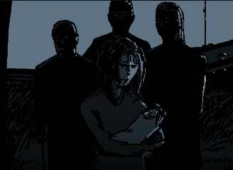**Who Are the Different Members of Henryk’s Family in The Family Photo**

Un this segment I will go over all of the members of Henryk’s family shown in this picture

Henryk’s daughter and her partner.

We know that the women in the centre of the image is Henryk’s daughter and that she is holding Henryk’s great-granddaughter.

Her partner is presumable the old man seen on the left of the image.

Henryks grandson or granddaughter and their partner.

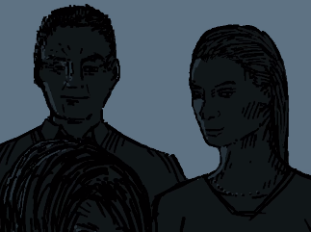We know that one of the people in this image is Henryk’s grandchild and the other is their partner.

My theory would be that the woman is Henryk’s grandchild. The only evidence I have for this theory is that both Henryk’s daughter and his great-granddaughter are female so this would match the pattern, obviously this is not really proof but I think it would make the most narrative sense.

**Analysis of Henryk**

**Henryk Is Polish**

Henryk is likely polish or from a polish family. His family are known to cock perogies and his name is polish.

Given the importance of World War 2 in the series this could imply that Henryk was one of the many refugees created by the Nazi invasion of Poland. This is not conferred or disproven by the series so far.

**How Did Henryk Survive His Suicide Attempted**

We see Henryk in the road before the crash and then it cuts to white, there is not enough spaces or time available for the car to turn into the river like we see it did.

This implies a part of his powers may be protecting him from harm in whatever way is possible. In this case I believe that Henryk realised a large amount of Cerebral Electricity and blow the car of the road, this is also supported by the fact we see a lot of Cerebral Electricity on the bridge after the crash. In episode 13 we see Henryk perfectly land after a fall which could be a much smaller use of this power.

**Henryks Death Is Very Complicated.**

During one scene from episode 23 we see Henryk getting blasted by a nuke casing him to die before getting covered with Cerebral Electricity and reviving.

This would seemingly imply that Henryk died to a nuclear blast, but we also know that Henryk was transformed when the sky’s where still blue, meaning before 1943.

This is odd as the first nuke was detonated in 1945, meaning that unless the events of when the skies where still blue are before Henryk’s transformation Henryk dying to a nuke seemingly cannot be true.

The most likely conclusion is that this is a small continuity error and that UMAMI did not realize that the first bomb test was 1945 but I think this could also imply that in the interfaces universe the early nuclear bomb testes where more successful than in our universe.

This could be explained by the presents of cerebral electricity in Interface if cerebral electricity or water weas used to power The Philadelphia Experiment was used instead of uranium this could explain how the development of nuclear blasts was quicker in Interface.

Amusing the bomb was seemingly powered by cerebral electricity would also explain how Henryk became a Cerebral Electricity Monster before The Philadelphia Experiment, as well as why the nuclear blast was likely bigger than the military expected.

Henryk transformation into a cerebral electricity monster prior to the Philadelphia experiment is not a contradiction as ghost stories and superstitions are explained to have always been a result of cerebral electricity but where only provable after the experiment acquired.

I believe that the nuclear blast weas larger than the military expected because of Henryk’s death the military wouldn’t tell Henryk to go somewhere they know he would die the only explanation is that they didn’t think the blast would be as big as it was. This may add to the evidence that the material used for bomb wasn’t uranium but something related to cerebral electricity.

A crazier theory for Henryk somehow dying to a nuke years before they were made is that Henryk may have time travelled after his death, he appears out of nowhere in episode 16 and this is the simplest explanation for this seaming continuity error additionally Cerebral electricity is shown to be able to effect time, as we see The Wind can freeze time, all that being said this is pretty blatantly not intended.

**Henryk Represents The Son of Man**



Henryk is clearly meant to represent The Son of Man in the show.

I believe there is a correlation between the apparent boringness of the original Son of Man with Henryk also seeming boring at first glance. In both cases it is not the appearance of the man that is meant to be interesting but the hidden details that are only hinted at in the original work. This could be supported by the chose to make Henryk a silent protagonist which makes him much more mysterious.

In short Henryk being represented by The Son of Man is a metaphor representing that Henryk is a lot more important and interesting than he first appears.

For a much deeper analysis of this painting and its importance to the show check out The Son of Man’s page here**.**

**Analysis of The Ghost**

**The Ghosts Deal with Mischief**

The Ghost requests that Mischief brings Henryk back to how he used to be, presumably meaning when he was less depressed. She also commands that Mischief informs Henryk of his grate-granddaughters survival.

In exchange for this Mischief will receive all that perish, the meaning of this is not entirely clear but it seems more than likely that this refers to the cerebral electricity in the interface, the interfaces is a form of digital afterlife that “all that perish” will presumably go to.

This would also explain The Ghost’s actions in episode 4 as she shows no resistance to being absorbed to the Greetings Robotics system. This appears odd in the series be could be explained by this being a part of their deal.

Mischief mentions in Episode 24 that he was worried about the consequences of Henryk not waking up this may imply that there are established consequences of breaking the deal that are not made clear in the series. Additionally, it is possible that this would only result in him not getting what The Ghost promised him.

Mischief likely could not have beaten The Mechanical Saccorhytus without being consumed by him and corrupting him, which is odd considering that The Mechanical Saccorhytus seams to be made with the intent of being able to absorb large amounts of cerebral electricity so Mischief should not be able to corrupt him. This leads me to believe that as part of their deal when Henryk and his greet-granddaughter are reunited she will somehow disable whatever was protecting The Mechanical Saccorhytus to allow Mischief to consume the Cerebral Electricity from The Interface.

**Shiva Comparison**

The Ghost is compared to a Hindu goddess called shiva by Greetings Robotics.

I believe that the origine of this is form the quote, “We knew the world would not be the same. A few people laughed; a few people cried. Most people were silent. I remembered the line from the Hindu scripture, the Bhagavad Gita; Vishnu is trying to persuade the prince that he should do his duty, and to impress him, takes on his multiarmed form and says, ‘Now I am become Death, the destroyer of worlds.’ I suppose we all thought that, one way or another.”

This quote is highly relevant to the series as it is about the change to the world after the creation of nuclear bombs, which allegorically relates to interfaces which is about the changes to the world after the discovery of cerebral electricity.

From what I have read Shiva is a different form of Vishnu and another god called Rudra. Noticeably all these gods are portrayed as having multiple arms which relates to The Ghost as she has many hands.

**Analysis of Henryk Presumed Granddaughter**

**Possible Relation To KAMI**

Henryk’s Presumed Granddaughter has a strong physical resemblance to KAMI which would lead some to believe that she has connection to her.

The only connection that would make sense is that she was made using Henryk’s Presumed Granddaughter, but this is impossible as we know her cerebral electricity has consumed by Mischief.

The meta reason for this was likely a reused asset.

**Analysis of Henryk’s Greet- Granddaughter.**

**Is She a Willing Hostage**

In Episode 21 she is shown to be much happier as her old apartment building is restored, she then walks away and is seemingly greeted by The Ghost, this seemingly implies she was tricked by Greetings Robotics into thinking that The Ghost was willingly working with them.

However in episode 24 she is clearly uncomfortable and runs away as soon as possible so she has likely figured out that this was only a copy of The Ghost being used by Greetings Robotics.

If I am right about her having been tricked, she would not be a willing hostage but would have likely gone with them willingly at first.

**References**

Episode 1 No Title

Episode 2 No Title

Episode 4 The Ghost

Episode 5 The Son of Man

Episode 6 Bear Witness

Episode 7 The Mechanical Saccorhytus

Episode 8 The Watchful Eyes

Episode 9 Camouflage

Episode 10 An Illusion of Time

Episode 11 Revelations

Episode 12 Metallic Evolution

Episode 13 The Right Direction

Episode 15 The Winds

Episode 16 When Skies Where Still Blue

Episode 17 The Fall

Episode 18 Rebuilding

Episode 19 Entangalment

Episode 20 All That Perish

Episode 21 Restoration

Episode 22 Ascent to Solitude

Episode 23 An Unconscious Conscience

Episode 24 The Abyss

Mr Greetings

The Chef

The Ghost

The Wind

Henryk’s Great-Granddaughter

Henryk

Mischief

KAMI

Greetings Robotics

Cerebral Electricity

**Sources**

Interface

https://www.youtube.com/watch?v=EHqsCmfTDmI&list=PLPnjato8iGXLQbppBPhOny8XLSRl7S5pM&index=1

Secondary source of information on interface and formatting ideas for webpages. <https://umami.fandom.com/wiki/Umami_Wiki>

**Greetings Robotics**

**Description of The Majer Members of the Greetings Robotics corporation**

This segment will go over all the basic information on the members of the Greetings Robotics corporation.

**Description of Mr Greetings**

Name: Joseph Greeting

Aliases: Mr Greetings, The Man of The Past, Old Man, CEO of Greetings Robotics

Gender Presentation: Male

Approximate Age: Older Than 74 Years Old

Status: Deceased (Upload to The Interface)

Species: Unclear

Voiced By: Philip Hersh

Physical Appearance

Mr Greetings is an extremely old man with white hair that is usually well dressed.

Personality

Mr Greetings is very contemplative commonly monologuing to himself and seems smart but also quite prejudice.

**Description of KAMI**

Name: Kinetic, Autonomous, Mechanical, Interface

Aliases: KAMI, KAMI MRK1, KAMI MRK2, The Creature, The Alter

Gender Presentation: Unclear (C.E.C)

Approximate Age: Unclear

Status: Unclear (presumed Transformed)

Species: Cerebral Electricity Container

Voiced By: None

Physical Appearance

KAMI is a white and black robot with wires coming out the back of her head that resembles dreadlocks, her chest is covered by what appears to be a ribcage with cerebral electricity behind it, at the centre of her ribcage is a small heart. On her back there is a Japanese’s symbol that means God or KAMI in Japanese’s.

KAMI’s mask has to bright red circles on her checks, bright red lips and to holes for her to see through.

Personality

KAMI is a robot that contains cerebral electricity if she has a personality, she doesn’t show it externally, beyond occasionally staring at her mask.

**Description of The Mechanical Saccorhytus**

Name: The Mechanical Saccorhytus

Aliases: Greetings Robotics blimp, Big Baby

Gender Presentation: none, Unclear

Approximate Age: Unclear

Status: Unclear

Species: Unclear (Cerebral Electricity Container)

Voiced By: None

Physical Appearance

The Mechanical Saccorhytus is usually a large blimp with a face at the front of it. However, The Mechanical Saccorhytus can transform into another form that heavily resembles a large baby.

Personality

The Mechanical Saccorhytus is usually inanimate but after transforming into a big baby we take on the usually personality of a baby being very hungry and emotional.

**Timeline**

This segment will be going over all the events of The greetings Robotics Corporation in order.

if multiple events happen in the same year that will be numbered in the order they occur, explanations below for clarity.

Events that happen **within an episode** not a flashback will have the ***episode number after the year***.

if the **order is unclear or there are *no other events*** then there will be ***no number*** to signify what the order they occurred in.

in cases where **only the order of some events are clear**, the events that have no clear order will ***share a number***.

The date is as specific as it is written, explanations below for clarity.

If a year is stated with **no additional** information that is the ***exact year*** it happened.

If it is stated to be **between two years**, then we know ***the events fall*** ***between two years***.

If a year is said to be **before** a year it is that year or ***any point before***.

If a year is said to be **after** a year it is that year or ***any*** ***point after***.

If a year is said to be **around** a year it is near that year but may be a few years ***before or after.***

Before 1925: Mr Greetings is born.

Justification

Mr Greetings must have been born at least 18 years before joining the military so the earliest possible date for him being born is 1925, it is possible he was born before this as he looks slightly old in the photos shown of him from 1943.

Before 1943:Mr Greetings joins the military more specifically the navy.

Justification

We know that Mr Greetings was in the military during 1943 as this is the date of The Philadelphia Experiment so he must have been in the military before that.

1943, 1: The Philadelphia Experiment accusers teleporting the USS Eldridge to New York from Philadelphia.

1943, 2: Mr Greetings is turned into pure cerebral electricity before rematerializing slightly above the USS Eldridge. Seemingly unharmed and uncharged.

1943, 3: Mr Greetings watches many of the solders aboard the USS Eldridge die after being fussed to the hull of the ship.

1943, 4: Mischief says boo to Mr Greetings before leaving.

Justification

The events of The Philadelphia Experiment is repeatedly mentioned to have taken places in 1943.

After 1945: Greetings Robotics is founded by Mr Greetings.

After 1945: The Mechanical Saccorhytus is bult by Greetings Robotics presumably ordered by Mr Greetings.

Justification

We do not get much information on when Greetings Robotics was founded but it can be assumed that this was shortly after World War 2 as Mr Greeting is a very well-known and established person in The Interfaces world which would imply that he has been actively working for quite some time.

It is easy to assume that The Mechanical Saccorhytus was more likely bult during the 2000s but we do not get any information on when it was bult or unveiled so all I can say for sure is that it was bult after World War 2. Additionally, it is possible that the blimp was originally made earlier, and latter modified into The Mechanical Saccorhytus.

2017, EP3: KAMI MRK 1 is constructed by Greetings Robotics.

2017, EP3, 1: The Mechanical Saccorhytus is seen floating near the United Nations Headquarters.

2017, EP3, 2: Mr Greetings hosts a meeting at the United Nations Headquarters.

2017, EP3, 3: KAMI MRK 1 is unveiled by Mr Greetings to the public at the United Nations Headquarters.

2017, EP4: KAMI floats down from The Mechanical Saccorhytus and attacks The Ghost and little girl, successfully capturing The Ghost.

2017, EP7, 1: The Mechanical Saccorhytus is seen floating near The Lighthouse.

2017, EP7, 2: Mr Greetings monologues well KAMI Is processing The Ghost.

2017, EP7, 3: KAMI is degaussed aboard The Mechanical Saccorhytusafter absorbing The Ghost.

2017, EP12, 1: The Mechanical Saccorhytus is seen floating above Montreal.

2017, EP12, 2: Mr Greetings monologues well Greetings Robotics prepares for the attack on The Chef.

2017, EP12, 3: KAMI looks at her mask well riding The Mechanical Saccorhytus.

2017, EP12, 4: KAMI floats down from The Mechanical Saccorhytus and attacks The Chef taking on her meany armed form and using The Ghost to protect herself.

2017, EP12, 5: KAMI is pinned to the Mount Royal Cross and ever destroyed or critically damaged by The Chef.

2017, EP12, 6: The Mechanical Saccorhytus is seen floating as The Ghost captures The Chef

2017, EP18, 1: KAMI is seen aboard The Mechanical Saccorhytus and is being repaired and upgraded as well as having absorbed The Chef.

2017, EP18, 2: KAMI is seen to view the memories of The Chef and learn about Henryk’s and Mischief.

2017, EP18, 3: The Mechanical Saccorhytus is seen floating above the bay near the apartment that The Ghost was staying in.

2017, EP21, 1: Mr Greetings is the subject of an interview by The Interviewer.

2017, EP21, 2: Mr Greetings remembers his past well talking to The Interviewer.

2017, EP22: The Mechanical Saccorhytus is seen floating towards The Lighthouse and transforming into his baby form.

2017, EP23, 1: Henryk meats Mr Greeting well in the interfaces and they go on a train ride together.

2017, EP23, 2: Mr Greeting and Henryk discuss Henryk’s past and how he died in a nuclear bomb text.

2017, EP23, 3: KAMI is seen in the simulation of New York inside The Twin Towers as a plane collides with them.

2017, EP23, 4: Henryk see his daughter in the interface, and they discuss if Henryk will stay in the interfaces.

2017, EP23, 5: Henryk looks at his family photo and the photo of The Winds before leaving the interface.

2017, EP24, 1: While onboard The Mechanical Saccorhytus, Mr Greetings executes himself to be permanently uploaded to The Interface.

2017, EP24, 2: The Mechanical Saccorhytus is seen waiting outside The Lighthouse.

2017, EP24, 3: The Mechanical Saccorhytus drinks the Cerebral Electricity of The Lighthouse and destroys it.

2017, EP24, 4: KAMI holds Henryks greet-granddaughter hostage well disguised as Henryk’s daughter

2017, EP24, 5: KAMI attacks Henryk and Mischiefs by using The Ghost’s hands.

2017, EP24, 6: KAMI’s mask is removed by Mischief.

2017, EP24, 7: Mischief talks with KAMI before KAMI Attack’s Mischief again.

2017, EP24, 8: Mischief interfaces with KAMI causing her to become corrupt and self-destruct.

2017, EP24, 9: The Mechanical Saccorhytus is seen crying after KAMI’s destruction.

2017, EP24, 10: Mischief is consumed by The Mechanical Saccorhytuswell Henryk and his great-granddaughter watches.

2017, EP24, 11: Mischief transfers to the interfaces via The Mechanical Saccorhytus and forces it into safe mode.

2017, EP24, 12: After KAMI dies, she persuasible transforms into The Oni.

**Analysis**

**What Dose Greetings Robotics Mean by Restoration**

The stated goal of the Greetings Robotics Corporation is restoration however what this mean is not really explained in the show. I believe that there are three different gaols enclosed in this, I will elaborate bellow.

**Meaning One: remove cerebral electricity from the world.**

Mr Greetings clearly wants to just completely remove cerebral electricity from the world but knows that he can’t as this seems to be a fundamental part of the universe. I believe that as he knows this his goal has now changed to trying to completely control all the cerebral electricity in the world.

**Meaning Two: Removal Of Cerebral Electricity Monsters from The World**

Well Mr Greetings cannot fully remove cerebral electricity from the world, but he likely could succeed in capturing and repurposing all the cerebral electricity monsters in the world, this would help to return the world to a state like it was in 1943.

**Meaning Three: Creation Of the Interface**

One of other clear gaols of greetings robotics is to build The Interfaces a form of digital afterlife, fuelled by cerebral electricity. This is seemingly intended to be a simulation of the world without cerebral electricity. A world without cerebral electricity would represent the ultimate return to normalcy from Mr Greetings prospective.

**Analysis of Mr Greetings**

**Mr Greetings Represents the Past**

I believe that both Henryk and Mr Greetings represent the past, I believe that Mr Greetings is meant to represent the old people in the world that refuse to except that the world has moved on from when they were young and are scared of the new world.

This is pretty clear throughout the series especially in Episode 21 Restoration where Mr Greetings admits that a lot of people born after 1943 don’t think there’s anything wrong with the new world and don’t understand what the past was like.

**What Species is Mr Greetings**

Mr Greetings appear to be a regular human being but we see in episode 21 restoration that during the Philadelphia Experiment that he was transformed into pure cerebral electricity and transformed back into his original form. This would seemingly imply that he is no longer purely human but it is not completely clear.

**Analysis of KAMI**

**KAMI Represents The Loss Of Individuality To Society**

Individuality is something that seems particularly important to the series, Mischief is arguably meant to represent individualisation, noticeably in episode 22 quoting The Red Book which is all about individuality.

KAMI how is directly antithetical to Mischief seems to be some form of robot that is powered by the collected Cerebral Electricity of the dead. I think this may be meant to represent the loss of individuality that society often tries to enforce, practically by people who are like Mr Greetings and are obsessed with an idea of how the world is meant to be.

**Analysis of The Mechanical Saccorhytus**

**Why Have KAMI When The Mechanical Saccorhytus Is So Much Stronger**

During her fight with The Chef, we see that The Chef was capable of beating KAMI before The Mechanical Saccorhytus using The Ghosts powers appears behind him capturing him. We also see that after KAMI self-destruction The Mechanical Saccorhytus is sent in to capture Mischief, this leads to the question why Greetings Robotics needed KAMI.

I think this is simply because KAMI is easier to control and can be relied upon while The Mechanical Saccorhytus is unreliable. When The Mechanical Saccorhytus is in his baby form he is massively emotionally and seams easily distracted likely meaning that he is not reliable for capturing other Cerebral electricity monsters.

**References**

Episode 3 Greetings Robotics

Episode 4 The Ghost

Episode 7 The Mechanical Saccorhytus

Episode 12 Metallic Evolution

Episode 18 Rebuilding

Episode 21 Restoration

Episode 22 Ascent to Solitude

Episode 23 an Unconscious Consciences

Episode 24 The Abyss

Mr Greetings

KAMI

The Mechanical Saccorhytus

The Oni

The Chef

The Ghost

The Wind

Henryk’s Great-Granddaughter

Henryk

Mischief

Cerebral electricity

**Sources**

Interface

https://www.youtube.com/watch?v=EHqsCmfTDmI&list=PLPnjato8iGXLQbppBPhOny8XLSRl7S5pM&index=1

Secondary source of information on interface and formatting ideas for webpages. <https://umami.fandom.com/wiki/Umami_Wiki>

**Hazmatz Monster Collection**

The Hazmatz Monster Collection is a production in the Interface universe, not much is clear about this organization and what they do, but we do know that they sell cerebral electricity monsters. Bellow we will go over all monsters involved and some analysis on the hazmat collection

**Description of The Majer Members of the Hazmatz Monster Collection**

This segment will go over all the basic information on the monsters seen in the Hazmatz Monster Collection.

Note, none of the characters in this list have official names or allies so I have given them allies that describe them to help talk about them directly.

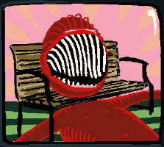**Description of The Bentch**

Name: Unknown

Aliases: The Bentch, Red Maw, Monster Number 1

Species: Cerebral Electricity Monsters

Voiced By: Phil Jamesson

Physical Appearance

The Bentch is a large red man that seems fused to a bench he is shown to be able to change his faces to a wide maw.

Personality

Going from how The Bentch looks he may be a failed-trickster and a hungry person.

Lines

“Growling”

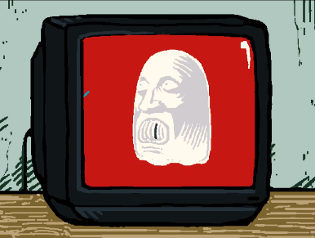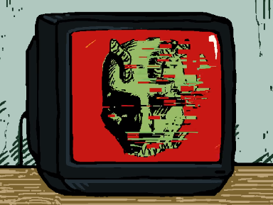**Description of The Ghastly**

Name: Unknown

Aliases: The Ghastly, The Ghost, Monster Number 2

Species: Cerebral Electricity Monsters

Voiced By: Phil Jamesson

Physical Appearance

The Ghastly appears as a classical carton white ghost.

Personality

Thay seam spooky and quite cute, as they seam made form The Ghost they may be good at dealing with kids.

Lines

“Wooing noise”

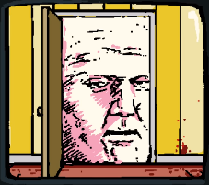**Description of The Doorman**

Name: Unknown

Aliases: The Doorman, Big Head Guy, Monster Number 3

Species: Cerebral Electricity Monsters

Voiced By: Phil Jamesson

Physical Appearance

Appears as a large head looking through a door.

Personality

The Doorman appears very threating and seemingly likes blood.

Lines

“I’m coming for your blood”

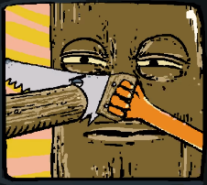**Description of The Tree**

Name: Unknown

Aliases: The Tree, Sawing Monster, Monster Number 4

Species: Cerebral Electricity Monsters

Voiced By: Phil Jamesson

Physical Appearance

The Tree looks like a big tree with humanoid features like eyes and hands, he is noticeable seen cutting of his nose.

Personality

The Tree is shown self-harming so he may be depressed, or he may just enjoys sawing thing.

Lines

“Sawing noise”

**Description of The Unseen**

Name: Unknown

Aliases: The Unseen, Of Camera Monster, Monster Number 5

Species: Cerebral Electricity Monsters

Voiced By: Phil Jamesson

Personality

The Unseen seams frighting and threatening.

Lines

“Complete the ritual.”

Note

This monster is not shown on screen only heard.

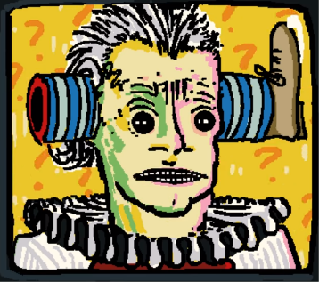**Description of Hazmatz Spokesperson**

Name: Unknown

Aliases: Hazmatz Spokesperson

Gender Presentation: Male

Approximate Age: Middle-Age

Status: Alive

Species: Humen

Voiced By: None

Physical Appearance

The Hazmatz Spokesperson appears to be a man dressed in clown cloths with one leg moved to the sides of his head.

Personality

In adverts his personality comes of as friendly and charming but this may just be as part of the performance.

In the advert Mischief is a bird he seems a lot more down and in pain Mischief implies some of this may be due to him having had one of his legs surgically moved to the side of his head, but it could also be because he has intestinal worms.

Note

The Hazmatz Spokesperson is not a part of the Hazmatz Monster Collection but as he is an extremely relevant part of the organisation, I have diced he should be included on the page.

**Analysis**

**How Is The Ghost In The Hazmatz Collection**

During the advert we see a shot of a cute cartoon ghost before a it briefly changes to show The Ghost also known as Henryk’s Granddaughter. This is odd as at this point The Ghost should have been uploaded to the interfaces for KAMI to use, I believe that this reviles some information on how greetings robotics operates that I will explain bellow.

The Ghost’s appearances in the advert makes the most seems if The Hazmatz Collection are working with Greetings Robotics, we know that greetings robotics seeks to capture and repurposes all cerebral electrify monsters and its possible that The Hazmatz collection sensitives to sell weakened and largely safe copies of cerebral electricity monsters for profit.

We know that Greetings Robotics is capable of making copies of cerebral electricity monsters and is capable of modifying them as this is reputedly shown in the series.

This would imply that Greetings Robotics has captured multiple Cerebral Electricity Monsters of screen, given that we see nothing else’s of these monsters it’s possible that they are to weak to be useful to KAMI which is how we usually see the monsters captured by Greetings Robotics.

A reason The Ghost may have been used despite being quite powerful is that she is shown to be very good with children as she has a granddaughter, she was raising prior to being taken by Greetings Robotics and she like also raised a child, but no information is given on this.

**References**

Episode 8 The Watchful Eyes

Greetings Robotics

The Ghost

Cerebral Electricity

**Sources**

Interface

https://www.youtube.com/watch?v=EHqsCmfTDmI&list=PLPnjato8iGXLQbppBPhOny8XLSRl7S5pM&index=1

Secondary source of information on interface and formatting ideas for webpages. <https://umami.fandom.com/wiki/Umami_Wiki>